UNIT IV

REGRESSION ANALYSIS AND FORECASTING

In the first three units of the text, you were introduced to basic statistics, distributions, and how to make inferences through confidence interval estimation and hypothesis testing. In [**Unit IV**](https://learning.oreilly.com/library/view/business-statistics-for/9781118213957/22_part04.html#part4), we explore relationships between variables through regression analysis and learn how to develop models that can be used to predict one variable by another variable or even multiple variables. We will examine a cadre of statistical techniques that can be used to forecast values from time-series data and how to measure how well the forecast is.

CHAPTER 12

Simple Regression Analysis and Correlation

**LEARNING OBJECTIVES**

The overall objective of this chapter is to give you an understanding of bivariate linear regression analysis, thereby enabling you to:

1. Calculate the Pearson product-moment correlation coefficient to determine if there is a correlation between two variables.
2. Explain what regression analysis is and the concepts of independent and dependent variable.
3. Calculate the slope and y-intercept of the least squares equation of a regression line and from those, determine the equation of the regression line.
4. Calculate the residuals of a regression line and from those determine the fit of the model, locate outliers, and test the assumptions of the regression model.
5. Calculate the standard error of the estimate using the sum of squares of error, and use the standard error of the estimate to determine the fit of the model.
6. Calculate the coefficient of determination to measure the fit for regression models, and relate it to the coefficient of correlation.
7. Use the *t* and *F* tests to test hypotheses for both the slope of the regression model and the overall regression model.
8. Calculate confidence intervals to estimate the conditional mean of the dependent variable and prediction intervals to estimate a single value of the dependent variable.
9. Determine the equation of the trend line to forecast outcomes for time periods in the future, using alternate coding for time periods if necessary.
10. Use a computer to develop a regression analysis, and interpret the output that is associated with it.

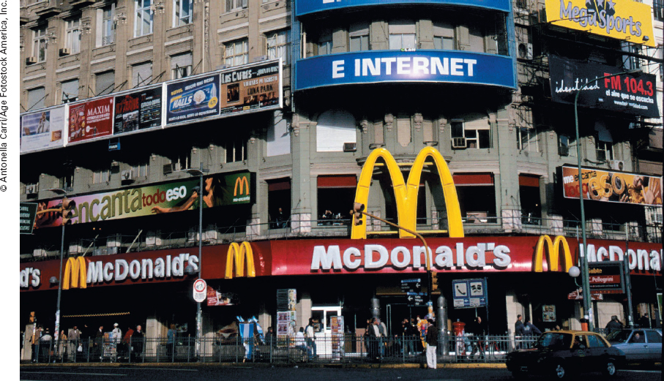

** Predicting International Hourly Wages by the Price of a Big Mac**

 The McDonald's Corporation is the leading global foodservice retailer with more than 30,000 local restaurants serving nearly 50 million people in more than 119 countries each day. This global presence, in addition to its consistency in food offerings and restaurant operations, makes McDonald's a unique and attractive setting for economists to make salary and price comparisons around the world. Because the Big Mac hamburger is a standardized hamburger produced and sold in virtually every McDonald's around the world, the *Economist*, a weekly newspaper focusing on international politics and business news and opinion, as early as 1986 was compiling information about Big Mac prices as an indicator of exchange rates. Building on this idea, researchers Ashenfelter and Jurajda proposed comparing wage rates across countries and the price of a Big Mac hamburger. Shown below are Big Mac prices and net hourly wage figures (in U.S. dollars) for 27 countries. Note that net hourly wages are based on a weighted average of 12 professions.

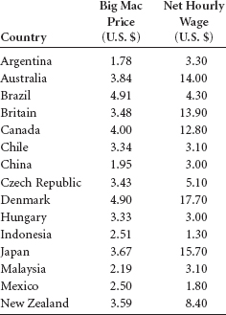

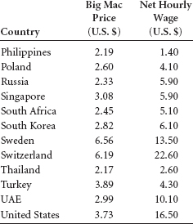

**Managerial and Statistical Questions**

1. Is there a relationship between the price of a Big Mac and the net hourly wages of workers around the world? If so, how strong is the relationship?
2. Is it possible to develop a model to predict or determine the net hourly wage of a worker around the world by the price of a Big Mac hamburger in that country? If so, how good is the model?
3. If a model can be constructed to determine the net hourly wage of a worker around the world by the price of a Big Mac hamburger, what would be the predicted net hourly wage of a worker in a country if the price of a Big Mac hamburger was $3.00?

*Sources:* McDonald's Web site, at [**http://www.mcdonalds.com/corp/about**](http://www.mcdonalds.com/corp/about). html; Michael R. Pakko and Patricia S. Pollard, “Burgernomics: A Big Mac Guide to Purchasing Power Parity,” research publication by the St. Louis Federal Reserve Bank, at [**http://research.stlouisfed.org/publications/review/03/11/pakko.pdf**](http://research.stlouisfed.org/publications/review/03/11/pakko.pdf;) Orley Ashenfelter and Stepán Jurajda, “Cross-Country Comparisons of Wage Rates: The Big Mac Index,” unpublished manuscript, Princeton University and CERGEEI/Charles University, October 2001; Nicholas Vardy, “The ‘Big Mac' Index for 2010,” at [**http://nickvardy.com/2010/07/29/the-big-mac-index-for-2010/;**](http://nickvardy.com/2010/07/29/the-big-mac-index-for-2010/;) “Prices and Earnings,” 2009 edition, UBS, at [**http://www.ubs.com/1/e/media_overview/media_global/releases?newsId=170250**](http://www.ubs.com/1/e/media_overview/media_global/releases?newsId=170250).

In business, the key to decision making often lies in the understanding of the relationships between two or more variables. For example, a company in the distribution business may determine that there is a relationship between the price of crude oil and the company's transportation costs. Financial experts, in studying the behavior of the bond market, might find it useful to know if the interest rates on bonds are related to the prime interest rate set by the Federal Reserve. A marketing executive might want to know how strong the relationship is between advertising dollars and sales dollars for a product or a company.

In this chapter, we will study the concept of correlation and how it can be used to estimate the relationship between two variables. We will also explore simple regression analysis through which mathematical models can be developed to predict one variable by another. We will examine tools for testing the strength and predictability of regression models, and we will learn how to use regression analysis to develop a forecasting trend line.

**12.1 CORRELATION**



**TABLE 12.1** Data for the Economics Example

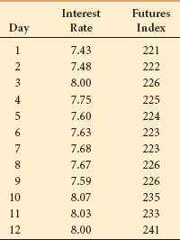

**Correlation** is *a measure of the degree of relatedness of variables.* It can help a business researcher determine, for example, whether the stocks of two airlines rise and fall in any related manner. For a sample of pairs of data, correlation analysis can yield a numerical value that represents the degree of relatedness of the two stock prices over time. In the transportation industry, is a correlation evident between the price of transportation and the weight of the object being shipped? If so, how strong are the correlations? In economics, how strong is the correlation between the producer price index and the unemployment rate? In retail sales, are sales related to population density, number of competitors, size of the store, amount of advertising, or other variables?

Several measures of correlation are available, the selection of which depends mostly on the level of data being analyzed. Ideally, researchers would like to solve for ρ, the population coefficient of correlation. However, because researchers virtually always deal with sample data, this section introduces a widely used sample **coefficient of correlation**, *r*. This measure is applicable only if both variables being analyzed have at least an interval level of data. [**Chapter 17**](https://learning.oreilly.com/library/view/business-statistics-for/9781118213957/29_chapter17.html#ch17) presents a correlation measure that can be used when the data are ordinal.

The statistic *r* is the **Pearson product-moment correlation coefficient**, named after Karl Pearson (1857–1936), an English statistician who developed several coefficients of correlation along with other significant statistical concepts. The term *r* is a *measure of the linear correlation of two variables.* It is a number that ranges from –1 to 0 to +1, representing the strength of the relationship between the variables. An *r* value of +1 denotes a perfect positive relationship between two sets of numbers. An *r* value of –1 denotes a perfect negative correlation, which indicates an inverse relationship between two variables: as one variable gets larger, the other gets smaller. An *r* value of 0 means no linear relationship is present between the two variables.

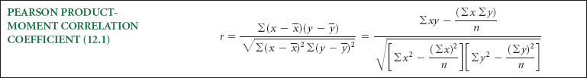

[**Figure 12.1**](https://learning.oreilly.com/library/view/business-statistics-for/9781118213957/23_chapter12.html#fig12.1) depicts five different degrees of correlation: (a) represents strong negative correlation, (b) represents moderate negative correlation, (c) represents moderate positive correlation, (d) represents strong positive correlation, and (e) contains no correlation.

What is the measure of correlation between the interest rate of federal funds and the commodities futures index? With data such as those shown in [**Table 12.1**](https://learning.oreilly.com/library/view/business-statistics-for/9781118213957/23_chapter12.html#tab12.1), which represent the values for interest rates of federal funds and commodities futures indexes for a sample of 12 days, a correlation coefficient, *r*, can be computed.

**FIGURE 12.1** Five Correlations

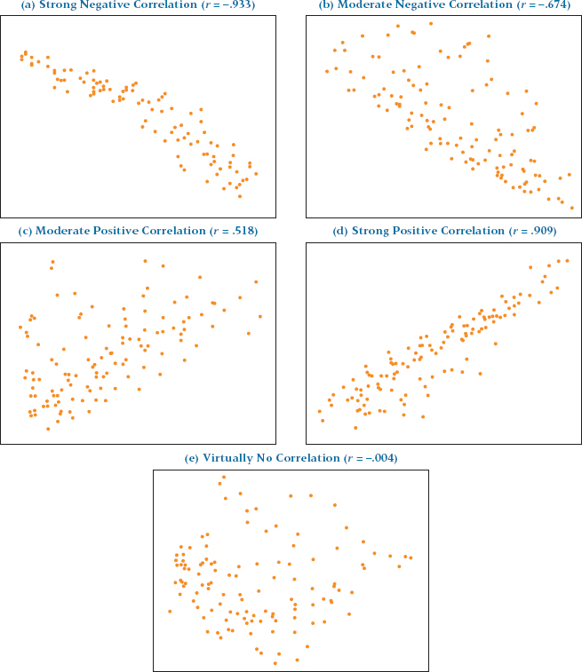

Examination of the formula for computing a Pearson product-moment correlation coefficient (12.1) reveals that the following values must be obtained to compute *r*: Σ *x*, Σ *x***2**, Σ *y*, Σ *y***2**, Σ*xy*, and *n*. In correlation analysis, it does not matter which variable is designated *x* and which is designated *y*. For this example, the correlation coefficient is computed as shown in [**Table 12.2**](https://learning.oreilly.com/library/view/business-statistics-for/9781118213957/23_chapter12.html#tab12.2). The *r* value obtained (*r* = .815) represents a relatively strong positive relationship between interest rates and commodities futures index over this 12-day period.

[**Figure 12.2**](https://learning.oreilly.com/library/view/business-statistics-for/9781118213957/23_chapter12.html#fig12.2) shows both Excel and Minitab output for this problem.

**Table 12.2** Computation of *r* for the Economics Example

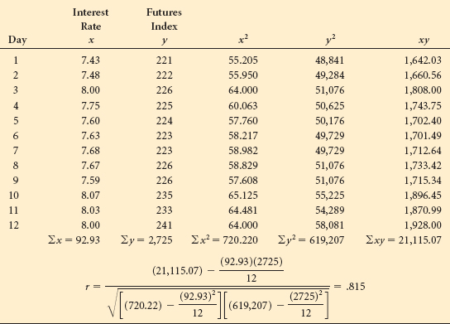

**FIGURE 12.2** Excel and Minitab Output for the Economics Example

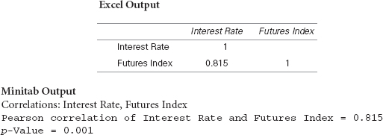

**12.1 PROBLEMS**

* **12.1** Determine the value of the coefficient of correlation, *r*, for the following data.



* **12.2** Determine the value of *r* for the following data.



* **12.3** In an effort to determine whether any correlation exists between the price of stocks of airlines, an analyst sampled six days of activity of the stock market. Using the following prices of Delta stock and Southwest stock, compute the coefficient of correlation. Stock prices have been rounded off to the nearest tenth for ease of computation.

| Delta | Southwest |
| --- | --- |
| 47.6 | 15.1 |
| 46.3 | 15.4 |
| 50.6 | 15.9 |
| 52.6 | 15.6 |
| 52.4 | 16.4 |
| 52.7 | 18.1 |

* **12.4** The following data are the claims (in $ millions) for BlueCross BlueShield benefits for nine states, along with the surplus (in $ millions) that the company had in assets in those states.

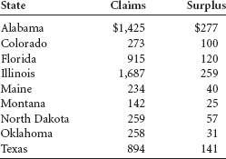

Use the data to compute a correlation coefficient, *r*, to determine the correlation between claims and surplus.

* **12.5** The National Safety Council released the following data on the incidence rates for fatal or lost-worktime injuries per 100 employees for several industries in three recent years.

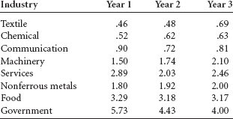

Compute *r* for each pair of years and determine which years are most highly correlated.

**12.2 INTRODUCTION TO SIMPLE REGRESSION ANALYSIS**

**Regression analysis** is *the process of constructing a mathematical model or function that can be used to predict or determine one variable by another variable or other variables*. The most elementary regression model is called **simple regression** or **bivariate regression** involving two variables in which one variable is predicted by another variable. In simple regression, *the variable to be predicted* is called the **dependent variable** and is designated as *y*. The *predictor* is called the **independent variable**, or *explanatory variable*, and is designated as *x*. In simple regression analysis, only a straight-line relationship between two variables is examined. Airline Cost Data Nonlinear relationships and regression models with more than one independent variable can be explored by using multiple regression models, which are presented in [**Chapters 13**](https://learning.oreilly.com/library/view/business-statistics-for/9781118213957/24_chapter13.html#ch13) and [**14**](https://learning.oreilly.com/library/view/business-statistics-for/9781118213957/25_chapter14.html#ch14).

**TABLE 12.3** Airline Cost Data

| Number of Passengers | Cost ($1,000) |
| --- | --- |
| 61 | 4.280 |
| 63 | 4.080 |
| 67 | 4.420 |
| 69 | 4.170 |
| 70 | 4.480 |
| 74 | 4.300 |
| 76 | 4.820 |
| 81 | 4.700 |
| 86 | 5.110 |
| 91 | 5.130 |
| 95 | 5.640 |
| 97 | 5.560 |

Can the cost of flying a commercial airliner be predicted using regression analysis? If so, what variables are related to such cost? A few of the many variables that can potentially contribute are type of plane, distance, number of passengers, amount of luggage/freight, weather conditions, direction of destination, and perhaps even pilot skill. Suppose a study is conducted using only Boeing 737s traveling 500 miles on comparable routes during the same season of the year. Can the number of passengers predict the cost of flying such routes? It seems logical that more passengers result in more weight and more baggage, which could, in turn, result in increased fuel consumption and other costs. Suppose the data displayed in [**Table 12.3**](https://learning.oreilly.com/library/view/business-statistics-for/9781118213957/23_chapter12.html#tab12.3) are the costs and associated number of passengers for twelve 500-mile commercial airline flights using Boeing 737s during the same season of the year. We will use these data to develop a regression model to predict cost by number of passengers.

Usually, the first step in simple regression analysis is to construct a **scatter plot** (or scatter diagram), discussed in [**Chapter 2**](https://learning.oreilly.com/library/view/business-statistics-for/9781118213957/10_chapter02.html#ch2). Graphing the data in this way yields preliminary information about the shape and spread of the data. [**Figure 12.3**](https://learning.oreilly.com/library/view/business-statistics-for/9781118213957/23_chapter12.html#fig12.3) is an Excel scatter plot of the data in [**Table 12.3**](https://learning.oreilly.com/library/view/business-statistics-for/9781118213957/23_chapter12.html#tab12.3). [**Figure 12.4**](https://learning.oreilly.com/library/view/business-statistics-for/9781118213957/23_chapter12.html#fig12.4) is a close-up view of the scatter plot produced by Minitab. Try to imagine a line passing through the points. Is a linear fit possible? Would a curve fit the data better? The scatter plot gives some idea of how well a regression line fits the data. Later in the chapter, we present statistical techniques that can be used to determine more precisely how well a regression line fits the data.

**FIGURE 12.3** Excel Scatter Plot of Airline Cost Data

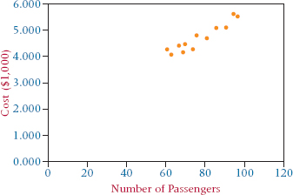

**FIGURE 12.4** Close-Up Minitab Scatter Plot of Airline Cost Data

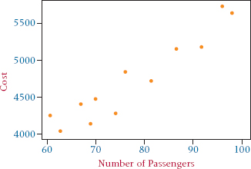

**12.3 DETERMINING THE EQUATION OF THE REGRESSION LINE**



The first step in determining the equation of the regression line that passes through the sample data is to establish the equation's form. Several different types of equations of lines are discussed in algebra, finite math, or analytic geometry courses. Recall that among these equations of a line are the two-point form, the point-slope form, and the slope-intercept form. In regression analysis, researchers use the slope-intercept equation of a line. In math courses, the slope-intercept form of the equation of a line often takes the form



where

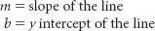

In statistics, the slope-intercept form of the equation of the regression line through the population points is



where

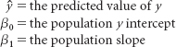

For any specific dependent variable value, *y****i***,



where

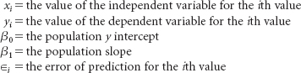

Unless the points being fitted by the regression equation are in perfect alignment, the regression line will miss at least some of the points. In the preceding equation, ∊***i*** represents the error of the regression line in fitting these points. If a point is on the regression line, ∊***i*** = 0.

These mathematical models can be either deterministic models or probabilistic models. **Deterministic models** are *mathematical models that produce an “exact” output for a given input.* For example, suppose the equation of a regression line is



For a value of *x* = 5, the exact predicted value of *y* is



We recognize, however, that most of the time the values of *y* will not equal exactly the values yielded by the equation. Random error will occur in the prediction of the *y* values for values of *x* because it is likely that the variable *x* does not explain all the variability of the variable *y*. For example, suppose we are trying to predict the volume of sales (*y*) for a company through regression analysis by using the annual dollar amount of advertising (*x*) as the predictor. Although sales are often related to advertising, other factors related to sales are not accounted for by amount of advertising. Hence, a regression model to predict sales volume by amount of advertising probably involves some error. For this reason, in regression, we present the general model as a probabilistic model. A **probabilistic model** is *one that includes an error term that allows for the y values to vary for any given value of x.*

A deterministic regression model is



The probabilistic regression model is



β**0** + β**1***x* is the deterministic portion of the probabilistic model, β**0** + β**1***x* + ∊. In a deterministic model, all points are assumed to be on the line and in all cases ∊ is zero.

Virtually all regression analyses of business data involve sample data, not population data. As a result, β**0** and β**1** are unattainable and must be estimated by using the sample statistics, *b***0** and *b***1**. Hence the equation of the regression line contains the sample *y* intercept, *b***0**, and the sample slope, *b***1**.

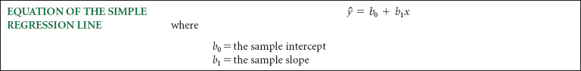

To determine the equation of the regression line for a sample of data, the researcher must determine the values for *b***0** and *b***1**. This process is sometimes referred to as least squares analysis. **Least squares analysis** is *a process whereby a regression model is developed by producing the minimum sum of the squared error values.* On the basis of this premise and calculus, a particular set of equations has been developed to produce components of the regression model.[**1**](https://learning.oreilly.com/library/view/business-statistics-for/9781118213957/23_chapter12.html#fn.001)

**FIGURE 12.5** Minitab Plot of a Regression Line

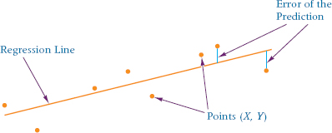

Examine the regression line fit through the points in [**Figure 12.5**](https://learning.oreilly.com/library/view/business-statistics-for/9781118213957/23_chapter12.html#fig12.5). Observe that the line does not actually pass through any of the points. The vertical distance from each point to the line is the error of the prediction. In theory, an infinite number of lines could be constructed to pass through these points in some manner. The least squares regression line is the regression line that results in the smallest sum of errors squared.

Formula 12.2 is an equation for computing the value of the sample slope. Several versions of the equation are given to afford latitude in doing the computations.

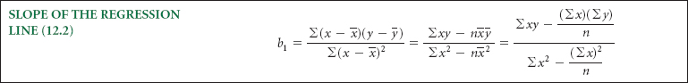

The expression in the numerator of the slope formula 12.2 appears frequently in this chapter and is denoted as *SS****xy***.



The expression in the denominator of the slope formula 12.2 also appears frequently in this chapter and is denoted as SS***xx***.

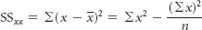

With these abbreviations, the equation for the slope can be expressed as in Formula 12.3.



Formula 12.4 is used to compute the sample *y* intercept. The slope must be computed before the *y* intercept.



Formulas 12.2, 12.3, and 12.4 show that the following data are needed from sample information to compute the slope and intercept: Σ*x*, Σ*y*, Σ*x***2**, and, Σ*xy*, unless sample means are used. [**Table 12.4**](https://learning.oreilly.com/library/view/business-statistics-for/9781118213957/23_chapter12.html#tab12.4) contains the results of solving for the slope and intercept and determining the equation of the regression line for the data in [**Table 12.3**](https://learning.oreilly.com/library/view/business-statistics-for/9781118213957/23_chapter12.html#tab12.3).

The least squares equation of the regression line for this problem is



**TABLE 12.4** Solving for the Slope and the y Intercept of the Regression Line for the Airline Cost Example

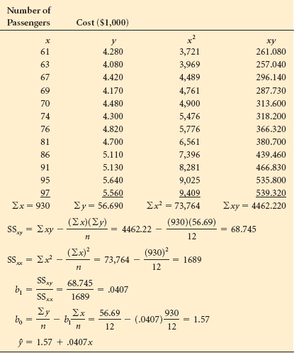

The slope of this regression line is .0407. Because the *x* values were recoded for the ease of computation and are actually in $1,000 denominations, the slope is actually $40.70. One interpretation of the slope in this problem is that for every unit increase in *x* (every person added to the flight of the airplane), there is a $40.70 increase in the cost of the flight. The *y*-intercept is the point where the line crosses the *y*-axis (where *x* is zero). Sometimes in regression analysis, the *y*-intercept is meaningless in terms of the variables studied. However, in this problem, one interpretation of the *y*-intercept, which is 1.570 or $1,570, is that even if there were no passengers on the commercial flight, it would still cost $1,570. In other words, there are costs associated with a flight that carries no passengers.

Superimposing the line representing the least squares equation for this problem on the scatter plot indicates how well the regression line fits the data points, as shown in the Excel graph in [**Figure 12.6**](https://learning.oreilly.com/library/view/business-statistics-for/9781118213957/23_chapter12.html#fig12.6). The next several sections explore mathematical ways of testing how well the regression line fits the points.

**FIGURE 12.6** Excel Graph of Regression Line for the Airline Cost Example

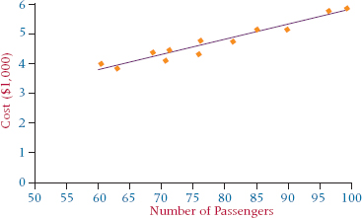

**DEMONSTRATION PROBLEM 12.1**

A specialist in hospital administration stated that the number of FTEs (full-time employees) in a hospital can be estimated by counting the number of beds in the hospital (a common measure of hospital size). A healthcare business researcher decided to develop a regression model in an attempt to predict the number of FTEs of a hospital by the number of beds. She surveyed 12 hospitals and obtained the following data. The data are presented in sequence, according to the number of beds.

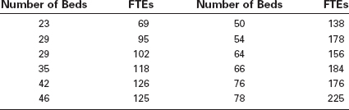

**Solution**

The following Minitab graph is a scatter plot of these data. Note the linear appearance of the data.

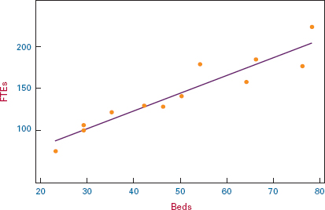

Next, the researcher determined the values of Σ*x*, Σ*y*, Σ*x***2**, and Σ*xy*.

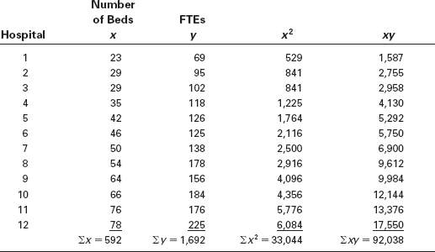

Using these values, the researcher solved for the sample slope (*b***1**) and the sample *y*-intercept (*b***0**)

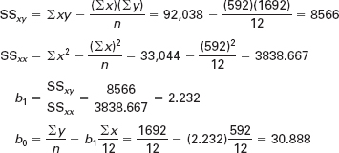

The least squares equation of the regression line is

*ŷ* = 30.888 + 2.232*x*

The slope of the line, *b***1** = 2.232, means that for every unit increase of *x* (every bed), *y* (number of FTEs) is predicted to increase by 2.232. Even though the *y*-intercept helps the researcher sketch the graph of the line by being one of the points on the line (0, 30.888), it has limited usefulness in terms of this solution because *x* = 0 denotes a hospital with no beds. On the other hand, it could be interpreted that a hospital has to have at least 31 FTEs to open its doors even with no patients—a sort of “fixed cost” of personnel.

**12.3 PROBLEMS**

* **12.6** Sketch a scatter plot from the following data, and determine the equation of the regression line.

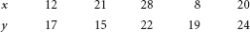

* **12.7** Sketch a scatter plot from the following data, and determine the equation of the regression line.



* **12.8** A corporation owns several companies. The strategic planner for the corporation believes dollars spent on advertising can to some extent be a predictor of total sales dollars. As an aid in long-term planning, she gathers the following sales and advertising information from several of the companies for 2011 ($ millions).

| Advertising | Sales |
| --- | --- |
| 12.5 | 148 |
| 3.7 | 55 |
| 21.6 | 338 |
| 60.0 | 994 |
| 37.6 | 541 |
| 6.1 | 89 |
| 16.8 | 126 |
| 41.2 | 379 |

* Develop the equation of the simple regression line to predict sales from advertising expenditures using these data.
* **12.9** Investment analysts generally believe the interest rate on bonds is inversely related to the prime interest rate for loans; that is, bonds perform well when lending rates are down and perform poorly when interest rates are up. Can the bond rate be predicted by the prime interest rate? Use the following data to construct a least squares regression line to predict bond rates by the prime interest rate.

| Bond Rate | Prime Interest Rate |
| --- | --- |
| 5% | 16% |
| 12 | 6 |
| 9 | 8 |
| 15 | 4 |
| 7 | 7 |

* **12.10** Is it possible to predict the annual number of business bankruptcies by the number of firm births (business starts) in the United States? The following data published by the U.S. Small Business Administration, Office of Advocacy, are pairs of the number of business bankruptcies (1000s) and the number of firm births (10,000s) for a six-year period. Use these data to develop the equation of the regression model to predict the number of business bankruptcies by the number of firm births.

Discuss the meaning of the slope.

| Business Bankruptcies (1000) | Firm Births (10,000) |
| --- | --- |
| 34.3 | 58.1 |
| 35.0 | 55.4 |
| 38.5 | 57.0 |
| 40.1 | 58.5 |
| 35.5 | 57.4 |
| 37.9 | 58.0 |

* **12.11** It appears that over the past 45 years, the number of farms in the United States declined while the average size of farms increased. The following data provided by the U.S. Department of Agriculture show five-year interval data for U.S. farms. Use these data to develop the equation of a regression line to predict the average size of a farm by the number of farms. Discuss the slope and *y*-intercept of the model

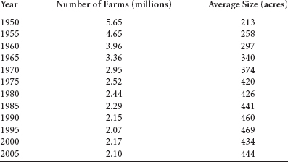

* **12.12** Can the annual new orders for manufacturing in the United States be predicted by the raw steel production in the United States? Shown on the next page are the annual new orders for 10 years according to the U.S. Census Bureau and the raw steel production for the same 10 years as published by the American Iron & Steel Institute. Use these data to develop a regression model to predict annual new orders by raw steel production. Construct a scatter plot and draw the regression line through the points.

| Raw Steel Production (100,000s of net tons) | New Orders ($ trillions) |
| --- | --- |
| 99.9 | 2.74 |
| 97.9 | 2.87 |
| 98.9 | 2.93 |
| 87.9 | 2.87 |
| 92.9 | 2.98 |
| 97.9 | 3.09 |
| 100.6 | 3.36 |
| 104.9 | 3.61 |
| 105.3 | 3.75 |
| 108.6 | 3.95 |

**12.4 RESIDUAL ANALYSIS**



How does a business researcher test a regression line to determine whether the line is a good fit of the data other than by observing the fitted line plot (regression line fit through a scatter plot of the data)? One particularly popular approach is to use the *historical data* (*x* and *y* values used to construct the regression model) to test the model. With this approach, the values of the independent variable (*x* values) are inserted into the regression model and a predicted value (*ŷ*) is obtained for each *x* value. These predicted values (*ŷ*) are then compared to the actual *y* values to determine how much error the equation of the regression line produced. *Each difference between the actual y values and the predicted y values is the error of the regression line at a given point, y* – *ŷ*, and is referred to as the **residual**. It is the sum of squares of these residuals that is minimized to find the least squares line.

[**Table 12.5**](https://learning.oreilly.com/library/view/business-statistics-for/9781118213957/23_chapter12.html#tab12.5) shows ŷ values and the residuals for each pair of data for the airline cost regression model developed in Section 12.3. The predicted values are calculated by inserting an *x* value into the equation of the regression line and solving for ŷ. For example, when *x* = 61, ŷ = 1.57 + .0407(61) = 4.053, as displayed in column 3 of the table. Each of these predicted *y* values is subtracted from the actual *y* value to determine the error, or residual. For example, the first *y* value listed in the table is 4.280 and the first predicted value is 4.053, resulting in a residual of 4.280 – 4.053 = .227. The residuals for this problem are given in column 4 of the table.

Note that the sum of the residuals is approximately zero. Except for rounding error, the sum of the residuals is *always zero.* The reason is that a residual is geometrically the vertical distance from the regression line to a data point. The equations used to solve for the slope and intercept place the line geometrically in the middle of all points. Therefore, vertical distances from the line to the points will cancel each other and sum to zero. [**Figure 12.7**](https://learning.oreilly.com/library/view/business-statistics-for/9781118213957/23_chapter12.html#fig12.7) is a Minitab-produced scatter plot of the data and the residuals for the airline cost example.

**TABLE 12.5** Predicted Values and Residuals for the Airline Cost Example

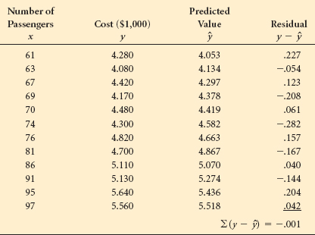

**FIGURE 12.7** Close-Up Minitab Scatter Plot with Residuals for the Airline Cost Example

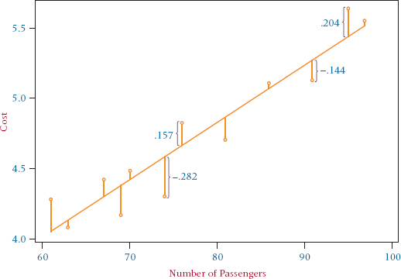

An examination of the residuals may give the researcher an idea of how well the regression line fits the historical data points. The largest residual for the airline cost example is –.282, and the smallest is .040. Because the objective of the regression analysis was to predict the cost of flight in $1,000s, the regression line produces an error of $282 when there are 74 passengers and an error of only $40 when there are 86 passengers. This result presents the *best* and *worst* cases for the residuals. The researcher must examine other residuals to determine how well the regression model fits other data points.

Sometimes residuals are used to locate outliers. **Outliers** are *data points that lie apart from the rest of the points.* Outliers can produce residuals with large magnitudes and are usually easy to identify on scatter plots. Outliers can be the result of misrecorded or miscoded data, or they may simply be data points that do not conform to the general trend. The equation of the regression line is influenced by every data point used in its calculation in a manner similar to the arithmetic mean. Therefore, outliers sometimes can unduly influence the regression line by “pulling” the line toward the outliers. The origin of outliers must be investigated to determine whether they should be retained or whether the regression equation should be recomputed without them.

Residuals are usually plotted against the *x*-axis, which reveals a view of the residuals as *x* increases. [**Figure 12.8**](https://learning.oreilly.com/library/view/business-statistics-for/9781118213957/23_chapter12.html#fig12.8) shows the residuals plotted by Excel against the *x*-axis for the airline cost example.

**FIGURE 12.8** Excel Graph of Residuals for the Airline Cost Example

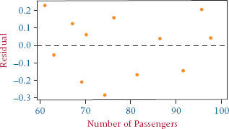

**FIGURE 12.9** Nonlinear Residual Plot

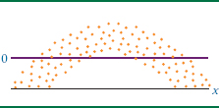

**FIGURE 12.10** Nonconstant Error Variance

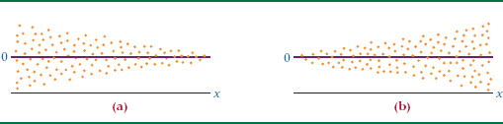

**Using Residuals to Test the Assumptions of the Regression Model**

One of the major uses of residual analysis is to test some of the assumptions underlying regression. The following are the assumptions of simple regression analysis.

1. The model is linear.
2. The error terms have constant variances.
3. The error terms are independent.
4. The error terms are normally distributed.

A particular method for studying the behavior of residuals is the residual plot. The **residual plot** is *a type of graph in which the residuals for a particular regression model are plotted along with their associated value of x as an ordered pair (x, y* – ŷ). Information about how well the regression assumptions are met by the particular regression model can be gleaned by examining the plots. Residual plots are more meaningful with larger sample sizes. For small sample sizes, residual plot analyses can be problematic and subject to overinterpretation. Hence, because the airline cost example is constructed from only 12 pairs of data, one should be cautious in reaching conclusions from [**Figure 12.8**](https://learning.oreilly.com/library/view/business-statistics-for/9781118213957/23_chapter12.html#fig12.8). The residual plots in [**Figures 12.9**](https://learning.oreilly.com/library/view/business-statistics-for/9781118213957/23_chapter12.html#fig12.9), [**12.10**](https://learning.oreilly.com/library/view/business-statistics-for/9781118213957/23_chapter12.html#fig12.10), and [**12.11**](https://learning.oreilly.com/library/view/business-statistics-for/9781118213957/23_chapter12.html#fig12.11), however, represent large numbers of data points and therefore are more likely to depict overall trends accurately.

If a residual plot such as the one in [**Figure 12.9**](https://learning.oreilly.com/library/view/business-statistics-for/9781118213957/23_chapter12.html#fig12.9) appears, the assumption that the model is linear does not hold. Note that the residuals are negative for low and high values of *x* and are positive for middle values of *x*. The graph of these residuals is parabolic, not linear. The residual plot does not have to be shaped in this manner for a nonlinear relationship to exist. Any significant deviation from an approximately linear residual plot may mean that a nonlinear relationship exists between the two variables.

The assumption of *constant error variance* sometimes is called **homoscedasticity**. If *the error variances are not constant* (called **heteroscedasticity**), the residual plots might look like one of the two plots in [**Figure 12.10**](https://learning.oreilly.com/library/view/business-statistics-for/9781118213957/23_chapter12.html#fig12.10). Note in [**Figure 12.10**](https://learning.oreilly.com/library/view/business-statistics-for/9781118213957/23_chapter12.html#fig12.10)(a) that the error variance is greater for small values of *x* and smaller for large values of *x*. The situation is reversed in [**Figure 12.10**](https://learning.oreilly.com/library/view/business-statistics-for/9781118213957/23_chapter12.html#fig12.10)(b).

If the error terms are not independent, the residual plots could look like one of the graphs in [**Figure 12.11**](https://learning.oreilly.com/library/view/business-statistics-for/9781118213957/23_chapter12.html#fig12.11). According to these graphs, instead of each error term being independent of the one next to it, the value of the residual is a function of the residual value next to it. For example, a large positive residual is next to a large positive residual and a small negative residual is next to a small negative residual.

The graph of the residuals from a regression analysis that meets the assumptions—a *healthy residual graph*—might look like the graph in [**Figure 12.12**](https://learning.oreilly.com/library/view/business-statistics-for/9781118213957/23_chapter12.html#fig12.12). The plot is relatively linear; the variances of the errors are about equal for each value of *x*, and the error terms do not appear to be related to adjacent terms.

**FIGURE 12.11** Graphs of Nonindependent Error Terms

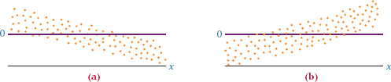

**FIGURE 12.12** Healthy Residual Graph

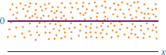

**Using the Computer for Residual Analysis**

Some computer programs contain mechanisms for analyzing residuals for violations of the regression assumptions. Minitab has the capability of providing graphical analysis of residuals. [**Figure 12.13**](https://learning.oreilly.com/library/view/business-statistics-for/9781118213957/23_chapter12.html#fig12.13) displays Minitab's residual graphic analyses for a regression model developed to predict the production of carrots in the United States per month by the total production of sweet corn. The data were gathered over a time period of 168 consecutive months (see WileyPLUS for the agricultural database).

These Minitab residual model diagnostics consist of three different plots. The graph on the upper right is a plot of the residuals versus the fits. Note that this residual plot “flares-out” as *x* gets larger. This pattern is an indication of heteroscedasticity, which is a violation of the assumption of constant variance for error terms. The graph in the upper left is a normal probability plot of the residuals. A straight line indicates that the residuals are normally distributed. Observe that this normal plot is relatively close to being a straight line, indicating that the residuals are nearly normal in shape. This normal distribution is confirmed by the graph on the lower left, which is a histogram of the residuals. The histogram groups residuals in classes so the researcher can observe where groups of the residuals lie without having to rely on the residual plot and to validate the notion that the residuals are approximately normally distributed. In this problem, the pattern is indicative of at least a mound-shaped distribution of residuals.

**FIGURE 12.13** Minitab Residual Analyses

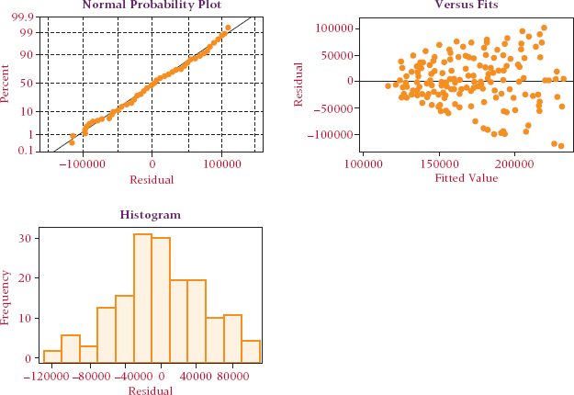

**DEMONSTRATION PROBLEM 12.2**

Compute the residuals for Demonstration Problem 12.1 in which a regression model was developed to predict the number of full-time equivalent workers (FTEs) by the number of beds in a hospital. Analyze the residuals by using Minitab graphic diagnostics.

**Solution**

The data and computed residuals are shown in the following table.

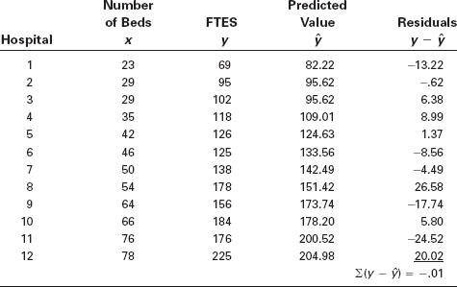

Note that the regression model fits these particular data well for hospitals 2 and 5, as indicated by residuals of –.62 and 1.37 FTEs, respectively. For hospitals 1, 8, 9, 11, and 12, the residuals are relatively large, indicating that the regression model does not fit the data for these hospitals well. The Residuals Versus the Fitted Values graph indicates that the residuals seem to increase as *x* increases, indicating a potential problem with heteroscedasticity. The normal plot of residuals indicates that the residuals are nearly normally distributed. The histogram of residuals shows that the residuals pile up in the middle, but are somewhat skewed toward the larger positive values.

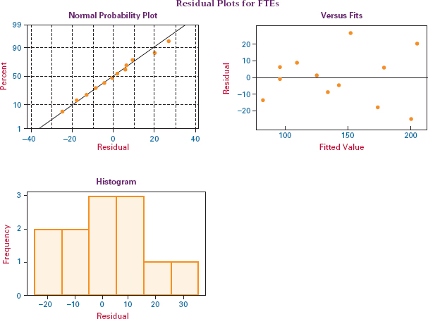

**12.4 PROBLEMS**

* **12.13** Determine the equation of the regression line for the following data, and compute the residuals.



* **12.14** Solve for the predicted values of *y* and the residuals for the data in Problem 12.6. The data are provided here again:



* **12.15** Solve for the predicted values of *y* and the residuals for the data in Problem 12.7. The data are provided here again:



* **12.16** Solve for the predicted values of *y* and the residuals for the data in Problem 12.8. The data are provided here again:



* **12.17** Solve for the predicted values of *y* and the residuals for the data in Problem 12.9. The data are provided here again:



* **12.18** In problem 12.10, you were asked to develop the equation of a regression model to predict the number of business bankruptcies by the number of firm births. Using this regression model and the data given in problem 12.10 (and provided here again), solve for the predicted values of *y* and the residuals. Comment on the size of the residuals.

| Business Bankruptcies (1,000) | Firm Births (10,000) |
| --- | --- |
| 34.3 | 58.1 |
| 35.0 | 55.4 |
| 38.5 | 57.0 |
| 40.1 | 58.5 |
| 35.5 | 57.4 |
| 37.9 | 58.0 |

* **12.19** The equation of a regression line is



and the data are as follows.



Solve for the residuals and graph a residual plot. Do these data seem to violate any of the assumptions of regression?

* **12.20** Wisconsin is an important milk-producing state. Some people might argue that because of transportation costs, the cost of milk increases with the distance of markets from Wisconsin. Suppose the milk prices in eight cities are as follows.

| Cost of Milk (per gallon) | Distance from Madison (miles) |
| --- | --- |
| $2.64 | 1,245 |
| 2.31 | 425 |
| 2.45 | 1,346 |
| 2.52 | 973 |
| 2.19 | 255 |
| 2.55 | 865 |
| 2.40 | 1,080 |
| 2.37 | 296 |

* Use the prices along with the distance of each city from Madison, Wisconsin, to develop a regression line to predict the price of a gallon of milk by the number of miles the city is from Madison. Use the data and the regression equation to compute residuals for this model. Sketch a graph of the residuals in the order of the *x* values. Comment on the shape of the residual graph.
* **12.21** Graph the following residuals, and indicate which of the assumptions underlying regression appear to be in jeopardy on the basis of the graph.

| *x* | *y–ŷ* |
| --- | --- |
| 213 | –11 |
| 216 | –5 |
| 227 | –2 |
| 229 | –1 |
| 237 | +6 |
| 247 | +10 |
| 263 | +12 |

* **12.22** Graph the following residuals, and indicate which of the assumptions underlying regression appear to be in jeopardy on the basis of the graph.

| *x* | *y–ŷ* |
| --- | --- |
| 10 | +6 |
| 11 | +3 |
| 12 | –1 |
| 13 | –11 |
| 14 | –3 |
| 15 | +2 |
| 16 | +5 |
| 17 | +8 |

* **12.23** Study the following Minitab Residuals Versus Fits graphic for a simple regression analysis. Comment on the residual evidence of lack of compliance with the regression assumptions.

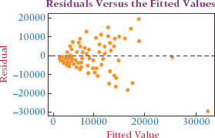

**12.5 STANDARD ERROR OF THE ESTIMATE**





Residuals represent errors of estimation for individual points. With large samples of data, residual computations become laborious. Even with computers, a researcher sometimes has difficulty working through pages of residuals in an effort to understand the error of the regression model. An alternative way of examining the error of the model is the standard error of the estimate, which provides a single measurement of the regression error.

Because the sum of the residuals is zero, attempting to determine the total amount of error by summing the residuals is fruitless. This zero-sum characteristic of residuals can be avoided by squaring the residuals and then summing them.

[**Table 12.6**](https://learning.oreilly.com/library/view/business-statistics-for/9781118213957/23_chapter12.html#tab12.6) contains the airline cost data from [**Table 12.3**](https://learning.oreilly.com/library/view/business-statistics-for/9781118213957/23_chapter12.html#tab12.3), along with the residuals and the residuals squared. The *total of the residuals squared* column is called the **sum of squares of error (SSE)**.



In theory, infinitely many lines can be fit to a sample of points. However, formulas 12.2 and 12.4 produce a line of best fit for which the SSE is the smallest for any line that can be fit to the sample data. This result is guaranteed, because formulas 12.2 and 12.4 are derived from calculus to minimize SSE. For this reason, the regression process used in this chapter is called *least squares* regression.

A computational version of the equation for computing SSE is less meaningful in terms of interpretation than Σ(*y* – ŷ)**2** but it is usually easier to compute. The computational formula for SSE follows.



For the airline cost example,

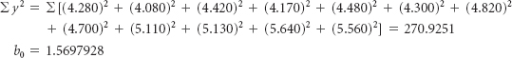

**TABLE 12.6** Determining SSE for the Airline Cost Example

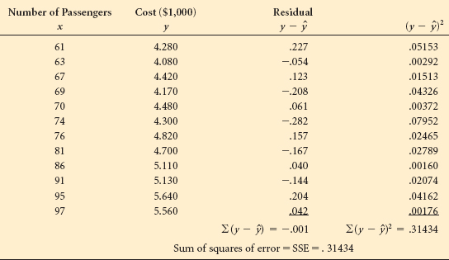

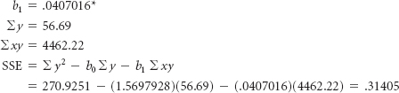[**\***](https://learning.oreilly.com/library/view/business-statistics-for/9781118213957/23_chapter12.html#fn.002)

The slight discrepancy between this value and the value computed in [**Table 12.6**](https://learning.oreilly.com/library/view/business-statistics-for/9781118213957/23_chapter12.html#tab12.6) is due to rounding error.

The sum of squares error is in part a function of the number of pairs of data being used to compute the sum, which lessens the value of SSE as a measurement of error. A more useful measurement of error is the standard error of the estimate. The **standard error of the estimate**, denoted *s****e***, is *a standard deviation of the error of the regression model* and has a more practical use than SSE. The standard error of the estimate follows.



The standard error of the estimate for the airline cost example is

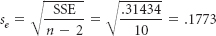

How is the standard error of the estimate used? As previously mentioned, the standard error of the estimate is a standard deviation of error. Recall from [**Chapter 3**](https://learning.oreilly.com/library/view/business-statistics-for/9781118213957/11_chapter03.html#ch3) that if data are approximately normally distributed, the empirical rule states that about 68% of all values are within μ ± 1σ and that about 95% of all values are within μ ± 2σ. One of the assumptions for regression states that for a given *x* the error terms are normally distributed. Because the error terms are normally distributed, *s****e*** is the standard deviation of error, and the average error is zero, approximately 68% of the error values (residuals) should be within 0 ± 1 *s****e*** and 95% of the error values (residuals) should be within 0 ± 2*s****e***. By having knowledge of the variables being studied and by examining the value of *s****e***, the researcher can often make a judgment about the fit of the regression model to the data by using *s****e***. How can the *s****e*** value for the airline cost example be interpreted?

The regression model in that example is used to predict airline cost by number of passengers. Note that the range of the airline cost data in [**Table 12.3**](https://learning.oreilly.com/library/view/business-statistics-for/9781118213957/23_chapter12.html#tab12.3) is from 4.08 to 5.64 ($4,080 to $5,640). The regression model for the data yields an *s****e*** of .1773. An interpretation of *s****e*** is that the standard deviation of error for the airline cost example is $177.30. If the error terms were normally distributed about the given values of *x*, approximately 68% of the error terms would be within ±$177.30 and 95% would be within ±2($177.30) = ±$354.60. Examination of the residuals reveals that 8 out of 12 (67%) of the residuals are within ±1 *s****e*** and 100% of the residuals are within 2 *s****e***. The standard error of the estimate provides a single measure of error, which, if the researcher has enough background in the area being analyzed, can be used to understand the magnitude of errors in the model. In addition, some researchers use the standard error of the estimate to identify outliers. They do so by looking for data that are outside ±2*s****e*** or ±3*s****e***.

**DEMONSTRATION PROBLEM 12.3**

Compute the sum of squares of error and the standard error of the estimate for Demonstration Problem 12.1, in which a regression model was developed to predict the number of FTEs at a hospital by the number of beds.

**Solution**

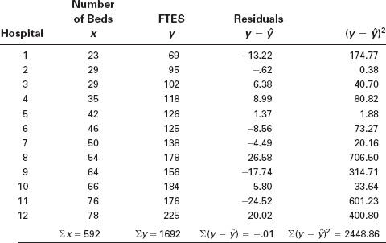

SSE = 2448.86

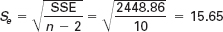

The standard error of the estimate is 15.65 FTEs. An examination of the residuals for this problem reveals that 8 of 12 (67%) are within ±1 *s****e*** and 100% are within ±2*s****e***. Is this size of error acceptable? Hospital administrators probably can best answer that question.

**12.5 PROBLEMS**

* **12.24** Determine the sum of squares of error (SSE) and the standard error of the estimate (*s****e***) for Problem 12.6. Determine how many of the residuals computed in Problem 12.14 (for Problem 12.6) are within one standard error of the estimate. If the error terms are normally distributed, approximately how many of these residuals should be within ±1*s****e***?
* **12.25** Determine the SSE and the *s****e*** for Problem 12.7. Use the residuals computed in Problem 12.15 (for Problem 12.7) and determine how many of them are within ±1*s****e*** and ±2*s****e***. How do these numbers compare with what the empirical rule says should occur if the error terms are normally distributed?
* **12.26** Determine the SSE and the *s****e*** for Problem 12.8. Think about the variables being analyzed by regression in this problem and comment on the value of *s****e***.
* **12.27** Determine the SSE and *s****e*** for Problem 12.9. Examine the variables being analyzed by regression in this problem and comment on the value of *s****e***.
* **12.28** In problem 12.10, you were asked to develop the equation of a regression model to predict the number of business bankruptcies by the number of firm births. For this regression model, solve for the standard error of the estimate and comment on it.
* **12.29** Use the data from problem 12.19 and determine the *s****e***.
* **12.30** Determine the SSE and the *s****e*** for Problem 12.20. Comment on the size of *s****e*** for this regression model, which is used to predict the cost of milk.
* **12.31** Determine the equation of the regression line to predict annual sales of a company from the yearly stock market volume of shares sold in a recent year. Compute the standard error of the estimate for this model. Does volume of shares sold appear to be a good predictor of a company's sales? Why or why not?

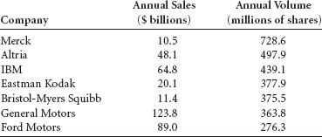

**12.6 COEFFICIENT OF DETERMINATION**



A widely used measure of fit for regression models is the **coefficient of determination**, or *r***2**. The coefficient of determination is *the proportion of variability of the dependent variable (y) accounted for or explained by the independent variable (x).*

The coefficient of determination ranges from 0 to 1. An *r***2** of zero means that the predictor accounts for none of the variability of the dependent variable and that there is no regression prediction of *y* by *x*. An *r***2** of 1 means perfect prediction of *y* by *x* and that 100% of the variability of *y* is accounted for by *x*. Of course, most *r***2** values are between the extremes. The researcher must interpret whether a particular *r***2** is high or low, depending on the use of the model and the context within which the model was developed.

In exploratory research where the variables are less understood, low values of *r***2** are likely to be more acceptable than they are in areas of research where the parameters are more developed and understood. One NASA researcher who uses vehicular weight to predict mission cost searches for the regression models to have an *r***2** of .90 or higher. However, a business researcher who is trying to develop a model to predict the motivation level of employees might be pleased to get an *r***2** near .50 in the initial research.

The dependent variable, *y*, being predicted in a regression model has a variation that is measured by the sum of squares of *y* (SS***yy***):

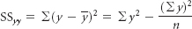

and is the sum of the squared deviations of the *y* values from the mean value of *y*. This variation can be broken into two additive variations: the *explained variation*, measured by the sum of squares of regression (SSR), and the *unexplained variation*, measured by the sum of squares of error (SSE). This relationship can be expressed in equation form as



If each term in the equation is divided by SS***yy***, the resulting equation is

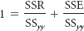

The term *r***2** is the proportion of the *y* variability that is explained by the regression model and represented here as

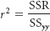

Substituting this equation into the preceding relationship gives

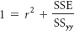

Solving for *r***2** yields formula 12.5.



The value of r**2** for the airline cost example is solved as follows:

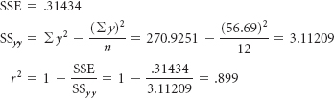

That is, 89.9% of the variability of the cost of flying a Boeing 737 airplane on a commercial flight is explained by variations in the number of passengers. This result also means that 11.1% of the variance in airline flight cost, *y*, is unaccounted for by *x* or unexplained by the regression model.

The coefficient of determination can be solved for directly by using

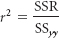

It can be shown through algebra that



From this equation, a computational formula for *r***2** can be developed.



For the airline cost example, *b***1** =.0407016, SS***xx*** = 1689, and SS***yy*** = 3.11209. Using the computational formula for *r***2** yields

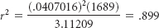

**DEMONSTRATION PROBLEM 12.4**

Compute the coefficient of determination (*r***2**) for Demonstration Problem 12.1, in which a regression model was developed to predict the number of FTEs of a hospital by the number of beds.

**Solution**

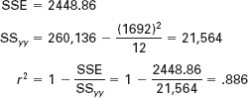

This regression model accounts for 88.6% of the variance in FTEs, leaving only 11.4% unexplained variance.

Using SS***xx*** = 3838.667 and *b***1** = 2.232 from Demonstration Problem 12.1, we can solve for *r***2** with the computational formula:

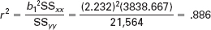

**Relationship Between *r* and *r*2**

Is *r*, the coefficient of correlation (introduced in Section 12.1), related to *r***2**, the coefficient of determination in linear regression? The answer is yes: *r***2** equals (*r*)**2**. The coefficient of determination is the square of the coefficient of correlation. In Demonstration Problem 12.1, a regression model was developed to predict FTEs by number of hospital beds. The *r***2** value for the model was.886. Taking the square root of this value yields *r* = .941, which is the correlation between the sample number of beds and FTEs. A word of caution here: Because *r***2** is always positive, solving for *r* by taking √*r***2** gives the correct magnitude of *r* but may give the wrong sign. The researcher must examine the sign of the slope of the regression line to determine whether a positive or negative relationship exists between the variables and then assign the appropriate sign to the correlation value.

**12.6 PROBLEMS**

* **12.32** Compute *r***2** for Problem 12.24 (Problem 12.6). Discuss the value of *r***2** obtained.
* **12.33** Compute *r***2** for Problem 12.25 (Problem 12.7). Discuss the value of *r***2** obtained.
* **12.34** Compute *r***2** for Problem 12.26 (Problem 12.8). Discuss the value of *r***2** obtained.
* **12.35** Compute *r***2** for Problem 12.27 (Problem 12.9). Discuss the value of *r***2** obtained.
* **12.36** In problem 12.10, you were asked to develop the equation of a regression model to predict the number of business bankruptcies by the number of firm births. For this regression model, solve for the coefficient of determination and comment on it.
* **12.37** The Conference Board produces a Consumer Confidence Index (CCI) that reflects people's feelings about general business conditions, employment opportunities, and their own income prospects. Some researchers may feel that consumer confidence is a function of the median household income. Shown here are the CCIs for nine years and the median household incomes for the same nine years published by the U.S. Census Bureau. Determine the equation of the regression line to predict the CCI from the median household income. Compute the standard error of the estimate for this model. Compute the value of *r***2**. Does median household income appear to be a good predictor of the CCI? Why or why not?

| CCI | Median Household Income ($1,000) |
| --- | --- |
| 116.8 | 37.415 |
| 91.5 | 36.770 |
| 68.5 | 35.501 |
| 61.6 | 35.047 |
| 65.9 | 34.700 |
| 90.6 | 34.942 |
| 100.0 | 35.887 |
| 104.6 | 36.306 |
| 125.4 | 37.005 |

**12.7 HYPOTHESIS TESTS FOR THE SLOPE OF THE REGRESSION MODEL AND TESTING THE OVERALL MODEL**

**Testing the Slope**

A hypothesis test can be conducted on the sample slope of the regression model to determine whether the population slope is significantly different from zero. This test is another way to determine how well a regression model fits the data. Suppose a researcher decides that it is not worth the effort to develop a linear regression model to predict *y* from *x*. An alternative approach might be to average the *y* values and use  as the predictor of *y* for all values of *x*. For the airline cost example, instead of using number of passengers as the predictor, the researcher would use the average value of airline cost, , as the predictor. In this case the average value of *y* is



Using this result as a model to predict *y*, if the number of passengers is 61, 70, or 95—or any other number—the predicted value of *y* is still 4.7242. Essentially, this approach fits the line of  = 4.7242 through the data, which is a horizontal line with a slope of zero. Would a regression analysis offer anything more than the  model? Using this nonregression model (the  model) as a worst case, the researcher can analyze the regression line to determine whether it adds a more significant amount of predictability of *y* than does the  model. Because the slope of the  line is zero, one way to determine whether the regression line adds significant predictability is to test the population slope of the regression line to find out whether the slope is different from zero. As the slope of the regression line diverges from zero, the regression model is adding predictability that the  line is not generating. For this reason, testing the slope of the regression line to determine whether the slope is different from zero is important. If the slope is not different from zero, the regression line is doing nothing more than the  line in predicting *y.*

How does the researcher go about testing the slope of the regression line? Why not just examine the observed sample slope? For example, the slope of the regression line for the airline cost data is .0407. This value is obviously not zero. The problem is that this slope is obtained from a sample of 12 data points; and if another sample was taken, it is likely that a different slope would be obtained. For this reason, the population slope is statistically tested using the sample slope. The question is: If all the pairs of data points for the population were available, would the slope of that regression line be different from zero? Here the sample slope, *b***1**, is used as evidence to test whether the population slope is different from zero. The hypotheses for this test follow.

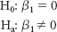

Note that this test is two tailed. The null hypothesis can be rejected if the slope is either negative or positive. A negative slope indicates an inverse relationship between *x* and *y*. That is, larger values of *x* are related to smaller values of *y*, and vice versa. Both negative and positive slopes can be different from zero. To determine whether there is a significant *positive* relationship between two variables, the hypotheses would be one tailed, or

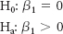

To test for a significant *negative* relationship between two variables, the hypotheses also would be one tailed, or

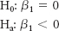

In each case, testing the null hypothesis involves a *t* test of the slope.

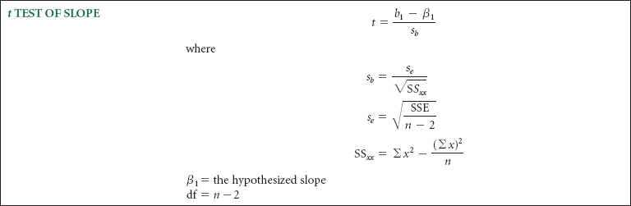

The test of the slope of the regression line for the airline cost regression model for α = .05 follows. The regression line derived for the data is



The sample slope is .0407 = *b***1**. The value of *s****e*** is.1773, Σ*x* = 930, Σ*x***2** = 73,764, and *n* = 12. The hypotheses are

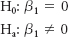

The df = *n* – 2 = 12 – 2 = 10. As this test is two tailed, α/2 = .025. The table *t* value is *t***.025,10** = ±2.228. The observed *t* value for this sample slope is

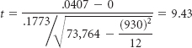

As shown in [**Figure 12.14**](https://learning.oreilly.com/library/view/business-statistics-for/9781118213957/23_chapter12.html#fig12.14), the *t* value calculated from the sample slope falls in the rejection region and the *p*-value is .00000014. The null hypothesis that the population slope is zero is rejected. This linear regression model is adding significantly more predictive information to the  model (no regression).

It is desirable to reject the null hypothesis in testing the slope of the regression model. In rejecting the null hypothesis of a zero population slope, we are stating that the regression model is adding something to the explanation of the variation of the dependent variable that the average value of *y* model does not. Failure to reject the null hypothesis in this test causes the researcher to conclude that the regression model has no predictability of the dependent variable, and the model, therefore, has little or no use.

**FIGURE 12.14** *t* Test of Slope from Airline Cost Example

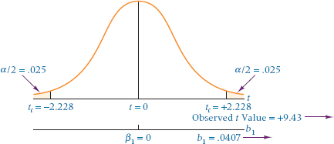

**THINKING CRITICALLY ABOUT STATISTICS IN BUSINESS TODAY**

**Are Facial Characteristics Correlated with CEO Traits?**

Researchers John R. Graham, Campbell R. Harvey, and Manju Puri, all of the Fuqua School of Business at Duke, conducted a study using almost 2,000 participants in an effort to determine if facial characteristics are related to various CEO traits. In one experiment of the study, the researchers showed pictures of 138 CEOs to 230 study participants who were asked to rate each CEO picture in terms of four attributes: competence, attractiveness, trustworthiness, and likeability. The results of the study showed that all four traits are positively correlated. That is, if a CEO (based on the picture) was rated as high on competence, he was also rated high on each of attractiveness, trustworthiness, and likeability. The largest correlation was between trustworthiness and likeability, and the smallest correlation was between trustworthiness and attractiveness. These ratings on each of the four traits were also analyzed to determine if there was a correlation with total sales of the CEO's firm and with CEO income. The results showed that there was a small positive correlation between CEO ratings on competence and company sales. There was also a small positive correlation between CEO ratings on competence and their income. In another experiment, 138 CEOs were rated on being “baby-faced.” Analysis of the study data showed that there was a positive correlation between CEOs baby-faced rating and likability. That is, the more a CEO appeared to be baby-faced, the higher they were rated in likeability. However, there was a negative correlation between CEOs baby-faced rating and competence.

**Things to Ponder**

1. Similar studies have been conducted in the area of political science to determine the electability of people running for office. What do you think is the real impact of studies like this in business?
2. The authors of the study suggest that baby-faced people tend to have large, round eyes, high eyebrows and a small chin thereby giving the perception of a baby-faced appearance. In this study, baby-faced CEOs were rated more highly on one attribute and low on another attribute. Based on these results, what advice would you give to a “baby-faced” business manager who aspires to be a CEO?

*Source:* John R. Graham, Campbell R. Harvey, and Manju Puri. “A Corporate Beauty Contest,” working paper (15906) in the NBER Working Paper Series, National Bureau of Economic Research, at [**http://www.nber.org/papers/w15906**](http://www.nber.org/papers/w15906), April 2010.

**DEMONSTRATION PROBLEM 12.5**

Test the slope of the regression model developed in Demonstration Problem 12.1 to predict the number of FTEs in a hospital from the number of beds to determine whether there is a significant positive slope. Usea α = .01.

**Solution**

The hypotheses for this problem are

H**0**: β**1** = 0

H**a**: β**1** > 0

The level of significance is .01. With 12 pairs of data, df = 10. The critical table *t* value is *t***.01,10** = 2.764. The regression line equation for this problem is

ŷ = 30.888 + 2.232*x*

The sample slope, *b***1**, is 2.232, and *s****e*** = 15.65, Σ*x* = 592, Σ*x***2** = 33,044, and *n* = 12. The observed *t* value for the sample slope is

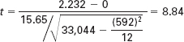

The observed *t* value (8.84) is in the rejection region because it is greater than the critical table *t* value of 2.764 and the *p*-value is .0000024. The null hypothesis is rejected. The population slope for this regression line is significantly different from zero in the positive direction. This regression model is adding significant predictability over the  model.

**Testing the Overall Model**

It is common in regression analysis to compute an *F* test to determine the overall significance of the model. Most computer software packages include the *F* test and its associated ANOVA table as standard regression output. In multiple regression ([**Chapters 13**](https://learning.oreilly.com/library/view/business-statistics-for/9781118213957/24_chapter13.html#ch13) and [**14**](https://learning.oreilly.com/library/view/business-statistics-for/9781118213957/25_chapter14.html#ch14)), this test determines whether at least one of the regression coefficients (from multiple predictors) is different from zero. Simple regression provides only one predictor and only one regression coefficient to test. Because the regression coefficient is the slope of the regression line, the *F* test for overall significance is testing the same thing as the *t* test in simple regression. The hypotheses being tested in simple regression by the *F* test for overall significance are

H**0**: β**1** = 0

H**a**: β**1** ≠ 0

In the case of simple regression analysis, *F* = *t***2**. Thus, for the airline cost example, the *F* value is

*F* = *t***2** = (9.43)**2** = 88.92

The *F* value is computed directly by

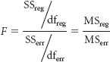

where

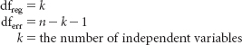

The values of the sum of squares (SS), degrees of freedom (df), and mean squares (MS) are obtained from the analysis of variance table, which is produced with other regression statistics as standard output from statistical software packages. Shown here is the analysis of variance table produced by Minitab for the airline cost example.

Analysis of Variance

Source DF SS MS *F* *p*

Regression 1 2.7980 2.7980 89.09 0.000

Residual Error 10 0.3141 0.0314

Total 11 3.1121

The *F* value for the airline cost example is calculated from the analysis of variance table information as

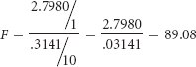

The difference between this value (89.08) and the value obtained by squaring the *t* statistic (88.92) is due to rounding error. The probability of obtaining an *F* value this large or larger by chance if there is no regression prediction in this model is .000 according to the ANOVA output (the *p*-value). This output value means it is highly unlikely that the population slope is zero and also unlikely that there is no prediction due to regression from this model given the sample statistics obtained. Hence, it is highly likely that this regression model adds significant predictability of the dependent variable.

Note from the ANOVA table that the degrees of freedom due to regression are equal to 1. Simple regression models have only one independent variable; therefore, *k* = 1. The degrees of freedom error in simple regression analysis is always *n* – *k* – 1 = *n* – 1 – 1 = *n* – 2. With the degrees of freedom due to regression (1) as the numerator degrees of freedom and the degrees of freedom due to error (*n* – 2) as the denominator degrees of freedom, [**Table A.7**](https://learning.oreilly.com/library/view/business-statistics-for/9781118213957/31_appendixa.html#taba.7) can be used to obtain the critical *F* value (*F***α, 1,*n*-2**) to help make the hypothesis testing decision about the overall regression model if the *p*-value of *F* is not given in the computer output. This critical *F* value is always found in the right tail of the distribution. In simple regression, the relationship between the critical *t* value to test the slope and the critical *F* value of overall significance is



For the airline cost example with a two-tailed test and α = .05, the critical value of *t***.025,10** is ±2.228 and the critical value of *F***.05,1,10** is 4.96.

*t***2.025,10** = (±2.228)**2** = 4.96 = *F***.05,1,10**

**12.7 PROBLEMS**

* **12.38** Test the slope of the regression line determined in Problem 12.6. Use α = .05.
* **12.39** Test the slope of the regression line determined in Problem 12.7. Use α = .01.
* **12.40** Test the slope of the regression line determined in Problem 12.8. Use α = .10.
* **12.41** Test the slope of the regression line determined in Problem 12.9. Use a 5% level of significance.
* **12.42** Test the slope of the regression line developed in Problem 12.10. Use a 5% level of significance.
* **12.43** Study the following analysis of variance table, which was generated from a simple regression analysis. Discuss the *F* test of the overall model. Determine the value of *t* and test the slope of the regression line.
* Analysis of Variance
* Source DF SS MS *F* *p*
* Regression 1 116.65 116.65 8.26 0.021
* Error 8 112.95 14.12

Total 9 229.60

**12.8 ESTIMATION**

One of the main uses of regression analysis is as a prediction tool. If the regression function is a good model, the researcher can use the regression equation to determine values of the dependent variable from various values of the independent variable. For example, financial brokers would like to have a model with which they could predict the selling price of a stock on a certain day by a variable such as unemployment rate or producer price index. Marketing managers would like to have a site location model with which they could predict the sales volume of a new location by variables such as population density or number of competitors. The airline cost example presents a regression model that has the potential to predict the cost of flying an airplane by the number of passengers.

In simple regression analysis, a point estimate prediction of *y* can be made by substituting the associated value of *x* into the regression equation and solving for *y*. From the airline cost example, if the number of passengers is *x* = 73, the predicted cost of the airline flight can be computed by substituting the *x* value into the regression equation determined in Section 12.3:

ŷ = 1.57 + .0407*x* = 1.57 + .0407(73) = 4.5411

The point estimate of the predicted cost is 4.5411 or $4,541.10.

**Confidence Intervals to Estimate the Conditional Mean of *y*: μ*y\x***

Although a point estimate is often of interest to the researcher, the regression line is determined by a sample set of points; and if a different sample is taken, a different line will result, yielding a different point estimate. Hence computing a *confidence interval* for the estimation is often useful. Because for any value of *x* (independent variable) there can be many values of *y* (dependent variable), one type of **confidence interval** is *an estimate of the average value of y for a given x.* This average value of *y* is denoted *E* (*y****x***)—the expected value of *y* and can be computed using formula (12.6).

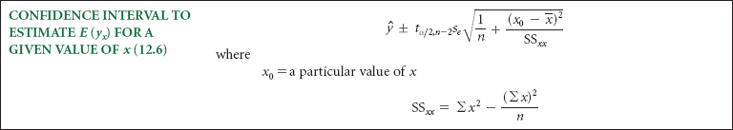

The application of this formula can be illustrated with construction of a 95% confidence interval to estimate the average value of *y* (airline cost) for the airline cost example when *x* (number of passengers) is 73. For a 95% confidence interval, α = .05 and α/2 = .025. The df = *n* – 2 = 12 – 2 = 10. The table *t* value is *t***.025,10** = 2.228. Other needed values for this problem, which were solved for previously, are



For *x****0*** = 73, the value of ŷ is 4.5411. The computed confidence interval for the average value of *y*, *E*(*y***73**), is

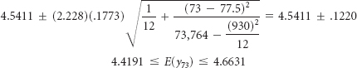

That is, with 95% confidence the average value of *y* for *x* = 73 is between 4.4191 and 4.6631.

[**Table 12.7**](https://learning.oreilly.com/library/view/business-statistics-for/9781118213957/23_chapter12.html#tab12.7) shows confidence intervals computed for the airline cost example for several values of *x* to estimate the average value of *y*. Note that as *x* values get farther from the mean *x* value (77.5), the confidence intervals get wider; as the *x* values get closer to the mean, the confidence intervals narrow. The reason is that the numerator of the second term under the radical sign approaches zero as the value of *x* nears the mean and increases as *x* departs from the mean.

**Prediction Intervals to Estimate a Single Value of *y***

A second type of interval in regression estimation is a **prediction interval** to *estimate a single value of y for a given value of x.*

**TABLE 12.7** Confidence Intervals to Estimate the Average Value of *y* for Some *x* Values in the Airline Cost Example

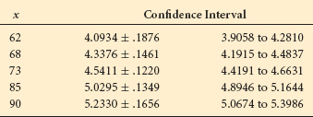

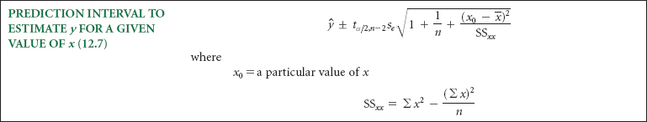

Formula 12.7 is virtually the same as formula 12.6, except for the additional value of 1 under the radical. This additional value widens the prediction interval to estimate a single value of *y* from the confidence interval to estimate the average value of *y*. This result seems logical because the average value of *y* is toward the middle of a group of *y* values. Thus the confidence interval to estimate the average need not be as wide as the prediction interval produced by formula 12.7, which takes into account all the *y* values for a given *x*.

A 95% prediction interval can be computed to estimate the single value of *y* for *x* = 73 from the airline cost example by using formula 12.7. The same values used to construct the confidence interval to estimate the average value of *y* are used here.



For *x***0** = 73, the value of ŷ = 4.5411. The computed prediction interval for the single value of *y* is

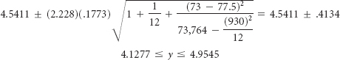

Prediction intervals can be obtained by using the computer. Shown in [**Figure 12.15**](https://learning.oreilly.com/library/view/business-statistics-for/9781118213957/23_chapter12.html#fig12.15) is the computer output for the airline cost example. The output displays the predicted value for *x* = 73 (ŷ = 4.5411), a 95% confidence interval for the average value of *y* for *x* = 73, and a 95% prediction interval for a single value of *y* for *x* = 73. Note that the resulting values are virtually the same as those calculated in this section.

[**Figure 12.16**](https://learning.oreilly.com/library/view/business-statistics-for/9781118213957/23_chapter12.html#fig12.16) displays Minitab confidence intervals for various values of *x* for the average *y* value and the prediction intervals for a single *y* value for the airline example. Note that the intervals flare out toward the ends, as the values of *x* depart from the average *x* value. Note also that the intervals for a single *y* value are always wider than the intervals for the average *y* value for any given value of *x*.

An examination of the prediction interval formula to estimate *y* for a given value of *x* explains why the intervals flare out.

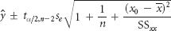

As we enter different values of *x***0** from the regression analysis into the equation, the only thing that changes in the equation is (*x***0** – )**2**. This expression increases as individual values of *x***0** get farther from the mean, resulting in an increase in the width of the interval. The interval is narrower for values of *x***0** nearer *x* and wider for values of *x***0** further from . A comparison of formulas 12.6 and 12.7 reveals them to be identical except that formula 12.7—to compute a prediction interval to estimate *y* for a given value of *x*—contains a 1 under the radical sign. This distinction ensures that formula 12.7 will yield wider intervals than 12.6 for otherwise identical data.

**FIGURE 12.15** Minitab Output for Prediction Intervals



**FIGURE 12.16** Minitab Intervals for Estimation

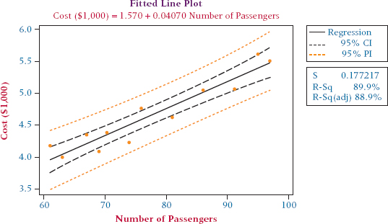

**Caution:** *A regression line is determined from a sample of points. The line, the r****2****, the s****e****, and the confidence intervals change for different sets of sample points. That is, the linear relationship developed for a set of points does not necessarily hold for values of x outside the domain of those used to establish the model. In the airline cost example, the domain of x values (number of passengers) varied from 61 to 97. The regression model developed from these points may not be valid for flights of say 40, 50, or 100 because the regression model was not constructed with x values of those magnitudes. However, decision makers sometimes extrapolate regression results to values of x beyond the domain of those used to develop the formulas (often in time-series sales forecasting). Understanding the limitations of this type of use of regression analysis is essential.*

**DEMONSTRATION PROBLEM 12.6**

Construct a 95% confidence interval to estimate the average value of *y* (FTEs) for Demonstration Problem 12.1 when *x* = 40 beds. Then construct a 95% prediction interval to estimate the single value of *y* for *x* = 40 beds.

**Solution**

For a 95% confidence interval, α = .05 *n* = 12, and df = 10. The table *t* value is *t***025,10** = 2. 228; *s****e*** = 15.65, Σ*x* = 592,  = 49.33, and Σ*x***2** = 33,044. For *x***0** = 40, ŷ = 120.17. The computed confidence interval for the average value of *y* is

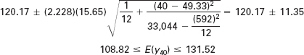

With 95% confidence, the statement can be made that the average number of FTEs for a hospital with 40 beds is between 108.82 and 131.52.

The computed prediction interval for the single value of *y* is

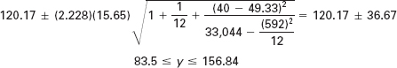

With 95% confidence, the statement can be made that a single number of FTEs for a hospital with 40 beds is between 83.5 and 156.84. Obviously this interval is much wider than the 95% confidence interval for the average value of *y* for *x* = 40.

The following Minitab graph depicts the 95% interval bands for both the average *y* value and the single *y* values for all 12 *x* values in this problem. Note once again the flaring out of the bands near the extreme values of *x*.

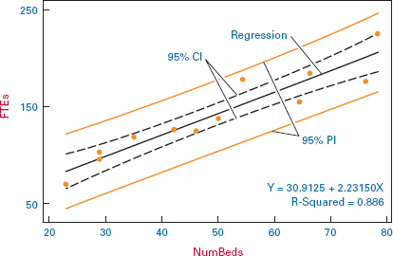

**12.8 PROBLEMS**

* **12.44** Construct a 95% confidence interval for the average value of *y* for Problem 12.6. Use *x* = 25.
* **12.45** Construct a 90% prediction interval for a single value of *y* for Problem 12.7; use *x* = 100. Construct a 90% prediction interval for a single value of *y* for Problem 14.2; use *x* = 130. Compare the results. Which prediction interval is greater? Why?
* **12.46** Construct a 98% confidence interval for the average value of *y* for Problem 12.8; use *x* = 20. Construct a 98% prediction interval for a single value of *y* for Problem 14.3; use *x* = 20. Which is wider? Why?
* **12.47** Construct a 99% confidence interval for the average bond rate in Problem 12.9 for a prime interest rate of 10%. Discuss the meaning of this confidence interval.

**12.9 USING REGRESSION TO DEVELOP A FORECASTING TREND LINE**

Business researchers often use historical data with measures taken over time in an effort to forecast what might happen in the future. A particular type of data that often lends itself well to this analysis is **time-series data** defined as *data gathered on a particular characteristic over a period of time at regular intervals.* Some examples of time-series data are 10 years of weekly Dow Jones Industrial Averages, twelve months of daily oil production, or monthly consumption of coffee over a two-year period. To be useful to forecasters, time-series measurements need to be made in regular time intervals and arranged according to time of occurrence. As an example, consider the time-series sales data over a 10-year time period for the Huntsville Chemical Company shown in [**Table 12.8**](https://learning.oreilly.com/library/view/business-statistics-for/9781118213957/23_chapter12.html#tab12.8). Note that the measurements (sales) are taken over time and that the sales figures are given on a yearly basis. Time-series data can also be reported daily, weekly, monthly, quarterly, semi-annually, or for other defined time periods.

**TABLE 12.8** Ten-Year Sales Data for Huntsville Chemicals

| Year | Sales ($ millions) |
| --- | --- |
| 2002 | 7.84 |
| 2003 | 12.26 |
| 2004 | 13.11 |
| 2005 | 15.78 |
| 2006 | 21.29 |
| 2007 | 25.68 |
| 2008 | 23.80 |
| 2009 | 26.43 |
| 2010 | 29.16 |
| 2011 | 33.06 |

It is generally believed that time-series data contain any one or combination of four elements: trend, cyclicality, seasonality, and irregularity. While each of these four elements will be discussed in greater deal in [**Chapter 15**](https://learning.oreilly.com/library/view/business-statistics-for/9781118213957/26_chapter15.html#ch15), Time-Series Forecasting and Index Numbers, here we examine **trend** and define it as *the long-term general direction of data*. Observing the scatter plot of the Huntsville Chemical Company's sales data shown in [**Figure 12.17**](https://learning.oreilly.com/library/view/business-statistics-for/9781118213957/23_chapter12.html#fig12.17), it is apparent that there is positive trend in the data. That is, there appears to be a long-term upward general direction of sales over time. How can trend be expressed in mathematical terms? In the field of forecasting, it is common to attempt to fit a trend line through time-series data by determining the equation of the trend line and then using the equation of the trend line to predict future data points. How does one go about developing such a line?

**Determining the Equation of the Trend Line**

Developing the equation of a linear trend line in forecasting is actually a special case of simple regression where the *y* or dependent variable is the variable of interest that a business analyst wants to forecast and for which a set of measurements has been taken over a period of time. For example, with the Huntsville Chemicals Company data, if company forecasters want to predict sales for the year 2014 using these data, sales would be the dependent variable in the simple regression analysis. In linear trend analysis, the time period is used as the *x*, the independent or predictor variable, in the analysis to determine the equation of the trend line. In the case of the Huntsville Chemicals Company, the *x* variable represents the years 2002–2011.

Using sales as the *y* variable and time (year) as the *x* variable, the equation of the trend line can be calculated in the usual way as shown in [**Table 12.9**](https://learning.oreilly.com/library/view/business-statistics-for/9781118213957/23_chapter12.html#tab12.9) and is determined to be: ŷ = – 5,333.91 + 2.6687 *x*. The slope, 2.6687, means that for every yearly increase in time, sales increases by an average of $2.6687 (million). The intercept would represent company sales in the year 0 which, of course, in this problem has no meaning since the Huntsville Chemical Company was not in existence in the year 0. [**Figure 12.18**](https://learning.oreilly.com/library/view/business-statistics-for/9781118213957/23_chapter12.html#fig12.18) is a Minitab display of the Huntsville sales data with the fitted trend line. Note that the output contains the equation of the trend line along with the values of *s* (standard error of the estimate) and *R*-Sq (*r***2**). As is typical with data that have a relatively strong trend, the *r***2** value (.963) is quite high.

**FIGURE 12.17 Minitab Scatter Plot of Huntsville Chemicals Data**

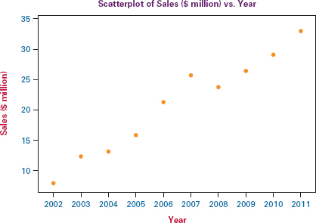

**TABLE 12.9** Determining the Equation of the Trend Line for the Huntsville Chemical Company Sales Data

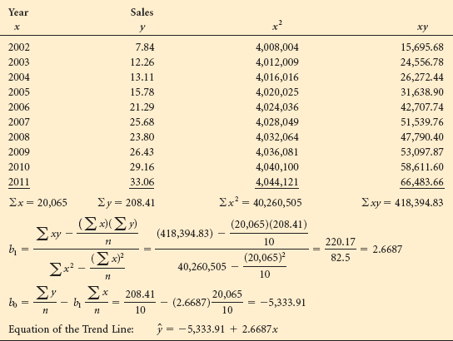

**Forecasting Using the Equation of the Trend Line**

The main use of the equation of a trend line by business analysts is for forecasting outcomes for time periods in the future. Recall the caution from Section 12.8 that using a regression model to predict *y* values for *x* values outside the domain of those used to develop the model may not be valid. Despite this caution and understanding the potential drawbacks, business forecasters nevertheless extrapolate trend lines beyond the most current time periods of the data and attempt to predict outcomes for time periods in the future. To forecast for future time periods using a trend line, insert the time period of interest into the equation of the trend line and solve for . For example, suppose forecasters for the Huntsville Chemicals Company want to predict sales for the year 2014 using the equation of the trend line developed from their historical time series data. Replacing *x* in the equation of the sales trend line with 2014, results in a forecast of $40.85 (million):

**FIGURE 12.18** Minitab Graph of Huntsville Sales Data with a Fitted Trend Line

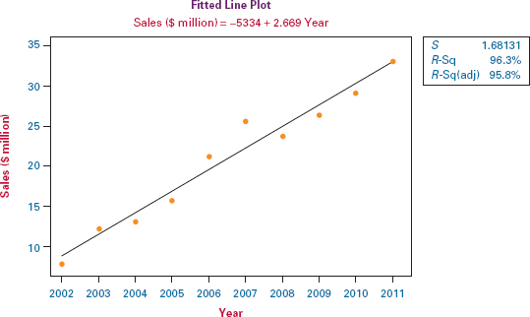

**FIGURE 12.19** Minitab Output for Trend Line and Forecasts

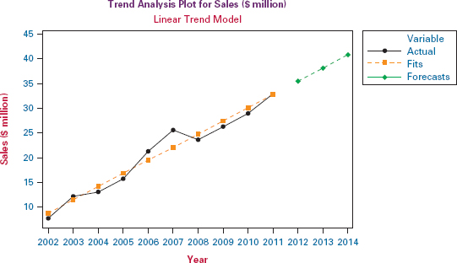

ŷ(2014) = –5,333.91 + 2.6687(2014) = 40.85

[**Figure 12.19**](https://learning.oreilly.com/library/view/business-statistics-for/9781118213957/23_chapter12.html#fig12.19) shows Minitab output for the Huntsville Chemicals Company data with the trend line through the data and graphical forecasts for the next three periods (2012, 2013, and 2014). Observe from the graph that the forecast for 2014 is about $41 (million).

**Alternate Coding for Time Periods**

If you manually calculate the equation of a trend line when the time periods are years, you notice that the calculations can get quite large and cumbersome (observe [**Table 12.9**](https://learning.oreilly.com/library/view/business-statistics-for/9781118213957/23_chapter12.html#tab12.9)). However, if the years are consecutive, they can be recoded using many different possible schemes and still produce a meaningful trend line equation (albeit a different *y* intercept value). For example, instead of using the years 2002–2011, suppose we use the years 1 to 10. That is, 2002 = 1 (first year), 2003 = 2, 2004 = 3, and so on, to 2011 = 10. This recoding scheme produces the trend line equation of: ŷ = 6.1632 + 2.6687*x* as shown in [**Table 12.10**](https://learning.oreilly.com/library/view/business-statistics-for/9781118213957/23_chapter12.html#tab12.10). Notice that the slope of the trend line is the same whether the years 2002 through 2011 are used or the recoded years of 1 through 10, but the *y* intercept (6.1632) is different. This needs to be taken into consideration when using the equation of the trend line for forecasting. Since the new trend equation was derived from recoded data, forecasts will also need to be made using recoded data. For example, using the recoded system of 1 through 10 to represent “years,” the year 2014 is recoded as 13 (2011 = 10, 2012 = 11, 2013 = 12, and 2014 = 13). Inserting this value into the trend line equation results in a forecast of $40.86, the same as the value obtained using raw years as time.

ŷ = 6.1632 + 2.6687*x* = 6.1632 + 2.6687(13) = $40.86 (million).

Similar time recoding schemes can be used in the calculating of trend line equations when the time variable is something other than years. For example, in the case of monthly time series data, the time periods can be recoded as:

January = 1, February = 2, March = 3, …, December = 12.

**TABLE 12.10 Using Recoded Data to Calculate the Trend Line Equation**

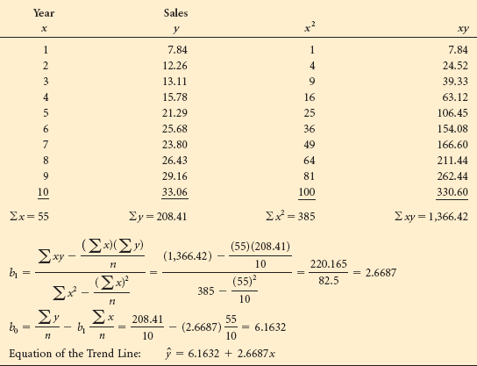

In the case of quarterly data over a two-year period, the time periods can be recoded with a scheme such as:

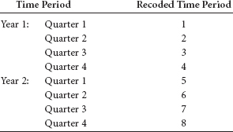

**DEMONSTRATION PROBLEM 12.7**

Shown below are monthly food and beverage sales in the United States during a recent year over an eight-month period ($ million). Develop the equation of a trend line through these data and use the equation to forecast sales for October.

| Month | Sales ($ million) |
| --- | --- |
| January | 32,569 |
| February | 32,274 |
| March | 32,583 |
| April | 32,304 |
| May | 32,149 |
| June | 32,077 |
| July | 31,989 |
| August | 31,977 |

**Solution**

Shown here is a Minitab-produced scatter diagram of these time series data:

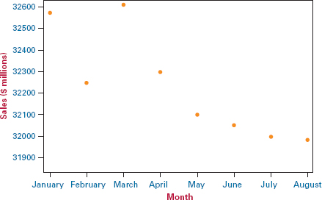

The months of January through August can be coded using the numbers of 1 through 8, respectively. Using these numbers as the time period values (*x*) and sales as the dependent variable (*y*), the following output was obtained from Minitab:

Regression Analysis: Sales versus Month

The regression equation is

Sales = 32628 - 86.2 Month

Predictor Coef SE Coef *T* *P*

Constant 32628.2 93.3 349.80 0.000

Month −86.21 18.47 −4.67 0.003

S = 119.708 R-Sq = 78.4% R-Sq(adj) = 74.8%

The equation of the trend line is: ŷ = 32,628.2 – 86.21*x*. A slope of –86.21 indicates that there is a downward trend of food and beverage sales over this period of time at a rate of $86.21 (million) per month. The *y* intercept of 32,628.2 represents what the trend line would estimate the sales to have been in period 0 or December of the previous year. The sales figure for October can be forecast by inserting *x* = 10 into this model and obtaining:

ŷ(10) = 32,628.2 – 86.21(10) = 31,766.1.

**12.9 PROBLEMS**

* **12.48** Determine the equation of the trend line for the data shown below on U.S. exports of fertilizers to Indonesia over a five-year period provided by the U.S Census Bureau. Using the trend line equation, forecast the value for the year 2013.

| Year | Fertilizer ($ millions) |
| --- | --- |
| 2007 | 11.9 |
| 2008 | 17.9 |
| 2009 | 22.0 |
| 2010 | 21.8 |
| 2011 | 26.0 |

* **12.49** Shown below are rental and leasing revenue figures for office machinery and equipment in the United States over a seven-year period according to the U.S. Census Bureau. Use these data to construct a trend line and forecast the rental and leasing revenue for the year 2012 using these data.

| Year | Fertilizer ($ millions) |
| --- | --- |
| 2004 | 5,860 |
| 2005 | 6,632 |
| 2006 | 7,125 |
| 2007 | 6,000 |
| 2008 | 4,380 |
| 2009 | 3,326 |
| 2010 | 2,642 |

* **12.50** After a somewhat uncertain start, e-commerce sales in the United States have been growing for the past several years. Shown below are quarterly e-commerce sales figures ($ billions) released by the Census Bureau for the United States over a three-year period. Use these data to determine the equation of a trend line for e-commerce sales during this time and use the trend “model” to forecast e-commerce sales for the third quarter of the year 2012.

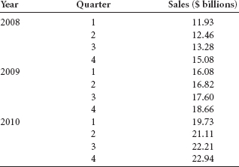

**12.10 INTERPRETING THE OUTPUT**

Although manual computations can be done, most regression problems are analyzed by using a computer. In this section, computer output from both Minitab and Excel will be presented and discussed.

At the top of the Minitab regression output, shown in [**Figure 12.20**](https://learning.oreilly.com/library/view/business-statistics-for/9781118213957/23_chapter12.html#fig12.20), is the regression equation. Next is a table that describes the model in more detail. “Coef” stands for coefficient of the regression terms. The coefficient of Number of Passengers, the *x* variable, is 0.040702. This value is equal to the slope of the regression line and is reflected in the regression equation. The coefficient shown next to the constant term (1.5698) is the value of the constant, which is the *y* intercept and also a part of the regression equation. The “T” values are a *t* test for the slope and a *t* test for the intercept or constant. (We generally do not interpret the *t* test for the constant.) The *t* value for the slope, *t* = 9.44 with an associated probability of .000, is the same as the value obtained manually in section 12.7. Because the probability of the *t* value is given, the *p*-value method can be used to interpret the *t* value.

**FIGURE 12.20** Minitab Regression Analysis of the Airline Cost Example

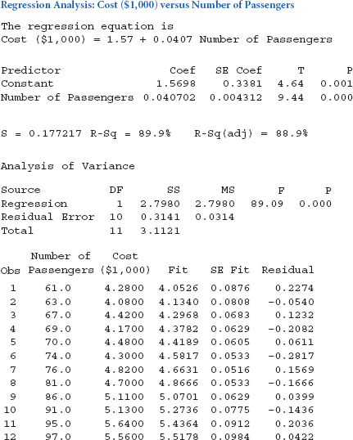

The next row of output is the standard error of the estimate *s****e***, S = 0.177217; the coefficient of determination, *r***2**, R-Sq = 89.9%; and the adjusted value of *r***2**, R-Sq(adj) = 88.9%. (Adjusted *r***2** will be discussed in [**Chapter 13**](https://learning.oreilly.com/library/view/business-statistics-for/9781118213957/24_chapter13.html#ch13).) Following these items is the analysis of variance table. Note that the value of *F* = 89.09 is used to test the overall model of the regression line. The final item of the output is the predicted value and the corresponding residual for each pair of points.

Although the Excel regression output, shown in [**Figure 12.21**](https://learning.oreilly.com/library/view/business-statistics-for/9781118213957/23_chapter12.html#fig12.21) for Demonstration Problem 12.1, is somewhat different from the Minitab output, the same essential regression features are present. The regression equation is found under Coefficients at the bottom of ANOVA. The slope or coefficient of *x* is 2.2315 and the *y*-intercept is 30.9125. The standard error of the estimate for the hospital problem is given as the fourth statistic under Regression Statistics at the top of the output, Standard Error = 15.6491. The *r***2** value is given as 0.886 on the second line. The *t* test for the slope is found under *t* Stat near the bottom of the ANOVA section on the “Number of Beds” (*x* variable) row, *t* = 8.83. Adjacent to the *t* Stat is the *P* -value, which is the probability of the *t* statistic occurring by chance if the null hypothesis is true. For this slope, the probability shown is 0.000005. The ANOVA table is in the middle of the output with the *F* value having the same probability as the *t* statistic, 0.000005, and equaling *t***2**. The predicted values and the residuals are shown in the Residual Output section.

**FIGURE 12.21** Excel Regression Output for Demonstration Problem 12.1

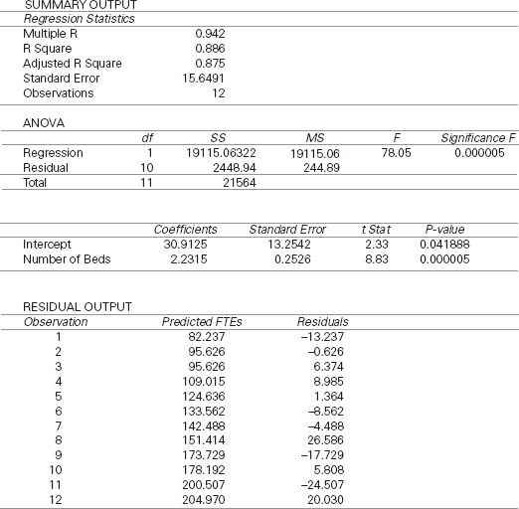

** Predicting International Hourly Wages by the Price of a Big Mac**

 In the Decision Dilemma, questions were raised about the relationship between the price of a Big Mac hamburger and net hourly wages around the world and if a model could be developed to predict net hourly wages by the price of a Big Mac. Data were given for a sample of 27 countries. In exploring the possibility that there is a relationship between these two variables, a Pearson product-moment correlation coefficient, *r*, was computed to be.717. This *r* value indicates that there is a relatively high correlation between the two variables and that developing a regression model to predict one variable by the other has potential. Designating net hourly wages as the *y* or dependent variable and the price of a Big Mac as the *x* or predictor variable, the following regression output was obtained for these data using Excel.

**Regression Statistics**

|  |  |
| --- | --- |
| Multiple *R* | 0.717 |
| *R* Square | 0.514 |
| Adjusted *R* Square | 0.495 |
| Standard Error | 4.213 |
| Observations | 27 |

ANOVA

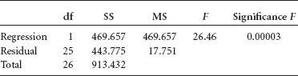

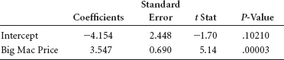

Taken from this output, the regression model is:

Net Hourly Wage = –4.154 + 3.547 (Price of Big Mac)

While the *y*-intercept has virtually no practical meaning in this analysis, the slope indicates that for every dollar increase in the price of a Big Mac, there is an incremental increase of $3.547 in net hourly wages for a country. It is worth underscoring here that just because there is a relationship between two variables, it does not mean there is a cause-and-effect relationship. That is, McDonald's cannot raise net hour wages in a country just by increasing the cost of a Big Mac!

Using this regression model, the net hourly wage for a country with a $3.00 Big Mac can be predicted by substituting *x* = 3 into the model:

Net Hourly Wage = –4.154 + 3.547(3) = $6.49

That is, the model predicts that the net hourly wage for a country is $6.49 when the price of a Big Mac is $3.00.

How good a fit is the regression model to the data? Observe from the Excel output that the *F* value for testing the overall significance of the model (26.46) is highly significant with a *p*-value of.00003, and that the *t* statistic for testing to determine if the slope is significantly different from zero is 5.14 with a *p*-value of.00003. In simple regression, the *t* statistic is the square root of the *F* value and these statistics relate essentially the same information—that there are significant regression effects in the model. The *r***2** value is 51.4%, indicating that the model has moderate predictability. The standard error of the model, *s* = 4.21, indicates that if the error terms are approximately normally distributed, about 68% of the predicted net hourly wages would fall within ±$4.21.

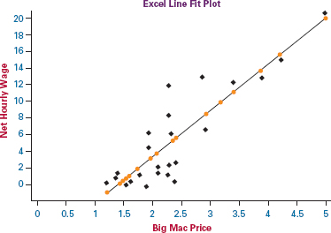

Shown here is an Excel-produced line fit plot. Note from the plot that there generally appears be a linear relationship between the variables but that many of the data points fall considerably away from the fitted regression line, indicating that the price of a Big Mac only partially accounts for net hourly wages.

**ETHICAL CONSIDERATIONS**

**Regression analysis offers several opportunities** for unethical behavior. One way is to present a regression model in isolation from information about the fit of the model. That is, the regression model is represented as a valid tool for prediction without any regard for how well it actually fits the data. While it is true that least squares analysis can produce a line of best fit through virtually any set of points, it does not necessarily follow that the regression model is a good predictor of the dependent variable. For example, sometimes business consultants sell regression models to companies as forecasting tools or market predictors without disclosing to the client that the *r***2** value is very low, the slope of the regression line is not significant, the residuals are large, and the standard error of the estimate is large. This is unethical behavior.

Another unethical use of simple regression analysis is stating or implying a cause-and-effect relationship between two variables just because they are highly correlated and produce a high *r***2** in regression. The Decision Dilemma presents a good example of this with the regression analysis of the price of a Big Mac hamburger and the net hourly wages in a country. While the coefficient of determination is 51.4% and there appears to be a modest fit of the regression line to the data, that does not mean that increasing the price of a Big Mac in a given country will increase the country's net hourly wages. Often, two correlated variables are related to a third variable that drives the two of them but is not included in the regression analysis. In the Decision Dilemma example, both Big Mac prices and net hourly wages may be related to exchange rates or a country's economic condition.

A third way that business analysts can act unethically in using regression analysis is to knowingly violate the assumptions underlying regression. Regression analysis requires equal error variance, independent error terms, and error terms that are normally distributed. Through the use of residual plots and other statistical techniques, a business researcher can test these assumptions. To present a regression model as fact when the assumptions underlying it are being grossly violated is unethical behavior.

It is important to remember that since regression models are developed from sample data, when an *x* value is entered into a simple regression model, the resulting prediction is only a point estimate. While business people do often use regression models as predicting tools, it should be kept in mind that the prediction value is an estimate not a guaranteed outcome. By utilizing or at least pointing out confidence intervals and prediction intervals, such as those presented in Section 12.8, the business researcher places the predicted point estimate within the context of inferential estimation and is thereby acting more ethically.

And lastly, another ethical problem that arises in regression analysis is using the regression model to predict values of the independent variable that are outside the domain of values used to develop the model. The airline cost model used in this chapter was built with between 61 and 97 passengers. A linear relationship appeared to be evident between flight costs and number of passengers over this domain. This model is not guaranteed to fit values outside the domain of 61 to 97 passengers, however. In fact, either a nonlinear relationship or no relationship may be present between flight costs and number of passengers if values from outside this domain are included in the model-building process. It is a mistake and probably unethical behavior to make claims for a regression model outside the perview of the domain of values for which the model was developed.

**SUMMARY**

Correlation measures the degree of relatedness of variables. The most well-known measure of correlation is the Pearson product-moment coefficient of correlation, *r*. This value ranges from –1 to 0 to +1. An *r* value of +1 is perfect positive correlation and an *r* value of –1 is perfect negative correlation. Positive correlation means that as one variable increases in value, the other variable tends to increase. Negative correlation means that as one variable increases in value, the other variable tends to decrease. For *r* values near zero, little or no correlation is present.

Regression is a procedure that produces a mathematical model (function) that can be used to predict one variable by other variables. Simple regression is bivariate (two variables) and linear (only a line fit is attempted). Simple regression analysis produces a model that attempts to predict a *y* variable, referred to as the dependent variable, by an *x* variable, referred to as the independent variable. The general form of the equation of the simple regression line is the slope-intercept equation of a line. The equation of the simple regression model consists of a slope of the line as a coefficient of *x* and a *y*-intercept value as a constant.

After the equation of the line has been developed, several statistics are available that can be used to determine how well the line fits the data. Using the historical data values of *x*, predicted values of *y* (denoted as ŷ) can be calculated by inserting values of *x* into the regression equation. The predicted values can then be compared to the actual values of *y* to determine how well the regression equation fits the known data. The difference between a specific *y* value and its associated predicted *y* value is called the residual or error of prediction. Examination of the residuals can offer insight into the magnitude of the errors produced by a model. In addition, residual analysis can be used to help determine whether the assumptions underlying the regression analysis have been met. Specifically, graphs of the residuals can reveal (1) lack of linearity, (2) lack of homogeneity of error variance, and (3) independence of error terms. Geometrically, the residuals are the vertical distances from the *y* values to the regression line. Because the equation that yields the regression line is derived in such a way that the line is in the geometric middle of the points, the sum of the residuals is zero.

A single value of error measurement called the standard error of the estimate, *s****e***, can be computed. The standard error of the estimate is the standard deviation of error of a model. The value of *s****e*** can be used as a single guide to the magnitude of the error produced by the regression model as opposed to examining all the residuals.

Another widely used statistic for testing the strength of a regression model is *r***2**, or the coefficient of determination. The coefficient of determination is the proportion of total variance of the *y* variable accounted for or predicted by *x*. The coefficient of determination ranges from 0 to 1. The higher the *r***2** is, the stronger is the predictability of the model.

Testing to determine whether the slope of the regression line is different from zero is another way to judge the fit of the regression model to the data. If the population slope of the regression line is not different from zero, the regression model is not adding significant predictability to the dependent variable. A *t* statistic is used to test the significance of the slope. The overall significance of the regression model can be tested using an *F* statistic. In simple regression, because only one predictor is present, this test accomplishes the same thing as the *t* test of the slope and *F* = *t***2**.

One of the most prevalent uses of a regression model is to predict the values of *y* for given values of *x*. Recognizing that the predicted value is often not the same as the actual value, a confidence interval has been developed to yield a range within which the mean *y* value for a given *x* should fall. A prediction interval for a single *y* value for a given *x* value also is specified. This second interval is wider because it allows for the wide diversity of individual values, whereas the confidence interval for the mean *y* value reflects only the range of average *y* values for a given *x*.

Time-series data are data that are gathered over a period of time at regular intervals. Developing the equation of a forecasting trend line for time-series data is a special case of simple regression analysis where the time factor is the predictor variable. The time variable can be in units of years, months, weeks, quarters, and others.

**KEY TERMS**



coefficient of determination (*r***2**)

confidence interval

dependent variable

deterministic model

heteroscedasticity

homoscedasticity

independent variable

least squares analysis

outliers

prediction interval

probabilistic model

regression analysis

residual

residual plot

scatter plot

simple regression

standard error of the estimate (*s****e***)

sum of squares of error (SSE)

**FORMULAS**

Pearson's product-moment correlation coefficient

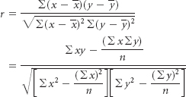

Equation of the simple regression line



Sum of squares

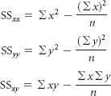

Slope of the regression line

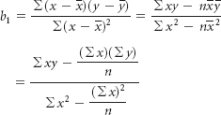

*y*-intercept of the regression line



Sum of squares of error



Standard error of the estimate

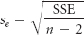

Coefficient of determination

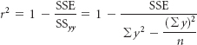

Computational formula for *r***2**

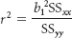

*t* test of slope

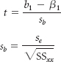

Confidence interval to estimate *E*(*y***x**) for a given value of *x*

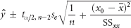

Prediction interval to estimate *y* for a given value of *x*

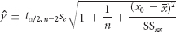

**SUPPLEMENTARY PROBLEMS**

**CALCULATING THE STATISTICS**

* **12.51** Determine the Pearson product-moment correlation coefficient for the following data.



* **12.52** Use the following data for parts (a) through (f).



* 1. Determine the equation of the least squares regression line to predict *y* by *x*.
  2. Using the *x* values, solve for the predicted values of *y* and the residuals.
  3. Solve for *s****e***.
  4. Solve for *r***2**.
  5. Test the slope of the regression line. Use α = .01.
  6. Comment on the results determined in parts (b) through (e), and make a statement about the fit of the line.
* **12.53** Use the following data for parts (a) through (g).



* 1. Determine the equation of the simple regression line to predict *y* from *x*.
  2. Using the *x* values, solve for the predicted values of *y* and the residuals.
  3. Solve for SSE.
  4. Calculate the standard error of the estimate.
  5. Determine the coefficient of determination.
  6. Test the slope of the regression line. Assume α = .05. What do you conclude about the slope?
  7. Comment on parts (d) and (e).
* **12.54** If you were to develop a regression line to predict *y* by *x*, what value would the coefficient of determination have?



* **12.55** Determine the equation of the least squares regression line to predict *y* from the following data.



* 1. Construct a 95% confidence interval to estimate the mean *y* value for *x* = 60.
  2. Construct a 95% prediction interval to estimate an individual *y* value for *x* = 70.
  3. Interpret the results obtained in parts (a) and (b).
* **12.56** Determine the equation of the trend line through the following cost data. Use the equation of the line to forecast cost for year 7.

| Year | Cost ($ millions) |
| --- | --- |
| 1 | 56 |
| 2 | 54 |
| 3 | 49 |
| 4 | 46 |
| 5 | 45 |

**TESTING YOUR UNDERSTANDING**

* **12.57** A manager of a car dealership believes there is a relationship between the number of salespeople on duty and the number of cars sold. Suppose the following sample is used to develop a simple regression model to predict the number of cars sold by the number of salespeople. Solve for *r***2** and explain what *r***2** means in this problem.

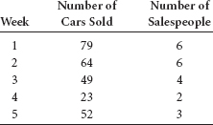

* **12.58** Executives of a video rental chain want to predict the success of a potential new store. The company's researcher begins by gathering information on number of rentals and average family income from several of the chain's present outlets.

| Rentals | Average Family Income ($1,000) |
| --- | --- |
| 710 | 65 |
| 529 | 43 |
| 314 | 29 |
| 504 | 47 |
| 619 | 52 |
| 428 | 50 |
| 317 | 46 |
| 205 | 29 |
| 468 | 31 |
| 545 | 43 |
| 607 | 49 |
| 694 | 64 |

* Develop a regression model to predict the number of rentals per day by the average family income. Comment on the output.
* **12.59** It seems logical that restaurant chains with more units (restaurants) would have greater sales. This assumption is mitigated, however, by several possibilities: some units may be more profitable than others, some units may be larger, some units may serve more meals, some units may serve more expensive meals, and so on. The data shown here were published by Technomic. Perform a simple regression analysis to predict a restaurant chain's sales by its number of units. How strong is the relationship?

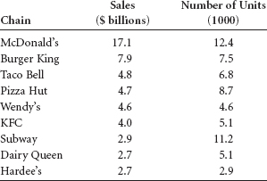

* **12.60** Shown here are the total employment labor force figures for the country of Romania over a 13-year period published in LABORSTA. Develop the equation of a trend line through these data and use the equation to predict the total employment labor force of Romania for the year 2013.

| Year | Total Employment (1000s) |
| --- | --- |
| 1996 | 10,935 |
| 1997 | 11,050 |
| 1998 | 10,845 |
| 1999 | 10,776 |
| 2000 | 10,764 |
| 2001 | 10,697 |
| 2002 | 9,234 |
| 2003 | 9,223 |
| 2004 | 9,158 |
| 2005 | 9,147 |
| 2006 | 9,313 |
| 2007 | 9,353 |
| 2008 | 9,369 |

* **12.61** How strong is the correlation between the inflation rate and 30-year treasury yields? The following data published by Fuji Securities are given as pairs of inflation rates and treasury yields for selected years over a 35-year period.

| Inflation Rate | 30-Year Treasury Yield |
| --- | --- |
| 1.57% | 3.05% |
| 2.23 | 3.93 |
| 2.17 | 4.68 |
| 4.53 | 6.57 |
| 7.25 | 8.27 |
| 9.25 | 12.01 |
| 5.00 | 10.27 |
| 4.62 | 8.45 |

* Compute the Pearson product-moment correlation coefficient to determine the strength of the correlation between these two variables. Comment on the strength and direction of the correlation.
* **12.62** According to the National Marine Fisheries Service, the current landings in millions of pounds of fish by U.S. fleets are more than one and one-half times what they were in the 1970s. In other words, fishing has not faded as an industry. However, the growth of this industry has varied by region as shown in the following data. Some regions have remained relatively constant, the South Atlantic region has dropped in pounds caught, and the Pacific-Alaska region has grown almost threefold.

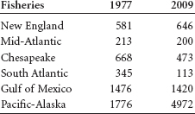

Develop a simple regression model to predict the 2009 landings by the 1977 landings. According to the model, if a region had 700 landings in 1977, what would the predicted number be for 2009? Construct a confidence interval for the average *y* value for the 700 landings. Use the *t* statistic to test to determine whether the slope is significantly different from zero. Use α = .05.

* **12.63** People in the aerospace industry believe the cost of a space project is a function of the weight of the major object being sent into space. Use the following data to develop a regression model to predict the cost of a space project by the weight of the space object. Determine *r***2** and *s****e***.

| Weight (tons) | Cost ($ millions) |
| --- | --- |
| 1.897 | $ 53.6 |
| 3.019 | 184.9 |
| 0.453 | 6.4 |
| 0.988 | 23.5 |
| 1.058 | 33.4 |
| 2.100 | 110.4 |
| 2.387 | 104.6 |

* **12.64** The following data represent a breakdown of state banks and all savings organizations in the United States every 5 years over a 60-year span according to the Federal Reserve System.

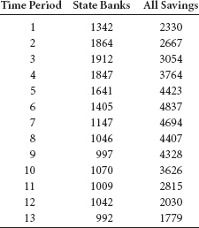

Develop a regression model to predict the total number of state banks by the number of all savings organizations. Comment on the strength of the model. Develop a time-series trend line for All Savings using the time periods given. Forecast All Savings for period 15 using this equation.

* **12.65** Is the amount of money spent by companies on advertising a function of the total revenue of the company? Shown are revenue and advertising cost data for seven companies published by *Advertising Age* and *Fortune* magazine.

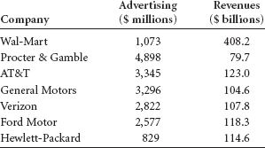

Use the data to develop a regression line to predict the amount of advertising by revenues. Compute *s****e*** and *r***2**. Assuming α = .05, test the slope of the regression line. Comment on the strength of the regression model.

* **12.66** Can the consumption of water in a city be predicted by air temperature? The following data represent a sample of a day's water consumption and the high temperature for that day.

| Water Use (millions of gallons) | Temperature (degrees Fahrenheit) |
| --- | --- |
| 219 | 103° |
| 56 | 39 |
| 107 | 77 |
| 129 | 78 |
| 68 | 50 |
| 184 | 96 |
| 150 | 90 |
| 112 | 75 |

* Develop a least squares regression line to predict the amount of water used in a day in a city by the high temperature for that day. What would be the predicted water usage for a temperature of 100°? Evaluate the regression model by calculating *s****e***, by calculating *r***2**, and by testing the slope. Let α = .01.

**INTERPRETING THE OUTPUT**

* **12.67** Study the following Minitab output from a regression analysis to predict *y* from *x*.
  1. What is the equation of the regression model?
  2. What is the meaning of the coefficient of x?
  3. What is the result of the test of the slope of the regression model? Let α = .10. Why is the *t* ratio negative?
  4. Comment on *r****2*** and the standard error of the estimate.
  5. Comment on the relationship of the *F* value to the *t* ratio for *x*.
  6. The correlation coefficient for these two variables is –.7918. Is this result surprising to you? Why or why not?
* Regression Analysis: *Y* versus *X*
* The regression equation is
* Y = 67.2 – 0.0565 *X*
* Predictor Coef SE Coef *T* *p*
* Constant 67.231 5.046 13.32 0.000
* *X* 0.05650 0.01027 5.50 0.000
* *S* = 10.32 *R*-Sq = 62.7% *R*-Sq(adj) = 60.6%
* Analysis of Variance
* Source DF SS MS *F* *P*
* Regression 1 3222.9 3222.9 30.25 0.000
* Residual Error 18 1918.0 106.6

Total 19 5141.0

* **12.68** Study the following Excel regression output for an analysis attempting to predict the number of union members in the United States by the size of the labor force for selected years over a 30-year period from data published by the U.S. Bureau of Labor Statistics. Analyze the computer output. Discuss the strength of the model in terms of proportion of variation accounted for, slope, and overall predictability. Using the equation of the regression line, attempt to predict the number of union members when the labor force is 110,000. Note that the model was developed with data already recoded in 1,000 units. Use the data in the model as is.

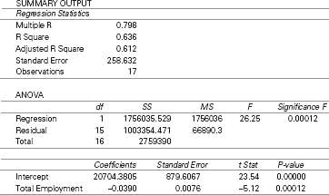

* **12.69** Study the following Minitab residual diagnostic graphs. Comment on any possible violations of regression assumptions.

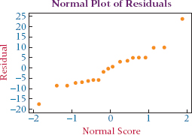

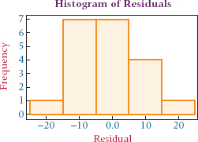

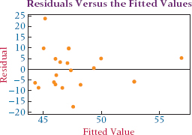

**ANALYZING THE DATABASES**



1. Develop a regression model from the Consumer Food database to predict Annual Food Spending by Annual Household Income. Discuss the model and its strength on the basis of statistics presented in this chapter. Now develop a regression model to predict Non-Mortgage Household Debt by Annual Household Income. Discuss this model and its strengths. Compare the two models. Does it make sense that Annual Food Spending and NonMortgage Household Debt could each be predicted by Annual Household Income? Why or why not?
2. Using the Hospital database, develop a regression model to predict the number of Personnel by the number of Births. Now develop a regression model to predict number of Personnel by number of Beds. Examine the regression output. Which model is stronger in predicting number of Personnel? Explain why, using techniques presented in this chapter. Use the second regression model to predict the number of Personnel in a hospital that has 110 beds. Construct a 95% confidence interval around this prediction for the average value of *y*.
3. Analyze all the variables except Type in the Financial database by using a correlation matrix. The seven variables in this database are capable of producing 21 pairs of correlations. Which are most highly correlated? Select the variable that is most highly correlated with P/E ratio and use it as a predictor to develop a regression model to predict P/E ratio. How did the model do?
4. Construct a correlation matrix for the six U.S. and international stock indicators. Describe what you find. That is, what indicators seem to be most strongly related to other indicators? Now focus on the three international stock indicators. Which pair of these stock indicators is most correlated? Develop a regression model to predict the DJIA by the Nikkei 225. How strong is the model? Develop a regression model to predict the DJIA by the Hang Seng. How strong is the model? Develop a regression model to predict the DJIA by the Mexico IPC. How strong is the model? Compare the three models.

**CASE: DELTA WIRE USES TRAINING AS A WEAPON**

The Delta Wire Corporation was founded in 1978 in Clarksdale, Mississippi. The company manufactures high-carbon specialty steel wire for global markets and at present employs about 100 people. For the past few years, sales increased each year.

A few years ago, however, things did not look as bright for Delta Wire because it was caught in a potentially disastrous bind. With the dollar declining in value, foreign competition was becoming a growing threat to Delta's market position. In addition to the growing foreign competition, industry quality requirements were becoming tougher each year.

Delta officials realized that some conditions, such as the value of the dollar, were beyond their control. However, one area that they could improve upon was employee education. The company worked with training programs developed by the state of Mississippi and a local community college to set up its own school. Delta employees were introduced to statistical process control and other quality assurance techniques. Delta reassured its customers that the company was working hard on improving quality and staying competitive. Customers were invited to sit in on the educational sessions. Because of this effort, Delta has been able to weather the storm and continues to sustain a leadership position in the highly competitive steel wire industry.

Delta continued its training and education program. In the 1990s, Delta instituted a basic skills training program that eventually led to a decrease in nonconforming material from 6% to 2% and a productivity increase from 70,000 to 90,000 pounds per week. In addition, this initiative resulted in a “best in class” award from Goodyear, its largest customer.

Although acquired by Bekaert of Belgium in January of 2006, the Delta Wire Corporation, a major supplier of bead wire for tire reinforcement and other specialized wire products for the North American market, continues to operate in its current capacity. Bekaert wants to support Delta Wire's market share growth and ensure adequate product availability to its customers.

**Discussion**

1. Delta Wire prides itself on its efforts in the area of employee education. Employee education can pay off in many ways. Discuss some of them. One payoff can be the renewed interest and excitement generated toward the job and the company. Some people theorize that because of a more positive outlook and interest in implementing things learned, the more education received by a worker, the less likely he or she is to miss work days. Suppose the following data represent the number of days of sick leave taken by 20 workers last year along with the number of contact hours of employee education/training they each received in the past year. Use the techniques learned in this chapter to analyze the data. Include both regression and correlation techniques. Discuss the strength of the relationship and any models that are developed.

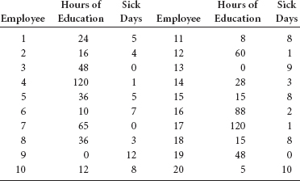

1. Many companies find that the implementation of total quality management eventually results in improved sales. Companies that fail to adopt quality efforts lose market share in many cases or go out of business. One measure of the effect of a company's quality improvement efforts is customer satisfaction. Suppose Delta Wire hired a research firm to measure customer satisfaction each year. The research firm developed a customer satisfaction scale in which totally satisfied customers can award a score as high as 50 and totally unsatisfied customers can award scores as low as 0. The scores are measured across many different industrial customers and averaged for a yearly mean customer score. Do sales increase with increases in customer satisfaction scores? To study this notion, suppose the average customer satisfaction score each year for Delta Wire is paired with the company's total sales of that year for the last 15 years, and a regression analysis is run on the data. Assume the following Minitab and Excel outputs are the result. Suppose you were asked by Delta Wire to analyze the data and summarize the results. What would you find?

**MINITAB OUTPUT**

Regression Analysis: Sales Versus Satisfaction

The regression equation is

Sales = 1.73 + 0.162 CustSat

Predictor Coef StDev *T* *p*

Constant 1.7332 0.4364 3.97 0.002

CustSat 0.16245 0.01490 10.90 0.000

*S* = 0.4113 *R*-Sq = 90.1% *R*-Sq(adj) = 89.4%

Analysis of Variance

Source DF SS MS *F* *p*

Regression 1 20.098 20.098 118.80 0.000

Residual Error 13 2.199 0.169

Total 14 22.297

EXCEL OUTPUT

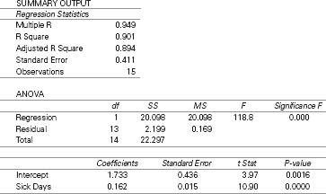

1. Delta Wire increased productivity from 70,000 to 90,000 pounds per week during a time when it instituted a basic skills training program. Suppose this program was implemented over an 18-month period and that the following data are the number of total cumulative basic skills hours of training and the per week productivity figures taken once a month over this time. Use techniques from this chapter to analyze the data and make a brief report to Delta about the predictability of productivity from cumulative hours of training.

| Cumulative Hours of Training | Productivity (in pounds per week) |
| --- | --- |
| 0 | 70,000 |
| 100 | 70,350 |
| 250 | 70,500 |
| 375 | 72,600 |
| 525 | 74,000 |
| 750 | 76,500 |
| 875 | 77,000 |
| 1,100 | 77,400 |
| 1,300 | 77,900 |
| 1,450 | 77,200 |
| 1,660 | 78,900 |
| 1,900 | 81,000 |
| 2,300 | 82,500 |
| 2,600 | 84,000 |
| 2,850 | 86,500 |
| 3,150 | 87,000 |
| 3,500 | 88,600 |
| 4,000 | 90,000 |

*Source*: Adapted from “Delta Wire Corporation,” *Strengthening America's Competitiveness: Resource Management Insights for Small Business Success.* Published by Warner Books on behalf of Connecticut Mutual Life Insurance Company and the U.S. Chamber of Commerce in association with the Blue Chip Enterprise Initiative, 1991, International Monetary Fund; Terri Bergman, “TRAINING: The Case for Increased Investment,” *Employment Relations Today*, Winter 1994–1995, pp. 381–391, available at [**http://www.ed.psu.edu/nwac/document/train/invest.html**](http://www.ed.psu.edu/nwac/document/train/invest.html). Bekaert Web site, at: [**http://www.bekaert.com/corporate/press/2006/31-jan-2006.htm**](http://www.bekaert.com/corporate/press/2006/31-jan-2006.htm).

**USING THE COMPUTER**

**EXCEL**

* Excel has the capability of doing simple regression analysis. For a more inclusive analysis, use the **Data Analysis** tool. For a more “a la carte” approach, use Excel's **Insert Function**.
* To use the **Data Analysis** tool for a more inclusive analysis, begin by selecting the **Data** tab on the Excel worksheet. From the **Analysis** panel at the right top of the **Data** tab worksheet, click on **Data Analysis**. If your Excel worksheet does not show the **Data Analysis** option, then you can load it as an add-in following directions given in [**Chapter 2**](https://learning.oreilly.com/library/view/business-statistics-for/9781118213957/10_chapter02.html#ch2). From the **Data Analysis** pulldown menu, select **Regression**. In the **Regression** dialog box, input the location of the *y* values in **Input Y Range**. Input the location of the *x* values in **Input X Range**. Input **Labels** and input **Confidence Level**. To pass the line through the origin, check **Constant is Zero**. To print out the raw residuals, check **Residuals**. To print out residuals converted to *z* scores, check **Standardized Residuals**. For a plot of the residuals, check **Residual Plots**. For a plot of the line through the points, check **Line Fit Plots**. Standard output includes *r*, *r***2**, *s****e***, and an ANOVA table with the *F* test, the slope and intercept, *t* statistics with associated *p*-values, and any optionally requested output such as graphs or residuals.
* To use the **Insert Function (*fx*)** go to the **Formulas** tab on an Excel worksheet (top center tab). The **Insert Function** is on the far left of the menu bar. In the **Insert Function** dialog box at the top, there is a pulldown menu where it says **Or select a category**. From the pulldown menu associated with this command, select **Statistical**. Select **INTERCEPT** from the **Insert Function's Statistical** menu to solve for the *y*-intercept, **RSQ** to solve for *r***2**, **SLOPE** to solve for the slope, and **STEYX** to solve for the standard error of the estimate.

**MINITAB**

* Minitab has a relatively thorough capability to perform regression analysis. To begin, select **Stat** from the menu bar. Select **Regression** from the **Stat** pulldown menu. Select **Regression** from the **Regression** pulldown menu. Place the column name or column location of the *y* variable in **Response**. Place the column name or column location of the *x* variable in **Predictors**. Select **Graphs** for options relating to residual plots. Use this option and check **Four in one** to produce the residual diagnostic plots shown in the chapter. Select **Options** for confidence intervals and prediction intervals. Select **Results** for controlling the regression analysis output. Select **Storage** to store fits and/or residuals.
* To obtain a fitted-line plot, select **Stat** from the menu bar. Select **Regression** from the **Stat** pulldown menu. Select **Fitted Line Plot** from the **Regression** pulldown menu. In the Fitted Line Plot dialog box, place the column name or column location of the *y* variable in **Response(Y).**

Place the column name or column location of the *x* variable in **Predictor(X)**. Check **Type of Regression Model as Linear** ([**Chapter 12**](https://learning.oreilly.com/library/view/business-statistics-for/9781118213957/23_chapter12.html#ch12)), **Quadratic**, or **Cubic**.

Select **Graphs** for options relating to residual plots. Use this option and check **Four in one** to produce the residual diagnostic plots shown in the chapter.

Select **Options** for confidence intervals and prediction intervals.

Select **Storage** to store fits and/or residuals.

[**1**](https://learning.oreilly.com/library/view/business-statistics-for/9781118213957/23_chapter12.html#FN01) Derivation of these formulas is beyond the scope of information being discussed here but is presented in WileyPLUS.

[**\***](https://learning.oreilly.com/library/view/business-statistics-for/9781118213957/23_chapter12.html#FN02) **Note:** In previous sections, the values of the slope and intercept were rounded off for ease of computation and interpretation. They are shown here with more precision in an effort to reduce rounding error.

CHAPTER 13

Multiple Regression Analysis

**LEARNING OBJECTIVES**

This chapter presents the potential of multiple regression analysis as a tool in business decision making and its applications, thereby enabling you to:

1. Explain how, by extending the simple regression model to a multiple regression model with two independent variables, it is possible to determine the multiple regression equation for any number of unknowns.
2. Examine significance tests of both the overall regression model and the regression coefficients.
3. Calculate the residual, standard error of the estimate, coefficient of multiple determination, and adjusted coefficient of multiple determination of a regression model.
4. Use a computer to find and interpret multiple regression outputs.



** Are You Going to Hate Your New Job?**

 Getting a new job can be an exciting and energizing event in your life.

But what if you discover after a short time on the job that you hate your job? Is there any way to determine ahead of time whether you will love or hate your job? Sue Shellenbarger of *The Wall Street Journal* discusses some of the things to look for when interviewing for a position that may provide clues as to whether you will be happy on that job.

Among other things, work cultures vary from hip, freewheeling start-ups to old-school organizational-driven domains. Some organizations place pressure on workers to feel tense and to work long hours while others place more emphasis on creativity and the bottom line. Shellenbarger suggests that job interviewees pay close attention to how they are treated in an interview. Are they just another cog in the wheel or are they valued as an individual? Is a work-life balance apparent within the company? Ask what a typical workday is like at that firm. Inquire about the values that undergird the management by asking questions such as “What is your proudest accomplishment?” Ask about flexible schedules and how job training is managed. For example, does the worker have to go to job training on their own time?

A “Work Trends” survey undertaking by the John J. Heldrich Center for Workforce Development at Rutgers University and the Center for Survey Research and Analysis at the University of Connecticut posed several questions to employees in a survey to ascertain their job satisfaction. Some of the themes included in these questions were relationship with your supervisor, overall quality of the work environment, total hours worked each week, and opportunities for advancement at the job.

Suppose another researcher gathered survey data from 19 employees on these questions and also asked the employees to rate their job satisfaction on a scale from 0 to 100 (with 100 being perfectly satisfied). Suppose the following data represent the results of this survey. Assume that relationship with supervisor is rated on a scale from 0 to 50 (0 represents poor relationship and 50 represents an excellent relationship), overall quality of the work environment is rated on a scale from 0 to 100 (0 represents poor work environment and 100 represents an excellent work environment), and opportunities for advancement is rated on a scale from 0 to 50 (0 represents no opportunities and 50 represents excellent opportunities).

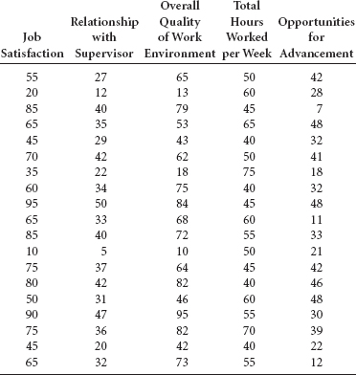

**Managerial and Statistical Questions**

1. Several variables are presented that may be related to job satisfaction. Which variables are stronger predictors of job satisfaction? Might other variables not mentioned here be related to job satisfaction?
2. Is it possible to develop a mathematical model to predict job satisfaction using the data given? If so, how strong is the model? With four independent variables, will we need to develop four different simple regression models and compare their results?

*Source:* Adapted from Sue Shellenbarger, “How to Find Out if You're Going to Hate a New Job Before You Agree to Take It,” *The Wall Street Journal*, June 13, 2002, p. D1.

Simple regression analysis (discussed in [**Chapter 12**](https://learning.oreilly.com/library/view/business-statistics-for/9781118213957/23_chapter12.html#ch12)) is bivariate linear regression in which one **dependent variable**, *y*, is predicted by one **independent variable**, *x.* Examples of simple regression applications include models to predict retail sales by population density, Dow Jones averages by prime interest rates, crude oil production by energy consumption, and CEO compensation by quarterly sales. However, in many cases, other independent variables, taken in conjunction with these variables, can make the regression model a better fit in predicting the dependent variable. For example, sales could be predicted by the size of store and number of competitors in addition to population density. A model to predict the Dow Jones average of 30 industrials could include, in addition to the prime interest rate, such predictors as yesterday's volume, the bond interest rate, and the producer price index. A model to predict CEO compensation could be developed by using variables such as company earnings per share, age of CEO, and size of company in addition to quarterly sales. A model could perhaps be developed to predict the cost of outsourcing by such variables as unit price, export taxes, cost of money, damage in transit, and other factors. Each of these examples contains only one dependent variable, *y*, as with simple regression analysis. However, multiple independent variables, *x* (predictors) are involved. *Regression analysis with two or more independent variables or with at least one nonlinear predictor* is called **multiple regression** analysis.

**13.1 THE MULTIPLE REGRESSION MODEL**

Multiple regression analysis is similar in principle to simple regression analysis. However, it is more complex conceptually and computationally. Recall from [**Chapter 12**](https://learning.oreilly.com/library/view/business-statistics-for/9781118213957/23_chapter12.html#ch12) that the equation of the probabilistic simple regression model is



where

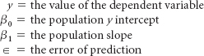

Extending this notion to multiple regression gives the general equation for the probabilistic multiple regression model.



where

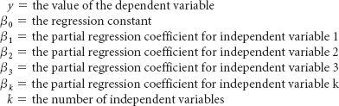

In multiple regression analysis, the dependent variable, *y*, is sometimes referred to as the **response variable**. The **partial regression coefficient** of an independent variable, β***i***, *represents the increase that will occur in the value of y from a one-unit increase in that independent variable if all other variables are held constant.* The “full” (versus partial) regression coefficient of an independent variable is a coefficient obtained from the bivariate model (simple regression) in which the independent variable is the sole predictor of *y*. The partial regression coefficients occur because more than one predictor is included in a model. The partial regression coefficients are analogous to β**1**, the slope of the simple regression model in [**Chapter 12**](https://learning.oreilly.com/library/view/business-statistics-for/9781118213957/23_chapter12.html#ch12).

In actuality, the partial regression coefficients and the regression constant of a multiple regression model are population values and are unknown. In virtually all research, these values are estimated by using sample information. Shown here is the form of the equation for estimating *y* with sample information.



where

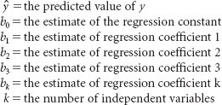

**Multiple Regression Model with Two Independent Variables (First-Order)**

The simplest multiple regression model is one constructed with two independent variables, where the highest power of either variable is 1 (first-order regression model). The regression model is



The constant and coefficients are estimated from sample information, resulting in the following model.



[**Figure 13.1**](https://learning.oreilly.com/library/view/business-statistics-for/9781118213957/24_chapter13.html#fig13.1) is a three-dimensional graph of a series of points (*x***1**, *x***2**, *y*) representing values from three variables used in a multiple regression model to predict the sales price of a house by the number of square feet in the house and the age of the house. Simple regression models yield a line that is fit through data points in the *xy* plane. In multiple regression analysis, the resulting model produces a **response surface**. In the multiple regression model shown here with two independent first-order variables, the response surface is a **response plane**. The response plane for such a model is fit in a three-dimensional space (*x***1**, *x***2**, *y*).

If such a response plane is fit into the points shown in [**Figure 13.1**](https://learning.oreilly.com/library/view/business-statistics-for/9781118213957/24_chapter13.html#fig13.1), the result is the graph in [**Figure 13.2**](https://learning.oreilly.com/library/view/business-statistics-for/9781118213957/24_chapter13.html#fig13.2). Notice that most of the points are not on the plane. As in simple regression, an error in the fit of the model in multiple regression is usually present. The distances shown in the graph from the points to the response plane are the errors of fit, or residuals (*y* – ŷ). Multiple regression models with three or more independent variables involve more than three dimensions and are difficult to depict geometrically.

Observe in [**Figure 13.2**](https://learning.oreilly.com/library/view/business-statistics-for/9781118213957/24_chapter13.html#fig13.2) that the regression model attempts to fit a plane into the threedimensional plot of points. Notice that the plane intercepts the *y* axis. [**Figure 13.2**](https://learning.oreilly.com/library/view/business-statistics-for/9781118213957/24_chapter13.html#fig13.2) depicts some values of *y* for various values of *x***1** and *x***2**. The error of the response plane (∊) in predicting or determining the *y* values is the distance from the points to the plane.

**FIGURE 13.1** Points in a Sample Space

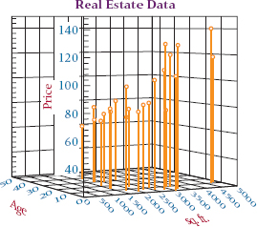

**FIGURE 13.2** Response Plane for a First-Order Two-Predictor Multiple Regression Model

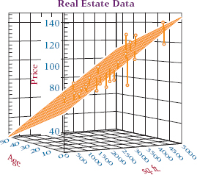

**Determining the Multiple Regression Equation**

The simple regression equations for determining the sample slope and intercept given in [**Chapter 12**](https://learning.oreilly.com/library/view/business-statistics-for/9781118213957/23_chapter12.html#ch12) are the result of using methods of calculus to minimize the sum of squares of error for the regression model. The procedure for developing these equations involves solving two simultaneous equations with two unknowns, *b***0** and *b***1**. Finding the sample slope and intercept from these formulas requires the values of Σ*x*, Σ*y*, Σ*xy*, and Σ*x***2**.

The procedure for determining formulas to solve for multiple regression coefficients is similar. The formulas are established to meet an objective of *minimizing the sum of squares of error for the model.* Hence, the regression analysis shown here is referred to as **least squares analysis**. Methods of calculus are applied, resulting in *k* + 1 equations with *k* + 1 unknowns (*b***0** and *k* values of *b****i***) for multiple regression analyses with *k* independent variables. Thus, a regression model with six independent variables will generate seven simultaneous equations with seven unknowns (*b***0**, *b***1**, *b***2**, *b***3**, *b***4**, *b***5**, *b***6**).

For multiple regression models with two independent variables, the result is three simultaneous equations with three unknowns (*b***0**, *b***1**, and *b***2**).

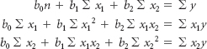

The process of solving these equations by hand is tedious and time-consuming. Solving for the regression coefficients and regression constant in a multiple regression model with two independent variables requires Σ*x***1**, Σ*x***2**, Σ*y*, Σ*x***12**, Σ*x***22**, Σ*x***1***x***2**, Σ*x***1***y*, and Σ*x***2***y.* In actuality, virtually all business researchers use computer statistical software packages to solve for the regression coefficients, the regression constant, and other pertinent information. In this chapter, we will discuss computer output and assume little or no hand calculation. The emphasis will be on the interpretation of the computer output.

**A Multiple Regression Model**

A real estate study was conducted in a small Louisiana city to determine what variables, if any, are related to the market price of a home. Several variables were explored, including the number of bedrooms, the number of bathrooms, the age of the house, the number of square feet of living space, the total number of square feet of space, and the number of garages. Suppose the researcher wants to develop a regression model to predict the market price of a home by two variables, “total number of square feet in the house” and “the age of the house.” Listed in [**Table 13.1**](https://learning.oreilly.com/library/view/business-statistics-for/9781118213957/24_chapter13.html#tab13.1) are the data for these three variables.

**TABLE 13.1** Real Estate Data

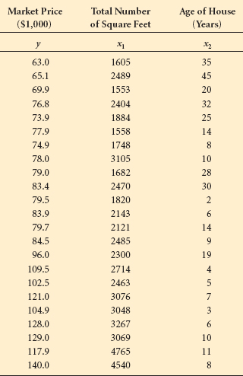

A number of statistical software packages can perform multiple regression analysis, including Excel and Minitab. The output for the Minitab multiple regression analysis on the real estate data is given in [**Figure 13.3**](https://learning.oreilly.com/library/view/business-statistics-for/9781118213957/24_chapter13.html#fig13.3). (Excel output is shown in Demonstration Problem 13.1.)

The Minitab output for regression analysis begins with “The regression equation is.” From [**Figure 13.3**](https://learning.oreilly.com/library/view/business-statistics-for/9781118213957/24_chapter13.html#fig13.3), the regression equation for the real estate data in [**Table 13.1**](https://learning.oreilly.com/library/view/business-statistics-for/9781118213957/24_chapter13.html#tab13.1) is



The regression constant, 57.4, is the *y*-intercept. The *y*-intercept is the value of ŷ if both *x***1** (number of square feet) and *x***2** (age) are zero. In this example, a practical understanding of the *y*-intercept is meaningless. It makes little sense to say that a house containing no square feet (*x***1** = 0) and no years of age (*x***2** = 0) would cost $57,400. Note in [**Figure 13.2**](https://learning.oreilly.com/library/view/business-statistics-for/9781118213957/24_chapter13.html#fig13.2) that the response plane crosses the *y*-axis (price) at 57.4.

**FIGURE 13.3** Minitab Output of Regression for the Real Estate Example

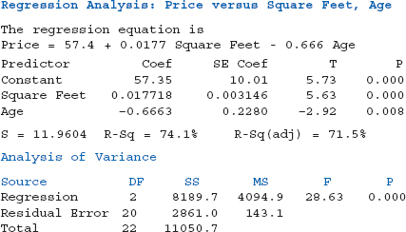

The coefficient of *x***1** (total number of square feet in the house) is .0177, which means that a one-unit increase in square footage would result in a predicted increase of .0177· ($1,000) = $17.70 in the price of the home if age were held constant. All other variables being held constant, the addition of 1 square foot of space in the house results in a predicted increase of $17.70 in the price of the home.

The coefficient of *x***2** (age) is –.666. The negative sign on the coefficient denotes an inverse relationship between the age of a house and the price of the house: the older the house, the lower the price. In this case, if the total number of square feet in the house is kept constant, a one-unit increase in the age of the house (1 year) will result in –.666 · ($1,000) = –$666, a predicted $666 drop in the price.

In examining the regression coefficients, it is important to remember that the independent variables are often measured in different units. It is usually not wise to compare the regression coefficients of predictors in a multiple regression model and decide that the variable with the largest regression coefficient is the best predictor. In this example, the two variables are in different units, square feet and years. Just because *x***2** has the larger coefficient (.666) does not necessarily make *x***2** the strongest predictor of *y*.

This regression model can be used to predict the price of a house in this small Louisiana city. If the house has 2500 square feet total and is 12 years old, *x***1** = 2500 and *x***2** = 12. Substituting these values into the regression model yields

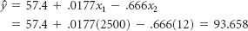

The predicted price of the house is $93,658. [**Figure 13.2**](https://learning.oreilly.com/library/view/business-statistics-for/9781118213957/24_chapter13.html#fig13.2) is a graph of these data with the response plane and the residual distances.

**DEMONSTRATION PROBLEM 13.1**

 Since 1980, the prime interest rate in the United States has varied from less than 5% to over 15%. What factor in the U.S. economy seems to be related to the prime interest rate? Two possible predictors of the prime interest rate are the annual unemployment rate and the savings rate in the United States. Shown below are data for the annual prime interest rate for the even-numbered years over a 28-year period in the United States along with the annual unemployment rate and the annual average personal saving (as a percentage of disposable personal income). Use these data to develop a multiple regression model to predict the annual prime interest rate by the unemployment rate and the average personal saving. Determine the predicted prime interest rate if the unemployment rate is 6.5 and the average personal saving is 5.0.

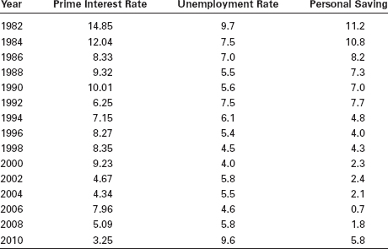

**Solution**

The following output shows the results of analyzing the data by using the regression portion of Excel.

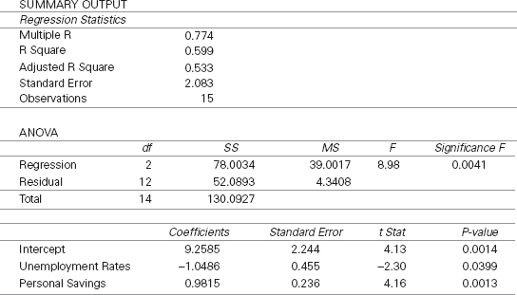

The regression equation is

ŷ = 9.2585 – 1.0486*x***1** + 0.9815*x***2**

where:

ŷ = prime interest rate

*x***1** = unemployment rate

*x***2** = personal saving

The model indicates that for every one-unit (1%) increase in the unemployment rate, the predicted prime interest rate decreases by 1.0486%, if personal saving is held constant. The model also indicates that for every one-unit (1%) increase in personal saving, the predicted prime interest rate increases by 0.9815%, if unemployment is held constant.

If the unemployment rate is 6.5 and the personal saving rate is 5.0, the predicted prime interest rate is 6.56%:

ŷ = 9.2585 – 1.0486(6.5) + 0.9815(5.0) = 7.35

**13.1 PROBLEMS**

* **13.1** Use a computer to develop the equation of the regression model for the following data. Comment on the regression coefficients. Determine the predicted value of *y* for *x***1** = 200 and *x***2** = 7.

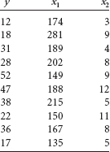

* **13.2** Use a computer to develop the equation of the regression model for the following data. Comment on the regression coefficients. Determine the predicted value of *y* for *x***1** = 33, *x***2** = 29, and *x***3** = 13.

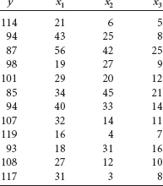

* **13.3** Using the following data, determine the equation of the regression model. How many independent variables are there? Comment on the meaning of these regression coefficients.

| Predictor | Coefficient |
| --- | --- |
| Constant | 121.62 |
| *x***1** | –.174 |
| *x***2** | 6.02 |
| *x***3** | .00026 |
| *x***4** | .0041 |

* **13.4** Use the following data to determine the equation of the multiple regression model. Comment on the regression coefficients.

| **Predictor** | **Coefficient** |
| --- | --- |
| Constant | 31,409.5 |
| *x***1** | .08425 |
| *x***2** | 289.62 |
| *x***3** | –.0947 |

* **13.5** Is there a particular product that is an indicator of per capita personal consumption for countries around the world? Shown on the next page are data on per capita personal consumption, paper consumption, fish consumption, and gasoline consumption for 11 countries. Use the data to develop a multiple regression model to predict per capita personal consumption by paper consumption, fish consumption, and gasoline consumption. Discuss the meaning of the partial regression weights.

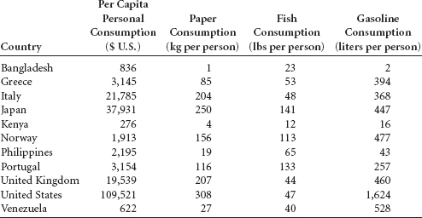

* **13.6** Jensen, Solberg, and Zorn investigated the relationship of insider ownership, debt, and dividend policies in companies. One of their findings was that firms with high insider ownership choose lower levels of both debt and dividends. Shown here is a sample of data of these three variables for 11 different industries. Use the data to develop the equation of the regression model to predict insider ownership by debt ratio and dividend payout. Comment on the regression coefficients.

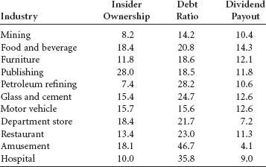

**13.2 SIGNIFICANCE TESTS OF THE REGRESSION MODEL AND ITS COEFFICIENTS**

Multiple regression models can be developed to fit almost any data set if the level of measurement is adequate and enough data points are available. Once a model has been constructed, it is important to test the model to determine whether it fits the data well and whether the assumptions underlying regression analysis are met. Assessing the adequacy of the regression model can be done in several ways, including testing the overall significance of the model, studying the significance tests of the regression coefficients, computing the residuals, examining the standard error of the estimate, and observing the coefficient of determination. In this section, we examine significance tests of the regression model and of its coefficients.

**Testing the Overall Model**

With simple regression, a *t* test of the slope of the regression line is used to determine whether the population slope of the regression line is different from zero—that is, whether the independent variable contributes significantly in linearly predicting the dependent variable.

The hypotheses for this test, presented in [**Chapter 12**](https://learning.oreilly.com/library/view/business-statistics-for/9781118213957/23_chapter12.html#ch12) are

H**0**: β**1** = 0

H**a**: β**1** # 0

For multiple regression, an analogous test makes use of the *F* statistic. The overall significance of the multiple regression model is tested with the following hypotheses.

H**0**: β**1** = β**2** = β**3**= ... = β***k*** = 0

H**a**: At least one of the regression coefficeients is # 0.

If we fail to reject the null hypothesis, we are stating that the regression model has no significant predictability for the dependent variable. A rejection of the null hypothesis indicates that at least one of the independent variables is adding significant predictability for *y.*

This *F* test of overall significance is often given as a part of the standard multiple regression output from statistical software packages. The output appears as an analysis of variance (ANOVA) table. Shown here is the ANOVA table for the real estate example taken from the Minitab output in [**Figure 13.3**](https://learning.oreilly.com/library/view/business-statistics-for/9781118213957/24_chapter13.html#fig13.3).

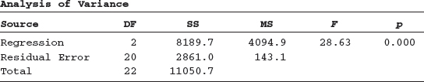

The *F* value is 28.63; because *p* = .000, the *F* value is significant at α = .001. The null hypothesis is rejected, and there is at least one significant predictor of house price in this analysis.

The *F* value is calculated by the following equation.

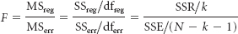

where

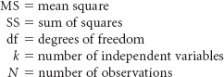

Note that in the ANOVA table for the real estate example, df**reg** = 2. The degrees of freedom formula for regression is the number of regression coefficients plus the regression constant minus 1. The net result is the number of regression coefficients, which equals the number of independent variables, *k*. The real estate example uses two independent variables, so *k* = 2. Degrees of freedom error in multiple regression equals the total number of observations minus the number of regression coefficients minus the regression constant, or *N* – *k* – 1. For the real estate example, *N* = 23; thus, df**err** = 23 – 2 – 1 = 20.

As shown in [**Chapter 11**](https://learning.oreilly.com/library/view/business-statistics-for/9781118213957/21_chapter11.html#ch11), MS = SS/df. The *F* ratio is formed by dividing MS**reg** by MS**err.** In using the *F* distribution table to determine a critical value against which to test the observed *F* value, the degrees of freedom numerator is df**reg** and the degrees of freedom denominator is df**err**. The table *F* value is obtained in the usual manner, as presented in [**Chapter 11**](https://learning.oreilly.com/library/view/business-statistics-for/9781118213957/21_chapter11.html#ch11). With α = .01 for the real estate example, the table value is

*F***.01,2,20** = 5.85

Comparing the observed *F* of 28.63 to this table value shows that the decision is to reject the null hypothesis. This same conclusion was reached using the *p*-value method from the computer output.

If a regression model has only one linear independent variable, it is a simple regression model. In that case, the *F* test for the overall model is the same as the *t* test for significance of the population slope. The *F* value displayed in the regression ANOVA table is related to the *t* test for the slope in the simple regression case as follows.

*F* = *t***2**

In simple regression, the *F* value and the *t* value give redundant information about the overall test of the model.

Most researchers who use multiple regression analysis will observe the value of *F* and its *p*-value rather early in the process. If *F* is not significant, then no population regression coefficient is significantly different from zero, and the regression model has no predictability for the dependent variable.

**Significance Tests of the Regression Coefficients**

In multiple regression, individual significance tests can be computed for each regression coefficient using a *t* test. Each of these *t* tests is analogous to the *t* test for the slope used in [**Chapter 12**](https://learning.oreilly.com/library/view/business-statistics-for/9781118213957/23_chapter12.html#ch12) for simple regression analysis. The hypotheses for testing the regression coefficient of each independent variable take the following form:

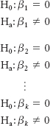

Most multiple regression computer packages yield observed *t* values to test the individual regression coefficients as standard output. Shown here are the *t* values and their associated probabilities for the real estate example as displayed with the multiple regression output in [**Figure 13.3**](https://learning.oreilly.com/library/view/business-statistics-for/9781118213957/24_chapter13.html#fig13.3).

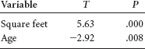

At α = .05, the null hypothesis is rejected for both variables because the probabilities (*p*) associated with their *t* values are less than .05. If the *t* ratios for any predictor variables are not significant (fail to reject the null hypothesis), the researcher might decide to drop that variable(s) from the analysis as a nonsignificant predictor(s). Other factors can enter into this decision. In [**Chapter 14**](https://learning.oreilly.com/library/view/business-statistics-for/9781118213957/25_chapter14.html#ch14), we will explore techniques for model building in which some variable sorting is required.

The degrees of freedom for each of these individual tests of regression coefficients are *n* – *k* – 1. In this particular example because there are *k* = 2 predictor variables, the degrees of freedom are 23 – 2 – 1 = 20. With α = .05 and a two-tailed test, the critical table *t* value is

*t***.025,20** = ±2.086

Notice from the *t* ratios shown here that if this critical table *t* value had been used as the hypothesis test criterion instead of the *p*-value method, the results would have been the same. Testing the regression coefficients not only gives the researcher some insight into the fit of the regression model, but it also helps in the evaluation of how worthwhile individual independent variables are in predicting *y*.

**13.2 PROBLEMS**

* **13.7** Examine the Minitab output shown here for a multiple regression analysis. How many predictors were there in this model? Comment on the overall significance of the regression model. Discuss the *t* ratios of the variables and their significance.
* The regression equation is

Y = 4.096 – 5.111X 1 + 2.662X 2 + 1.557X 3 + 1.141X 4 + 1.650X 5 – 1.248X 6 + 0.436X 7 + 0.962X 8 + 1.289X 9

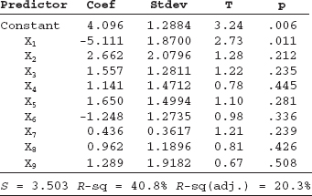

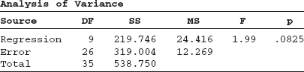

* **13.8** Displayed here is the Minitab output for a multiple regression analysis. Study the ANOVA table and the *t* ratios and use these to discuss the strengths of the regression model and the predictors. Does this model appear to fit the data well? From the information here, what recommendations would you make about the predictor variables in the model?
* The regression equation is

Y = 34.7 + 0.0763 X 1 + 0.00026X 2 – 1.12 X 3

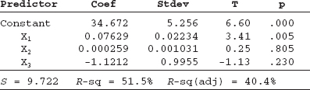

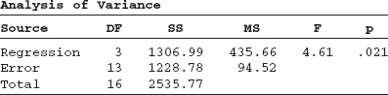

* **13.9** Using the data in Problem 13.5, develop a multiple regression model to predict per capita personal consumption by the consumption of paper, fish, and gasoline. Discuss the output and pay particular attention to the *F* test and the *t* tests.
* **13.10** Using the data from Problem 13.6, develop a multiple regression model to predict insider ownership from debt ratio and dividend payout. Comment on the strength of the model and the predictors by examining the ANOVA table and the *t* tests.
* **13.11** Develop a multiple regression model to predict *y* from *x***1**, *x***2**, and *x***3** using the following data. Discuss the values of *F* and *t*.

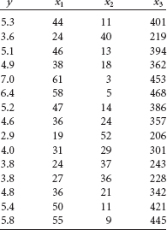

* **13.12** Use the following data to develop a regression model to predict *y* from *x***1** and *x***2**. Comment on the output. Develop a regression model to predict *y* from *x***1** only. Compare the results of this model with those of the model using both predictors. What might you conclude by examining the output from both regression models?

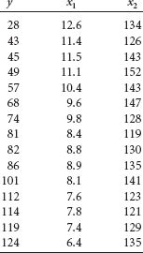

* **13.13** Study the following Excel multiple regression output. How many predictors are in this model? How many observations? What is the equation of the regression line? Discuss the strength of the model in terms *F.* Which predictors, if any, are significant? Why or why not? Comment on the overall effectiveness of the model.

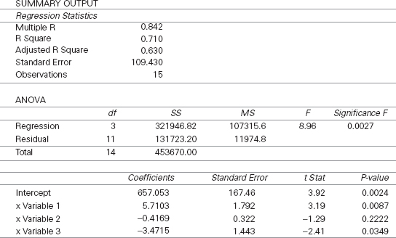

**13.3 RESIDUALS, STANDARD ERROR OF THE ESTIMATE, AND *R*2**

**TABLE 13.2** Residuals for the Real Estate Regression Model

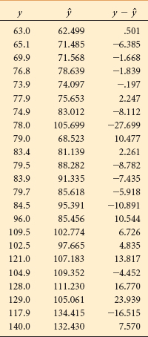

Three more statistical tools for examining the strength of a regression model are the residuals, the standard error of the estimate, and the coefficient of multiple determination.

**Residuals**

The **residual**, or error, of the regression model is *the difference between the y value and the predicted value*, ŷ.

Residual = *y* – ŷ

The residuals for a multiple regression model are solved for in the same manner as they are with simple regression. First, a predicted value, ŷ, is determined by entering the value for each independent variable for a given set of observations into the multiple regression equation and solving for ŷ. Next, the value of *y* – ŷ is computed for each set of observations. Shown here are the calculations for the residuals of the first set of observations from [**Table 13.1**](https://learning.oreilly.com/library/view/business-statistics-for/9781118213957/24_chapter13.html#tab13.1). The predicted value of *y* for *x***1** = 1605 and *x***2** = 35 is

ŷ = 57.4 + .0177(1605) –.666(35) = 62.499

Actual value of *y* = 63.0

Residual = *y* – *ŷ* = 63.0 – 62.499 = 0.501

All residuals for the real estate data and the regression model displayed in [**Table 13.1**](https://learning.oreilly.com/library/view/business-statistics-for/9781118213957/24_chapter13.html#tab13.1) and [**Figure 13.3**](https://learning.oreilly.com/library/view/business-statistics-for/9781118213957/24_chapter13.html#fig13.3) are displayed in [**Table 13.2**](https://learning.oreilly.com/library/view/business-statistics-for/9781118213957/24_chapter13.html#tab13.2).

An examination of the residuals in [**Table 13.2**](https://learning.oreilly.com/library/view/business-statistics-for/9781118213957/24_chapter13.html#tab13.2) can reveal some information about the fit of the real estate regression model. The business researcher can observe the residuals and decide whether the errors are small enough to support the accuracy of the model. The house price figures are in units of $1,000. Two of the 23 residuals are more than 20.00, or more than $20,000 off in their prediction. On the other hand, two residuals are less than 1, or $1,000 off in their prediction.

Residuals are also helpful in locating outliers. **Outliers** are *data points that are apart, or far, from the mainstream of the other data.* They are sometimes data points that were mistakenly recorded or measured. Because every data point influences the regression model, outliers can exert an overly important influence on the model based on their distance from other points. In examining the residuals in [**Table 13.2**](https://learning.oreilly.com/library/view/business-statistics-for/9781118213957/24_chapter13.html#tab13.2) for outliers, the eighth residual listed is –27.699. This error indicates that the regression model was not nearly as successful in predicting house price on this particular house as it was with others (an error of more than $27,000). For whatever reason, this data point stands somewhat apart from other data points and may be considered an outlier.

**FIGURE 13.4** Minitab Residual Diagnosis for the Real Estate Example

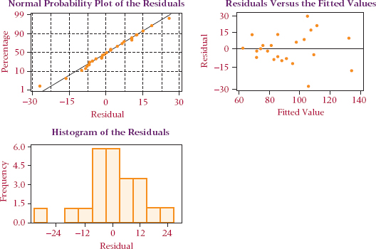

Residuals are also useful in testing the assumptions underlying regression analysis. [**Figure 13.4**](https://learning.oreilly.com/library/view/business-statistics-for/9781118213957/24_chapter13.html#fig13.4) displays Minitab diagnostic techniques for the real estate example. In the top right is a graph of the residuals. Notice that residual variance seems to increase in the right half of the plot, indicating potential heteroscedasticity. As discussed in [**Chapter 12**](https://learning.oreilly.com/library/view/business-statistics-for/9781118213957/23_chapter12.html#ch12), one of the assumptions underlying regression analysis is that the error terms have homoscedasticity or homogeneous variance. That assumption might be violated in this example. The normal plot of residuals is nearly a straight line, indicating that the assumption of normally distributed error terms probably has not been violated.

**SSE and Standard Error of the Estimate**

One of the properties of a regression model is that the residuals sum to zero. As pointed out in [**Chapter 12**](https://learning.oreilly.com/library/view/business-statistics-for/9781118213957/23_chapter12.html#ch12), this property precludes the possibility of computing an “average” residual as a single measure of error. In an effort to compute a single statistic that can represent the error in a regression analysis, the zero-sum property can be overcome by *squaring the residuals and then summing the squares.* Such an operation produces the sum of squares of error (SSE).

The formula for computing the sum of squares error (SSE) for multiple regression is the same as it is for simple regression.

SSE = Σ(*y* – ŷ)**2**

For the real estate example, SSE can be computed by squaring and summing the residuals displayed in [**Table 13.2**](https://learning.oreilly.com/library/view/business-statistics-for/9781118213957/24_chapter13.html#tab13.2).

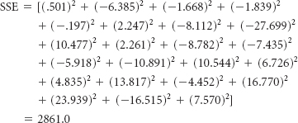

SSE can also be obtained directly from the multiple regression computer output by selecting the value of SS (sum of squares) listed beside error. Shown here is the ANOVA portion of the output displayed in [**Figure 13.3**](https://learning.oreilly.com/library/view/business-statistics-for/9781118213957/24_chapter13.html#fig13.3), which is the result of a multiple regression analysis model developed to predict house prices. Note that the SS for error shown in the ANOVA table equals the value of Σ(*y* – ŷ)**2** just computed (2861.0).

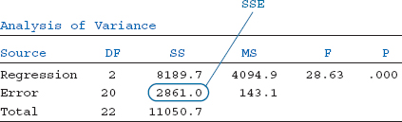

SSE has limited usage as a measure of error. However, it is a tool used to solve for other, more useful measures. One of those is the **standard error of the estimate, *se***, which is essentially *the standard deviation of residuals (error) for the regression model.* As explained in [**Chapter 12**](https://learning.oreilly.com/library/view/business-statistics-for/9781118213957/23_chapter12.html#ch12), an assumption underlying regression analysis is that the error terms are approximately normally distributed with a mean of zero. With this information and by the empirical rule, approximately 68% of the residuals should be within ±1*s****e*** and 95% should be within ±2*s****e***. This property makes the standard error of the estimate a useful tool in estimating how accurately a regression model is fitting the data.

The standard error of the estimate is computed by dividing SSE by the degrees of freedom of error for the model and taking the square root.

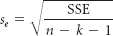

where

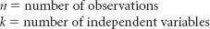

The value of *s****e*** can be computed for the real estate example as follows.

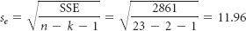

The standard error of the estimate, *s****e***, is usually given as standard output from regression analysis by computer software packages. The Minitab output displayed in [**Figure 13.3**](https://learning.oreilly.com/library/view/business-statistics-for/9781118213957/24_chapter13.html#fig13.3) contains the standard error of the estimate for the real estate example.

S = 11.96

By the empirical rule, approximately 68% of the residuals should be within ±1*s****e*** = ±1(11.96) = ±11.96. Because house prices are in units of $1,000, approximately 68% of the predictions are within 11.96($1,000), or ±$11,960. Examining the output displayed in [**Table 13.2**](https://learning.oreilly.com/library/view/business-statistics-for/9781118213957/24_chapter13.html#tab13.2), 18/23, or about 78%, of the residuals are within this span. According to the empirical rule, approximately 95% of the residuals should be within ±2*s****e***, or ±2(11.96) = ±23.92. Further examination of the residual values in [**Table 13.2**](https://learning.oreilly.com/library/view/business-statistics-for/9781118213957/24_chapter13.html#tab13.2) shows that 21 of 23, or 91%, fall within this range. The business researcher can study the standard error of the estimate and these empirical rule–related ranges and decide whether the error of the regression model is sufficiently small to justify further use of the model.

**Coefficient of Multiple Determination (*R*2)**

The **coefficient of multiple determination (*R*2)** is analogous to the coefficient of determination (*r***2**) discussed in [**Chapter 12**](https://learning.oreilly.com/library/view/business-statistics-for/9781118213957/23_chapter12.html#ch12). *R***2** represents *the proportion of variation of the dependent variable, y, accounted for by the independent variables in the regression model.* As with *r***2**, the range of possible values for *R***2** is from 0 to 1. An *R***2** of 0 indicates no relationship between the predictor variables in the model and *y*. An *R***2** of 1 indicates that 100% of the variability of *y* has been accounted for by the predictors. Of course, it is desirable for *R***2** to be high, indicating the strong predictability of a regression model. The coefficient of multiple determination can be calculated by the following formula:

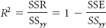

*R***2** can be calculated in the real estate example by using the sum of squares regression (SSR), the sum of squares error (SSE), and sum of squares total (SS***yy***) from the ANOVA portion of [**Figure 13.3**](https://learning.oreilly.com/library/view/business-statistics-for/9781118213957/24_chapter13.html#fig13.3).

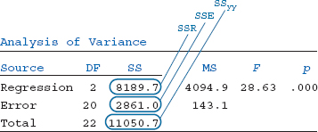

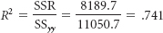

or

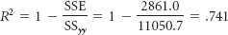

In addition, virtually all statistical software packages print out *R***2** as standard output with multiple regression analysis. A reexamination of [**Figure 13.3**](https://learning.oreilly.com/library/view/business-statistics-for/9781118213957/24_chapter13.html#fig13.3) reveals that *R***2** is given as

*R*-sq = 74.1%

This result indicates that a relatively high proportion of the variation of the dependent variable, house price, is accounted for by the independent variables in this regression model.

**Adjusted *R*2**

As additional independent variables are added to a regression model, the value of *R***2** cannot decrease, and in most cases it will increase. In the formulas for determining *R***2**,

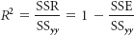

The value of SS***yy*** for a given set of observations will remain the same as independent variables are added to the regression analysis because SS***yy*** is the sum of squares for the dependent variable. Because additional independent variables are likely to increase SSR at least by some amount, the value of *R***2** will probably increase for any additional independent variables.

However, sometimes additional independent variables add no *significant* information to the regression model, yet *R***2** increases. *R***2** therefore may yield an inflated figure. Statisticians have developed an **adjusted *R*2** *to take into consideration both the additional information each new independent variable brings to the regression model and the changed degrees of freedom of regression.* Many standard statistical computer packages now compute and report adjusted *R***2** as part of the output. The formula for computing adjusted *R***2** is

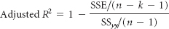

The value of adjusted *R***2** for the real estate example can be solved by using information from the ANOVA portion of the computer output in [**Figure 13.3**](https://learning.oreilly.com/library/view/business-statistics-for/9781118213957/24_chapter13.html#fig13.3).

**THINKING CRITICALLY ABOUT STATISTICS IN BUSINESS TODAY**

**Assessing Property Values Using Multiple Regression**

According to county assessor sources, Colorado state statute requires that all county assessors in the state value residential real property solely by a market approach. Furthermore, in the statute, it is stated that such a market approach will be based on a representative body of sales sufficient to set a pattern. No specifics on market analysis methods are given in the statutes, but there are several commonly used methods, including multiple regression. In the multiple regression approach, an attempt is made to develop a model to predict recent sales (dependent variable) by such property characteristics (independent variables) as location, lot size, building square feet, construction quality, property type (single family, condominium, townhouse), garage size, basement type, and other features. One county Web site states that “regression does not require strict similarity between property sales because it estimates the value contribution (coefficient) for each attribute....” In producing a sound multiple regression model to predict property values, several models are developed, refined, and compared using the typical indicators of a good fit, such as *R***2**, standard error of the estimate, *F* test for the overall model, and *p*-values associated with the *t* tests of significance for predictors. The final multiple regression model is then used in the estimation of property values by the appraiser, who enters into the regression model (equation) the specific measure of each independent (predictor) variable for a given property, resulting in a predicted appraised property value for tax purposes. The models are updated for currency and based on data that are never more than two years old.

**Things to Ponder**

1. How does the multiple regression method improve the validity of property value assessments over typical standard methods? Do you think it is more fair and equitable? If so, why?
2. Can you think of other similar possible applications of multiple regression in business?

*Source:* Douglas County, Colorado, Assessor's Office, at [**http:/www.douglas.co.us/assessor/Multiple_Regression.html**](http://www.douglas.co.us/assessor/Multiple_Regression.html), March 20, 2011, and Gunnison County Assessor's Office, at [**http://www.gunnisoncounty.org/ assessor_assessment_process.html**](http://www.gunnisoncounty.org/assessor_assessment_process.html), March 20, 2011.

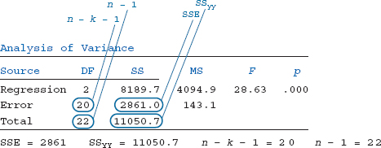

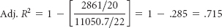

The standard Minitab regression output in [**Figure 13.3**](https://learning.oreilly.com/library/view/business-statistics-for/9781118213957/24_chapter13.html#fig13.3) contains the value of the adjusted *R***2** already computed. For the real estate example, this value is shown as

*R*-sq (adj.) = 71.5%

A comparison of *R***2**(.741) with the adjusted *R***2**(.715) for this example shows that the adjusted *R***2** reduces the overall proportion of variation of the dependent variable accounted for by the independent variables by a factor of.026, or 2.6%. The gap between the *R***2** and adjusted *R***2** tends to increase as nonsignificant independent variables are added to the regression model. As *n* increases, the difference between *R***2** and adjusted *R***2** becomes less.

**13.3 PROBLEMS**

* **13.14** Study the Minitab output shown in Problem 13.7. Comment on the overall strength of the regression model in light of *S, R***2**, and adjusted *R***2**.
* **13.15** Study the Minitab output shown in Problem 13.8. Comment on the overall strength of the regression model in light of *S, R***2**, and adjusted *R***2**.
* **13.16** Using the regression output obtained by working Problem 13.5, comment on the overall strength of the regression model using *S, R***2**, and adjusted *R***2**.
* **13.17** Using the regression output obtained by working Problem 13.6, comment on the overall strength of the regression model using *S, R***2**, and adjusted *R***2**.
* **13.18** Using the regression output obtained by working Problem 13.11, comment on the overall strength of the regression model using *S, R***2**, and adjusted *R***2**.
* **13.19** Using the regression output obtained by working Problem 13.12, comment on the overall strength of the regression model using *S, R***2**, and adjusted *R***2**.
* **13.20** Study the Excel output shown in Problem 13.13. Comment on the overall strength of the regression model in light of *S, R***2**, and adjusted *R***2**.
* **13.21** Study the Minitab residual diagnostic output that follows. Discuss any potential problems with meeting the regression assumptions for this regression analysis based on the residual graphics.

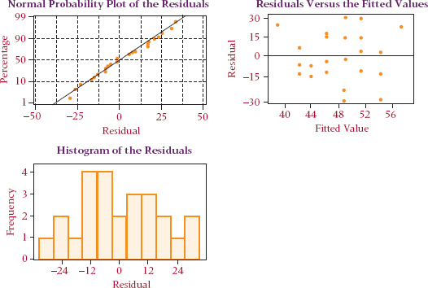

**13.4 INTERPRETING MULTIPLE REGRESSION COMPUTER OUTPUT**

**A Reexamination of the Multiple Regression Output**

[**Figure 13.5**](https://learning.oreilly.com/library/view/business-statistics-for/9781118213957/24_chapter13.html#fig13.5) shows again the Minitab multiple regression output for the real estate example. Many of the concepts discussed thus far in the chapter are highlighted. Note the following items:

1. The equation of the regression model
2. The ANOVA table with the *F* value for the overall test of the model
3. The *t* ratios, which test the significance of the regression coefficients
4. The value of SSE
5. The value of *s****e***
6. The value of *R***2**
7. The value of adjusted *R***2**

**FIGURE 13.5** Annotated Version of the Minitab Output of Regression for the Real Estate Example

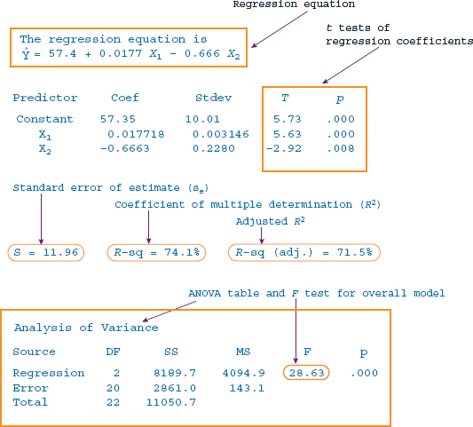

**DEMONSTRATION PROBLEM 13.2**

Discuss the Excel multiple regression output for Demonstration Problem 13.1. Comment on the *F* test for the overall significance of the model, the *t* tests of the regression coefficients, and the values of *s****e***, *R***2**, and adjusted *R***2**.

**Solution**

This multiple regression analysis was done to predict the prime interest rate using the predictors of unemployment and personal saving. The equation of the regression model was presented in the solution of Demonstration Problem 13.1. Shown here is the complete multiple regression output from the Excel analysis of the data.

The value of *F* for this problem is 12.21, with a *p*-value of.0013, which is significant at α = .01. On the basis of this information, the null hypothesis is rejected for the overall test of significance. At least one of the predictor variables is statistically significant from zero, and there is significant predictability of the prime interest rate by this model.

An examination of the *t* ratios reveals that personal savings is a significant predictor at α = .001 (*t* = 4.86 with a *p*-value of .0004) and that unemployment rates is a significant predictor at α = .05 (*t* = –2.85 with a *p*-value of .0147). The positive signs on the regression coefficient and the *t* value for personal savings indicate that as personal savings increase, the prime interest rate tends to get higher. On the other hand, the negative signs on the regression coefficient and the *t* value for unemployment rates indicate that as the unemployment rate increases, the prime interest rate tends to decrease.

The standard error of the estimate is *s****e*** = 1.890, indicating that approximately 68% of the residuals are within ±1.890. An examination of the Excel-produced residuals shows that actually 11 out of 15, or 73.3%, fall in this interval. Approximately 95% of the residuals should be within ±2(1.890) = ±3.780, and an examination of the Excel-produced residuals shows that 14 out of 15, or 93.3%, of the residuals are within this interval.

*R***2** for this regression analysis is .671, or 67.1%. The adjusted *R***2** is .616, indicating that there is some inflation in the *R***2** value. Overall, there is modest predictability in this model.

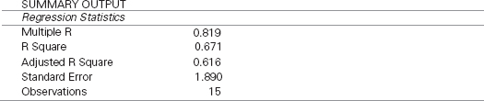

ANOVA

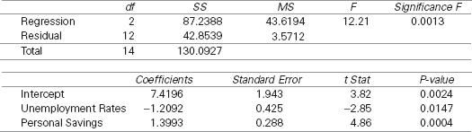

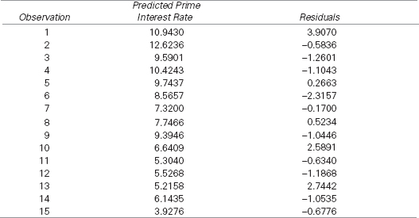

**13.4 PROBLEMS**

* **13.22** Study the Minitab regression output that follows. How many predictors are there? What is the equation of the regression model? Using the key statistics discussed in this chapter, discuss the strength of the model and the predictors.

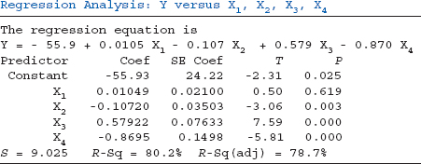

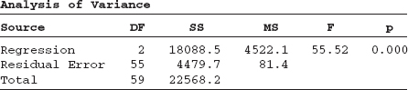

* **13.23** Study the Excel regression output that follows. How many predictors are there? What is the equation of the regression model? Using the key statistics discussed in this chapter, discuss the strength of the model and its predictors.

SUMMARY OUTPUT

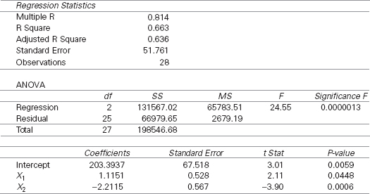

** Are You Going to Hate Your New Job?**

 In the Decision Dilemma, several variables are considered in attempting to determine whether a person will like his or her new job. Four predictor (independent) variables are given with the data set: relationship with supervisor, overall quality of work environment, total hours worked per week, and opportunities for advancement. Other possible variables might include openness of work culture, amount of pressure, how the interviewee is treated during the interview, availability of flexible scheduling, size of office, amount of time allotted for lunch, availability of management, interesting work, and many others.

Using the data that are given, a multiple regression model can be developed to predict job satisfaction from the four independent variables. Such an analysis allows the business researcher to study the entire data set in one model rather than constructing four different simple regression models, one for each independent variable. In the multiple regression model, job satisfaction is the dependent variable. There are 19 observations. The Excel regression output for this problem follows.

The test for overall significance of the model produced an *F* of 87.79 with a *p*-value of .000000001 (significant at α = .00000001). The *R***2** of .962 and adjusted *R***2** of .951 indicate very strong predictability in the model. The standard error of the estimate, 5.141, can be viewed in light of the job satisfaction values that ranged from 10 to 95 and the residuals, which are not shown here. Fourteen of the 19 residuals (73.7%) are within the standard error of the estimate. Examining the *t* statistics and their associated *p*-values reveals that two independent variables, relationship with supervisor (*t* = 5.33, *p*-value = .0001), and overall quality of work environment (*t* = 2.73, *p*-value = .0162) are significant predictors at α = .05. Judging by their large *p*-values, it appears that total hours worked per week and opportunities for advancement are not good predictors of job satisfaction.

SUMMARY OUTPUT

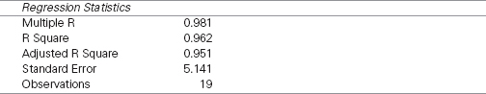

ANOVA

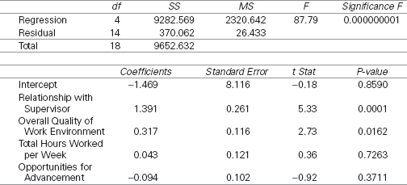

**ETHICAL CONSIDERATIONS**

**Multiple regression analysis can be used either** intentionally or unintentionally in questionable or unethical ways. When degrees of freedom are small, an inflated value of *R***2** can be obtained, leading to overenthusiastic expectations about the predictability of a regression model. To prevent this type of reliance, a researcher should take into account the nature of the data, the variables, and the value of the adjusted *R***2**.

Another misleading aspect of multiple regression can be the tendency of researchers to assume cause-and-effect relationships between the dependent variable and predictors. Just because independent variables produce a significant *R***2** does not necessarily mean those variables are causing the deviation of the *y* values. Indeed, some other force not in the model may be driving both the independent variables and the dependent variable over the range of values being studied.

Some people use the estimates of the regression coefficients to compare the worth of the predictor variables; the larger the coefficient, the greater is its worth. At least two problems can be found in this approach. The first is that most variables are measured in different units. Thus, regression coefficient weights are partly a function of the unit of measurement of the variable. Second, if multicollinearity (discussed in [**Chapter 14**](https://learning.oreilly.com/library/view/business-statistics-for/9781118213957/25_chapter14.html#ch14)) is present, the interpretation of the regression coefficients is questionable. In addition, the presence of multicollinearity raises several issues about the interpretation of other regression output. Researchers who ignore this problem are at risk of presenting spurious results.

Another danger in using regression analysis is in the extrapolation of the model to values beyond the range of values used to derive the model. A regression model that fits data within a given range does not necessarily fit data outside that range. One of the uses of regression analysis is in the area of forecasting. Users need to be aware that what has occurred in the past is not guaranteed to continue to occur in the future. Unscrupulous and sometimes even wellintentioned business decision makers can use regression models to project conclusions about the future that have little or no basis. The receiver of such messages should be cautioned that regression models may lack validity outside the range of values in which the models were developed.

**SUMMARY**

Multiple regression analysis is a statistical tool in which a mathematical model is developed in an attempt to predict a dependent variable by two or more independent variables or in which at least one predictor is nonlinear. Because doing multiple regression analysis by hand is extremely tedious and time-consuming, it is almost always done on a computer.

The standard output from a multiple regression analysis is similar to that of simple regression analysis. A regression equation is produced with a constant that is analogous to the *y*-intercept in simple regression and with estimates of the regression coefficients that are analogous to the estimate of the slope in simple regression. An *F* test for the overall model is computed to determine whether at least one of the regression coefficients is significantly different from zero. This *F* value is usually displayed in an ANOVA table, which is part of the regression output. The ANOVA table also contains the sum of squares of error and sum of squares of regression, which are used to compute other statistics in the model.

Most multiple regression computer output contains *t* values, which are used to determine the significance of the regression coefficients. Using these *t* values, statisticians can make decisions about including or excluding variables from the model.

Residuals, standard error of the estimate, and *R***2** are also standard computer regression output with multiple regression. The coefficient of determination for simple regression models is denoted *r***2**, whereas for multiple regression it is *R***2**. The interpretation of residuals, standard error of the estimate, and *R***2** in multiple regression is similar to that in simple regression. Because *R***2** can be inflated with nonsignificant variables in the mix, an adjusted *R***2** is often computed. Unlike *R***2**, adjusted *R***2** takes into account the degrees of freedom and the number of observations.

**KEY TERMS**

 adjusted *R***2**

coefficient of multiple

determination (*R***2**)

dependent variable

independent variable

least squares analysis

multiple regression

outliers

partial regression coefficient

*R***2**

residual

response plane

response surface

response variable

standard error of the

estimate (*s****e***)

sum of squares of error (SSE)

**FORMULAS**

The *F* value

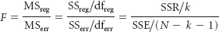

Sum of squares of error



Standard error of the estimate

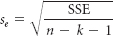

Coefficient of multiple determination

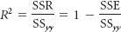

Adjusted *R***2**

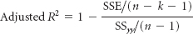

**SUPPLEMENTARY PROBLEMS**

**CALCULATING THE STATISTICS**

* **13.24** Use the following data to develop a multiple regression model to predict *y* from *x***1** and *x***2**. Discuss the output, including comments about the overall strength of the model, the significance of the regression coefficients, and other indicators of model fit.

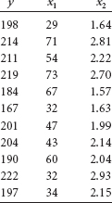

* **13.25** Given here are the data for a dependent variable, *y*, and independent variables. Use these data to develop a regression model to predict *y*. Discuss the output.

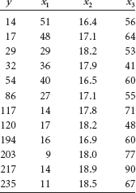

**TESTING YOUR UNDERSTANDING**

* **13.26** The U.S. Bureau of Mines produces data on the price of minerals. Shown here are the average prices per year for several minerals over a decade. Use these data and multiple regression to produce a model to predict the average price of gold from the other variables. Comment on the results of the process.

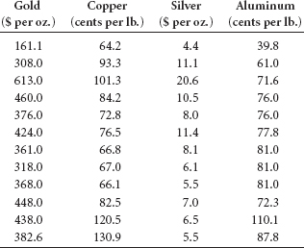

* **13.27** The Shipbuilders Council of America in Washington, D.C., publishes data about private shipyards. Among the variables reported by this organization are the employment figures (per 1000), the number of naval vessels under construction, and the number of repairs or conversions done to commercial ships (in $ millions). Shown here are the data for these three variables over a seven-year period. Use the data to develop a regression model to predict private shipyard employment from number of naval vessels under construction and repairs or conversions of commercial ships. Comment on the regression model and its strengths and its weaknesses.

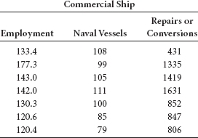

* **13.28** The U.S. Bureau of Labor Statistics produces consumer price indexes for several different categories. Shown here are the percentage changes in consumer price indexes over a period of 20 years for food, shelter, apparel, and fuel oil. Also displayed are the percentage changes in consumer price indexes for all commodities. Use these data and multiple regression to develop a model that attempts to predict all commodities by the other four variables. Comment on the result of this analysis.

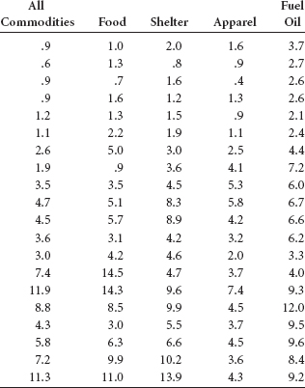

* **13.29** The U.S. Department of Agriculture publishes data annually on various selected farm products. Shown here are the unit production figures (in millions of bushels) for three farm products for 10 years during a 20-year period. Use these data and multiple regression analysis to predict corn production by the production of soybeans and wheat. Comment on the results.

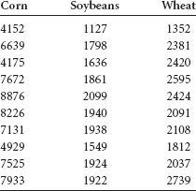

* **13.30** The American Chamber of Commerce Researchers Association compiles cost-of-living indexes for selected metropolitan areas. Shown here are cost-of-living indexes for 25 different cities on five different items for a recent year. Use the data to develop a regression model to predict the grocery cost-of-living index by the indexes of housing, utilities, transportation, and healthcare. Discuss the results, highlighting both the significant and nonsignificant predictors.

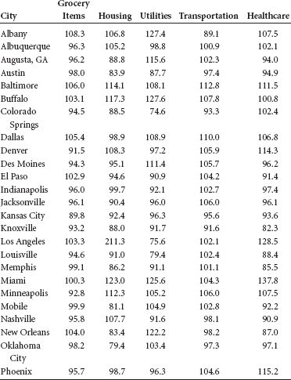

**INTERPRETING THE OUTPUT**

* **13.31** Shown here are the data for y and three predictors, *x***1**, *x***2**, and *x***3**. A multiple regression analysis has been done on these data; the Minitab results are given. Comment on the outcome of the analysis in light of the data.

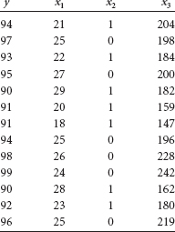

Regression Analysis: Y versus X1,X2,X3

The regression equation is

Y = 87.9 - 0.256 X1 - 2.71 X2 + 0.0706 X3

Predictor Coef SE Coef T P

Constant 87.890 3.445 25.51 0.000

X1 −0.25612 0.08317 −3.08 0.013

X2 −2.7137 0.7306 −3.71 0.005

X3 0.07061 0.01353 5.22 0.001

S = 0.850311 R-Sq = 94.1% R-Sq(adj) = 92.1%

Analysis of Variance

Source DF SS MS F p

Regression 3 103.185 34.395 47.57 0.000

Residual Error 9 6.507 0.723

Total 12 109.692

* **13.32** Minitab residual diagnostic output from the multiple regression analysis for the data given in Problem 13.30 follows. Discuss any potential problems with meeting the regression assumptions for this regression analysis based on the residual graphics.

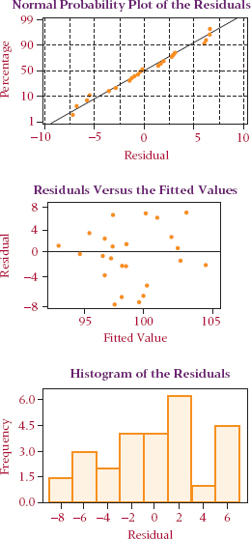

**ANALYZING THE DATABASES**

*  1. Use the Manufacturing database to develop a multiple regression model to predict Cost of Materials by Number of Employees, New Capital Expenditures, Value Added by Manufacture, and End-of-Year Inventories. Discuss the results of the analysis.
* 2. Develop a regression model using the Financial database. Use Total Revenues, Total Assets, Return on Equity, Earnings Per Share, Average Yield, and Dividends Per Share to predict the average P/E ratio for a company. How strong is the model? Which variables seem to be the best predictors?
* 3. Using the International Stock Market database, develop a multiple regression model to predict the Nikkei by the DJIA, the Nasdaq, the S&P 500, the Hang Seng, the FTSE 100, and the IPC. Discuss the outcome, including the model, the strength of the model, and the strength of the predictors.
* 4. Develop a multiple regression model to predict Annual Food Spending by Annual Household Income and NonMortgage Household Debt using the Consumer Food database. How strong is the model? Which of the two predictors seems to be stronger? Why?

**CASE: STARBUCKS INTRODUCES DEBIT CARD**

Starbucks is a resounding restaurant success story. Beginning with its first coffee house in 1971, Starbucks has grown to more than 11,000 U.S. locations. Opening up its first international outlet in the mid 1990s, Starbucks now operates in more than 50 countries outside of North America. Besides selling beverages, pastries, confections, and coffee-related accessories and equipment at its retail outlets, Starbucks also purchases and roasts high-quality coffee beans in several locations. The company's objective is to become the most recognized and respected brand in the world. Starbucks maintains a strong environmental orientation and is committed to taking a leadership position environmentally. In addition, the company has won awards for corporate social responsibility through its community-building programs, its strong commitment to its origins (coffee producers, family, community), and the Starbucks Foundation, which is dedicated to creating hope, discovery, and opportunity in the communities where Starbucks resides.

In November 2001, Starbucks launched its prepaid (debit) Starbucks Card. The card, which holds between $5 and $500, can be used at virtually any Starbucks location. The card was so popular when it first was released that many stores ran out. By mid-2002, Starbucks had activated more than 5 million of these cards. The Starbucks Card has surpassed the $2.5 billion mark for total activations and reloads since its introduction. As customers “reload” the cards, it appears they are placing more money on them than the initial value of the card.

Starbucks has gone on to promote their Starbucks Card as a flexible marketing tool that can be used by individuals as a gift of thanks and appreciation for friendship or service and can be used by companies to reward loyal customers and as an incentive to employees.

**Discussion**

1. Starbucks enjoyed considerable success with its debit cards, which they sell for $5 to $500. Suppose Starbucks management wants to study the reasons why some people purchase debit cards with higher prepaid amounts than do other people. Suppose a study of 25 randomly selected prepaid card purchasers is taken. Respondents are asked the amount of the prepaid card, the customer's age, the number of days per month the customer makes a purchase at Starbucks, the number of cups of coffee the customer drinks per day, and the customer's income. The data follow. Using these data, develop a multiple regression model to study how well the amount of the prepaid card can be predicted by the other variables and which variables seem to be more promising in doing the prediction. What sales implications might be evident from this analysis?

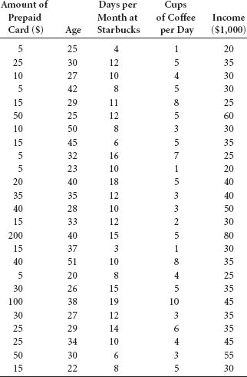

1. Suppose marketing wants to be able to profile frequent visitors to a Starbucks store. Using the same data set already provided, develop a multiple regression model to predict Days per month at Starbucks by Age, Income, and Number of cups of coffee per day. How strong is the model? Which particular independent variables seem to have more promise in predicting how many days per month a customer visits Starbucks? What marketing implications might be evident from this analysis?
2. Over the past decade or so, Starbucks has grown quite rapidly. As they add stores and increase the number of drinks, their sales revenues increase. In reflecting about this growth, think about some other variables that might be related to the increase in Starbucks sales revenues. Some data for the past seven years on the number of Starbucks stores (worldwide), approximate sales revenue (in $ millions), number of different drinks sold, and average weekly earnings of U.S. production workers are given here. Most figures are approximate. Develop a multiple regression model to predict sales revenue by number of drinks sold, number of stores, and average weekly earnings. How strong is the model? What are the key predictors, if any? How might this analysis help Starbucks management in attempting to determine what drives sales revenues?

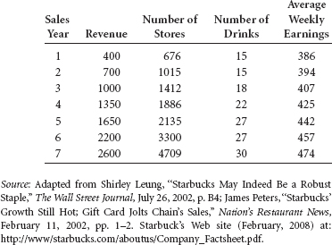

**USING THE COMPUTER**

**EXCEL**

* Excel has the capability of doing multiple regression analysis. The commands are essentially the same as those for simple regression except that the *x* range of data may include several columns. Excel will determine the number of predictor variables from the number of columns entered in to **Input X Range**.
* Begin by selecting the **Data** tab on the Excel worksheet. From the **Analysis** panel at the right top of the **Data** tab worksheet, click on **Data Analysis**. If your Excel worksheet does not show the **Data Analysis** option, then you can load it as an add-in following directions given in [**Chapter 2**](https://learning.oreilly.com/library/view/business-statistics-for/9781118213957/10_chapter02.html#ch2). From the **Data Analysis** pulldown menu, select **Regression**. In the **Regression** dialog box, input the location of the *y* values in **Input Y Range**. Input the location of the *x* values in **Input X Range**. Input **Labels** and input **Confidence Level**. To pass the line through the origin, check **Constant is Zero**. To printout the raw residuals, check **Residuals**. To printout residuals converted to *z* scores, check **Standardized Residuals**. For a plot of the residuals, check **Residual Plots**. For a plot of the line through the points check **Line Fit Plots**.
* Standard output includes *R*, *R***2**, *s****e***, and an ANOVA table with the *F* test, the slope and intercept, *t* statistics with associated *p*-values, and any optionally requested output, such as graphs or residuals.

**MINITAB**

* Multiple regression analysis can be performed by Minitab using the following commands. Select **Stat** from the menu bar. Select **Regression** from the **Stat** pulldown menu. Select **Regression** from the **Regression** pulldown menu. Place the column name or column location of the *y* variable in **Response**. Place the column name(s) or column location(s) of the *x* variable(s) in **Predictors**. Select **Graphs** for options relating to residual plots. Use this option and check **Four in one** to produce the residual diagnostic plots shown in the chapter. Select **Options** for confidence intervals and prediction intervals. Select **Results** for controlling the regression analysis output. Select **Storage** to store fits and/or residuals.
* To obtain a fitted-line plot, select **Stat** from the menu bar. Select **Regression** from the **Stat** pulldown menu. Select **Fitted Line Plot** from the **Regression** pulldown menu. In the Fitted Line Plot dialog box, place the column name or column location of the *y* variable in **Response(Y)**. Place the column name(s) or column location(s) of the *x* variable(s) in **Response(X)**. Check **Type of Regression Model** as **Linear, Quadratic**, or **Cubic**. Select **Graphs** for options relating to residual plots. Use this option and check **Four in one** to produce the residual diagnostic plots shown in the chapter. Select **Options** for confidence intervals and prediction intervals. Select **Storage** to store fits and/or residuals.

CHAPTER 14

Building Multiple Regression Models

**LEARNING OBJECTIVES**

This chapter presents several advanced topics in multiple regression analysis, enabling you to:

1. Generalize linear regression models as polynomial regression models using model transformation and Tukey's ladder of transformation, accounting for possible interaction among the independent variables.
2. Examine the role of indicator, or dummy, variables as predictors or independent variables in multiple regression analysis.
3. Use all possible regressions, stepwise regression, forward selection, and backward elimination search procedures to develop regression models that account for the most variation in the dependent variable and are parsimonious.
4. Recognize when multicollinearity is present, understanding general techniques for preventing and controlling it.
5. Explain when to use logistic regression, and interpret its results.



** Determining Compensation for CEOs**

 Chief executive officers for large companies receive widely varying amounts of compensation for their work. Why is the range so wide? What are some of the variables that seem to contribute to the diversity of CEO compensation packages?

As a starting place, one might examine the role of company size as measured by sales volume, number of employees, number of plants, and so on in determining CEO compensation. It could be argued that CEOs of larger companies carry larger responsibilities and hence should receive higher compensation. Some researchers believe CEO compensation is related to such things as industry performance of the firm, percentage of stock that has outside ownership, and proportion of insiders on the board. At least a significant proportion of CEOs are likely to be compensated according to the performance of their companies during the fiscal period preceding compensation. Company performance can be measured by such variables as earnings per share, percentage change in profit, sales, and profit. In addition, some theorize that companies with outside ownership are more oriented toward declaring dividends to stockholders than toward large CEO compensation packages.

Do CEOs' individual and family characteristics play a role in their compensation? Do such things as CEO age, degrees obtained, marital status, military experience, and number of children matter in compensation? Do type of industry and geographic location of the company matter? What are the significant factors in determining CEO compensation?

What follow are CEO compensation data generated by using management compensation models published by Wyatt Data Services. In the first column on the left are cash compensation figures (in $1,000) for 20 CEOs. Those figures represent salary, bonuses, and any other cash remuneration given to the CEO as part of compensation. The four columns to the right contain data on four variables associated with each CEO's company: sales, number of employees, capital investment, and whether the company is in manufacturing. Sales figures and capital investment figures are given in $ millions.

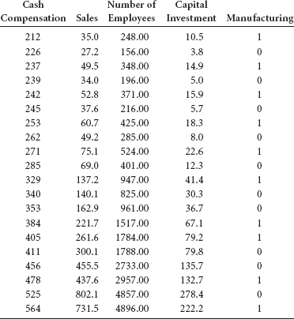

**Managerial and Statistical Questions**

1. Can a model be developed to predict CEO compensation?
2. If a model is developed, how can the model be evaluated to determine whether it is valid?
3. Is it possible to sort out variables that appear to be related to CEO compensation and determine which variables are more significant predictors?
4. Are some of the variables related to CEO compensation but in a nonlinear manner?
5. Are some variables highly interrelated and redundant in their potential for determining CEO compensation?

*Sources:* Adapted from Jeffrey L. Kerr and Leslie Kren, “Effect of Relative Decision Monitoring on Chief Executive Compensation,” *Academy of Management Journal*, vol. 35, no. 2 (June 1992). Used with permission. Robin L. Bartlett, James H. Grant, and Timothy I. Miller, “The Earnings of Top Executives: Compensating Differentials for Risky Business,” *Quarterly Reviews of Economics and Finance*, vol. 32, no. 1 (Spring 1992). Used with permission. Database derived using models published in *1993/1994 Top Management Compensation Regression Analysis Report*, 44th ed. Fort Lee, NJ: Wyatt Data Services/ECS, December 1994.

**14.1 NONLINEAR MODELS: MATHEMATICAL TRANSFORMATION**

The regression models presented thus far are based on the general linear regression model, which has the form



where

β**0** = the regression constant

β**1**, β**2** …, β***k*** are the partial regression coefficients for the *k* independent variables

*x***1**, …, *x****k*** are the independent variables

*k* = the number of independent variables

In this general linear model, the parameters, β***i***, are linear. It does not mean, however, that the dependent variable, *y*, is necessarily linearly related to the predictor variables. Scatter plots sometimes reveal a curvilinear relationship between *x* and *y*. Multiple regression response surfaces are not restricted to linear surfaces and may be curvilinear.

To this point in the text, the variables, *x****i***, have represented different predictors. For example, in the real estate example presented in [**Chapter 13**](https://learning.oreilly.com/library/view/business-statistics-for/9781118213957/24_chapter13.html#ch13), the variables—*x***1**, *x***2**— represented two predictors: number of square feet in the house and the age of the house, respectively. Certainly, regression models can be developed for more than two predictors. For example, a marketing site location model could be developed in which sales, as the response variable, is predicted by population density, number of competitors, size of the store, and number of salespeople. Such a model could take the form



This regression model has four *x****i*** variables, each of which represents a different predictor.

The general linear model also applies to situations in which some *x****i*** represent recoded data from a predictor variable already represented in the model by another independent variable. In some models, *x****i*** represents variables that have undergone a mathematical transformation to allow the model to follow the form of the general linear model.

In this section of this chapter, we explore some of these other models, including polynomial regression models, regression models with interaction, and models with transformed variables.

**Polynomial Regression**

Regression models in which the highest power of any predictor variable is 1 and in which there are no interaction terms—cross products (*x****i*** · *x****j***)—are referred to as *first-order models.* Simple regression models like those presented in [**Chapter 12**](https://learning.oreilly.com/library/view/business-statistics-for/9781118213957/23_chapter12.html#ch12) are *first-order models with one independent variable.* The general model for simple regression is



If a second independent variable is added, the model is referred to as a first-order model with two independent variables and appears as



Polynomial regression models are regression models that are second- or higher-order models. They contain squared, cubed, or higher powers of the predictor variable(s) and contain response surfaces that are curvilinear. Yet, they are still special cases of the general linear model given in formula 14.1.

Consider a regression model with one independent variable where the model includes a second predictor, which is the independent variable squared. Such a model is referred to as a second-order model with one independent variable because the highest power among the predictors is 2, but there is still only one independent variable. This model takes the following form:

**TABLE 14.1** Sales Data for 13 Manufacturing Companies

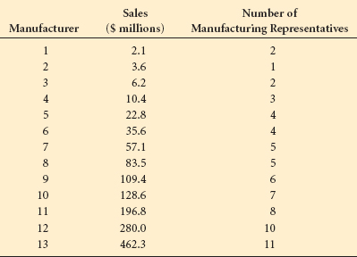



This model can be used to explore the possible fit of a quadratic model in predicting a dependent variable. A **quadratic model** is *a multiple regression model in which the predictors are a variable and the square of the variable.* How can this be a special case of the general linear model be equal to *x***12** then , becomes . Through what process does a researcher go to develop the regression constant and coefficients for a curvilinear model such as this one?

Multiple regression analysis assumes a linear fit of the regression coefficients and regression constant, but not necessarily a linear relationship of the independent variable values (*x*). Hence, a researcher can often accomplish curvilinear regression by recoding the data before the multiple regression analysis is attempted.

As an example, consider the data given in [**Table 14.1**](https://learning.oreilly.com/library/view/business-statistics-for/9781118213957/25_chapter14.html#tab14.1). This table contains sales volumes (in $ millions) for 13 manufacturing companies along with the number of manufacturer's representatives associated with each firm. A simple regression analysis to predict sales by the number of manufacturer's representatives results in the Excel output in [**Figure 14.1**](https://learning.oreilly.com/library/view/business-statistics-for/9781118213957/25_chapter14.html#fig14.1).

**FIGURE 14.1** Excel Simple Regression Output for Manufacturing Example

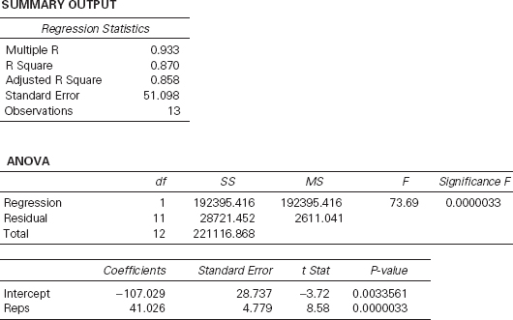

**FIGURE 14.2** Minitab Scatter Plots of Manufacturing Data

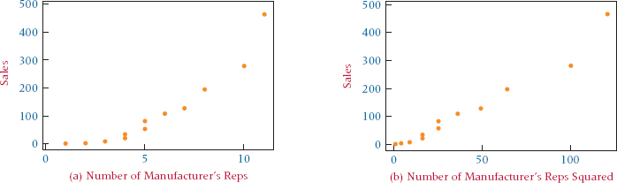

This regression output shows a regression model with an *r* **2** of 87.0%, a standard error of the estimate equal to 51.10, a significant overall *F* test for the model, and a significant *t* ratio for the predictor' number of manufacturer's representatives.

[**Figure 14.2**](https://learning.oreilly.com/library/view/business-statistics-for/9781118213957/25_chapter14.html#fig14.2)(a) is a scatter plot for the data in [**Table 14.1**](https://learning.oreilly.com/library/view/business-statistics-for/9781118213957/25_chapter14.html#tab14.1). Notice that the plot of number of representatives and sales is not a straight line and is an indication that the relationship between the two variables may be curvilinear. To explore the possibility that a quadratic relationship may exist between sales and number of representatives, the business researcher creates a second predictor variable, (number of manufacturer's representatives)**2**, to use in the regression analysis to predict sales along with number of manufacturer's representatives, as shown in [**Table 14.2**](https://learning.oreilly.com/library/view/business-statistics-for/9781118213957/25_chapter14.html#tab14.2). Thus, a variable can be created to explore second-order parabolic relationships by squaring the data from the independent variable of the linear model and entering it into the analysis. [**Figure 14.2**](https://learning.oreilly.com/library/view/business-statistics-for/9781118213957/25_chapter14.html#fig14.2)(b) is a scatter plot of sales with (number of manufacturer's reps)**2**. Note that this graph, with the squared term, more closely approaches a straight line than does the graph in [**Figure 14.2**](https://learning.oreilly.com/library/view/business-statistics-for/9781118213957/25_chapter14.html#fig14.2)(a). By recoding the predictor variable, the researcher creates a potentially better regression fit.

With these data, a multiple regression model can be developed. [**Figure 14.3**](https://learning.oreilly.com/library/view/business-statistics-for/9781118213957/25_chapter14.html#fig14.3) shows the Excel output for the regression analysis to predict sales by number of manufacturer's representatives and (number of manufacturer's representatives)**2**.

Examine the output in [**Figure 14.3**](https://learning.oreilly.com/library/view/business-statistics-for/9781118213957/25_chapter14.html#fig14.3) and compare it with the output in [**Figure 14.1**](https://learning.oreilly.com/library/view/business-statistics-for/9781118213957/25_chapter14.html#fig14.1) for the simple regression model. The *R***2** for this model is 97.3%, which is an increase from the *r***2** of 87.0% for the single linear predictor model. The standard error of the estimate for this model is 24.59, which is considerably lower than the 51.10 value obtained from the simple regression model. Remember, the sales figures were $ millions. The quadratic model reduced the standard error of the estimate by 26.51($1,000,000), or $26,510,000. It appears that the quadratic model is a better model for predicting sales.

**TABLE 14.2** Display of Manufacturing Data with Newly Created Variable

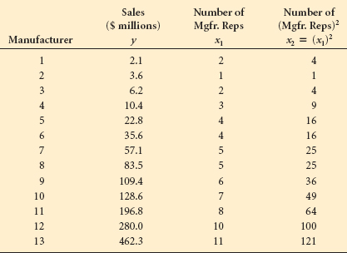

**FIGURE 14.3** Excel Output for Quadratic Model of Manufacturing Example

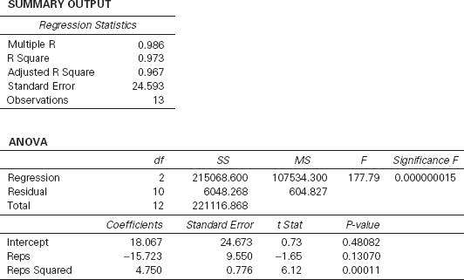

An examination of the *t* statistic for the squared term and its associated probability in [**Figure 14.3**](https://learning.oreilly.com/library/view/business-statistics-for/9781118213957/25_chapter14.html#fig14.3) shows that it is statistically significant at α = .001(*t* = 6.12 with a probability of .0001). If this *t* statistic were not significant, the researcher would most likely drop the squared term and revert to the first-order model (simple regression model).

In theory, third- and higher-order models can be explored. Generally, business researchers tend to utilize first- and second-order regression models more than higherorder models. Remember that most regression analysis is used in business to aid decision making. Higher-power models (third, fourth, etc.) become difficult to interpret and difficult to explain to decision makers. In addition, the business researcher is usually looking for trends and general directions. The higher the order in regression modeling, the more the model tends to follow irregular fluctuations rather than meaningful directions.

**Tukey's Ladder of Transformations**

As just shown with the manufacturing example, recoding data can be a useful tool in improving the regression model fit. Many other ways of recoding data can be explored in this process. John W. Tukey[**1**](https://learning.oreilly.com/library/view/business-statistics-for/9781118213957/25_chapter14.html#fn.001) presented a “ladder of expressions” that can be explored to straighten out a plot of *x* and *y*, thereby offering potential improvement in the predictability of the regression model. **Tukey's ladder of transformations** gives the following expressions for both *x* and *y*.

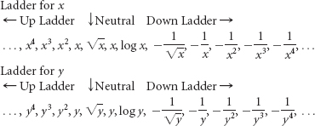

**FIGURE 14.4** Tukey's Four-Quadrant Approach

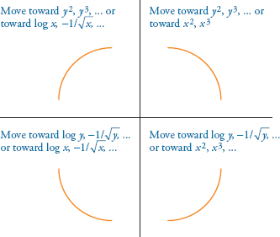

These ladders suggest to the user potential ways to recode the data. Tukey published a **four-quadrant approach** to determining which expressions on the ladder are more appropriate for a given situation. This approach is based on the shape of the scatter plot of *x* and *y*. [**Figure 14.4**](https://learning.oreilly.com/library/view/business-statistics-for/9781118213957/25_chapter14.html#fig14.4) shows the four quadrants and the associated recoding expressions. For example, if the scatter plot of *x* and *y* indicates a shape like that shown in the upper left quadrant, recoding should move “down the ladder” for the *x* variable toward

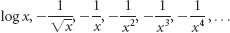

or “up the ladder” for the *y* variable toward

*y***2**, *y***3**, *y***4**, ...

Or, if the scatter plot of *x* and *y* indicates a shape like that of the lower right quadrant, the recoding should move “up the ladder” for the *x* variable toward

*x***2**, *x***3**, *x***4**, ...

or “down the ladder” for the *y* variable toward

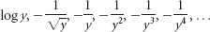

In the manufacturing example, the graph in [**Figure 14.2**](https://learning.oreilly.com/library/view/business-statistics-for/9781118213957/25_chapter14.html#fig14.2)(a) is shaped like the curve in the lower right quadrant of Tukey's four-quadrant approach. His approach suggests that the business researcher move “up the ladder” on *x* as was done by using the squared term. The researcher could have explored other options such as continuing on up the ladder of *x* or going down the ladder of *y.* Tukey's ladder is a continuum and leaves open other recoding possibilities between the expressions. For example, between *x***2** and *x***3** are many possible powers of *x* that can be explored, such as *x***2.1**, *x***2.5**, or *x***2.86**.

**Regression Models with Interaction**

Sometimes when two different independent variables are used in a regression analysis, an *interaction* occurs between the two variables. This interaction was discussed in [**Chapter 11**](https://learning.oreilly.com/library/view/business-statistics-for/9781118213957/21_chapter11.html#ch11) in two-way analysis of variance, where one variable will act differently over a given range of values for the second variable than it does over another range of values for the second variable. For example, in a manufacturing plant, temperature and humidity might interact in such a way as to have an effect on the hardness of the raw material. The air humidity may affect the raw material differently at different temperatures.

In regression analysis, interaction can be examined as a separate independent variable. An interaction predictor variable can be designed by multiplying the data values of one variable by the values of another variable, thereby creating a new variable. One model that includes an interaction variable is



**TABLE 14.3** Prices of Three Stocks over a 15 Month Period

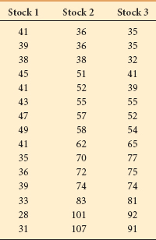

The *x***1***x***2** term is the interaction term. Even though this model has 1 as the highest power of any one variable, it is considered to be a second-order equation because of the *x***1** *x***2** term.

Suppose the data in [**Table 14.3**](https://learning.oreilly.com/library/view/business-statistics-for/9781118213957/25_chapter14.html#tab14.3) represent the closing stock prices for three corporations over a period of 15 months. An investment firm wants to use the prices for stocks 2 and 3 to develop a regression model to predict the price of stock 1. The form of the general linear regression equation for this model is



where

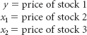

Using Minitab to develop this regression model, the firm's researcher obtains the first output displayed in [**Figure 14.5**](https://learning.oreilly.com/library/view/business-statistics-for/9781118213957/25_chapter14.html#fig14.5). This regression model is a first-order model with two predictors, *x***1** and *x***2**. This model produced a modest *R***2** of .472. Both of the *t* ratios are small and statistically nonsignificant (*t* = –.62 with a *p*-value of .549 and *t* = –.36 with a *p*-value of .728). Although the overall model is statistically significant, *F* = 5.37 with probability of .022, neither predictor is significant.

Sometimes the effects of two variables are not additive because of the interacting effects between the two variables. In such a case, the researcher can use multiple regression analysis to explore the interaction effects by including an interaction term in the equation.

**FIGURE 14.5** Two Minitab Regression Outputs—without and with Interaction

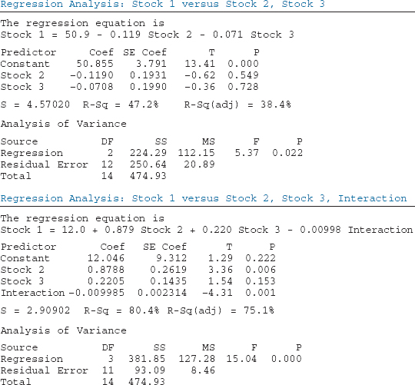

**FIGURE 14.6** Response Surfaces for the Stock Example—Without and with Interaction

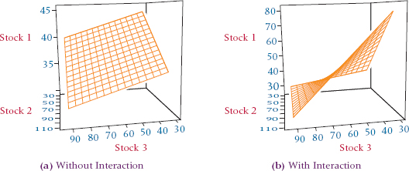



The equation fits the form of the general linear model



where *x* = *x***1***x***2**. Each individual observation of *x***3** is obtained through a recoding**3** process by multiplying the associated observations of *x***1** and *x***2**.

Applying this procedure to the stock example, the researcher uses the interaction term and Minitab to obtain the second regression output shown in [**Figure 14.5**](https://learning.oreilly.com/library/view/business-statistics-for/9781118213957/25_chapter14.html#fig14.5). This output contains *x***1**, *x***2**, and the interaction term, *x***1** *x***2**. Observe the *R***2**, which equals .804 for this model. The introduction of the interaction term caused the *R***2** to increase from 47.2% to 80.4%. In addition, the standard error of the estimate decreased from 4.570 in the first model to 2.909 in the second model. The *t* ratios for both the *x***1** term and the interaction term are statistically significant in the second model (*t* = 3.36 with a *p*-value of.006 for *x***1** and *t* = –4.31 with a probability of .001 for *x***1***x***2**). The inclusion of the interaction term helped the regression model account for a substantially greater amount of the dependent variable and is a significant contributor to the model.

[**Figure 14.6**](https://learning.oreilly.com/library/view/business-statistics-for/9781118213957/25_chapter14.html#fig14.6)(a) is the response surface for the first regression model presented in [**Figure 14.5**](https://learning.oreilly.com/library/view/business-statistics-for/9781118213957/25_chapter14.html#fig14.5) (the model without interaction). As you observe the response plane with stock 3 as the point of reference, you see the plane moving upward with increasing values of stock 1 as the plane moves away from you toward smaller values of stock 2. Now examine [**Figure 14.6**](https://learning.oreilly.com/library/view/business-statistics-for/9781118213957/25_chapter14.html#fig14.6)(b), the response surface for the second regression model presented in [**Figure 14.5**](https://learning.oreilly.com/library/view/business-statistics-for/9781118213957/25_chapter14.html#fig14.5) (the model with interaction). Note how the response plane is twisted, with its slope changing as it moves along stock 2. This pattern is caused by the interaction effects of stock 2 prices and stock 3 prices. A cross-section of the plane taken from left to right at any given stock 2 price produces a line that attempts to predict the price of stock 3 from the price of stock 1. As you move back through different prices of stock 2, the slope of that line changes, indicating that the relationship between stock 1 and stock 3 varies according to stock 2.

A researcher also could develop a model using two independent variables with their squares and interaction. Such a model would be a second-order model with two independent variables. The model would look like this.



**Model Transformation**

To this point in examining polynomial and interaction models, the focus has been on recoding values of *x* variables. Some multiple regression situations require that the dependent variable, *y*, be recoded. To examine different relationships between *x* and *y*, Tukey's four-quadrant analysis and ladder of transformations can be used to explore ways to recode *x* or *y* in attempting to construct regression models with more predictability. Included on the ladder are such *y* transformations as log *y* and 1/*y*.

Suppose the following data represent the annual sales and annual advertising expenditures for seven companies. Can a regression model be developed from these figures that can be used to predict annual sales by annual advertising expenditures?

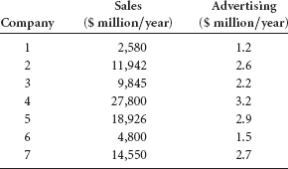

One mathematical model that is a good candidate for fitting these data is an exponential model of the form



This model can be transformed (by taking the log of each side) so that it is in the form of the general linear equation.



This transformed model requires a recoding of the *y* data through the use of logarithms. Notice that *x* is not recoded but that the regression constant and coefficient are in logarithmic scale. If we let *y*′ = log *y*, β**′0** = log β**0**, and β′**1** = log β**1**, the exponential model is in the form of the general linear model.



The process begins by taking the log of the *y* values. The data used to build the regression model and the Excel regression output for these data follow.

| Log Sales (*y*) | Advertising (*x*) |
| --- | --- |
| 3.4116 | 1.2 |
| 4.0771 | 2.6 |
| 3.9932 | 2.2 |
| 4.4440 | 3.2 |
| 4.2771 | 2.9 |
| 3.6812 | 1.5 |
| 4.1629 | 2.7 |

**SUMMARY OUTPUT**

| *Regression Statistics* | |
| --- | --- |
| Multiple R | 0.990 |
| R Square | 0.980 |
| Adjusted R Square | 0.977 |
| Standard Error | 0.0543 |
| Observations | 7 |

**ANOVA**

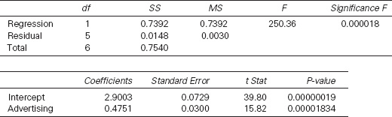

A simple regression model (without the log recoding of the *y* variable) yields an *R***2** of 87%, whereas the exponential model *R***2** is 98%. The *t* statistic for advertising is 15.82 with a *p*-value of 0.00001834 in the exponential model and 5.77 with a *p*-value of 0.00219 in the simple regression model. Thus the exponential model gives a better fit than does the simple regression model. An examination of (*x***2**, *y*) and (*x***3**, *y*) models reveals *R***2** of .930 and .969, respectively, which are quite high but still not as good as the *R***2** yielded by the exponential model (the output for these models is not shown here).

The resulting equation of the exponential regression model is



In using this regression equation to determine predicted values of *y* for *x*, remember that the resulting predicted *y* value is in logarithmic form and the antilog of the predicted *y* must be taken to get the predicted *y* value in raw units. For example, to get the predicted *y* value (sales) for an advertising figure of 2.0 ($ million), substitute *x* = 2.0 into the regression equation.



The log of sales is 3.8505. Taking the antilog of 3.8505 results in the predicted sales in raw units.

antilog(3.8505) = 7087.61($ million)

Thus, the exponential regression model predicts that $2.0 million of advertising will result in $7,087.61 million of sales.

Other ways can be used to transform mathematical models so that they can be treated like the general linear model. One example is an inverse model such as

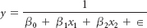

Such a model can be manipulated algebraically into the form

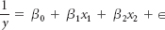

Substituting *y*′ = 1/*y* into this equation results in an equation that is in the form of the general linear model.



To use this “inverse” model, recode the data values for *y* by using 1/*y*. The regression analysis is done on the 1/*y*, *x***1**, and *x***2** data. To get predicted values of *y* from this model, enter the raw values of *x* and *x***2**. The resulting predicted value of *y* from the regression equation will be the inverse of the actual predicted *y* value.

**DEMONSTRATION PROBLEM 14.1**

 In the aerospace and defense industry, some cost estimators predict the cost of new space projects by using mathematical models that take the form



These cost estimators often use the weight of the object being sent into space as the predictor (*x*) and the cost of the object as the dependent variable (*y*). Quite often β**1** turns out to be a value between 0 and 1, resulting in the predicted value of *y* equaling some root of *x*

Use the sample cost data given here to develop a cost regression model in the form just shown to determine the equation for the predicted value of *y*. Use this regression equation to predict the value of *y* for *x* = 3,000.

| *y*(cost in billions) | *x*(weight in tons) |
| --- | --- |
| 1.2 | 450 |
| 9.0 | 20,200 |
| 4.5 | 9,060 |
| 3.2 | 3,500 |
| 13.0 | 75,600 |
| 0.6 | 175 |
| 1.8 | 800 |
| 2.7 | 2,100 |

**Solution**

The equation



is not in the form of the general linear model, but it can be transformed by using logarithms:



which takes on the general linear form



where

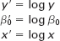

This equation requires that both *x* and *y* be recoded by taking the logarithm of each.

| log *y* | log *x* |
| --- | --- |
| .0792 | 2.6532 |
| .9542 | 4.3054 |
| .6532 | 3.9571 |
| .5051 | 3.5441 |
| 1.1139 | 4.8785 |
| –.2218 | 2.2430 |
| .2553 | 2.9031 |
| .4314 | 3.3222 |

Using these data, the computer produces the following regression constant and coefficient:

*b*′**0** = –1.25292 *b***1** = .49606

From these values, the equation of the predicted *y* value is determined to be

log ŷ = –1.25292 + .49606 log *x*

If *x* = 3,000, log *x* = 3.47712, and

log ŷ = –1.25292 + .49606(3.47712) = .47194

then

ŷ = antilog(log ŷ) = antilog(.47194) = 2.9644

The predicted value of *y* is $2.9644 billion for *x* = 3000 tons of weight.

Taking the antilog of *b′***0** = –1.25292 yields .055857. From this and *b***1** = .49606, the

model can be written in the original form:

*y* = (.055857)*x***.49606**

Substituting *x* = 3000 into this formula also yields $2.9644 billion for the predicted value of *y*

**14.1 PROBLEMS**

* **14.1** Use the following data to develop a quadratic model to predict *y* from *x*. Develop a simple regression model from the data and compare the results of the two models. Does the quadratic model seem to provide any better predictability? Why or why not?

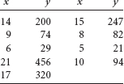

* **14.2** Develop a multiple regression model of the form

*y* = *b***0***b****x*1** ∊

using the following data to predict *y* from *x*. From a scatter plot and Tukey's ladder of transformation, explore ways to recode the data and develop an alternative regression model. Compare the results.

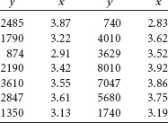

* **14.3** The Publishers Information Bureau in New York City released magazine advertising expenditure data compiled by leading national advertisers. The data were organized by product type over several years. Shown here are data on total magazine advertising expenditures and household equipment and supplies advertising expenditures. Using these data, develop a regression model to predict total magazine advertising expenditures by household equipment and supplies advertising expenditures and by (household equipment and supplies advertising expenditures)**2**. Compare this model to a regression model to predict total magazine advertising expenditures by only household equipment and supplies advertising expenditures. Construct a scatter plot of the data. Does the shape of the plot suggest some alternative models in light of Tukey's four-quadrant approach? If so, develop at least one other model and compare the model to the other two previously developed.

| Total Magazine Advertising Expenditures ($ millions) | Household Equipment and Supplies Expenditures ($ millions) |
| --- | --- |
| 1193 | 34 |
| 2846 | 65 |
| 4668 | 98 |
| 5120 | 93 |
| 5943 | 102 |
| 6644 | 103 |

* **14.4** Dun & Bradstreet reports, among other things, information about new business incorporations and number of business failures over several years. Shown here are data on business failures and current liabilities of the failing companies over several years. Use these data and the following model to predict current liabilities of the failing companies by the number of business failures. Discuss the strength of the model.



Now develop a different regression model by recoding *x.* Use Tukey's four-quadrant approach as a resource. Compare your models.

| **Rate of Business Failures (10,000)** | **Current Liabilities of Failing Companies ($ millions)** |
| --- | --- |
| 44 | 1,888 |
| 43 | 4,380 |
| 42 | 4,635 |
| 61 | 6,955 |
| 88 | 15,611 |
| 110 | 16,073 |
| 107 | 29,269 |
| 115 | 36,937 |
| 120 | 44,724 |
| 102 | 34,724 |
| 98 | 39,126 |
| 65 | 44,261 |

* **14.5** Use the following data to develop a curvilinear model to predict *y*. Include both *x***1** and *x***2** in the model in addition to *x***12** and *x***22**, and the interaction term *x***1***x***2**. Comment on the overall strength of the model and the significance of each predictor. Develop a regression model with the same independent variables as the first model but without the interaction variable. Compare this model to the model with interaction.

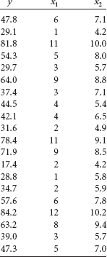

* **14.6** What follows is Excel output from a regression model to predict *y* using *x***1**, *x***2**, *x***12**, *x***22** and the interaction term, *x***1***x***2**. Comment on the overall strength of the model and the significance of each predictor. The data follow the Excel output. Develop a regression model with the same independent variables as the first model but without the interaction variable. Compare this model to the model with interaction.

**SUMMARY OUTPUT**

| *Regression Statistics* |  |
| --- | --- |
| Multiple R | 0.954 |
| R Square | 0.910 |
| Adjusted R Square | 0.878 |
| Standard Error | 7.544 |
| Observations | 20 |

**ANOVA**

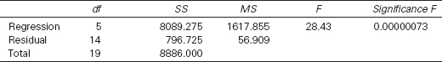

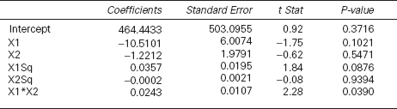

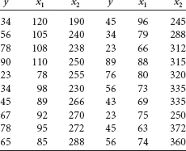

**14.2 INDICATOR (DUMMY) VARIABLES**

Some variables are referred to as **qualitative variables** (as opposed to *quantitative* variables) because qualitative variables do not yield quantifiable outcomes. Instead, *qualitative variables yield nominal- or ordinal-level information*, which is used more to categorize items. These variables have a role in multiple regression and are referred to as **indicator**, or **dummy variables**. In this section, we will examine the role of indicator, or dummy, variables as predictors or independent variables in multiple regression analysis.

Indicator variables arise in many ways in business research. Mail questionnaire or personal interview demographic questions are prime candidates because they tend to generate qualitative measures on such items as sex, geographic region, occupation, marital status, level of education, economic class, political affiliation, religion, management/ nonmanagement status, buying/leasing a home, method of transportation, or type of broker. In one business study, business researchers were attempting to develop a multiple regression model to predict the distances shoppers drive to malls in the greater Cleveland area. One independent variable was whether the mall was located on the shore of Lake Erie. In a second study, a site location model for pizza restaurants included indicator variables for (1) whether the restaurant served beer and (2) whether the restaurant had a salad bar.

These indicator variables are qualitative in that no interval or ratio level measurement is assigned to a response. For example, if a mall is located on the shore of Lake Erie, awarding it a score of 20 or 30 or 75 because of its location makes no sense. In terms of sex, what value would you assign to a man or a woman in a regression study? Yet these types of indicator, or dummy, variables are often useful in multiple regression studies and can be included if they are coded in the proper format.

Most researchers code indicator variables by using 0 or 1. For example, in the shopping mall study, malls located on the shore of Lake Erie could be assigned a 1, and all other malls would then be assigned a 0. The assignment of 0 or 1 is arbitrary, with the number merely holding a place for the category. For this reason, the coding is referred to as “dummy” coding; the number represents a category by holding a place and is not a measurement.

Many indicator, or dummy, variables are dichotomous, such as male/female, salad bar/no salad bar, employed/not employed, and rent/own. For these variables, a value of 1 is arbitrarily assigned to one category and a value of 0 is assigned to the other category. Some qualitative variables contain several categories, such as the variable “type of job,” which might have the categories assembler, painter, and inspector. In this case, using a coding of 1, 2, and 3, respectively, is tempting. However, that type of coding creates problems for multiple regression analysis. For one thing, the category “inspector” would receive a value that is three times that of “painter.” In addition, the values of 1, 2, and 3 indicate a hierarchy of job types: assembler < painter < inspector. The proper way to code such indicator variables is with the 0, 1 coding. Two separate independent variables should be used to code the three categories of type of job. The first variable is assembler, where a 1 is recorded if the person's job is assembler and a 0 is recorded if it is not. The second variable is painter, where a 1 is recorded if the person's job is painter and a 0 is recorded if it is not. A variable should not be assigned to inspector, because all workers in the study for whom a 1 was not recorded either for the assembler variable or the painter variable must be inspectors. Thus, coding the inspector variable would result in redundant information and is not necessary. This reasoning holds for all indicator variables with more than two categories. If an indicator variable has *c* categories, then *c* – 1 dummy variables must be created and inserted into the regression analysis in order to include the indicator variable in the multiple regression.[**2**](https://learning.oreilly.com/library/view/business-statistics-for/9781118213957/25_chapter14.html#fn.002)

An example of an indicator variable with more than two categories is the result of the following question taken from a typical questionnaire.

Your office is located in which region of the country?



Suppose a researcher is using a multiple regression analysis to predict the cost of doing business and believes geographic location of the office is a potential predictor. How does the researcher insert this qualitative variable into the analysis? Because *c* = 4 for this question, three dummy variables are inserted into the analysis. [**Table 14.4**](https://learning.oreilly.com/library/view/business-statistics-for/9781118213957/25_chapter14.html#tab14.4) shows one possible way this process works with 13 respondents. Note that rows 2, 7, and 11 contain all zeros, which indicate that those respondents have offices in the West. Thus, a fourth dummy variable for the West region is not necessary and, indeed, should not be included because the information contained in such a fourth variable is contained in the other three variables.

**TABLE 14.4** Coding for the Indicator Variable of Geographic Location for Regression Analysis

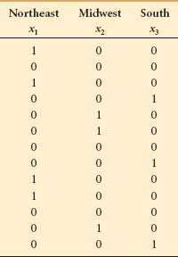

A word of caution is in order. Because of degrees of freedom and interpretation considerations, it is important that a multiple regression analysis have enough observations to handle adequately the number of independent variables entered. Some researchers recommend as a rule of thumb at least three observations per independent variable. If a qualitative variable has multiple categories, resulting in several dummy independent variables, and if several qualitative variables are being included in an analysis, the number of predictors can rather quickly exceed the limit of recommended number of variables per number of observations. Nevertheless, dummy variables can be useful and are a way in which nominal or ordinal information can be recoded and incorporated into a multiple regression model.

As an example, consider the issue of sex discrimination in the salary earnings of workers in some industries. In examining this issue, suppose a random sample of 15 workers is drawn from a pool of employed laborers in a particular industry and the workers' average monthly salaries are determined, along with their age and gender. The data are shown in [**Table 14.5**](https://learning.oreilly.com/library/view/business-statistics-for/9781118213957/25_chapter14.html#tab14.5). As sex can be only male or female, this variable is a dummy variable requiring 0, 1 coding. Suppose we arbitrarily let 1 denote male and 0 denote female. [**Figure 14.7**](https://learning.oreilly.com/library/view/business-statistics-for/9781118213957/25_chapter14.html#fig14.7) is the multiple regression model developed from the data of [**Table 14.5**](https://learning.oreilly.com/library/view/business-statistics-for/9781118213957/25_chapter14.html#tab14.5) by using Minitab to predict the dependent variable, monthly salary, by two independent variables, age and sex.

**TABLE 14.5** Data for the Monthly Salary Example

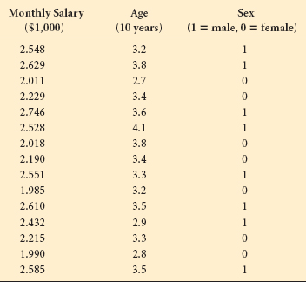

The computer output in [**Figure 14.7**](https://learning.oreilly.com/library/view/business-statistics-for/9781118213957/25_chapter14.html#fig14.7) contains the regression equation for this model.



An examination of the *t* ratios reveals that the dummy variable “sex” has a regression coefficient that is significant at α = .001 (*t* = 8.58, *p* = .000). The overall model is significant at α = .001(*F* = 48.54, *p* = .000). The standard error of the estimate, *s****e*** = .09679, indicates that approximately 68% of the errors of prediction are within ±$96.79 (.09679· $1,000). The *R***2** is relatively high at 89.0%, and the adjusted *R***2** is 87.2%.

The *t* value for sex indicates that it is a significant predictor of monthly salary in this model. This significance is apparent when one looks at the effects of this dummy variable another way. [**Figure 14.8**](https://learning.oreilly.com/library/view/business-statistics-for/9781118213957/25_chapter14.html#fig14.8) shows the graph of the regression equation when sex = 1 (male) and the graph of the regression equation when sex = 0 (female). When sex = 1 (male), the regression equation becomes



**FIGURE 14.7** Minitab Regression Output for the Monthly Salary Example

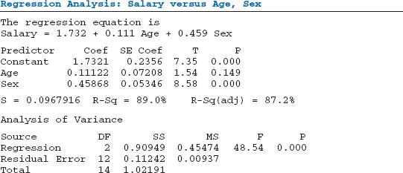

**FIGURE 14.8** Minitab Graph of Regression Lines for Males and Females

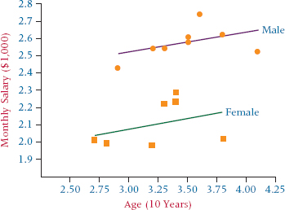

When sex = 0 (female), the regression equation becomes 1.732 + .111(Age) + .459(0) = 1.732 + .111(Age).

The full regression model (with both predictors) has a response surface that is a plane in a three-dimensional space. However, if a value of 1 is entered for sex into the full regression model, as just shown, the regression model is reduced to a line passing through the plane formed by monthly salary and age. If a value of 0 is entered for sex, as shown, the full regression model also reduces to a line passing through the plane formed by monthly salary and age. [**Figure 14.8**](https://learning.oreilly.com/library/view/business-statistics-for/9781118213957/25_chapter14.html#fig14.8) displays these two lines. Notice that the only difference in the two lines is the *y*-intercept. Observe the monthly salary with male sex, as depicted by , versus the monthly salary with female sex, depicted by . The difference in the *y*-intercepts of these two lines is.459, which is the value of the regression coefficient for sex. This intercept figure signifies that, on average, men earn $459 per month more than women for this population.

THINKING CRITICALLY ABOUT STATISTICS IN BUSINESS TODAY

**Predicting Export Intensity of Chinese Manufacturing Firms Using Multiple Regression Analysis**

According to business researchers Hongxin Zhao and Shaoming Zou, little research has been done on the impact of external or uncontrollable variables on the export performance of a company. These two researchers conducted a study of Chinese manufacturing firms and used multiple regression to determine whether both domestic market concentration and firm location are good predictors of a firm's export intensity. The study included 999 Chinese manufacturing firms that exported. The dependent variable was “export intensity,” which was defined to be the proportion of production output that is exported and was computed by dividing the firm's export value by its production output value. The higher the proportion was, the higher the export intensity. Zhao and Zou used covariate techniques (beyond the scope of this text) to control for the fact that companies in the study varied by size, capital intensity, innovativeness, and industry. The independent variables were industry concentration and location. Industry concentration was computed as a ratio, with higher values indicating more concentration in the industry. The location variable was a composite index taking into account total freight volume, available modes of transportation, number of telephones, and size of geographic area.

The multiple regression model produced an *R***2** of approximately 52%. Industry concentration was a statistically significant predictor at α = .01, and the sign on the regression coefficient indicated that a negative relationship may exist between industry concentration and export intensity. It means export intensity is lower in highly concentrated industries and higher in lower concentrated industries. The researchers believe that in a more highly concentrated industry, the handful of firms dominating the industry will stifle the export competitiveness of firms. In the absence of dominating firms in a more fragmented setting, more competition and an increasing tendency to export are noted. The location variable was also a significant predictor at α = .01. Firms located in coastal areas had higher export intensities than did those located in inland areas.

*Source:* Hongxin Zhao and Shaoming Zou, “The Impact of Industry Concentration and Firm Location on Export Propensity and Intensity: An Empirical Analysis of Chinese Manufacturing Firms,” *Journal of International Marketing*, vol. 10, no. 1 (2002), pp. 52–71.

**14.2 PROBLEMS**

* **14.7** Analyze the following data by using a multiple regression computer software package to predict *y* using *x***1** and *x***2**. Notice that *x***2** is a dummy variable. Discuss the output from the regression analysis; in particular, comment on the predictability of the dummy variable.

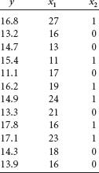

* **14.8** Given here are the data from a dependent variable and two independent variables. The second independent variable is an indicator variable with several categories. Hence, this variable is represented by *x***2**, *x***3**, and *x***4**. How many categories are needed in total for this independent variable? Use a computer to perform a multiple regression analysis on this data to predict *y* from the *x* values. Discuss the output and pay particular attention to the dummy variables.

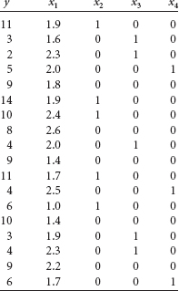

* **14.9** The Minitab output displayed here is the result of a multiple regression analysis with three independent variables. Variable *x***1** is a dummy variable. Discuss the computer output and the role *x***1** plays in this regression model.
* The regression equation is
* Y = 121 + 13.4 X 1 - 0.632 X 2 + 1.42 X 3
* Predictor Coef Stdev T p
* Constant 121.31 11.56 10.50 .000
* X1 13.355 4.714 2.83 .014
* X2 −0.6322 0.2270 −2.79 .015
* X3 1.421 3.342 0.43 .678

S = 7.041 R-sq = 79.5% R-sq(adj) = 74.7%

Analysis of Variance

Source df SS MS F p

Regression 3 2491.98 830.66 16.76 .000

Error 13 644.49 49.58

Total 16 3136.47

* **14.10** Given here is Excel output for a multiple regression model that was developed to predict *y* from two independent variables, *x***1** and *x***2**. Variable *x***2** is a dummy variable. Discuss the strength of the multiple regression model on the basis of the output. Focus on the contribution of the dummy variable. Plot *x***1** and *y* with *x***2** as 0, and then plot *x***1** and *y* with *x***2** as 1. Compare the two lines and discuss the differences.

**SUMMARY OUTPUT**

| *Regression Statistics* | |
| --- | --- |
| Multiple R | 0.623 |
| R Square | 0.388 |
| Adjusted R Square | 0.341 |
| Standard Error | 11.744 |
| Observations | 29 |

**ANOVA**

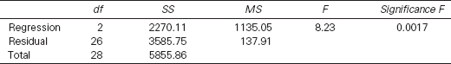

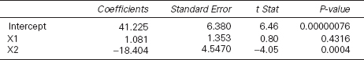

* **14.11** Falvey, Fried, and Richards developed a multiple regression model to predict the average price of a meal at New Orleans restaurants. The variables explored included such indicator variables as the following: Accepts reservations, Accepts credit cards, Has its own parking lot, Has a separate bar or lounge, Has a maitre d', Has a dress code, Is candlelit, Has live entertainment, Serves alcoholic beverages, Is a steakhouse, Is in the French Quarter. Suppose a relatively simple model is developed to predict the average price of a meal at a restaurant in New Orleans from the number of hours the restaurant is open per week, the probability of being seated upon arrival, and whether the restaurant is located in the French Quarter. Use the following data and a computer to develop such a model. Comment on the output.

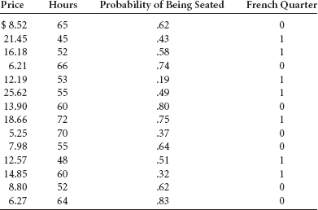

* **14.12** A researcher gathered 155 observations on four variables: job satisfaction, occupation, industry, and marital status. She wants to develop a multiple regression model to predict job satisfaction by the other three variables. All three predictor variables are qualitative variables with the following categories.
  1. Occupation: accounting, management, marketing, finance
  2. Industry: manufacturing, healthcare, transportation
  3. Marital status: married, single

How many variables will be in the regression model? Delineate the number of predictors needed in each category and discuss the total number of predictors.

**14.3 MODEL-BUILDING: SEARCH PROCEDURES**

To this point in the chapter, we have explored various types of multiple regression models. We evaluated the strengths of regression models and learned how to understand more about the output from multiple regression computer packages. In this section we examine procedures for developing several multiple regression model options to aid in the decisionmaking process.

Suppose a researcher wants to develop a multiple regression model to predict the world production of crude oil. The researcher realizes that much of the world crude oil market is driven by variables related to usage and production in the United States. The researcher decides to use as predictors the following five independent variables.

1. U.S. energy consumption
2. Gross U.S. nuclear electricity generation
3. U.S. coal production
4. Total U.S. dry gas (natural gas) production
5. Fuel rate of U.S.-owned automobiles

The researcher measured data for each of these variables for the year preceding each data point of world crude oil production, figuring that the world production is driven by the previous year's activities in the United States. It would seem that as the energy consumption of the United States increases, so would world production of crude oil. In addition, it makes sense that as nuclear electricity generation, coal production, dry gas production, and fuel rates increase, world crude oil production would decrease if energy consumption stays approximately constant.

[**Table 14.6**](https://learning.oreilly.com/library/view/business-statistics-for/9781118213957/25_chapter14.html#tab14.6) shows data for the five independent variables along with the dependent variable, world crude oil production. Using the data presented in [**Table 14.6**](https://learning.oreilly.com/library/view/business-statistics-for/9781118213957/25_chapter14.html#tab14.6), the researcher attempted to develop a multiple regression model using five different independent variables. The result of this process was the Minitab output in [**Figure 14.9**](https://learning.oreilly.com/library/view/business-statistics-for/9781118213957/25_chapter14.html#fig14.9). Examining the output, the researcher can reach some conclusions about that particular model and its variables.

The output contains an *R***2** value of 92.1%, a standard error of the estimate of 1.215, and an overall significant *F* value of 46.62. Notice from [**Figure 14.9**](https://learning.oreilly.com/library/view/business-statistics-for/9781118213957/25_chapter14.html#fig14.9) that the *t* ratios indicate that the regression coefficients of four of the predictor variables, nuclear, coal, dry gas, and fuel rate, are not significant at α = .05. If the researcher were to drop these four variables out of the regression analysis and rerun the model with the other predictor only, what would happen to the model? What if the researcher ran a regression model with only three predictors? How would these models compare to the full model with all five predictors? Are all the predictors necessary?

Developing regression models for business decision making involves at least two considerations. The first is to develop a regression model that accounts for the most variation of the dependent variable—that is, develop models that maximize the explained proportion of the deviation of the *y* values. At the same time, the regression model should be as parsimonious (simple and economical) as possible. The more complicated a quantitative model becomes, the harder it is for managers to understand and implement the model. In addition, as more variables are included in a model, it becomes more expensive to gather historical data or update present data for the model. These two considerations (dependent variable explanation and parsimony of the model) are quite often in opposition to each other. Hence the business researcher, as the model builder, often needs to explore many model options.

**TABLE 14.6** Data for Multiple Regression Model to Predict Crude Oil Production

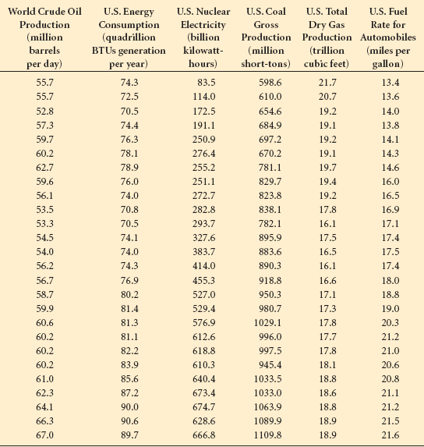

**FIGURE 14.9** Minitab Output of Regression for Crude Oil Production Example

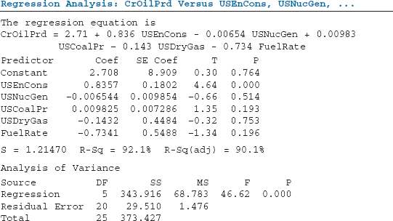

**TABLE 14.7** Predictors for All Possible Regressions with Five Independent Variables

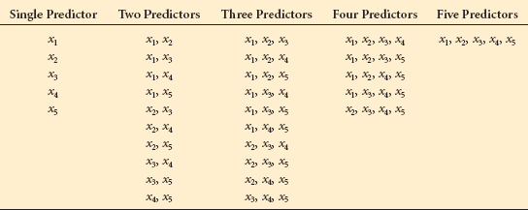

In the world crude oil production regression model, if three variables explain the deviation of world crude oil production nearly as well as five variables, the simpler model is more attractive. How might researchers conduct regression analysis so that they can examine several models and then choose the most attractive one? The answer is to use search procedures.

**Search Procedures**

**Search procedures** are processes *whereby more than one multiple regression model is developed for a given database, and the models are compared and sorted by different criteria*, depending on the given procedure. Virtually all search procedures are done on a computer. Several search procedures are discussed in this section, including all possible regressions, stepwise regression, forward selection, and backward elimination.

**All Possible Regressions**

The all **possible regressions** search procedure *computes all possible linear multiple regression models from the data using all variables.* If a data set contains *k* independent variables, all possible regressions will determine 2 ***k*** – 1 different models.

For the crude oil production example, the procedure of all possible regressions would produce 2**5** – 1 = 31 different models from the *k* = 5 independent variables. With *k* = 5 predictors, the procedure produces all single-predictor models, all models with two predictors, all models with three predictors, all models with four predictors, and all models with five predictors, as shown in [**Table 14.7**](https://learning.oreilly.com/library/view/business-statistics-for/9781118213957/25_chapter14.html#tab14.7).

The all possible regressions procedure enables the business researcher to examine every model. In theory, this method eliminates the chance that the business researcher will never consider some models, as can be the case with other search procedures. On the other hand, the search through all possible models can be tedious, time-consuming, inefficient, and perhaps overwhelming.

**Stepwise Regression**

Perhaps the most widely known and used of the search procedures is stepwise regression. **Stepwise regression** is *a step-by-step process that begins by developing a regression model with a single predictor variable and adds and deletes predictors one step at a time*, examining the fit of the model at each step until no more significant predictors remain outside the model.

STEP 1. In step 1 of a stepwise regression procedure, the *k* independent variables are examined one at a time by developing a simple regression model for each independent variable to predict the dependent variable. The model containing the largest absolute value of *t* for an independent variable is selected, and the independent variable associated with the model is selected as the “best” single predictor of *y* at the first step. Some computer software packages use an *F* value instead of a *t* value to make this determination. Most of these computer programs allow the researcher to predetermine critical values for *t* or *F*, but also contain a default value as an option. If the first independent variable selected at step 1 is denoted *x***1**, the model appears in the form



If, after examining all possible single-predictor models, it is concluded that none of the independent variables produces a *t* value that is significant at a, then the search procedure stops at step 1 and recommends no model.

STEP 2. In step 2, the stepwise procedure examines all possible two-predictor regression models with *x***1** as one of the independent variables in the model and determines which of the other *k* – 1 independent variables in conjunction with *x***1** produces the highest absolute *t* value in the model. If this other variable selected from the remaining independent variables is denoted *x***2** and is included in the model selected at step 2 along with *x***1**, the model appears in the form



At this point, stepwise regression pauses and examines the *t* value of the regression coefficient for *x***1**. Occasionally, the regression coefficient for *x***1** will become statistically nonsignificant when *x***2** is entered into the model. In that case, stepwise regression will drop *x***1** out of the model and go back and examine which of the other *k* – 2 independent variables, if any, will produce the largest significant absolute *t* value when that variable is included in the model along with *x***2**. If no other variables show significant *t* values, the procedure halts. It is worth noting that the regression coefficients are likely to change from step to step to account for the new predictor being added in the process. Thus, if *x***1** stays in the model at step 2, the value of *b***1** at step 1 will probably be different from the value of *b***1** at step 2.

STEP 3. Step 3 begins with independent variables, *x***1** and *x***2** (the variables that were finally selected at step 2), in the model. At this step, a search is made to determine which of the *k* – 2 remaining independent variables in conjunction with *x***1** and *x***2** produces the largest significant absolute *t* value in the regression model. Let us denote the one that is selected as *x***3**. If no significant *t* values are acknowledged at this step, the process stops here and the model determined in step 2 is the final model. At step 3, the model appears in the form



In a manner similar to step 2, stepwise regression now goes back and examines the *t* values of the regression coefficients of *x***1** and *x***2** in this step 3 model. If either or both of the *t* values are now nonsignificant, the variables are dropped out of the model and the process calls for a search through the remaining *k* – 3 independent variables to determine which, if any, in conjunction with *x***3** produce the largest significant *t* values in this model. The stepwise regression process continues step by step until no significant independent variables remain that are not in the model.

In the crude oil production example, recall that [**Table 14.6**](https://learning.oreilly.com/library/view/business-statistics-for/9781118213957/25_chapter14.html#tab14.6) contained data that can be used to develop a regression model to predict world crude oil production from as many as five different independent variables. [**Figure 14.9**](https://learning.oreilly.com/library/view/business-statistics-for/9781118213957/25_chapter14.html#fig14.9) displayed the results of a multiple regression analysis to produce a model using all five predictors. Suppose the researcher were to use a stepwise regression search procedure on these data to find a regression model. Recall that the following independent variables were being considered.

1. U.S. energy consumption
2. U.S. nuclear generation
3. U.S. coal production

**TABLE 14.8** Step 1: Results of Simple Regression Using Each Independent Variable to Predict Oil Production

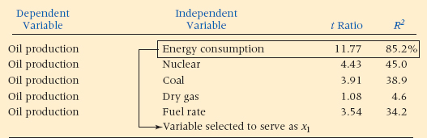

1. U.S. dry gas production
2. U.S. fuel rate

STEP 1. Each of the independent variables is examined one at a time to determine the strength of each predictor in a simple regression model. The results are reported in [**Table 14.8**](https://learning.oreilly.com/library/view/business-statistics-for/9781118213957/25_chapter14.html#tab14.8).

Note that the independent variable “energy consumption” was selected as the predictor variable, *x***1**, in step 1. An examination of [**Table 14.8**](https://learning.oreilly.com/library/view/business-statistics-for/9781118213957/25_chapter14.html#tab14.8) reveals that energy consumption produced the largest absolute *t* value (11.77) of the single predictors. By itself, energy consumption accounted for 85.2% of the variation of the *y* values (world crude oil production). The regression equation taken from the computer output for this model is



where

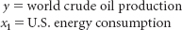

STEP 2. In step 2, *x***1** was retained initially in the model and a search was conducted among the four remaining independent variables to determine which of those variables in conjunction with *x***1** produced the largest significant *t* value. [**Table 14.9**](https://learning.oreilly.com/library/view/business-statistics-for/9781118213957/25_chapter14.html#tab14.9) reports the results of this search.

The information in [**Table 14.9**](https://learning.oreilly.com/library/view/business-statistics-for/9781118213957/25_chapter14.html#tab14.9) shows that the model selected in step 2 includes the independent variables “energy consumption” and “fuel rate.” Fuel rate has the largest absolute *t* value (–3.75), and it is significant at α = .05. Other variables produced varying sizes of *t* values. The model produced at step 2 has an *R***2** of 90.8%. These two variables taken together account for almost 91% of the variation of world crude oil production in this sample.

From other computer information, it is ascertained that the *t* value for the *x***1** variable in this model is 11.91, which is even higher than in step 1. Therefore, *x***1** will not be dropped from the model by the stepwise regression procedure. The step 2 regression model from the computer output is



**TABLE 14.9** Step 2: Regression Results with Two Predictors

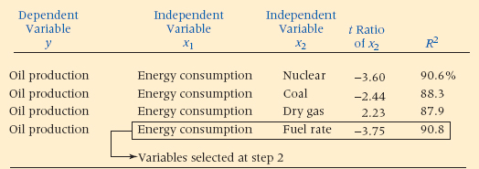

**TABLE 14.10** Step 3: Regression Results with Three Predictors

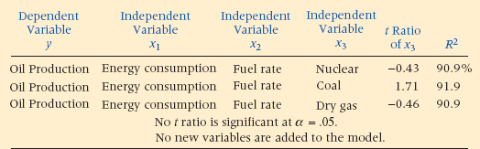

where

*y* = world crude oil production

*x***1** = U.S. energy consumption

*x***2** = U.S. fuel rate

Note that the regression coefficient for *x***1** changed from .580 at step 1 in the model to .772 at step 2.

The *R***2** for the model in step 1 was 85.2%. Notice that none of the *R***2** values produced from step 2 models is less than 85.2%. The reason is that *x***1** is still in the model, so the *R***2** at this step must be at least as high as it was in step 1, when only *x***1** was in the model. In addition, by examining the *R***2** values in [**Table 14.9**](https://learning.oreilly.com/library/view/business-statistics-for/9781118213957/25_chapter14.html#tab14.9), you can get a feel for how much the prospective new predictor adds to the model by seeing how much *R***2** increases from 85.2%. For example, with *x***2** (fuel rate) added to the model, the *R***2** goes up to 90.8%. However, adding the variable “dry gas” to *x***1** increases *R***2** very little (it goes up 87.9%).

STEP 3. In step 3, the search procedure continues to look for an additional predictor variable from the three independent variables remaining out of the solution. Variables *x***1** and *x***2** are retained in the model. [**Table 14.10**](https://learning.oreilly.com/library/view/business-statistics-for/9781118213957/25_chapter14.html#tab14.10) reports the result of this search.

In this step, regression models are explored that contain *x***1** (energy consumption) and *x***2** (fuel rate) in addition to one of the three remaining variables. None of the three models produces *t* ratios that are significant at α = .05. No new variables are added to the model produced in step 2. The stepwise regression process ends.

[**Figure 14.10**](https://learning.oreilly.com/library/view/business-statistics-for/9781118213957/25_chapter14.html#fig14.10) shows the Minitab stepwise regression output for the world crude oil production example. The results printed in the table are virtually identical to the step-by-step results discussed in this section but are in a different format.

**FIGURE 14.10** Minitab Stepwise Regression Output for the Crude Oil Production Example

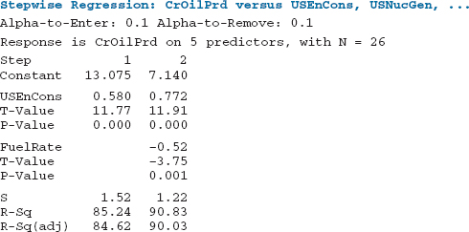

Each column in [**Figure 14.10**](https://learning.oreilly.com/library/view/business-statistics-for/9781118213957/25_chapter14.html#fig14.10) contains information about the regression model at each step. Thus, column 1 contains data on the regression model for step 1. In each column at each step you can see the variables in the model. As an example, at step 2, energy consumption and fuel rate are in the model. The numbers above the *t* ratios are the regression coefficients. The coefficients and the constant in column 2, for example, yield the regression model equation values for step 2.



The values of *R***2** (*R*-Sq) and the standard error of the estimate (S) are displayed on the bottom row of the output along with the adjusted value of *R***2**.

**Forward Selection**

Another search procedure is forward selection. **Forward selection** is essentially the same as stepwise regression, but once a variable is entered into the process, it is never dropped out. Forward selection begins by finding the independent variable that will produce the largest absolute value of *t* (and largest *R***2**) in predicting *y*. The selected variable is denoted here as *x***1** and is part of the model



Forward selection proceeds to step 2. While retaining *x***1**, it examines the other *k* – 1 independent variables and determines which variable in the model with *x***1** produces the highest absolute value of *t* that is significant. To this point, forward selection is the same as stepwise regression. If this second variable is designated *x***2**, the model is



At this point, forward selection does not reexamine the *t* value of *x***1**. Both *x***1** and *x***2** remain in the model as other variables are examined and included. When independent variables are correlated in forward selection, the overlapping of information can limit the potential predictability of two or more variables in combination. Stepwise regression takes this into account, in part, when it goes back to reexamine the *t* values of predictors already in the model to determine whether they are still significant predictors of *y* given the variables that have now entered the process. In other words, stepwise regression acknowledges that the strongest single predictor of *y* that is selected at step 1 may not be a significant predictor of *y* when taken in conjunction with other variables.

Using a forward selection procedure to develop multiple regression models for the world crude oil production example would result in the same outcome as that provided by stepwise regression because neither *x***1** nor *x***2** were removed from the model in that particular stepwise regression. The difference in the two procedures is more apparent in examples where variables selected at earlier steps in the process are removed during later steps in stepwise regression.

**Backward Elimination**

The **backward elimination** search procedure is *a step-by-step process that begins with the “full” model (all k predictors)*. Using the *t* values, a search is made to determine whether any nonsignificant independent variables are in the model. If no nonsignificant predictors are found, the backward process ends with the full model. If nonsignificant predictors are found, the predictor with the smallest absolute value of *t* is eliminated and a new model is developed with *k* – 1 independent variables.

This model is then examined to determine whether it contains any independent variables with nonsignificant *t* values. If it does, the predictor with the smallest absolute *t* value is eliminated from the process and a new model is developed for the next step.

This procedure of identifying the smallest nonsignificant *t* value and eliminating that variable continues until all variables left in the model have significant *t* values. Sometimes this process yields results similar to those obtained from forward selection and other times it does not. A word of caution is in order. Backward elimination always begins with all possible predictors in the model. Sometimes the sample data do not provide enough observations to justify the use of all possible predictors at the same time in the model. In this case, backward elimination is not a suitable option with which to build regression models.

**TABLE 14.11** Step 1: Backward Elimination, Full Model

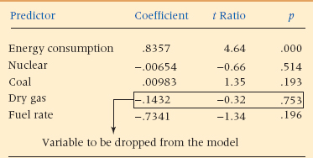

**TABLE 14.12** Step 2: Backward Elimination, Four Predictors

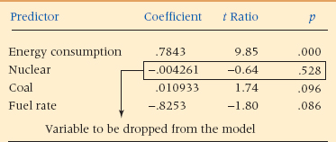

The following steps show how the backward elimination process can be used to develop multiple regression models to predict world crude oil production using the data and five predictors displayed in [**Table 14.6**](https://learning.oreilly.com/library/view/business-statistics-for/9781118213957/25_chapter14.html#tab14.6).

STEP 1. A full model is developed with all predictors. The results are shown in [**Table 14.11**](https://learning.oreilly.com/library/view/business-statistics-for/9781118213957/25_chapter14.html#tab14.11). The *R***2** for this model is 92.1%. A study of [**Table 14.11**](https://learning.oreilly.com/library/view/business-statistics-for/9781118213957/25_chapter14.html#tab14.11) reveals that the predictor “dry gas” has the smallest absolute value of a nonsignificant *t* (*t* = .32, *p* = .753). In step 2, this variable will be dropped from the model.

STEP 2. A second regression model is developed with *k* – 1 = 4 predictors. Dry gas has been eliminated from consideration. The results of this multiple regression analysis are presented in [**Table 14.12**](https://learning.oreilly.com/library/view/business-statistics-for/9781118213957/25_chapter14.html#tab14.12). The computer results in [**Table 14.12**](https://learning.oreilly.com/library/view/business-statistics-for/9781118213957/25_chapter14.html#tab14.12) indicate that the variable “nuclear” has the smallest absolute value of a nonsignificant *t* of the variables remaining in the model (*t* = –.64, *p* = .528). In step 3, this variable will be dropped from the model.

STEP 3. A third regression model is developed with *k* – 2 = 3 predictors. Both nuclear and dry gas variables have been removed from the model. The results of this multiple regression analysis are reported in [**Table 14.13**](https://learning.oreilly.com/library/view/business-statistics-for/9781118213957/25_chapter14.html#tab14.13). The computer results in [**Table 14.13**](https://learning.oreilly.com/library/view/business-statistics-for/9781118213957/25_chapter14.html#tab14.13) indicate that the variable “coal” has the smallest absolute value of a nonsignificant *t* of the variables remaining in the model (*t* = 1.71, *p* = .102). In step 4, this variable will be dropped from the model.

STEP 4. A fourth regression model is developed with *k* – 3 = 2 predictors. Nuclear, dry gas, and coal variables have been removed from the model. The results of this multiple regression analysis are reported in [**Table 14.14**](https://learning.oreilly.com/library/view/business-statistics-for/9781118213957/25_chapter14.html#tab14.14). Observe that all *p*-values are less than α = .05, indicating that all *t* values are significant, so no additional independent variables need to be removed. The backward elimination process ends with two predictors in the model. The final model obtained from this backward elimination process is the same model as that obtained by using stepwise regression.

**TABLE 14.13** Step 3: Backward Elimination, Three Predictors

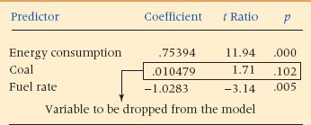

**TABLE 14.14** Step 4: Backward Elimination, Two Predictors

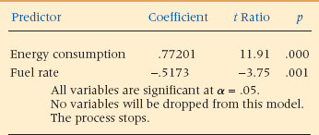

**14.3 PROBLEMS**

* **14.13** Use a stepwise regression procedure and the following data to develop a multiple regression model to predict *y*. Discuss the variables that enter at each step, commenting on their *t* values and on the value of *R***2**.

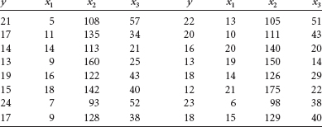

* **14.14** Given here are data for a dependent variable and four potential predictors. Use these data and a stepwise regression procedure to develop a multiple regression model to predict *y*. Examine the values of *t* and *R***2** at each step and comment on those values. How many steps did the procedure use? Why do you think the process stopped?

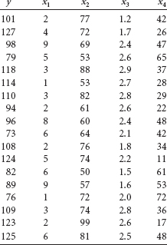

* **14.15** The computer output given here is the result of a stepwise multiple regression analysis to predict a dependent variable by using six predictor variables. The number of observations was 108. Study the output and discuss the results. How many predictors ended up in the model? Which predictors, if any, did not enter the model?

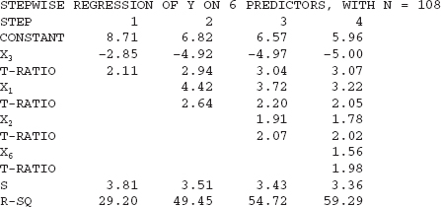

* **14.16** Study the output given here from a stepwise multiple regression analysis to predict *y* from four variables. Comment on the output at each step.

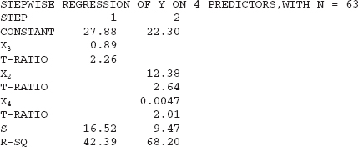

* **14.17** The National Underwriter Company in Cincinnati, Ohio, publishes property and casualty insurance data. Given here is a portion of the data published. These data include information from the U.S. insurance industry about (1) net income after taxes, (2) dividends to policyholders, (3) net underwriting gain/loss, and (4) premiums earned. Use the data and stepwise regression to predict premiums earned from the other three variables.

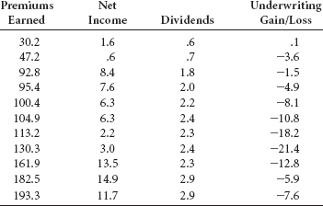

* **14.18** The U.S. Energy Information Administration releases figures in their publication, *Monthly Energy Review*, about the cost of various fuels and electricity. Shown here are the figures for four different items over a 12-year period. Use the data and stepwise regression to predict the cost of residential electricity from the cost of residential natural gas, residual fuel oil, and leaded regular gasoline. Examine the data and discuss the output.

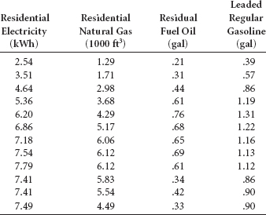

**14.4 MULTICOLLINEARITY**

One problem that can arise in multiple regression analysis is multicollinearity. **Multicollinearity** is *when two or more of the independent variables of a multiple regression model are highly correlated*. Technically, if two of the independent variables are correlated, we have collinearity; when three or more independent variables are correlated, we have multicollinearity. However, the two terms are frequently used interchangeably.

The reality of business research is that most of the time some correlation between predictors (independent variables) will be present. The problem of multicollinearity arises when the intercorrelation between predictor variables is high. This relationship causes several other problems, particularly in the interpretation of the analysis.

1. It is difficult, if not impossible, to interpret the estimates of the regression coefficients.
2. Inordinately small *t* values for the regression coefficients may result.
3. The standard deviations of regression coefficients are overestimated.
4. The algebraic sign of estimated regression coefficients may be the opposite of what would be expected for a particular predictor variable.

The problem of multicollinearity can arise in regression analysis in a variety of business research situations. For example, suppose a model is being developed to predict salaries in a given industry. Independent variables such as years of education, age, years in management, experience on the job, and years of tenure with the firm might be considered as predictors. It is obvious that several of these variables are correlated (virtually all of these variables have something to do with number of years, or time) and yield redundant information. Suppose a financial regression model is being developed to predict bond market rates by such independent variables as Dow Jones average, prime interest rates, GNP, producer price index, and consumer price index. Several of these predictors are likely to be intercorrelated.

In the world crude oil production example used in section 14.3, several of the independent variables are intercorrelated, leading to the potential of multicollinearity problems. [**Table 14.15**](https://learning.oreilly.com/library/view/business-statistics-for/9781118213957/25_chapter14.html#tab14.15) gives the correlations of the predictor variables for this example. Note that *r* values are quite high (*r* > .90) for fuel rate and nuclear (.972), fuel rate and coal (.968), and coal and nuclear (.952).

[**Table 14.15**](https://learning.oreilly.com/library/view/business-statistics-for/9781118213957/25_chapter14.html#tab14.15) shows that fuel rate and coal production are highly correlated. Using fuel rate as a single predictor of crude oil production produces the following simple regression model.



Notice that the estimate of the regression coefficient, .7838, is positive, indicating that as fuel rate increases, oil production increases. Using coal as a single predictor of crude oil production yields the following simple regression model.



The multiple regression model developed using both fuel rate and coal to predict crude oil production is



**TABLE 14.15** Correlations Among Oil Production Predictor Variables

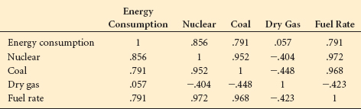

pObserve that this regression model indicates a *negative* relationship between fuel rate and oil production (–.3934), which is in opposition to the *positive* relationship shown in the regression equation for fuel rate as a single predictor. Because of the multicollinearity between coal and fuel rate, these two independent variables interact in the regression analysis in such a way as to produce regression coefficient estimates that are difficult to interpret. Extreme caution should be exercised before interpreting these regression coefficient estimates.

The problem of multicollinearity can also affect the *t* values that are used to evaluate the regression coefficients. Because the problems of multicollinearity among predictors can result in an overestimation of the standard deviation of the regression coefficients, the *t* values tend to be underrepresentative when multicollinearity is present. In some regression models containing multicollinearity in which all *t* values are nonsignificant, the overall *F* value for the model is highly significant. In Section 14.1, an example was given of how including interaction when it is significant strengthens a regression model. The computer output for the regression models both with and without the interaction term was shown in [**Figure 14.5**](https://learning.oreilly.com/library/view/business-statistics-for/9781118213957/25_chapter14.html#fig14.5). The model without interaction produced a statistically significant *F* value but neither predictor variable was significant. Further investigation of this model reveals that the correlation between the two predictors, *x***1** and *x***2**, is .945. This extremely high correlation indicates a strong collinearity between the two predictor variables.

This collinearity may explain the fact that the overall model is significant but neither predictor is significant. It also underscores one of the problems with multicollinearity: underrepresented *t* values. The *t* values test the strength of the predictor given the other variables in the model. If a predictor is highly correlated with other independent variables, it will appear not to add much to the explanation of *y* and produce a low *t* value. However, had the predictor not been in the presence of these other correlated variables, the predictor might have explained a high proportion of variation of *y*.

Many of the problems created by multicollinearity are interpretation problems. The business researcher should be alert to and aware of multicollinearity potential with the predictors in the model and view the model outcome in light of such potential.

The problem of multicollinearity is not a simple one to overcome. However, several methods offer an approach to the problem. One way is to examine a correlation matrix like the one in [**Table 14.15**](https://learning.oreilly.com/library/view/business-statistics-for/9781118213957/25_chapter14.html#tab14.15) to search for possible intercorrelations among potential predictor variables. If several variables are highly correlated, the researcher can select the variable that is most correlated to the dependent variable and use that variable to represent the others in the analysis. One problem with this idea is that correlations can be more complex than simple correlation among variables. In other words, simple correlation values do not always reveal multiple correlation between variables. In some instances, variables may not appear to be correlated as pairs, but one variable is a linear combination of several other variables. This situation is also an example of multicollinearity, and a cursory observation of the correlation matrix will probably not reveal the problem.

Stepwise regression is another way to prevent the problem of multicollinearity. The search process enters the variables one at a time and compares the new variable to those in solution. If a new variable is entered and the *t* values on old variables become nonsignificant, the old variables are dropped out of solution. In this manner, it is more difficult for the problem of multicollinearity to affect the regression analysis. Of course, because of multicollinearity, some important predictors may not enter in to the analysis.

Other techniques are available to attempt to control for the problem of multicollinearity. One is called a **variance inflation factor**, in which a regression analysis is conducted to predict an independent variable by the other independent variables. In this case, the independent variable being predicted becomes the dependent variable. As this process is done for each of the independent variables, it is possible to determine whether any of the independent variables are a function of the other independent variables, yielding evidence of multicollinearity. By using the results from such a model, a variance inflation factor (VIF) can be computed to determine whether the standard errors of the estimates are inflated:

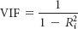

where *R***i2** is the coefficient of determination for any of the models, used to predict an inde pendent variable by the other *k* – 1 independent variables. Some researchers follow a guideline that any variance inflation factor greater than 10 or *R***i2** value more than .90 for the largest variance inflation factors indicates a severe multicollinearity problem.[**3**](https://learning.oreilly.com/library/view/business-statistics-for/9781118213957/25_chapter14.html#fn.003)

**14.4 PROBLEMS**

* **14.19** Develop a correlation matrix for the independent variables in Problem 14.13. Study the matrix and make a judgment as to whether substantial multicollinearity is present among the predictors. Why or why not?
* **14.20** Construct a correlation matrix for the four independent variables for Problem 14.14 and search for possible multicollinearity. What did you find and why?
* **14.21** In Problem 14.17, you were asked to use stepwise regression to predict premiums earned by net income, dividends, and underwriting gain or loss. Study the stepwise results, including the regression coefficients, to determine whether there may be a problem with multicollinearity. Construct a correlation matrix of the three variables to aid you in this task.
* **14.22** Study the three predictor variables in Problem 14.18 and attempt to determine whether substantial multicollinearity is present between the predictor variables. If there is a problem of multicollinearity, how might it affect the outcome of the multiple regression analysis?

**14.5 LOGISTIC REGRESSION**

There are times when business statisticians need to develop models to predict dependent variables that are dichotomous (have only two outcomes). For example, a major bank sends out credit cards to selected pre-qualified people. To use the credit card, the person must call a national telephone number and activate it. Why do some people activate the card and others do not? Can a model be developed to predict whether a person will activate the card? A financial institution is trying to get people to invest in a new annuity product. What variables seem to be related to whether a person invests? Can a model be developed to predict whether someone will invest? There are many other instances in business where it can be interesting and informative to develop a regression-type model to predict a dichotomous outcome.

In such models, a 0, 1 coding is used for the dependent variable in a manner similar to the coding used for dummy (qualitative) independent variables in regression analysis. However, unlike the use of dummy variables as predictors in regression, developing regression models to predict a dichotomous dependent variable is problematic. Such models violate assumptions underlying multiple regression because 1.) the error terms do not follow a normal distribution, 2.) the error terms are not independent, and 3.) there is heteroscedasticity of error variances. In addition, even with transformations accounting for nonlinear effects, there is no guarantee with multiple regression that the predicted values would always be between 0 and 1. For these reasons, a different methodology, logistic regression, is commonly used to develop models to predict dichotomous dependent variables.

The methods used in logistic regression have some properties similar to those used in multiple regression; however, there are differences. Logistic regression does not assume a linear relationship between the dependent and independent variables. The independent variables do not have to be interval/ratio in data level, the data need not be normally distributed, and within-group variances need not be equal. In addition, because of the methodology used, sample size requirements for logistic regression are larger than for multiple regression. Generally, there should be at least 50 observations for each predictor variable in logistic regression.

**An Example**

Suppose an auto club mails a flier to its members offering to send more information on a supplemental health insurance plan if the club member returns a brief form in an enclosed envelop. Why do some club members return the form and others do not? Can a model be developed to predict whether a club member will return the form? One theory is that older people are more likely to return the form inquiring about additional health insurance because they are more concerned about their health and they may have more disposable income to afford such coverage. Suppose a random sample of 92 club members is taken and club members are asked their age and if they have returned the form. The resulting data are shown in [**Table 14.16**](https://learning.oreilly.com/library/view/business-statistics-for/9781118213957/25_chapter14.html#tab14.16). For clarity of understanding, the data are organized by whether the club member returned the form.

[**Figure 14.11**](https://learning.oreilly.com/library/view/business-statistics-for/9781118213957/25_chapter14.html#fig14.11) displays a scatter plot of the data.

**TABLE 14.16** Data on Auto Club Members

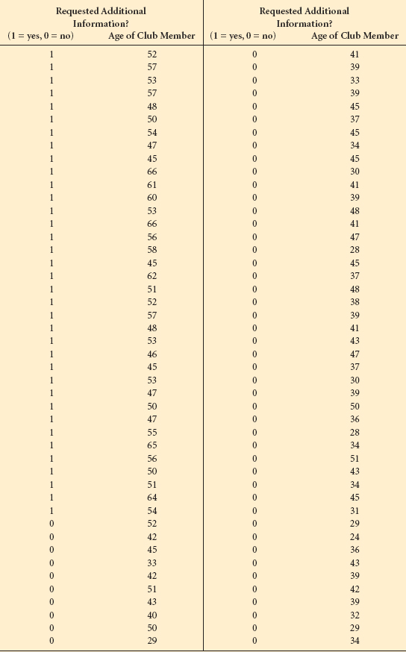

**FIGURE 14.11** Scatter Plot of Auto Club Member Data

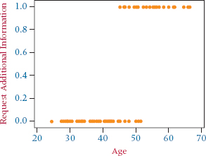

**The Logistic Regression Model**

Note that in the graph of the data in [**Figure 14.11**](https://learning.oreilly.com/library/view/business-statistics-for/9781118213957/25_chapter14.html#fig14.11) there are only two *y* values, 0 and 1. Imagine trying to fit a line through the data. Among other problems, the line would not begin nor end at 0 and 1. Over time, statisticians have experimented with various curves that might fit this type of data and have determined that the following function models these types of data well:

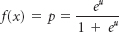

This particular function, which results in an “s-shaped” curve, is called the logistic model. It approaches 0 at the lower end and 1 at the upper end. [**Figure 14.12**](https://learning.oreilly.com/library/view/business-statistics-for/9781118213957/25_chapter14.html#fig14.12) contains the same scatter plot of the auto club data with such a curve fit to the data.

In a manner analogous to simple regression where there is only one predictor variable and the model is first order, we begin with the simplest model, μ = β**0** + β**1***x***1**. Substituting this expression for m in the equation results in

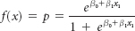

where *p* is the probability that a club member fits into group 1 (returns the form). In general for multiple predictors, the logistic model is:

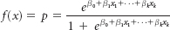

**FIGURE 14.12** Scatter Plot of Auto Club Data with Logistic Model

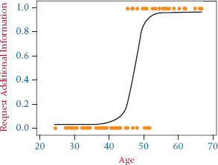

For ease of computation in logistic regression, this expression is transformed into an odds ratio. Recall that the odds of an event occurring are computed by dividing the probability of the event occurring by the probability that the event will not occur. For example, if there is a .60 probability that it will rain, then there is a 1 –.60 = .40 probability that it will not rain. The odds that it will rain are: Prob. (rain) Prob. (not rain) or .60/.40 = 1.50. In transforming the logistic model, the function is converted to an odds ratio:

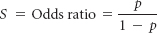

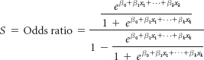

Rearranging and reducing this by algebra results in:



The transformation is completed by taking the natural log of each side of the equation, resulting in:



This log of the odds ratio is called the logit, and the transformed model is now linear in the β's. In logistic regression, for reasons mentioned before, least squares regression methodology is not used to develop the model but rather a maximum likelihood method, which maximizes the probability of getting the observed results, is employed. Maximum likelihood estimation is an iterative process using the computer and is not described here. Minitab uses a maximum likelihood procedure to produce logistic regression results. We will now focus on interpreting the results of such an analysis.

**Interpreting the Output**

[**Figure 14.13**](https://learning.oreilly.com/library/view/business-statistics-for/9781118213957/25_chapter14.html#fig14.13) contains Minitab output from its binary logistic regression analysis of the auto club data. The model was developed in an attempt to predict whether an auto club member would send in a form asking for additional health insurance information by the age of the member.

Notice that in the Minitab summary of information, 36 of the 92 auto club members sent in the form (a little over 39%) and 56 of the members did not (almost 61%).

**FIGURE 14.13** Minitab Binary Logistic Regression Output for the Auto Club Example

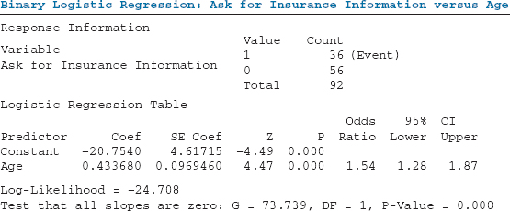

**Determining Logistic Regression Model**

Found in the column Coef are the coefficients of the resulting logistic model: –20.7540 for Constant and 0.433680 for Age.

Thus, the log of the odds ratio or logit equation is:



Suppose we want to determine the probability that a 50-year-old auto club member will return the form. Inserting Age = 50 into the logit equation, ln(*S*) = –20.7540 + 0.433680 Age, results in a ln odds of –20.7540 + 0.433680(50) = 0.93.

Taking the antilog of this value results in the odds, *S*:



The odds that a 50-year-old returns the form are 2.535 to 1. From this, we can compute the probability that a 50-year-old returns the form as:

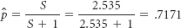

How can the probability that an auto club member will return the form be computed directly? The logistic model to predict the probability of returning the form is determined by:

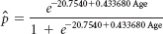

For the 50-year-old, the predicted probability is:

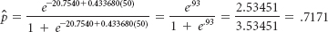

The predicted probability that the 50-year-old returns the form is.7171. Using a probability of .50 as a cutoff between predicting a 0 or a 1, the 50-year-old would be classified as a 1 (a member who will return the form). The predicted probability that he/she will not return the form is 1 – .7171 = .2829. Computing the odds from these probability values:



This answer agrees with the odds calculated above using the odds ratio. In summary, with the logistic regression equation, one can calculate the probability, determine the log**e** of the odds, and compute the odds of being in the 1 group.

**Testing the Overall Model**

In regression analysis, an *F* test is computed to determine if there is overall significance in the model. In multiple regression, this test determines whether at least one of the regression coefficients is different from zero. Logistic regression has an analogous test, the *G* statistic. While business researchers will generally obtain *G* for a model from computer output, it can be computed by:

*G* = 2{[log likelihood with variable] – [log likelihood without variable]}

Given in [**Figure 14.13**](https://learning.oreilly.com/library/view/business-statistics-for/9781118213957/25_chapter14.html#fig14.13), which contains Minitab output for the auto club problem, is the log likelihood value for the model with the variable age:

Log Likelihood = –24.708

Analogous to the “no predictor” model (average *y* value) used in regression, in logistic regression a model without a predictor in it, sometimes referred to as the “constant only” model, can be analyzed using the Maximum Likelihood methodology. The log likelihood of this model can also be computed manually by:

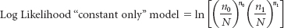

Where *n***0** is the number of “0” observations, *n***1** is the number of “1” observations, and *N* is the total number of observations in the study.

For the auto club example, the log likelihood of the constant-only model can be computed as:

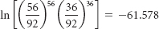

Where *n***0** is the number of auto club members who did not send in the form (56) and *n***1** is the number of auto club members who did send in the form (36). While this log likelihood is not given in the Minitab output, it is used to calculate *G*. For the auto club example, *G* is computed as:



With a null hypothesis that β**1** is zero, the *G* statistic for a one predictor model is approximately chi-square distributed with degrees of freedom of 1. The Minitab output of the auto club problem gives the following:

Test that all slopes are zero: G = 73.739, DF = 1, P-Value = 0.000

Thus, at least one of the predictors in this model is significant (there is only one), and there is overall significance in this model.

Logistic regression can be run for models with more than one predictor. In these models, the *G* statistic yields the same information as the single-predictor model, is computed the same way as the single predictor model, and is approximately chi-square distributed. However, for multiple-predictor models, the degrees of freedom are equal *p*, which equals the number of predictors in the model. Thus, if there are four predictors in the model, the degrees of freedom are 4. In the case of multiple predictors, a significant *G* statistic indicates that at least one of the predictor variables is significant.

**Testing Individual Predictor Variables**

Determining the significance of individual predictor variables in logistic regression can be done by studying *z* values and their associated *p*-values. Minitab output contains the *z* value and its associated *p*-value for each predictor variable. Note in [**Figure 14.13**](https://learning.oreilly.com/library/view/business-statistics-for/9781118213957/25_chapter14.html#fig14.13) that the *z* value for Age is 4.47 with a *p*-value of .000. This indicates that age is a significant predictor in the model. With the single-predictor model, this information is similar to that gleaned from the test of the overall model. However, in models with multiple predictors, such *z* statistics and their associated *p*-values can help determine which variables are significant and are contributing to the model and which are not.

**14.5 PROBLEMS**

* **14.23** The Hospital database associated with this text and found in WileyPLUS contains a dichotomous variable, Service, which represents two types of hospitals, general medical and psychiatric. In the database, general medical hospitals are coded as 1 and psychiatric hospitals as 2. However, to run a logistic regression model to predict service, the data were recoded so that general medical hospitals are 0 and psychiatric hospitals are 1. Shown below is Minitab output from a logistic regression attempt to predict service by payroll expenditures. Study the output. What is the model? How good is the overall fit of the model? Comment on the strength of the predictor. Thinking about hospitals, does the model make sense to you? Use the model to estimate the probability that a hospital is a psychiatric hospital if the payroll expenditures are $80,000.
* Variable Value Count
* Service 1 32 (Event)
* 0 168
* Total 200
* Logistic Regression Table
* Odds 95% CI
* Predictor Coef SE Coef Z P Ratio Lower Upper
* Constant −0.932546 0.289749 −3.22 0.001
* Payroll Exp. −0.0000323 0.0000123 −2.64 0.008 1.00 1.00 1.00
* Log-Likelihood = −82.346

Test that all slopes are zero: G = 11.175, DF = 1, P-Value = 0.001

* **14.24** Another database associated with this text and found in WileyPLUS is the Consumer Food database. There is a dichotomous variable in this database, and that is whether a family lives in a metro area or outside. In the database, metro is coded as 1 and outside metro as 2. However, to run a logistic regression model to predict service, the data were recoded so that families in metro areas are 0 and families outside of metro areas are 1. Shown below is Minitab output from a logistic regression attempt to predict if a family is from outside a metro area by annual food spending by household. Study the output. What is the model? How good is the overall fit of the model? Comment on the strength of the predictor. Thinking about households and metro areas, does the model make sense to you? Use the model to estimate the probability that a household is from outside a metro area if their annual food spending by household is $12,000. Compute the log-likelihood of the constantonly model.
* Response Information
* Value Count
* Variable 1 80 (Event)
* 0 = metro 1 = outside metro 0 120
* Total 200
* Logistic Regression Table
* Odds
* Predictor Coef SE Coef Z P Ratio
* Constant 0.705987 0.451245 1.56 0.118
* Annual Food Spending ($) –0.0001257 0.0000489 –2.57 0.010 1.00
* Log-Likelihood = −131.124

Test that all slopes are zero: G = 6.957, DF = 1, P-Value = 0.008

* **14.25** The Manufacturing database associated with this text and found in WileyPLUS has a variable, Value of Industrial Shipments, that is coded 0 if the value is small and 1 if the value is large. Using Minitab, a logistic regression analysis was done in an attempt to predict the value of industrial shipments by the number of production workers. The Minitab output is given below. Study the output. What is the model? How good is the overall fit of the model? Comment on the strength of the predictor. Use the model to estimate the probability that a selected company has a large value of industrial shipments if their number of production workers is 30.
* Logistic Regression Table
* Odds 95% CI
* Predictor Coef SE Coef Z P Ratio Lower Upper
* Constant –3.07942 0.535638 –5.75 0.000
* No. Prod. Wkrs. 0.0544532 0.0096833 5.62 0.000 1.06 1.04 1.08
* Log-Likelihood = –48.166

Test that all slopes are zero: G = 97.492, DF = 1, P-Value = 0.000

* **14.26** Suppose logistic regression is used to develop a second model from the Manufacturing database discussed in problem 14.25 to predict the value of industrial shipments by two variables, Number of Production Workers and New Capital Expenditures. The Minitab output for this analysis is given below. Since number of production workers was used as the single predictor in problem 14.25, how does this output compare to that given in problem 14.25?
* Logistic Regression Table
* Odds 95% CI
* Predictor Coef SE Coef Z P Ratio Lower Upper
* Constant −5.40701 1.08209 −5.00 0.000
* No. Prod. Wkrs. 0.0295051 0.0095208 3.10 0.002 1.03 1.01 1.05
* New Cap. Exp. 0.0074783 0.0018749 3.99 0.000 1.01 1.00 1.01
* Log-Likelihood = −27.346

Test that all slopes are zero: G = 139.132, DF = 2, P-Value = 0.000

Use the model to estimate the probability that a selected company has a large value of industrial shipments if their number of production workers is 80 and new capital expenditures are 1,000.

**Sources for Section 14.5**

1. Alfred, DeMaris “A Tutorial in Logistic Regression,” *Journal of Marriage and Family*, vol. 57, no. 4, November 1995, 956–968.
2. Joseph F. Hair Jr., William C. Black, Barry J. Babin, and Rolph E. Anderson, *Multivariate Data Analysis*, 7th ed., Saddle River, NJ: Pearson, 2010.
3. David W. Hosmer and Stanley Lemeshow, *Applied Logistic Regression*, 2nd ed. New York: John Wiley & Sons, 2000.
4. David G. Kleinbaum and Mitchel Klein, *Logistic Regression: A Self-Learning Text*, 2nd ed. New York: Springer Science Productions, 2002.
5. Fred C. Pampel, *Logistic Regression: A Primer.* Thousand Oaks, CA: Sage, 2000.

** Determining Compensation for CEOs**

 One statistical tool that can be used to study CEO compensation is multiple regression analysis. Regression models can be developed using predictor variables, such as age, years of experience, worth of company, or others, for analyzing CEO compensation. Search procedures such as stepwise regression can be used to sort out the more significant predictors of CEO compensation.

The researcher prepares for the multiple regression analysis by conducting a study of CEOs and gathering data on several variables. The data presented in the Decision Dilemma could be used for such an analysis. It seems reasonable to believe that CEO compensation is related to the size and worth of a company, therefore it makes sense to attempt to develop a regression model or models to predict CEO compensation by the variables company sales, number of employees in the company, and the capital investment of a company. Qualitative or dummy variables can also be used in such an analysis. In the database given in the Decision Dilemma, one variable indicates whether a company is a manufacturing company. One way to recode this variable for regression analysis is to assign a 1 to companies that are manufacturers and a 0 to others.

A stepwise regression procedure can sort out the variables that seem to be more important predictors of CEO compensation. A stepwise regression analysis was conducted on the Decision Dilemma database using sales, number of employees, capital investment, and whether a company is in manufacturing as the four independent variables. The result of this analysis follows.

Stepwise Regression: Cash Compen versus Sales,

No. of Emp.,...

Alpha-to-Enter: 0.15 Alpha-to-Remove: 0.15

Response is Cash Com on 4 predictors, with *N* = 20

Step 1 2 3 4

Constant 243.9 232.2 223.8 223.3

No. of E 0.0696 0.1552 0.0498

*T*-Value 13.67 4.97 0.98

*P*-Value 0.000 0.000 0.343

Cap. Inv −1.66 −2.92 −3.06

*T*-Value −2.77 −3.97 −4.27

*P*-Value 0.013 0.001 0.001

Sales 1.08 1.45

*T*-Value 2.46 6.10

*P*-Value 0.026 0.000

*S* 32.6 27.9 24.5 24.5

*R*-Sq 91.22 93.95 95.61 95.34

*R*-Sq(adj) 90.73 93.24 94.78 94.80

The stepwise regression analysis produces a single predictor model at step 1 with a high *R***2** value of .9122. The number of employees variable used in a simple regression model accounts for over 91.2% of the variation of CEO compensation data. An examination of the regression coefficient of number of employees at the first step (.0696) indicates that a one-employee increase results in a predicted increase of (.0696· $1,000) about $70 in the CEO's compensation.

At step 2, the company's capital investment enters the model. Notice that the *R***2** increases only by .0273 and that the regression coefficient on capital investment is negative. This result seems counterintuitive because we would expect that the more capital investment a company has, the more the CEO should be compensated for the responsibility. A Minitab simple regression analysis using only capital investment produces the following model:

The regression equation is

CashCompen = 257 + 1.29 CapInv

Notice that the regression coefficient in this model is positive as we would suppose. Multicollinearity is likely present. In fact, multicollinearity is evident among sales, number of employees, and capital investment. Each is a function or determiner of company size. Examine the following correlation coefficient:

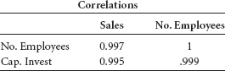

Notice that these three predictors are highly interrelated. Therefore, the interpretation of the regression coefficients and the order of entry of these variables in the stepwise regression become more difficult. Nevertheless, number of employees is most highly related to CEO compensation in these data. Observe also in the stepwise regression output that number of employees actually drops out of the model at step 4. The *t* ratio for number of employees is not significant (*t* = 0.98) at step 3. However, the *R***2** actually drops slightly when number of employees are removed. In searching for a model that is both parsimonious and explanatory, the researcher could do worse than to merely select the model at step 1.

Researchers might want to explore more complicated nonlinear models. Some of the independent variables might be related to CEO compensation but in some nonlinear manner.

A brief study of the predictor variables in the Decision Dilemma database reveals that as compensation increases, the values of the data in the independent variables do not increase at a linear rate. Scatter plots of sales, number of employees, and capital investment with CEO compensation confirm this suspicion. Shown here is a scatter plot of sales with cash compensation.

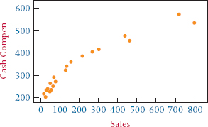

Observe that the graph suggests more of a logarithmic fit than a linear one. We can use recoding techniques presented in the chapter to conduct a multiple regression analysis to predict compensation using the log of each of these variables. In the analysis, the compensation figures remain the same, but each of the three quantitative independent variables are recoded by taking the log of each value and entering the resultant variable in the model. A second stepwise regression analysis is under-taken with the log variables in the mix along with the original variables. The results follow:

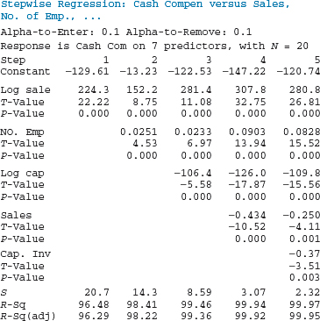

Note that in this stepwise regression analysis, the variable log sales has the highest single predictability of compensation producing an *R***2** of .9648, which is higher than the value at step 1 in the first stepwise regression analysis. Number of employees enters at step 2 and log of capital investment at step 3. However, such a high *R***2** at step 1 leaves little room for improved predictability. Our search through the variables may well end with the decision to use the log of sales as the efficient, predictable model of compensation. The final model might be:

CEO Compensation = –129.61 + 224.3 Log sales

Human resource managers sometimes use compensation tables to assist them in determining ranges and ballparks for salary offers. Company boards of directors can use such models as the one developed here to assist them in negotiations with possible candidates for CEO positions or to aid them in determining whether a presently employed CEO is over- or undercompensated. In addition, candidates who are searching for new CEO opportunities can use models like these to determine the potential compensation for a new position and to help them be more adequately prepared for salary negotiations should they be offered a CEO position.

Some of the variables in this study will undoubtedly produce redundant information. The use of a correlation matrix and a stepwise regression process can protect the analysis from some of the problems of multicollinearity. The use of multiple regression analysis on a large sample of CEO compensation data with many independent variables could provide some interesting and exciting results.

**ETHICAL CONSIDERATIONS**

**Some business researchers misuse the results of** search procedures by using the order in which variables come into a model (on stepwise and forward selection) to rank the variables in importance. They state that the variable entered at step 1 is the most important predictor of *y*, the variable entering at step 2 is second most important, and so on. In actuality, variables entering the analysis after step 1 are being analyzed by how much of the unaccounted-for variation (residual variation) they are explaining, not how much they are related to *y* by themselves. A variable that comes into the model at the fourth step is the variable that most greatly accounts for the variation of the *y* values left-over after the first three variables have explained the rest. However, the fourth variable taken by itself might explain more variation of *y* than the second or third variable when seen as single predictors.

Some people use the estimates of the regression coefficients to compare the worth of the predictor variables; the larger the coefficient is, the greater its worth. At least two problems plague this approach. The first is that most variables are measured in different units. Thus, regression coefficient weights are partly a function of the unit of measurement of the variable. Second, if multicollinearity is present, the interpretation of the regression coefficients is questionable. In addition, the presence of multicollinearity raises several issues about the interpretation of other regression output. Researchers who ignore this problem are at risk of presenting spurious results. Because of assumption violations, it is greatly frowned upon by statisticians to use least squares multiple regression to develop regression models to predict dichotomous variables. To do so could be considered a form of unethical behavior, especially by knowledgeable business researchers.

**SUMMARY**

Multiple regression analysis can handle nonlinear independent variables. One way to accommodate this issue is to recode the data and enter the variables into the analysis in the normal way. Other nonlinear regression models, such as exponential models, require that the entire model be transformed. Often the transformation involves the use of logarithms. In some cases, the resulting value of the regression model is in logarithmic form and the antilogarithm of the answer must be taken to determine the predicted value of *y*.

Indicator, or dummy, variables are qualitative variables used to represent categorical data in the multiple regression model. These variables are coded as 0, 1 and are often used to represent nominal or ordinal classification data that the researcher wants to include in the regression analysis. If a qualitative variable contains more than two categories, it generates multiple dummy variables. In general, if a qualitative variable contains *c* categories, *c* – 1 dummy variables should be created.

Search procedures are used to help sort through the independent variables as predictors in the examination of various possible models. Several search procedures are available, including all possible regressions, stepwise regression, forward selection, and backward elimination. The all possible regressions procedure computes every possible regression model for a set of data. The drawbacks of this procedure include the time and energy required to compute all possible regressions and the difficulty of deciding which models are most appropriate. The stepwise regression procedure involves selecting and adding one independent variable at a time to the regression process after beginning with a one-predictor model. Variables are added to the model at each step if they contain the most significant *t* value associated with the remaining variables. If no additional *t* value is statistically significant at any given step, the procedure stops. With stepwise regression, at each step the process examines the variables already in the model to determine whether their *t* values are still significant. If not, they are dropped from the model, and the process searches for other independent variables with large, significant *t* values to replace the variable(s) dropped. The forward selection procedure is the same as stepwise regression but does not drop variables out of the model once they have been included. The backward elimination procedure begins with a “full” model, a model that contains all the independent variables. The sample size must be large enough to justify a full model, which can be a limiting factor. Backward elimination drops out the least important predictors one at a time until only significant predictors are left in the regression model. The variable with the smallest absolute *t* value of the statistically nonsignificant *t* values is the independent variable that is dropped out of the model at each step.

One of the problems in using multiple regression is multicollinearity, or correlations among the predictor variables. This problem can cause overinflated estimates of the standard deviations of regression coefficients, misinterpretation of regression coefficients, undersized *t* values, and misleading signs on the regression coefficients. It can be lessened by using an intercorrelation matrix of independent variables to help recognize bivariate correlation, by using stepwise regression to sort the variables one at a time, or by using statistics such as a variance inflation factor. For a variety of reasons, including assumption violations, statisticians do not recommend using least squares regression analysis to develop models to predict dichotomous dependent variables. A commonly used methodology for developing such models is logistic regression, which has some properties similar to multiple regression. However, logistic regression does not assume a linear relationship between the dependent and independent variables, and several of the assumptions underlying least squares regression need not be met. Sample size requirements for logistic regression are larger than for multiple regression, and it is recommended that there be at least 50 observations for each predictor variable in logistic regression.

**KEY TERMS**



all possible regressions

backward elimination

dummy variable

forward selection

indicator variable

logistic regression

multicollinearity

quadratic model

qualitative variable

search procedures

stepwise regression

Tukey's four-quadrant

approach

Tukey's ladder of

transformations

variance inflation

factor

**FORMULAS**

Variance inflation factor

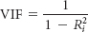

General Logistic Model:

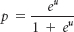

Logistic Model for Multiple Predictors:

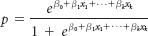

Odds Ratio:

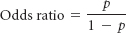

Logit:



G = 2{[log likelihood with variable]

– [log likelihood without variable]}

**SUPPLEMENTARY PROBLEMS**

**CALCULATING THE STATISTICS**

* **14.27** Given here are the data for a dependent variable, *y*, and independent variables. Use these data to develop a regression model to predict *y*. Discuss the output. Which variable is an indicator variable? Was it a significant predictor of *y*?

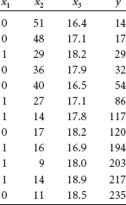

* **14.28** Use the following data and a stepwise regression analysis to predict *y*. In addition to the two independent variables given here, include three other predictors in your analysis: the square of each *x* as a predictor and an interaction predictor. Discuss the results of the process.

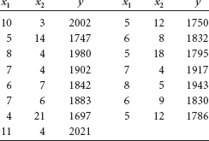

* **14.29** Use the *x***1** values and the log of the *x***1** values given here to predict the *y* values by using a stepwise regression procedure. Discuss the output. Were either or both of the predictors significant?

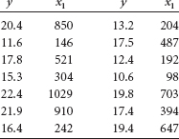

**TESTING YOUR UNDERSTANDING**

* **14.30** The U.S. Commodities Futures Trading Commission reports on the volume of trading in the U.S. commodity futures exchanges. Shown here are the figures for grain, oilseeds, and livestock products over a period of several years. Use these data to develop a multiple regression model to predict grain futures volume of trading from oilseeds volume and livestock products volume. All figures are given in units of millions. Graph each of these predictors separately with the response variable and use Tukey's four-quadrant approach to explore possible recoding schemes for nonlinear relationships. Include any of these in the regression model. Comment on the results.

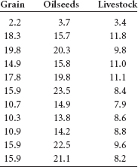

* **14.31** The U.S. Bureau of Mines produces data on the price of minerals. Shown here are the average prices per year for several minerals over a decade. Use these data and a stepwise regression procedure to produce a model to predict the average price of gold from the other variables. Comment on the results of the process.

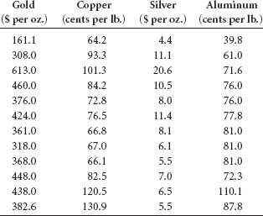

* **14.32** The Shipbuilders Council of America in Washington, D.C., publishes data about private shipyards. Among the variables reported by this organization are the employment figures (per 1000), the number of naval vessels under construction, and the number of repairs or conversions done to commercial ships (in $ millions). Shown here are the data for these three variables over a seven-year period. Use the data to develop a regression model to predict private shipyard employment from number of naval vessels under construction and repairs or conversions of commercial ships. Graph each of these predictors separately with the response variable and use Tukey's four-quadrant approach to explore possible recoding schemes for nonlinear relationships. Include any of these in the regression model. Comment on the regression model and its strengths and its weaknesses.

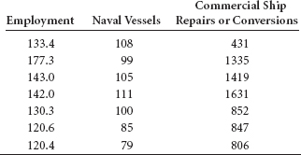

* **14.33** The U.S. Bureau of Labor Statistics produces consumer price indexes for several different categories. Shown here are the percentage changes in consumer price indexes over a period of 20 years for food, shelter, apparel, and fuel oil. Also displayed are the percentage changes in consumer price indexes for all commodities. Use these data and a stepwise regression procedure to develop a model that attempts to predict all commodities by the other four variables. Construct scatter plots of each of these variables with all commodities. Examine the graphs in light of Tukey's four-quadrant approach. Develop any other appropriate predictor variables by recoding data and include them in the analysis. Comment on the result of this analysis.

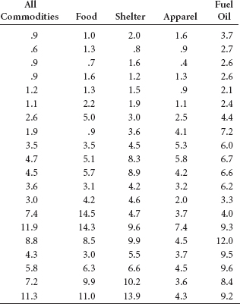

* **14.34** The U.S. Department of Agriculture publishes data annually on various selected farm products. Shown here are the unit production figures for three farm products for 10 years during a 20-year period. Use these data and a stepwise regression analysis to predict corn production by the production of soybeans and wheat. Comment on the results.

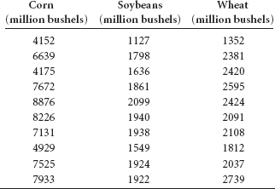

* **14.35** The American Chamber of Commerce Researchers Association compiles cost-of-living indexes for selected metropolitan areas. Shown here are cost-of-living indexes for 25 different cities on five different items for a recent year. Use the data to develop a regression model to predict the grocery cost-of-living index by the indexes of housing, utilities, transportation, and healthcare. Discuss the results, highlighting both the significant and nonsignificant predictors.

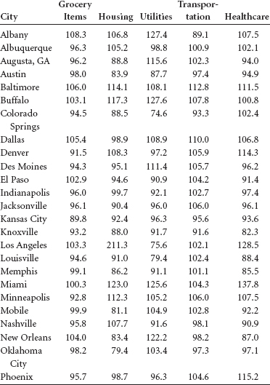

**INTERPRETING THE OUTPUT**

* **14.36** A stepwise regression procedure was used to analyze a set of 20 observations taken on four predictor variables to predict a dependent variable. The results of this procedure are given next. Discuss the results.
* STEPWISE REGRESSION OF Y ON 4 PREDICTORS,
* WITH N = 20
* STEP 1 2
* CONSTANT 152.2 124.5
* X1 –50.6 –43.4
* T-RATIO 7.42 6.13
* X2 1.36
* T-RATIO 2.13
* S 15.2 13.9

R-SQ 75.39 80.59

* **14.37** Shown here are the data for *y* and three predictors, *x***1**, *x***2**, and *x***3**. A stepwise regression procedure has been done on these data; the results are also given. Comment on the outcome of the stepwise analysis in light of the data.

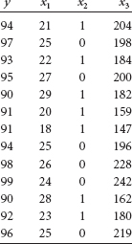

Step 1 2 3

Constant 74.81 82.18 87.89

X3 0.099 0.067 0.071

T-Value 6.90 3.65 5.22

P-Value 0.000 0.004 0.001

X2 –2.26 –2.71

T-Value –2.32 –3.71

P-Value 0.043 0.005

X1 –0.256

T-Value –3.08

P-Value 0.013

S 1.37 1.16 0.850

R-Sq 81.24 87.82 94.07

R-Sq(adj)79.53 85.38 92.09

* **14.38** Shown below is output from two Excel regression analyses on the same problem. The first output was done on a “full” model. In the second output, the variable with the smallest absolute *t* value has been removed, and the regression has been rerun like a second step of a backward elimination process. Examine the two outputs. Explain what happened, what the results mean, and what might happen in a third step.

**FULL MODEL**

| *Regression Statistics* | |
| --- | --- |
| Multiple R | 0.567 |
| R Square | 0.321 |
| Adjusted R Square | 0.208 |
| Standard Error | 159.681 |
| Observations | 29 |

**ANOVA**

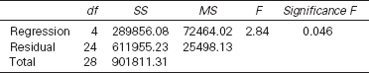

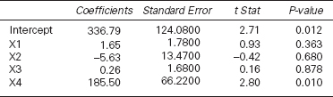

**SECOND MODEL**

| *Regression Statistics* | |
| --- | --- |
| Multiple R | 0.566 |
| R Square | 0.321 |
| Adjusted R Square | 0.239 |
| Standard Error | 156.534 |
| Observations | 29 |

**ANOVA**

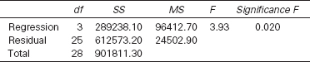

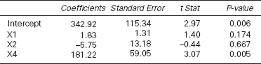

* **14.39** Shown below is Minitab output from a logistic regression analysis to develop a model to predict whether a shopper in a mall store would purchase something by the number of miles the shopper drives to get to the mall store. The original data were coded as 1 if the shopper purchases something and 0 if they do not. Study the output and determine the model. Discuss the strength or lack of strength of the model and the predictor. Use the output to compute the predicted probability that a person would purchase something if he/she drives 5 miles to get to the store. Now calculate the probabilities for 4 miles, 3 miles, 2 miles, and 1 mile. What happens to the probability over these values?
* Variable Value Count
* Buy? 1 65 (Event)
* 0 55
* Total 120
* Logistic Regression Table
* Odds 95% CI
* Predictor Coef SE Coef Z P Ratio Lower Upper
* Constant –3.94828 0.736737 –5.36 0.000
* Miles to Store 1.36988 0.255838 5.35 0.000 3.93 2.38 6.50
* Log-Likelihood = –32.492

Test that all slopes are zero: G = 100.537, DF = 1, P-Value = 0.000

*see* [**www.wiley.com/college/black**](http://www.wiley.com/college/black) and WileyPLUS

**ANALYZING THE DATABASES**

1.  Use the Manufacturing database to develop a multiple regression model to predict Cost of Materials by Number of Employees, New Capital Expenditures, Value Added by Manufacture, Value of Industry Shipments, and End-ofYear Inventories. Create indicator variables for values of industry shipments that have been coded from 1 to 4. Use a stepwise regression procedure. Does multicollinearity appear to be a problem in this analysis? Discuss the results of the analysis.
2. Construct a correlation matrix for the Hospital database variables. Are some of the variables highly correlated? Which ones and why? Perform a stepwise multiple regression analysis to predict Personnel by Control, Service, Beds, Admissions, Census, Outpatients, and Births. The variables Control and Service will need to be coded as indicator variables. Control has four subcategories, and Service has two.
3. Develop a regression model using the Financial database. Use Total Revenues, Total Assets, Return on Equity, Earnings per Share, Average Yield, and Dividends per Share to predict the average P/E ratio for a company. How strong is the model? Use stepwise regression to help sort out the variables. Several of these variables may be measuring similar things. Construct a correlation matrix to explore the possibility of multicollinearity among the predictors.
4. Using the International Stock Market database, conduct a stepwise multiple regression procedure to predict the DJIA by the Nasdaq, the S&P 500, the Nikkei, the Hang Seng, the FTSE 100, and the IPC. Discuss the outcome of the analysis including the model, the strength of the model, and the predictors.

**CASE: VIRGINIA SEMICONDUCTOR**

Virginia Semiconductor is a leading manufacturer of prime silicon substrates. The company, situated in Fredericksburg, Virginia, was founded in 1978 by Dr. Thomas G. Digges and his brother, Robert. Virginia Semiconductor (VSI) was growing and prospering in the early 1980s by selling a high volume of low-profit-margin wafers in the microelectronic industry. However, in 1985, without notice, VSI lost two major customers that represented 65% of its business. Left with only 35% of its sales base, the company desperately needed customers.

Dr. Digges, CEO of VSI, decided to seek markets where his company's market share would be small but profit margin would be high because of the value of its engineering research and its expertise. This decision turned out to be a wise direction for the small, versatile company. VSI developed a silicon wafer that was two inches in diameter, 75 microns thick, and polished on both sides. Such wafers were needed by several customers but had never been produced before. The company produced a number of these wafers and sold them for more than 10 times the price of conventional wafers.

Soon the company was making wafers from 2 to 4 microns thick (extremely thin), wafers with textured surfaces for infrared applications, and wafers with micromachined holes or shapes and selling them in specialized markets. It was able to deliver these products faster than competitors were able to deliver standard wafers.

Having made inroads at replacing lost sales, Virginia Semiconductor still had to streamline operations and control inventory and expenses. No layoffs occurred, but the average work-week dropped to 32 hours and the president took an 80% pay reduction for a time. Expenses were cut as far as seemed possible. The company had virtually no long-term debt and fortunately was able to make it through this period without incurring any additional significant debt. The absence of large monthly debt payments enabled the company to respond quickly to new production needs.

Virginia Semiconductor improved production quality by cross-training employees. In addition, the company participated in the state of Virginia's economic development efforts to find markets in Europe, Japan, Korea, and Israel. Exports, which were only 1% of the company's business in 1985, grew to over 40%.

The company continues to find new customers because of product development. VSI has distributors of their products in 29 different countries. Underscoring a core value of VSI, it is stated on the company's Web page: “As always, VSI can actually make any silicon wafer to any specification and continues to supply small, complicated orders to valued customers.”

**Discussion**

1. It is often useful to decision makers at a company to determine what factors enter into the size of a customer's purchase. Suppose decision makers at Virginia Semiconductor want to determine from past data what variables might be predictors of size of purchase and are able to gather some data on various customer companies. Assume the following data represent information gathered for 16 companies on five variables: the total amount of purchases made during a one-year period (size of purchase), the size of the purchasing company (in total sales volume), the percentage of all purchases made by the customer company that were imports, the distance of the customer company from Virginia Semiconductor, and whether the customer company had a single central purchasing agent. Use these data to generate a multiple regression model to predict size of purchase by the other variables. Summarize your findings in terms of the strength of the model, significant predictor variables, and any new variables generated by recoding.

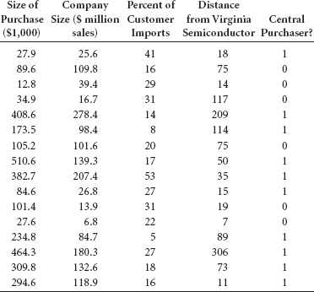

1. Suppose that the next set of data is Virginia Semiconductor's sales figures for the past 11 years, along with the average number of hours worked per week by a full-time employee and the number of different customers the company has for its unique wafers. How do the average workweek length and number of customers relate to total sales figures? Use scatter plots to examine possible relationships between sales and hours per week and sales and number of customers. Use Tukey's four-quadrant approach for possible ways to recode the data. Use stepwise regression analysis to explore the relationships. Let the response variable be “sales” and the predictors be “average number of hours worked per week,” “number of customers,” and any new variables created by recoding. Explore quadratic relationships, interaction, and other relationships that seem appropriate by using stepwise regression. Summarize your findings in terms of model strength and significant predictors.

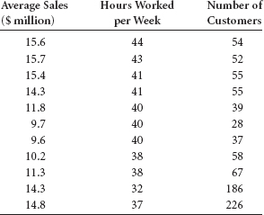

1. As Virginia Semiconductor continues to grow and prosper, the potential for slipping back into inefficient ways is always present. Suppose that after a few years the company's sales begin to level off, but it continues hiring employees. Such figures over a 10-year period of time may look like the data given here. Graph these data, using sales as the response variable and number of employees as the predictor. Study the graph in light of Tukey's fourquadrant approach. Using the information learned, develop a regression model to predict sales by the number of employees. On the basis of what you find, what would you recommend to management about the trend if it were to continue? What do you see in these data that would concern management?

| Sales ($ million) | Number of Employees |
| --- | --- |
| 20.2 | 120 |
| 24.3 | 122 |
| 28.6 | 127 |
| 33.7 | 135 |
| 35.2 | 142 |
| 35.9 | 156 |
| 36.3 | 155 |
| 36.2 | 167 |
| 36.5 | 183 |
| 36.6 | 210 |

*Source:* Adapted from “Virginia Semiconductor: A New Beginning,” *RealWorld Lessons for America's Small Businesses: Insights from the Blue Chip Enterprise Initiative 1994*. Published by *Nation's Business* magazine on behalf of Connecticut Mutual Life Insurance Company and the U.S. Chamber of Commerce in association with the Blue Chip Enterprise Initiative, 1994. Virginia Semiconductor's Web site (2011) at: [**http://www.virginiasemi.com**](http://www.virginiasemi.com/).

**USING THE COMPUTER**

**EXCEL**

* Excel does not have Model Building-Search Procedure capability. However, Excel can perform multiple regression analysis. The commands are essentially the same as those for simple regression except that the *x* range of data may include several columns. Excel will determine the number of predictor variables from the number of columns entered in to **Input X Range**.
* Begin by selecting the **Data** tab on the Excel worksheet. From the **Analysis** panel at the right top of the **Data** tab worksheet, click on **Data Analysis**. If your Excel worksheet does not show the **Data Analysis** option, then you can load it as an add-in following directions given in [**Chapter 2**](https://learning.oreilly.com/library/view/business-statistics-for/9781118213957/10_chapter02.html#ch2). From the **Data Analysis** pulldown menu, select **Regression**. In the **Regression** dialog box, input the location of the *y* values in **Input Y Range**. Input the location of the *x* values in **Input X Range**. Input **Labels** and input **Confidence Level**. To pass the line through the origin, check **Constant is Zero**. To printout the raw residuals, check **Residuals**. To printout residuals converted to *z* scores, check **Standardized Residuals**. For a plot of the residuals, check **Residual Plots**. For a plot of the line through the points check **Line Fit Plots**.
* Standard output includes *R*, *R***2**, *s****e***, and an ANOVA table with the *F* test, the slope and intercept, *t* statistics with associated *p*-values, and any optionally requested output, such as graphs or residuals.

**MINITAB**

* Minitab does have Model Building–Search Procedure capability procedures including both forward and backward Stepwise regression, Forward Selection, and Backward Elimination.
* To begin, select **Stat** from the menu bar. Select **Regression** from the **Stat** pulldown menu. Select **Stepwise** from the **Regression** pulldown menu. Place the column name or column location of the *y* variable in **Response**. Place the column name(s) or column location(s) of the *x* variable(s) in **Predictors**. If you want to guarantee inclusion of particular variables in the model, place the column name or column locations of such variables in **Predictors to include in every model**. This is optional. Select **Methods** for Model Building options and selection of criterion for adding or removing a variable.
* In the **Methods** dialog box, Check **Use alpha values** to use alpha as the criterion for adding or removing a variable. Check **Use F values** to use *F* values as the criterion for adding or removing a variable. Check **Stepwise (forward and backward)** to run a standard forward or backward stepwise regression procedure. To specify particular variables to be included in the initial model, place the column name or column location of such variables in the box labeled **Predictors in initial model**. Check **Forward selection** to run a forward selection regression. Check **Backward elimination** to run a backward elimination regression. In each of these model-building procedures, you have the option of setting particular values of alpha or *F* for the entering and/or removing variables from the model. Minitab defaults to an alpha of 0.15 and an *F* of 4.
* To use Logistic Regression in Minitab, select **Stat** from the menu bar. From the pulldown menu, select **Regression**. From the **Regression** pulldown menu, select **Binary Logistic Regression** ... In the dialog box, check **Response in response/frequency format** if you want to enter the data as variables. In the **Response: box**, enter the name of the dichotomous dependent variable. In the **model** box, specify the variable or variables that you want in the model. In the dialog box, check **Response in event/trial format** if the response data has been entered as two columns—one containing the number of successes and one column containing the number of trials. Enter the **Number of events** and the **Number of trials** in the boxes. Specify the model.

[**1**](https://learning.oreilly.com/library/view/business-statistics-for/9781118213957/25_chapter14.html#FN01) John W. Tukey, *Exploratory Data Analysis.* Reading, MA: Addison-Wesley, 1977.

[**2**](https://learning.oreilly.com/library/view/business-statistics-for/9781118213957/25_chapter14.html#FN02) If *c* indicator variables are included in the analysis, no unique estimator of the regression coefficients can be found. [J. Neter, M. H. Kuter, W. Wasserman, and C. Nachtsheim, *Applied Linear Regression Models*, 3rd ed. Chicago: Richard D. Irwin, 1996.]

[**3**](https://learning.oreilly.com/library/view/business-statistics-for/9781118213957/25_chapter14.html#FN03) William Mendenhall and Terry Sincich, *A Second Course in Business Statistics: Regression Analysis*. San Francisco: Dellen Publishing Company, 1989; John Neter, William Wasserman, and Michael H. Kutner, *Applied Linear Regression Models*, 2nd ed. Homewood, IL: Richard D. Irwin, 1989.

CHAPTER 15

Time-Series Forecasting and Index Numbers

**LEARNING OBJECTIVES**

This chapter discusses the general use of forecasting in business, several tools that are available for making business forecasts, the nature of time-series data, and the role of index numbers in business, thereby enabling you to:

1. Differentiate among various measurements of forecasting error, including mean absolute deviation and mean square error, in order to assess which forecasting method to use
2. Describe smoothing techniques for forecasting models, including naïve, simple average, moving average, weighted moving average, and exponential smoothing
3. Determine trend in time-series data by using linear regression trend analysis, quadratic model trend analysis, and Holt's two-parameter exponential smoothing method
4. Account for seasonal effects of time-series data by using decomposition and Winters' three-parameter exponential smoothing method
5. Test for autocorrelation using the Durbin-Watson test, overcoming it by adding independent variables and transforming variables and taking advantage of it with autoregression
6. Differentiate among simple index numbers, unweighted aggregate price index numbers, weighted aggregate price index numbers, Laspeyres price index numbers, and Paasche price index numbers by defining and calculating each



** Forecasting Air Pollution**

 For the past two decades, there has been a heightened awareness of and increased concern over pollution in various forms in the United States. One of the main areas of environmental concern is air pollution, and the U.S. Environmental Protection Agency (EPA) regularly monitors the quality of air around the country. Some of the air pollutants monitored include carbon monoxide emissions, nitrogen oxide emissions, volatile organic compounds, sulfur dioxide emissions, particulate matter, fugitive dust, and lead emissions. Shown below are emission data for two of these air pollution variables, carbon monoxide and nitrogen oxides, over a 24-year period reported by the EPA in millions short-tons.

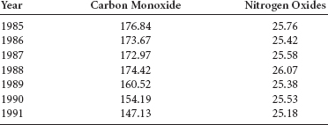

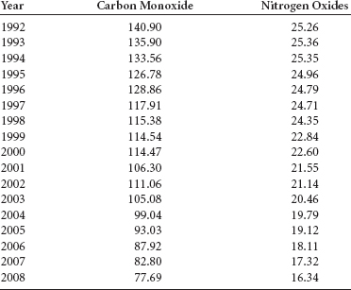

**Managerial and Statistical Questions**

1. Is it possible to forecast the emissions of carbon monoxide or nitrogen oxides for the year 2013, 2017, or even 2025 using these data?
2. What techniques best forecast the emissions of carbon monoxide or nitrogen oxides for future years from these data?

*Source:* Adapted from statistics published as National Transportation Statistics by the Bureau of Transportation Statistics (U.S. government) at: [**http://www.bts.gov/publications/national_transportation_statistics/html/table_04_40.html**](http://www.bts.gov/publications/national_transportation_statistics/html/table_04_40.html); [**http://www.bts.gov/publications/national_transportation_statistics/html/table_04_41.html**](http://www.bts.gov/publications/national_transportation_statistics/html/table_04_41.html).

Every day, **forecasting**—*the art or science of predicting the future*—is used in the decisionmaking process to help business people reach conclusions about buying, selling, producing, hiring, and many other actions. As an example, consider the following items:

* Market watchers predict a resurgence of stock values next year.
* City planners forecast a water crisis in Southern California.
* Future brightens for solar power.
* Energy secretary sees rising demand for oil.
* CEO says difficult times won't be ending soon for U.S. airline industry.
* Life insurance outlook fades.
* Increased competition from overseas businesses will result in significant layoffs in the U.S. computer chip industry.

How are these and other conclusions reached? What forecasting techniques are used? Are the forecasts accurate? In this chapter we discuss several forecasting techniques, how to measure the error of a forecast, and some of the problems that can occur in forecasting. In addition, this chapter will focus only on data that occur over time, time-series data.

**Time-series data** are *data gathered on a given characteristic over a period of time at regular intervals.* Time-series forecasting techniques attempt to account for changes over time by examining patterns, cycles, or trends, or using information about previous time periods to predict the outcome for a future time period. Time-series methods include naïve methods, averaging, smoothing, regression trend analysis, and the decomposition of the possible time-series factors, all of which are discussed in subsequent sections.

**15.1 INTRODUCTION TO FORECASTING**

Virtually all areas of business, including production, sales, employment, transportation, distribution, and inventory, produce and maintain time-series data. [**Table 15.1**](https://learning.oreilly.com/library/view/business-statistics-for/9781118213957/26_chapter15.html#tab15.1) provides an example of time-series data released by the Office of Market Finance, U.S. Department of the Treasury. The table contains the bond yield rates of three-month Treasury Bills for a 17-year period.

**TABLE 15.1** Bond Yields of Three-Month Treasury Bills

| Year | Average Yield |
| --- | --- |
| 1 | 14.03% |
| 2 | 10.69 |
| 3 | 8.63 |
| 4 | 9.58 |
| 5 | 7.48 |
| 6 | 5.98 |
| 7 | 5.82 |
| 8 | 6.69 |
| 9 | 8.12 |
| 10 | 7.51 |
| 11 | 5.42 |
| 12 | 3.45 |
| 13 | 3.02 |
| 14 | 4.29 |
| 15 | 5.51 |
| 16 | 5.02 |
| 17 | 5.07 |

Why does the average yield differ from year to year? Is it possible to use these time series data to predict average yields for year 18 or ensuing years? [**Figure 15.1**](https://learning.oreilly.com/library/view/business-statistics-for/9781118213957/26_chapter15.html#fig15.1) is a graph of these data over time. Often graphical depiction of time-series data can give a clue about any trends, cycles, or relationships that might exist there. Does the graph in [**Figure 15.1**](https://learning.oreilly.com/library/view/business-statistics-for/9781118213957/26_chapter15.html#fig15.1) show that bond yields are decreasing? Will next year's yield rate be lower or is a cycle occurring in these data that will result in an increase? To answer such questions, it is sometimes helpful to determine which of the four components of time-series data exist in the data being studied.

**Time-Series Components**

It is generally believed that time-series data are composed of four elements: trend, cyclicality, seasonality, and irregularity. Not all time-series data have all these elements. Consider [**Figure 15.2**](https://learning.oreilly.com/library/view/business-statistics-for/9781118213957/26_chapter15.html#fig15.2), which shows the effects of these time-series elements on data over a period of 13 years.

*The long-term general direction* of data is referred to as **trend**. Notice that even though the data depicted in [**Figure 15.2**](https://learning.oreilly.com/library/view/business-statistics-for/9781118213957/26_chapter15.html#fig15.2) move through upward and downward periods, the general direction or trend is increasing (denoted in [**Figure 15.2**](https://learning.oreilly.com/library/view/business-statistics-for/9781118213957/26_chapter15.html#fig15.2) by the line). **Cycles** are *patterns of highs and lows through which data move over time periods usually of more than a year.* Notice that the data in [**Figure 15.2**](https://learning.oreilly.com/library/view/business-statistics-for/9781118213957/26_chapter15.html#fig15.2) seemingly move through two periods or cycles of highs and lows over a 13-year period. Time-series data that do not extend over a long period of time may not have enough “history” to show **cyclical effects**. **Seasonal effects**, on the other hand, are *shorter cycles, which usually occur in time periods of less than one year.* Often seasonal effects are measured by the month, but they may occur by quarter, or may be measured in as small a time frame as a week or even a day. Note the seasonal effects shown in [**Figure 15.2**](https://learning.oreilly.com/library/view/business-statistics-for/9781118213957/26_chapter15.html#fig15.2) as up and down cycles, many of which occur during a 1-year period. **Irregular fluctuations** are *rapid changes or “bleeps” in the data, which occur in even shorter time frames than seasonal effects.* Irregular fluctuations can happen as often as day to day. They are subject to momentary change and are often unexplained. Note the irregular fluctuations in the data of [**Figure 15.2**](https://learning.oreilly.com/library/view/business-statistics-for/9781118213957/26_chapter15.html#fig15.2).

**FIGURE 15.1** Excel Graph of Bond Yield Time-Series Data (new)

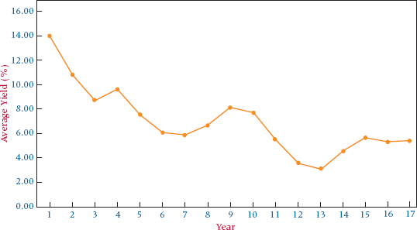

**FIGURE 15.2** Time-Series Effects

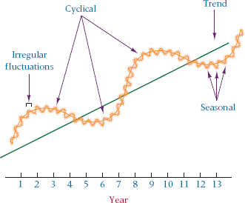

Observe again the bond yield data depicted in [**Figure 15.1**](https://learning.oreilly.com/library/view/business-statistics-for/9781118213957/26_chapter15.html#fig15.1). The general trend seems to move downward and contain two cycles. Each of the cycles traverses approximately 5 to 8 years. It is possible, although not displayed here, that seasonal periods of highs and lows within each year result in seasonal bond yields. In addition, irregular daily fluctuations of bond yield rates may occur but are unexplainable.

*Time-series data that contain no trend, cyclical, or seasonal effects* are said to be **stationary**. Techniques used to forecast stationary data analyze only the irregular fluctuation effects.

**The Measurement of Forecasting Error**

In this chapter, several forecasting techniques will be introduced that typically produce different forecasts. How does a decision maker know which forecasting technique is doing the best job in predicting the future? One way is to compare forecast values with actual values and determine the amount of **forecasting error** a technique produces. An examination of individual errors gives some insight into the accuracy of the forecasts. However, this process can be tedious, especially for large data sets, and often a single measurement of overall forecasting error is needed for the entire set of data under consideration. Any of several methods can be used to compute error in forecasting. The choice depends on the forecaster's objective, the forecaster's familiarity with the technique, and the method of error measurement used by the computer forecasting software. Several techniques can be used to measure overall error, including mean error (ME), mean absolute deviation (MAD), mean square error (MSE), mean percentage error (MPE), and mean absolute percentage error (MAPE). Here we will consider the mean absolute deviation (MAD) and the mean square error (MSE).

**Error**

The **error of an individual forecast** is *the difference between the actual value and the forecast of that value.*



**Mean Absolute Deviation (MAD)**

One measure of overall error in forecasting is the mean absolute deviation, MAD. The **mean absolute deviation (MAD)** is *the mean, or average, of the absolute values of the errors.*

**TABLE 15.2** Nonfarm Partnership Tax Returns

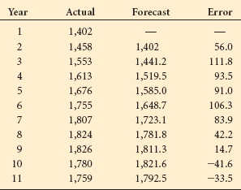

[**Table 15.2**](https://learning.oreilly.com/library/view/business-statistics-for/9781118213957/26_chapter15.html#tab15.2) presents the nonfarm partnership tax returns (1,000) in the United States over an 11-year period along with the forecast for each year and the error of the forecast. An examination of these data reveals that some of the forecast errors are positive and some are negative. In summing these errors in an attempt to compute an overall measure of error, the negative and positive values offset each other resulting in an underestimation of the total error. The mean absolute deviation overcomes this problem by taking the absolute value of the error measurement, thereby analyzing the magnitude of the forecast errors without regard to direction.



The mean absolute error can be computed for the forecast errors in [**Table 15.2**](https://learning.oreilly.com/library/view/business-statistics-for/9781118213957/26_chapter15.html#tab15.2) as follows.



**Mean Square Error (MSE)**

The **mean square error (MSE)** is another way to circumvent the problem of the canceling effects of positive and negative forecast errors. The MSE is *computed by squaring each error (thus creating a positive number) and averaging the squared errors.* The following formula states it more formally.



The mean square error can be computed for the errors shown in [**Table 15.2**](https://learning.oreilly.com/library/view/business-statistics-for/9781118213957/26_chapter15.html#tab15.2) as follows.



Selection of a particular mechanism for computing error is up to the forecaster. It is important to understand that different error techniques will yield different information. The business researcher should be informed enough about the various error measurement techniques to make an educated evaluation of the forecasting results.

**15.1 PROBLEMS**

* **15.1** Use the forecast errors given here to compute MAD and MSE. Discuss the information yielded by each type of error measurement.

| Period | *e* |
| --- | --- |
| 1 | 2.3 |
| 2 | 1.6 |
| 3 | –1.4 |
| 4 | 1.1 |
| 5 | .3 |
| 6 | –.9 |
| 7 | –1.9 |
| 8 | –2.1 |
| 9 | .7 |

* **15.2** Determine the error for each of the following forecasts. Compute MAD and MSE.

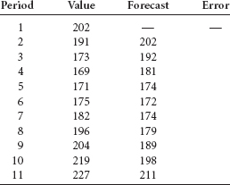

* **15.3** Using the following data, determine the values of MAD and MSE. Which of these measurements of error seems to yield the best information about the forecasts? Why?

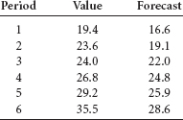

* **15.4** Figures for acres of tomatoes harvested in the United States from an 11-year period follow. The data are published by the U.S. Department of Agriculture. With these data, forecasts have been made by using techniques presented later in this chapter. Compute MAD and MSE on these forecasts. Comment on the errors.

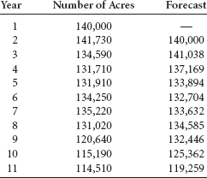

**15.2 SMOOTHING TECHNIQUES**

Several techniques are available to forecast time-series data that are stationary or that include no significant trend, cyclical, or seasonal effects. These techniques are often referred to as **smoothing techniques** because they *produce forecasts based on “smoothing out” the irregular fluctuation effects in the time-series data.* Three general categories of smoothing techniques are presented here: (1) naïve forecasting models, (2) averaging models, and (3) exponential smoothing.

**Naïve Forecasting Models**

**Naïve forecasting models** are *simple models in which it is assumed that the more recent time periods of data represent the best predictions or forecasts for future outcomes.* Naïve models do not take into account data trend, cyclical effects, or seasonality. For this reason, naïve models seem to work better with data that are reported on a daily or weekly basis or in situations that show no trend or seasonality. The simplest of the naïve forecasting methods is the model in which the forecast for a given time period is the value for the previous time period.

*F****t*** = *x****t*–1**

where

*F****t*** = the forecast value for time period *t*

*x****t*–1** = the value for time period *t* – 1

As an example, if 532 pairs of shoes were sold by a retailer last week, this na ïve forecasting model would predict that the retailer will sell 532 pairs of shoes this week. With this naïve model, the actual sales for this week will be the forecast for next week.

Observe the agricultural data in [**Table 15.3**](https://learning.oreilly.com/library/view/business-statistics-for/9781118213957/26_chapter15.html#tab15.3) representing the total reported domestic rail, truck, and air shipments of bell peppers in the United States for a given year reported by the U.S. Department of Agriculture. [**Figure 15.3**](https://learning.oreilly.com/library/view/business-statistics-for/9781118213957/26_chapter15.html#fig15.3) presents an Excel graph of these shipments over the 12-month period. From these data, we can make a naïve forecast of the total number of reported shipments of bell peppers for January of the next year by using the figure for December, which is 412.

Another version of the naïve forecast might be to use the number of shipments for January of the previous year as the forecast for January of next year, because the business researcher may believe a relationship exists between bell pepper shipments and the month of the year. In this case, the naïve forecast for next January from [**Table 15.3**](https://learning.oreilly.com/library/view/business-statistics-for/9781118213957/26_chapter15.html#tab15.3) is 336 (January of the previous year). The forecaster is free to be creative with the naïve forecast model method and search for other relationships or rationales within the limits of the time-series data that would seemingly produce a valid forecast.

**TABLE 15.3** Total Reported Domestic Shipments of Bell Peppers

| Month | Shipments (millions of pounds) |
| --- | --- |
| January | 336 |
| February | 308 |
| March | 582 |
| April | 771 |
| May | 935 |
| June | 808 |
| July | 663 |
| August | 380 |
| September | 333 |
| October | 412 |
| November | 458 |
| December | 412 |

**FIGURE 15.3** Excel Graph of Shipments of Bell Peppers over a 12-Month Period

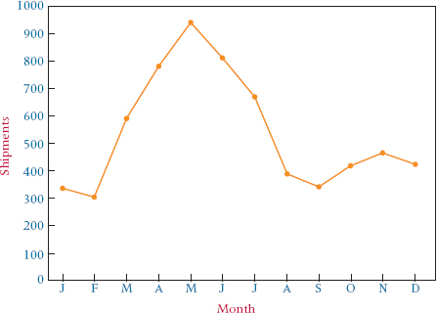

**TABLE 15.4** Cost of Residential Heating Oil (cents per gallon)

| Time Frame | Cost of Heating Oil |
| --- | --- |
| January (year 1) | 66.1 |
| February | 66.1 |
| March | 66.4 |
| April | 64.3 |
| May | 63.2 |
| June | 61.6 |
| July | 59.3 |
| August | 58.1 |
| September | 58.9 |
| October | 60.9 |
| November | 60.7 |
| December | 59.4 |
| January (year 2) | 61.3 |
| February | 63.3 |
| March | 62.1 |
| April | 59.8 |
| May | 58.4 |
| June | 57.6 |
| July | 55.7 |
| August | 55.1 |
| September | 55.7 |
| October | 56.7 |
| November | 57.2 |
| December | 58.0 |
| January (year 3) | 58.2 |
| February | 58.3 |
| March | 57.7 |
| April | 56.7 |
| May | 56.8 |
| June | 55.5 |
| July | 53.8 |
| August | 52.8 |

**Averaging Models**

Many naïve model forecasts are based on the value of one time period. Often such forecasts become a function of irregular fluctuations of the data; as a result, the forecasts are “oversteered.” Using averaging models, a forecaster enters information from several time periods into the forecast and “smoothes” the data. **Averaging models** are computed by *averaging data from several time periods and using the average as the forecast for the next time period.*

**Simple Averages**

The most elementary of the averaging models is the **simple average model**. With this model, *the forecast for time period t is the average of the values for a given number of previous time periods*, as shown in the following equation.



The data in [**Table 15.4**](https://learning.oreilly.com/library/view/business-statistics-for/9781118213957/26_chapter15.html#tab15.4) provide the costs of residential heating oil in the United States for 3 years. [**Figure 15.4**](https://learning.oreilly.com/library/view/business-statistics-for/9781118213957/26_chapter15.html#fig15.4) displays a Minitab graph of these data.

A simple 12-month average could be used to forecast the cost of residential heating oil for September of year 3 from the data in [**Table 15.4**](https://learning.oreilly.com/library/view/business-statistics-for/9781118213957/26_chapter15.html#tab15.4) by averaging the values for September of year 2 through August of year 3 (the preceding 12 months).



With this **simple average**, the forecast for year 3 September heating oil cost is 56.45 cents. Note that none of the previous 12-month figures equal this value and that this average is not necessarily more closely related to values early in the period than to those late in the period. The use of the simple average over 12 months tends to smooth the variations, or fluctuations, that occur during this time.

**Moving Averages**

Suppose we were to attempt to forecast the heating oil cost for October of year 3 by using averages as the forecasting method. Would we still use the simple average for September of year 2 through August of year 3 as we did to forecast for September of year 3? Instead of using the same 12 months' average used to forecast September of year 3, it would seem to make sense to use the 12 months prior to October of year 3 (October of year 2 through September of year 3) to average for the new forecast. Suppose in September of year 3 the cost of heating oil is 53.3 cents. We could forecast October of year 3 with a new average that includes the same months used to forecast September of year 3, but without the value for September of year 2 and with the value of September of year 3 added.

**FIGURE 15.4** Minitab Graph of Heating Oil Cost Data

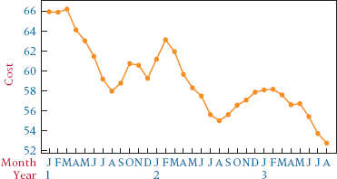



Computing an average of the values from October of year 2 through September of year 3 produces a moving average, which can be used to forecast the cost of heating oil for October of year 3. In computing this moving average, the earliest of the previous 12 values, September of year 2, is dropped and the most recent value, September of year 3, is included.

A **moving average** is *an average that is updated or recomputed for every new time period being considered.* The most recent information is utilized in each new moving average. This advantage is offset by the disadvantages that (1) it is difficult to choose the optimal length of time for which to compute the moving average, and (2) moving averages do not usually adjust for such time-series effects as trend, cycles, or seasonality. To determine the more optimal lengths for which to compute the moving averages, we would need to forecast with several different average lengths and compare the errors produced by them.

**DEMONSTRATION PROBLEM 15.1**

Shown here are shipments (in millions of dollars) for electric lighting and wiring equipment over a 12-month period. Use these data to compute a 4-month moving average for all available months.

| Month | Shipments |
| --- | --- |
| January | 1056 |
| February | 1345 |
| March | 1381 |
| April | 1191 |
| May | 1259 |
| June | 1361 |
| July | 1110 |
| August | 1334 |
| September | 1416 |
| October | 1282 |
| November | 1341 |
| December | 1382 |

**Solution**

The first moving average is



This first 4-month moving average can be used to forecast the shipments in May. Because 1259 shipments were actually made in May, the error of the forecast is

Error**May** = 1259 – 1243.25 = 15.75

Shown next, along with the monthly shipments, are the 4-month moving averages and the errors of forecast when using the 4-month moving averages to predict the next month's shipments. The first moving average is displayed beside the month of May because it is computed by using January, February, March, and April and because it is being used to forecast the shipments for May. The rest of the 4-month moving averages and errors of forecast are as shown.

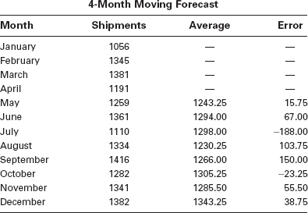

The following Minitab graph shows the actual shipment values and the forecast shipment values based on the 4-month moving averages. Notice that the moving averages are “smoothed” in comparison with the individual data values. They appear to be less volatile and seem to be attempting to follow the general trend of the data.

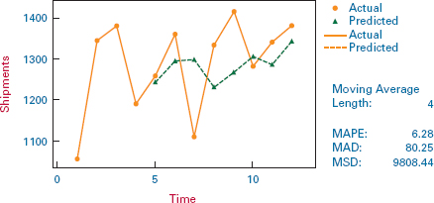

**Weighted Moving Averages**

A forecaster may want to place more weight on certain periods of time than on others. For example, a forecaster might believe that the previous month's value is three times as important in forecasting as other months. *A moving average in which some time periods are weighted differently than others* is called a **weighted moving average**.

As an example, suppose a 3-month weighted average is computed by weighting last month's value by 3, the value for the previous month by 2, and the value for the month before that by 1. This weighted average is computed as

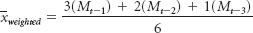

where

*M****t*–1** = last month's value

*M****t*–2** = value for the previous month

*M****t*–3** = value for the month before the previous month

Notice that the divisor is 6. With a weighted average, the divisor always equals the total number of weights. In this example, the value of *M****t*–1** counts three times as much as the value for *M****t*–3**.

**DEMONSTRATION PROBLEM 15.2**

Compute a 4-month weighted moving average for the electric lighting and wiring data from Demonstration Problem 15.1, using weights of 4 for last month's value, 2 for the previous month's value, and 1 for each of the values from the 2 months prior to that.

**Solution**

The first weighted average is



This moving average is recomputed for each ensuing month. Displayed next are the monthly values, the weighted moving averages, and the forecast error for the data.

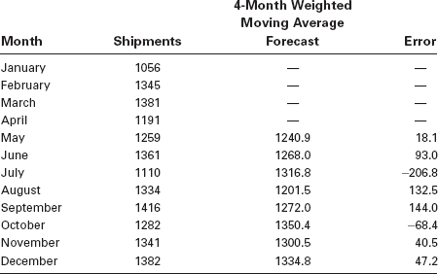

Note that in this problem the errors obtained by using the 4-month weighted moving average were greater than most of the errors obtained by using an unweighted 4-month moving average, as shown here.

| Forecast Error, Unweighted 4-Month Moving Average | Forecast Error, Weighted 4-Month Moving Average |
| --- | --- |
| — | — |
| — | — |
| — | — |
| — | — |
| 15.8 | 18.1 |
| 67.0 | 93.0 |
| –188.0 | –206.8 |
| 103.8 | 132.5 |
| 150.0 | 144.0 |
| –23.3 | –68.4 |
| 55.5 | 40.5 |
| 38.8 | 47.2 |

Larger errors with weighted moving averages are not always the case. The forecaster can experiment with different weights in using the weighted moving average as a technique. Many possible weighting schemes can be used.

**Exponential Smoothing**

Another forecasting technique, **exponential smoothing**, is *used to weight data from previous time periods with exponentially decreasing importance in the forecast.* Exponential smoothing is accomplished by multiplying the actual value for the present time period, *X****t***, by a value between 0 and 1 (the exponential smoothing constant) referred to asa (not the samea used for a Type I error) and adding that result to the product of the present time period's forecast, *F****t***, and (1 – α). The following is a more formalized version.

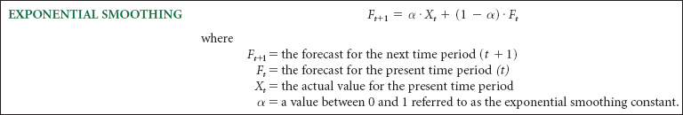

The value of α is determined by the forecaster. The essence of this procedure is that the new forecast is a combination of the present forecast and the present actual value. Ifa is chosen to be less than .5, less weight is placed on the actual value than on the forecast of that value. Ifa is chosen to be greater than .5, more weight is being put on the actual value than on the forecast value.

As an example, suppose the prime interest rate for a time period is 5% and the forecast of the prime interest rate for this time period was 6%. If the forecast of the prime interest rate for the next period is determined by exponential smoothing with α = .3, the forecast is



Notice that the forecast value of 5.7% for the next period is weighted more toward the previous forecast of 6% than toward the actual value of 5% becausea is .3. Suppose we use α = .7 as the exponential smoothing constant. Then,



This value is closer to the actual value of 5% than the previous forecast of 6% because the exponential smoothing constant, α, is greater than .5.

To see why this procedure is called exponential smoothing, examine the formula for exponential smoothing again.



If exponential smoothing has been used over a period of time, the forecast for *F****t*** will have been obtained by



Substituting this forecast value, *F****t***, into the preceding equation for *F****t*+1** produces

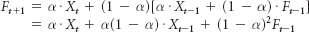

but



Substituting this value of *F****t*–1** into the preceding equation for *F****t*+1** produces

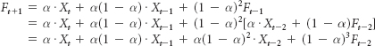

Continuing this process shows that the weights on previous-period values and forecasts include (1 – α)***n*** (exponential values). The following chart shows the values of α, (1 – α), (1 – α)**2**, and (1 – α)**3** for three different values ofa. Included is the value of α(1 – α)**3**, which is the weight of the actual value for three time periods back. Notice the rapidly decreasing emphasis on values for earlier time periods. The impact of exponential smoothing on timeseries data is to place much more emphasis on recent time periods. The choice ofa determines the amount of emphasis.

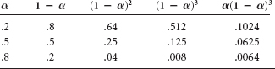

Some forecasters use the computer to analyze time-series data for various values of a. By setting up criteria with which to judge the forecasting errors, forecasters can select the value ofa that best fits the data.

The exponential smoothing formula



can be rearranged algebraically as



This form of the equation shows that the new forecast, *F****t*+1**, equals the old forecast, *F****t***, plus an adjustment based ona times the error of the old forecast (*X****t*** – *F****t***). The smallera is, the less impact the error has on the new forecast and the more the new forecast is like the old. It demonstrates the dampening effect ofa on the forecasts.

**DEMONSTRATION PROBLEM 15.3**

The U.S. Census Bureau reports the total units of new privately owned housing started over a 16-year recent period in the United States are given here. Use exponential smoothing to forecast the values for each ensuing time period. Work the problem using α = .2, .5, and .8.

| Year | Total Units (1000) |
| --- | --- |
| 1 | 1193 |
| 2 | 1014 |
| 3 | 1200 |
| 4 | 1288 |
| 5 | 1457 |
| 6 | 1354 |
| 7 | 1477 |
| 8 | 1474 |
| 9 | 1617 |
| 10 | 1641 |
| 11 | 1569 |
| 12 | 1603 |
| 13 | 1705 |
| 14 | 1848 |
| 15 | 1956 |
| 16 | 2068 |

**Solution**

An Excel graph of these data is shown here.

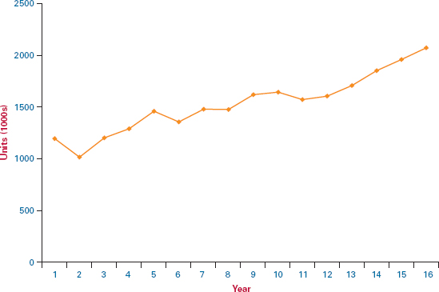

The following table provides the forecasts with each of the three values of alpha. Note that because no forecast is given for the first time period, we cannot compute a forecast based on exponential smoothing for the second period. Instead, we use the actual value for the first period as the forecast for the second period to get started. As examples, the forecasts for the third, fourth, and fifth periods are computed for α = .2 as follows.

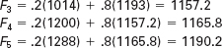

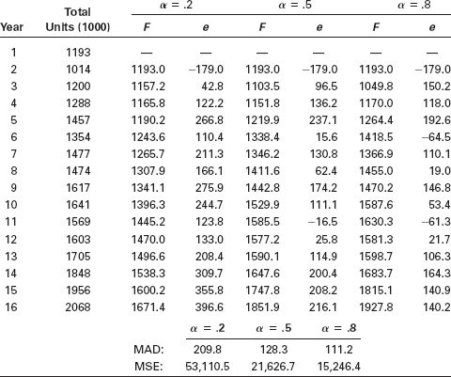

Which value of alpha works best on the data? At the bottom of the preceding analysis are the values of two different measurements of error for each of the three different values of alpha. With each measurement of error, α = .8 produces the smallest measurement of error. Observe from the Excel graph of the original data that the data vary up and down considerably. In exponential smoothing, the value of alpha is multiplied by the actual value and 1 – α is multiplied by the forecast value to get the next forecast. Because the actual values are varying considerably, the exponential smoothing value with the largest alpha seems to be forecasting the best. By placing the greatest weight on the actual values, the new forecast seems to predict the new value better.

**THINKING CRITICALLY ABOUT STATISTICS IN BUSINESS TODAY**

**Can Scrap Metal Prices Forecast the Economy?**

Economists are constantly on the lookout for valid indicators of a country's economy. Forecasters have sifted through oil indicators, the price of gold, the Dow Jones averages, government-published indexes, and practically anything else that might seem related in some way to the economy.

One rather promising indicator of economic activity in the United States back in the 1990s was the price of scrap metal. At the time, several well-known forecasters, including the Federal Reserve chairman, Alan Greenspan, and the chief market analyst for Chase Manhattan, Donald Fine, believed that the price of scrap metal was a good indicator of the industrial economy.

Scrap metal is leftover copper, steel, aluminum, and other metals. The theory was that as U.S. manufacturing increases, the demand for scrap metals increases, as does its price, because as the industrial economy heats up, inventories of readily available metals are reduced, thereby increasing the demand for scrap metal. In the past, in some cases, the price of scrap metal correctly predicted no economic recovery when some government measures indicated that a recovery was underway.

Now, 20 years later, it is a new world economy and the United States is impacted by growth and demand for metals in other countries. Demand for steel and other metals in China, India, Turkey, the Middle East, and other emerging areas of the world has helped drive up the price of scrap metal in the United States even when the U.S. economy has been somewhat stagnant. That is, perhaps the price of scrap metal in the United States is now more of a forecaster of the world economy than the U.S. economy.

As a side note, as the U.S. economy has gone through a down cycle, supplies of scrap metal from individual sellers have increased. In tough economic times, instead of trashing old bicycles, appliances, and other items containing metals, people have been selling them to scrap-metal recyclers to earn extra household income.

**Things to Ponder**

1. According to the Institute of Scrap Recycling Industries (ISRI), the U.S.-based scrap recycling industry meets 40% of the global raw materials needs. If this is so, this industry is heavily involved in world industrial growth. Do you think that this source will continually replenish itself or eventually dry up? Why or why not? What are some factors?
2. If U.S.-based scrap metal is reduced in the coming years, how might this impact world construction? Are there replacement sources? Where might such sources come from?

*Source:* Anita Raghavan and David Wessel, “In Scraping Together Economic Data, Forecasters Turn to Scrap-Metal Prices,” *Wall Street Journal* (April 27, 1992), C1; “Scrap-Metal Recycling Grows as Economy Shrinks”, [**WRAL.com**](http://wral.com/) at [**http://www.wral.com/news/local/story/3187137/**](http://www.wral.com/news/local/story/3187137/) July 2008; Industry Facts, Web site for ISRI, at [**http://www.isri.org/iMIS15_PROD/ISRI/About_ISRI/Industry_Facts/ISRI/Navigation/AboutISRI/Industry_Facts.aspx?hkey=9e68d6a2-7b25-4a0e-ac22-06a259f893cc**](http://www.isri.org/iMIS15_PROD/ISRI/About_ISRI/Industry_Facts/ISRI/Navigation/AboutISRI/Industry_Facts.aspx?hkey=9e68d6a2-7b25-4a0e-ac22-06a259f893cc), March 28, 2011.

**15.2 PROBLEMS**

* **15.5** Use the following time-series data to answer the given questions.

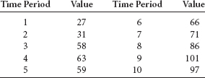

* 1. Develop forecasts for periods 5 through 10 using 4-month moving averages.
  2. Develop forecasts for periods 5 through 10 using 4-month weighted moving averages. Weight the most recent month by a factor of 4, the previous month by 2, and the other months by 1.
  3. Compute the errors of the forecasts in parts (a) and (b) and observe the differences in the errors forecast by the two different techniques.
* **15.6** Following are time-series data for eight different periods. Use exponential smoothing to forecast the values for periods 3 through 8. Use the value for the first period as the forecast for the second period. Compute forecasts using two different values of alpha, α = .1 and α = .8. Compute the errors for each forecast and compare the errors produced by using the two different exponential smoothing constants.

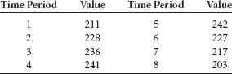

* **15.7** Following are time-series data for nine time periods. Use exponential smoothing with constants of .3 and .7 to forecast time periods 3 through 9. Let the value for time period 1 be the forecast for time period 2. Compute additional forecasts for time periods 4 through 9 using a 3-month moving average. Compute the errors for the forecasts and discuss the size of errors under each method.

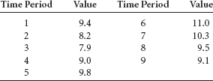

* **15.8** The U.S. Census Bureau publishes data on factory orders for all manufacturing, durable goods, and nondurable goods industries. Shown here are factory orders in the United States over a 13-year period ($ billion).
  1. Use these data to develop forecasts for the years 6 through 13 using a 5-year moving average.
  2. Use these data to develop forecasts for the years 6 through 13 using a 5-year weighted moving average. Weight the most recent year by 6, the previous year by 4, the year before that by 2, and the other years by 1.
  3. Compute the errors of the forecasts in parts (a) and (b) and observe the differences in the errors of the forecasts.

| Year | Factory Orders ($ billion) |
| --- | --- |
| 1 | 2,512.7 |
| 2 | 2,739.2 |
| 3 | 2,874.9 |
| 4 | 2,934.1 |
| 5 | 2,865.7 |
| 6 | 2,978.5 |
| 7 | 3,092.4 |
| 8 | 3,356.8 |
| 9 | 3,607.6 |
| 10 | 3,749.3 |
| 11 | 3,952.0 |
| 12 | 3,949.0 |
| 13 | 4,137.0 |

* **15.9** The following data show the number of issues from initial public offerings (IPOs) for a 13-year period released by the Securities Data Company. Use these data to develop forecasts for the years 3 through 13 using exponential smoothing techniques with alpha values of .2 and .9. Let the forecast for year 2 be the value for year 1. Compare the results by examining the errors of the forecasts.

| Year | Number of Issues |
| --- | --- |
| 1 | 332 |
| 2 | 694 |
| 3 | 518 |
| 4 | 222 |
| 5 | 209 |
| 6 | 172 |
| 7 | 366 |
| 8 | 512 |
| 9 | 667 |
| 10 | 571 |
| 11 | 575 |
| 12 | 865 |
| 13 | 609 |

**15.3 TREND ANALYSIS**

There are several ways to determine trend in time-series data and one of the more prominent is by using regression analysis. In Section 12.9, we explored the use of simple regression analysis in determining the equation of a trend line. In time-series regression trend analysis, the response variable, *Y*, is the variable being forecast, and the independent variable, *X*, represents time.

Many possible trend fits can be explored with time-series data. In this section we examine only the linear model and the quadratic model because they are the easiest to understand and simplest to compute. Because seasonal effects can confound trend analysis, it is assumed here that no seasonal effects occur in the data or they were removed prior to determining the trend.

**Linear Regression Trend Analysis**

The data in [**Table 15.5**](https://learning.oreilly.com/library/view/business-statistics-for/9781118213957/26_chapter15.html#tab15.5) represent 35 years of data on the average length of the workweek in Canada for manufacturing workers. A regression line can be fit to these data by using the time periods as the independent variable and length of workweek as the dependent variable. Because the time periods are consecutive, they can be entered as *X* along with the time-series data (*Y*) into a regression analysis. The linear model explored in this example is

**TABLE 15.5** Average Hours per Week in Manufacturing by Canadian Workers

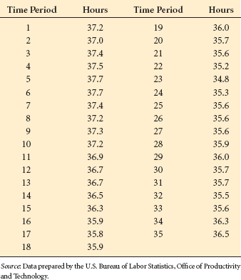

**FIGURE 15.5** Excel Regression Output for Hours Worked Using

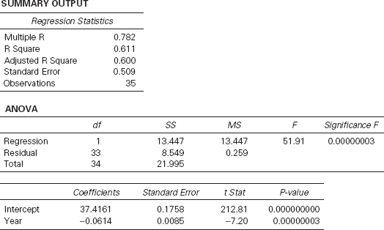



where

*Y****i*** = data value for period *i*

*X****ti*** = *i*th time period

[**Figure 15.5**](https://learning.oreilly.com/library/view/business-statistics-for/9781118213957/26_chapter15.html#fig15.5) shows the Excel regression output for this example. By using the coefficients of the *X* variable and intercept, the equation of the trend line can be determined to be



The slope indicates that for every unit increase in time period, *X****t***, a predicted decrease of .0614 occurs in the length of the average workweek in manufacturing. Because the workweek is measured in hours, the length of the average workweek decreases by an average of (.0614)(60 minutes) = 3.7 minutes each year in Canada in manufacturing. The *Y* intercept, 37.4161, indicates that in the year prior to the first period of these data the average workweek was 37.4161 hours.

The probability of the *t* ratio (.00000003) indicates that significant linear trend is present in the data. In addition, *R***2** = .611 indicates considerable predictability in the model. Inserting the various period values (1, 2, 3, ..., 35) into the preceding regression equation produces the predicted values of *Y* that are the trend. For example, for period 23 the predicted value is

ŷ = 37.4161 – .0614(23) = 36.0 hours

The model was developed with 35 periods (years). From this model, the average workweek in Canada in manufacturing for period 41 (the 41st year) can be forecast:

ŷ = 37.4161 – .0614(41) = 34.9 hours

[**Figure 15.6**](https://learning.oreilly.com/library/view/business-statistics-for/9781118213957/26_chapter15.html#fig15.6) presents an Excel scatter plot of the average workweek lengths over the 35 periods (years). In this Excel plot, the trend line has been fitted through the points. Observe the general downward trend of the data, but also note the somewhat cyclical nature of the points. Because of this pattern, a forecaster might want to determine whether a quadratic model is a better fit for trend.

**FIGURE 15.6** Excel Graph of Canadian Manufacturing Data with Trend Line

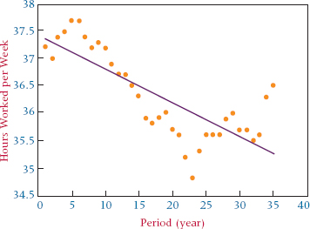

**Regression Trend Analysis Using Quadratic Models**

In addition to linear regression, forecasters can explore using quadratic regression models to predict data by using the time-series periods. The quadratic regression model is

*Y****i*** = β**0** + β**1***X***ti** + β**2***X****ti*2** + **i**

where

*Y****i*** = the time-series data value for period *i*

*X****ti*** = the *i*th period

*X****ti*2** = the square of the *i*th period

This model can be implemented in time-series trend analysis by using the time periods squared as an additional predictor. Thus, in the hours worked example, besides using *X****t*** = 1,2,3,4, ..., 35 as a predictor, we would also use *X****t*2** = 1,4,9,16,...,1225 as a predictor.

[**Table 15.6**](https://learning.oreilly.com/library/view/business-statistics-for/9781118213957/26_chapter15.html#tab15.6) provides the data needed to compute a quadratic regression trend model on the manufacturing workweek data. Note that the table includes the original data, the time periods, and the time periods squared.

**TABLE 15.6** Data for Quadratic Fit of Manufacturing Workweek Example

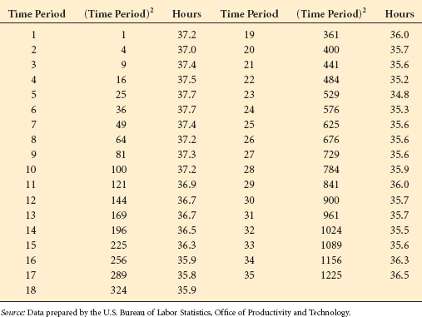

**FIGURE 15.7** Excel Regression Output for Canadian Manufacturing Example with Quadratic Trend

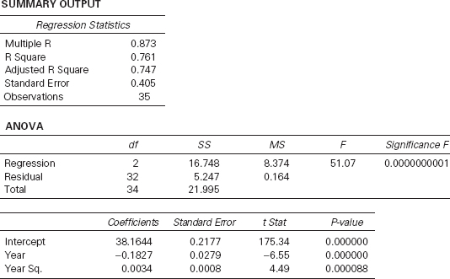

**FIGURE 15.8** Excel Graph of Canadian Manufacturing Data with a Second-Degree Polynomial Fit

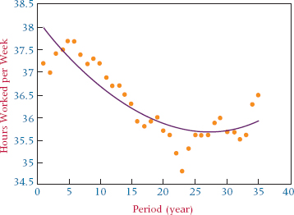

The Excel computer output for this quadratic trend regression analysis is shown in [**Figure 15.7**](https://learning.oreilly.com/library/view/business-statistics-for/9781118213957/26_chapter15.html#fig15.7). We see that the quadratic regression model produces an *R***2** of .761 with both *X****t*** and *X***t2** in the model. The linear model produced an *R***2** of .611 with *X****t*** alone. The quad ratic regression seems to add some predictability to the trend model. [**Figure 15.8**](https://learning.oreilly.com/library/view/business-statistics-for/9781118213957/26_chapter15.html#fig15.8) displays an Excel scatter plot of the week work data with a second-degree polynomial fit through the data.

**DEMONSTRATION PROBLEM 15.4**

 Following are data on the employed U.S. civilian labor force (100,000) for 1991 through 2008, obtained from the U.S. Bureau of Labor Statistics. Use regression analysis to fit a trend line through the data. Explore a quadratic regression trend also. Does either model do well? Compare the two models.

| Year | Labor Force (100,000) |
| --- | --- |
| 1991 | 117.72 |
| 1992 | 118.49 |
| 1993 | 120.26 |
| 1994 | 123.06 |
| 1995 | 124.90 |
| 1996 | 126.71 |
| 1997 | 129.56 |
| 1998 | 131.46 |
| 1999 | 133.49 |
| 2000 | 136.89 |
| 2001 | 136.93 |
| 2002 | 136.49 |
| 2003 | 137.74 |
| 2004 | 139.25 |
| 2005 | 141.73 |
| 2006 | 144.43 |
| 2007 | 146.05 |
| 2008 | 145.36 |

**Solution**

Recode the time periods as 1 through 18 and let that be *X.* Run the regression analysis with the labor force members as *Y*, the dependent variable, and the time period as the independent variable. Now square all the *X* values, resulting in 1, 4, 9, ..., 225, 256, 289, 324 and let those formulate a second predictor (*X***2**). Run the regression analysis to predict the number in the labor force with both the time period variable (*X*) and the (time period)**2** variable. The Minitab output for each of these regression analyses follows.

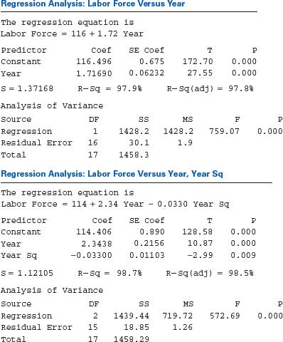

A comparison of the models shows that the linear model accounts for 97.9% of the variability in the labor force figures, and the quadratic model only increases that predictability to 98.7%. Shown next are Minitab scatter plots of the data. First is the linear model, and then the quadratic model is presented.

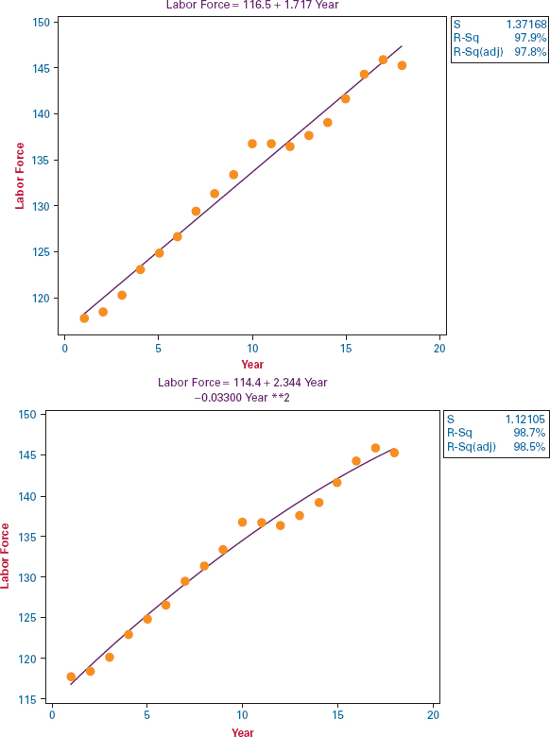

**Holt's Two-Parameter Exponential Smoothing Method**

The exponential smoothing technique presented in Section 15.2 (single exponential smoothing) is appropriate to use in forecasting stationary time-series data but is ineffective in forecasting time-series data with a trend because the forecasts will lag behind the trend. However, another exponential smoothing technique, Holt's two-parameter exponential smoothing method, can be used for trend analysis. Holt's technique uses weights (β) to smooth the trend in a manner similar to the smoothing used in single exponential smoothing (α). Using these two weights and several equations, Holt's method is able to develop forecasts that include both a smoothing value and a trend value. A more detailed explanation of Holt's two-parameter exponential smoothing method, along with examples and practice problems, can be accessed at WileyPLUS and at the Wiley Web site for this text.

**15.3 PROBLEMS**

* **15.10** The “Economic Report to the President of the United States” included data on the amounts of manufacturers' new and unfilled orders in millions of dollars. Shown here are the figures for new orders over a 21-year period. Use a computer to develop a regression model to fit the trend effects for these data. Use a linear model and then try a quadratic model. How well does either model fit the data?

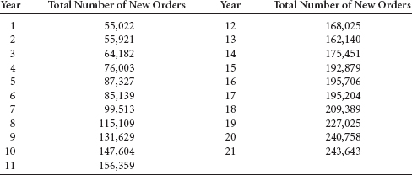

* **15.11** The following data on the number of union members in the United States for the years 1984 through 2010 are provided by the U.S. Bureau of Labor Statistics. Using regression techniques discussed in this section, analyze the data for trend. Develop a scatter plot of the data and fit the trend line through the data. Discuss the strength of the model.

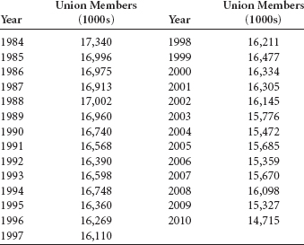

* **15.12** Shown below are dollar figures for commercial and industrial loans at all commercial banks in the United States as recorded for the month of April during a recent 9-year period and published by the Federal Reserve Bank of St. Louis. Plot the data, fit a trend line, and discuss the strength of the regresssion model. In addition, explore a quadratic trend and compare the results of the two models.

| Year | Loans ($ billions) |
| --- | --- |
| 1 | 741.0 |
| 2 | 807.4 |
| 3 | 871.3 |
| 4 | 951.6 |
| 5 | 1,033.6 |
| 6 | 1,089.8 |
| 7 | 1,002.6 |
| 8 | 940.8 |
| 9 | 888.5 |

**15.4 SEASONAL EFFECTS**

Earlier in the chapter, we discussed the notion that time-series data consist of four elements: trend, cyclical effects, seasonality, and irregularity. In this section, we examine techniques for identifying seasonal effects. **Seasonal effects** are *patterns of data behavior that occur in periods of time of less than one year.* How can we separate out the seasonal effects?

**TABLE 15.7** Shipments of Household Appliances

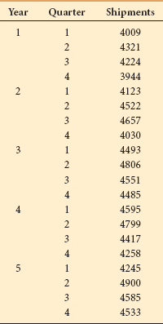

**Decomposition**

One of the main techniques for isolating the effects of seasonality is **decomposition**. The decomposition methodology presented here uses the multiplicative model as its basis. The multiplicative model is:

*T* · *C* · *S* · *I*

where

*T* = trend

*C* = cyclicality

*S* = seasonality

*I* = irregularity

To illustrate the decomposition process, we will use the 5-year quarterly time-series data on U.S. shipments of household appliances given in [**Table 15.7**](https://learning.oreilly.com/library/view/business-statistics-for/9781118213957/26_chapter15.html#tab15.7). [**Figure 15.9**](https://learning.oreilly.com/library/view/business-statistics-for/9781118213957/26_chapter15.html#fig15.9) provides a graph of these data.

According to the multiplicative time-series model, *T · C · S · I*, the data can contain the elements of trend, cyclical effects, seasonal effects, and irregular fluctuations. The process of isolating the seasonal effects begins by determining *T · C* for each value and dividing the time-series data (*T · C · S · I*) by *T · C.* The result is

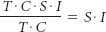

The resulting expression contains seasonal effects along with irregular fluctuations. After reducing the time-series data to the effects of *SI* (seasonality and irregularity), a method for eliminating the irregular fluctuations can be applied, leaving only the seasonal effects.

Suppose we start with time-series data that cover several years and are measured in quarterly increments. If we average the data over four quarters, we will have “dampened” the seasonal effects of the data because the rise and fall of values during the quarterly periods will have been averaged out over the year.

We begin by computing a 4-quarter moving average for quarter 1 through quarter 4 of year 1, using the data from [**Table 15.7**](https://learning.oreilly.com/library/view/business-statistics-for/9781118213957/26_chapter15.html#tab15.7).



**FIGURE 15.9** Minitab Time-Series Graph of Household Appliance Data

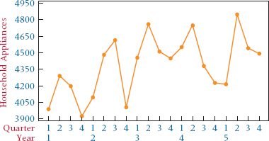

The 4-quarter moving average for quarter 1 through quarter 4 of year 1 is 4,124.5 ($ million) worth of shipments. Because the 4-quarter average is in the middle of the four quarters, it would be placed in the decomposition table between quarter 2 and quarter 3.

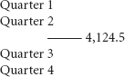

To remove seasonal effects, we need to determine a value that is “centered” with each quarter. To find this value, instead of using a 4-quarter moving average, we use 4-quarter moving totals and then sum two consecutive moving totals. This 8-quarter total value is divided by 8 to produce a “centered” 4-quarter moving average that lines up across from a quarter. Using this method is analogous to computing two consecutive 4-quarter moving averages and averaging them, thus producing a value that falls on line with a quarter, in between the two averages. The results of using this procedure on the data from [**Table 15.7**](https://learning.oreilly.com/library/view/business-statistics-for/9781118213957/26_chapter15.html#tab15.7) are shown in [**Table 15.8**](https://learning.oreilly.com/library/view/business-statistics-for/9781118213957/26_chapter15.html#tab15.8) in column 5.

A 4-quarter moving total can be computed on these data starting with quarter 1 of year 1 through quarter 4 of year 1 as follows:

First Moving Total = 4,009 + 4,321 + 4,224 + 3,944 = 16,498

In [**Table 15.8**](https://learning.oreilly.com/library/view/business-statistics-for/9781118213957/26_chapter15.html#tab15.8), 16,498 is between quarter 2 and quarter 3 of year 1. The 4-month moving total for quarter 2 of year 1 through quarter 1 of year 2 is

Second Moving Total = 4,321 + 4,224 + 3,944 + 4,123 = 16,612

In [**Table 15.8**](https://learning.oreilly.com/library/view/business-statistics-for/9781118213957/26_chapter15.html#tab15.8), this value is between quarter 3 and quarter 4 of year 1. The 8-quarter (2-year) moving total is computed for quarter 3 of year 1 as

8-Quarter Moving Total = 16,498 + 16,612 = 33,110

**TABLE 15.8** Development of 4-Quarter Moving Averages for the Household Appliance Data

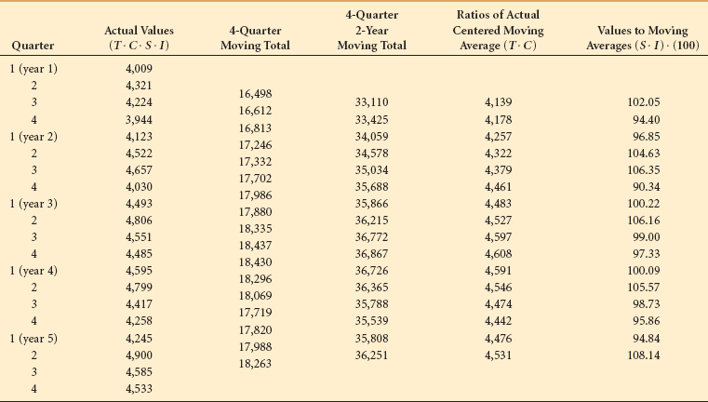

**TABLE 15.9** Seasonal Indexes for the Household Appliance Data

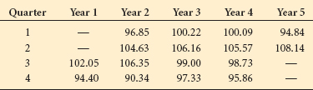

Notice that in [**Table 15.8**](https://learning.oreilly.com/library/view/business-statistics-for/9781118213957/26_chapter15.html#tab15.8) this value is centered with quarter 3 of year 1 because it is between the two adjacent 4-quarter moving totals. Dividing this total by 8 produces the 4-quarter moving average for quarter 3 of year 1 shown in column 5 of [**Table 15.8**](https://learning.oreilly.com/library/view/business-statistics-for/9781118213957/26_chapter15.html#tab15.8).



Column 3 contains the uncentered 4-quarter moving totals, column 4 contains the 2-year centered moving totals, and column 5 contains the 4-quarter centered moving averages.

The 4-quarter centered moving averages shown in column 5 of [**Table 15.8**](https://learning.oreilly.com/library/view/business-statistics-for/9781118213957/26_chapter15.html#tab15.8) represent *T · C*. Seasonal effects have been removed from the original data (actual values) by summing across the 4-quarter periods. Seasonal effects are removed when the data are summed across the time periods that include the seasonal periods and the irregular effects are smoothed, leaving only trend and cycle.

Column 2 of [**Table 15.8**](https://learning.oreilly.com/library/view/business-statistics-for/9781118213957/26_chapter15.html#tab15.8) contains the original data (actual values), which include all effects (*T · C · S · I*). Column 5 contains only the trend and cyclical effects, *T · C*. If column 2 is divided by column 5, the result is *S · I*, which is displayed in column 6 of [**Table 15.8**](https://learning.oreilly.com/library/view/business-statistics-for/9781118213957/26_chapter15.html#tab15.8).

The values in column 6, sometimes called ratios of actuals to moving average, have been multiplied by 100 to index the values. These values are thus seasonal indexes. An **index number** is *a ratio of a measure taken during one time frame to that same measure taken during another time frame, usually denoted as the time period.* Often the ratio is multipled by 100 and expressed as a percentage. Index numbers will be discussed more fully in section 15.6. Column 6 contains the effects of seasonality and irregular fluctuations. Now we must remove the irregular effects.

**TABLE 15.10** Final Seasonal Indexes for the Household Appliance Data

| Quarter | Index |
| --- | --- |
| 1 | 98.47 |
| 2 | 105.87 |
| 3 | 100.53 |
| 4 | 95.13 |

[**Table 15.9**](https://learning.oreilly.com/library/view/business-statistics-for/9781118213957/26_chapter15.html#tab15.9) contains the values from column 6 of [**Table 15.8**](https://learning.oreilly.com/library/view/business-statistics-for/9781118213957/26_chapter15.html#tab15.8) organized by quarter and year. Each quarter in these data has four seasonal indexes. Throwing out the high and low index for each quarter eliminates the extreme values. The remaining two indexes are averaged as follows for quarter 1.

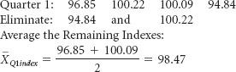

[**Table 15.10**](https://learning.oreilly.com/library/view/business-statistics-for/9781118213957/26_chapter15.html#tab15.10) gives the final seasonal indexes for all the quarters of these data.

After the final adjusted seasonal indexes are determined, the original data can be **deseasonalized**. The deseasonalization of actual values is relatively common with data published by the government and other agencies. Data can be deseasonalized by dividing the actual values, which consist of *T · C · S · I*, by the final adjusted seasonal effects.

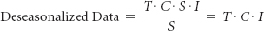

Because the seasonal effects are in terms of index numbers, the seasonal indexes must be divided by 100 before deseasonalization. Shown here are the computations for deseasonalizing the household appliance data from [**Table 15.7**](https://learning.oreilly.com/library/view/business-statistics-for/9781118213957/26_chapter15.html#tab15.7) for quarter 1 of year 1.

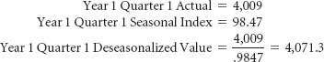

[**Table 15.11**](https://learning.oreilly.com/library/view/business-statistics-for/9781118213957/26_chapter15.html#tab15.11) gives the deseasonalized data for this example for all years.

[**Figure 15.10**](https://learning.oreilly.com/library/view/business-statistics-for/9781118213957/26_chapter15.html#fig15.10) is a graph of the deseasonalized data.

**TABLE 15.11** Deseasonalized Household Appliance Data

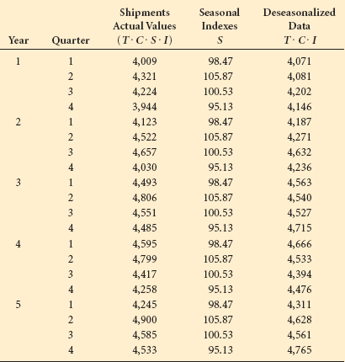

**Finding Seasonal Effects with the Computer**

Through Minitab, decomposition can be performed on the computer with relative ease. The commands for this procedure are given at the end of the chapter in the Using the Computer section. [**Figure 15.11**](https://learning.oreilly.com/library/view/business-statistics-for/9781118213957/26_chapter15.html#fig15.11) displays Minitab output for seasonal decomposition of the household appliance example. Note that the seasonal indexes are virtually identical to those shown in [**Table 15.10**](https://learning.oreilly.com/library/view/business-statistics-for/9781118213957/26_chapter15.html#tab15.10) computed by hand.

**Winters' Three-Parameter Exponential Smoothing Method**

Holt's two-parameter exponential smoothing method can be extended to include seasonal analysis. This technique, referred to as Winters' method, not only smoothes observations and trend but also smoothes the seasonal effects. In addition to the single exponential smoothing weight ofa and the trend weight ofb, Winters' method introducesg, a weight for seasonality. Using these three weights and several equations, Winters' method is able to develop forecasts that include a smoothing value for observations, a trend value, and a seasonal value. A more detailed explanation of Winters' three-parameter exponential smoothing method along with examples and practice problems is presented in WileyPLUS and at the Wiley Web site for this text.

**FIGURE 15.10** Graph of the Deseasonalized Household Appliance Data

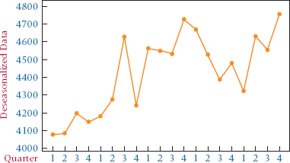

**FIGURE 15.11** Minitab Output for Seasonal Decomposition of the Household Appliance Data

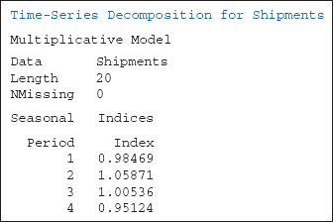

**15.4 PROBLEMS**

* **15.13** The U.S. Department of Agriculture publishes statistics on the production of

various types of food commodities by month. Shown here are the production figures on broccoli for January of a recent year through December of the next year. Use these data to compute 12-month centered moving averages (*T · C*). Using these computed values, determine the seasonal effects (*S · I*).

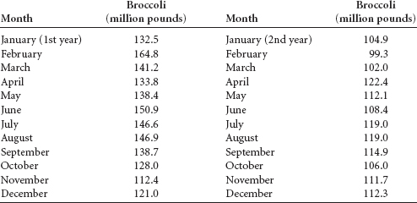

* **15.14** The U.S. Department of Commerce publishes census information on manufacturing. Included in these figures are monthly shipment data for the paperboard container and box industry shown on the next page for 6 years. The shipment figures are given in millions of dollars. Use the data to analyze the effects of seasonality, trend, and cycle. Develop the trend model with a linear model only.

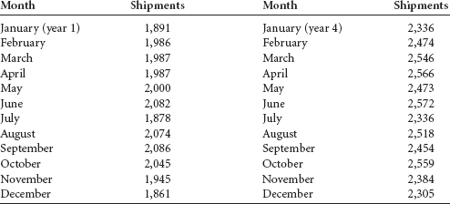

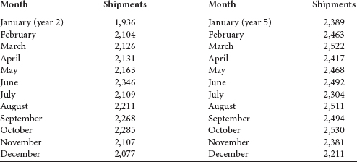

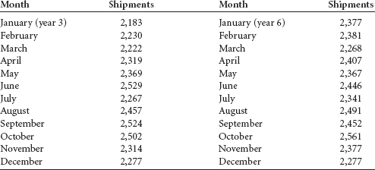

**15.5 AUTOCORRELATION AND AUTOREGRESSION**

Data values gathered over time are often correlated with values from past time periods. This characteristic can cause problems in the use of regression in forecasting and at the same time can open some opportunities. One of the problems that can occur in regressing data over time is autocorrelation.

**Autocorrelation**

**Autocorrelation**, or **serial correlation**, occurs in data *when the error terms of a regression forecasting model are correlated.* The likelihood of this occurring with business data increases over time, particularly with economic variables. Autocorrelation can be a problem in using regression analysis as the forecasting method because one of the assumptions underlying regression analysis is that the error terms are independent or random (not correlated). In most business analysis situations, the correlation of error terms is likely to occur as positive autocorrelation (positive errors are associated with positive errors of comparable magnitude and negative errors are associated with negative errors of comparable magnitude).

When autocorrelation occurs in a regression analysis, several possible problems might arise. First, the estimates of the regression coefficients no longer have the minimum variance property and may be inefficient. Second, the variance of the error terms may be greatly underestimated by the mean square error value. Third, the true standard deviation of the estimated regression coefficient may be seriously underestimated. Fourth, the confidence intervals and tests using the *t* and *F* distributions are no longer strictly applicable.

First-order autocorrelation results from correlation between the error terms of adjacent time periods (as opposed to two or more previous periods). If first-order autocorrelation is present, the error for one time period, *e****t***, is a function of the error of the previous time period, *e****t*–1**, as follows.

*e****t*** = p*e****t*–1** + v***t***

The first-order autocorrelation coefficient, ρ, measures the correlation between the error terms. It is a value that lies between –1 and 0 and +1, as does the coefficient of correlation discussed in [**Chapter 12**](https://learning.oreilly.com/library/view/business-statistics-for/9781118213957/23_chapter12.html#ch12). *v****t*** is a normally distributed independent error term. If positive autocorrelation is present, the value of r is between 0 and +1. If the value of ρ is 0, *e****t*** = *v****t***, which means there is no autocorrelation and *e****t*** is just a random, independent error term.

One way to *test to determine whether autocorrelation is present in a time-series regression analysis* is by using the **Durbin-Watson test** for autocorrelation. Shown next is the formula for computing a Durbin-Watson test for autocorrelation.



Note from the formula that the Durbin-Watson test involves finding the difference between successive values of error (*e****t*** – *e****t*–1**). If errors are positively correlated, this difference will be smaller than with random or independent errors. Squaring this term eliminates the cancellation effects of positive and negative terms.

The null hypothesis for this test is that there is *no* autocorrelation. For a two-tailed test, the alternative hypothesis is that there *is* autocorrelation.

*H***0**:ρ = 0

*H***a**:ρ # 0

As mentioned before, most business forecasting autocorrelation is positive autocorrelation. In most cases, a one-tailed test is used.

*H***0**:ρ = 0

*H***a**:ρ > 0

In the Durbin-Watson test, *D* is the observed value of the Durbin-Watson statistic using the residuals from the regression analysis. A critical value for *D* can be obtained from the values of α, *n*, and *k* by using [**Table A.9**](https://learning.oreilly.com/library/view/business-statistics-for/9781118213957/31_appendixa.html#taba.9) in the appendix, wherea is the level of significance, *n* is the number of data items, and *k* is the number of predictors. Two Durbin-Watson tables are given in the appendix. One table contains values for α = .01 and the other for α = .05. The Durbin-Watson tables in [**Appendix A**](https://learning.oreilly.com/library/view/business-statistics-for/9781118213957/31_appendixa.html#appa) include values for *d****U*** and *d****L***. These values range from 0 to 4. If the observed value of *D* is above *d****U***, we fail to reject the null hypothesis and there is no significant autocorrelation. If the observed value of *D* is below *d****L***, the null hypothesis is rejected and there is autocorrelation. Sometimes the observed statistic, *D*, is between the values of *d****U*** and *d****L***. In this case, the Durbin-Watson test is inconclusive.

**TABLE 15.12** U.S. Crude Oil Production and Natural Gas Withdrawals over a 25-Year Period

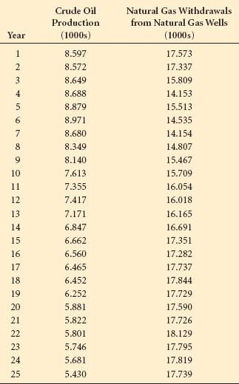

As an example, consider [**Table 15.12**](https://learning.oreilly.com/library/view/business-statistics-for/9781118213957/26_chapter15.html#tab15.12), which contains crude oil production and natural gas withdrawal data for the United States over a 25-year period published by the Energy Information Administration in their Annual Energy Review. A regression line can be fit through these data to determine whether the amount of natural gas withdrawals can be predicted by the amount of crude oil production. The resulting errors of prediction can be tested by the Durbin-Watson statistic for the presence of significant positive autocorrelation by using α =.05. The hypotheses are

*H***0**:ρ = 0

*H***a**:ρ > 0

The following regression equation was obtained by means of a Minitab computer analysis.

Natural Gas Withdrawals = 22.7372 – 0.8507 Crude Oil Production

Using the values for crude oil production (*X*) from [**Table 15.12**](https://learning.oreilly.com/library/view/business-statistics-for/9781118213957/26_chapter15.html#tab15.12) and the regression equation shown here, predicted values of *Y* (natural gas withdrawals) can be computed. From the predicted values and the actual values, the errors of prediction for each time interval, *e****t***, can be calculated. [**Table 15.13**](https://learning.oreilly.com/library/view/business-statistics-for/9781118213957/26_chapter15.html#tab15.13) shows the values of ŷ, *e***t**, *e***t2**, (*e****t*** – *e***t–1**), and (*e****t*** – *e***t–1**)**2** for this example. Note that the first predicted value of *Y* is

*Ÿ***1** = 22.7372 – 0.8507(8.597) = 15.4237

The error for year 1 is

Actual**1** – Predicted**1** = 17.573 – 15.4237 = 2.1493

The value of *e****t*** – *e****t*–1** for year 1 and year 2 is computed by subtracting the error for year 1 from the error of year 2.

*e***year2** – *e***year1** = 1.8920 – 2.1493 = –0.2573

**TABLE 15.13** Predicted Values and Error Terms for the Crude Oil Production and Natural Gas Withdrawal Data

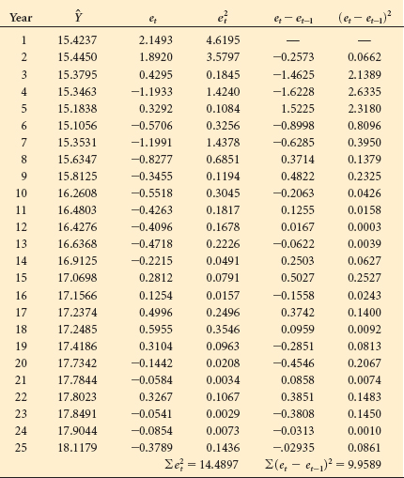

The Durbin-Watson statistic can now be computed:

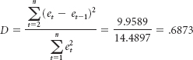

Because we used a simple linear regression, the value of *k* is 1. The sample size, *n*, is 25, and α = .05. The critical values in [**Table A.9**](https://learning.oreilly.com/library/view/business-statistics-for/9781118213957/31_appendixa.html#taba.9) are

*d****U*** = 1.45 and *d****L*** = 1.29

Because the computed *D* statistic, .6873, is less than the value of *d****L*** = 1.29, the null hypothesis is rejected. A positive autocorrelation is present in this example.

**Ways to Overcome the Autocorrelation Problem**

Several approaches to data analysis can be used when autocorrelation is present. One uses additional independent variables and another transforms the independent variable.

**Addition of Independent Variables**

Often the reason autocorrelation occurs in regression analyses is that one or more important predictor variables have been left out of the analysis. For example, suppose a researcher develops a regression forecasting model that attempts to predict sales of new homes by sales of used homes over some period of time. Such a model might contain significant autocorrelation. The exclusion of the variable “prime mortgage interest rate” might be a factor driving the autocorrelation between the other two variables. Adding this variable to the regression model might significantly reduce the autocorrelation.

**Transforming Variables**

When the inclusion of additional variables is not helpful in reducing autocorrelation to an acceptable level, transforming the data in the variables may help to solve the problem. One such method is the **first-differences approach**. With the first-differences approach, *each value of X is subtracted from each succeeding time period value of X*; these “differences” become the new and transformed *X* variable. The same process is used to transform the *Y* variable. The regression analysis is then computed on the transformed *X* and transformed *Y* variables to compute a new model that is hopefully free of significant autocorrelation effects.

Another way is to generate new variables by using the percentage changes from period to period and regressing these new variables. A third way is to use autoregression models.

**Autoregression**

A forecasting technique that takes advantage of the relationship of values (*Y****t***) to previous-period values (*Y****t*–1**, *Y****t*–2**, *Y****t*–3**, ...) is called autoregression. **Autoregression** is *a multiple regression technique in which the independent variables are time-lagged versions of the dependent variable*, which means we try to predict a value of *Y* from values of *Y* from previous time periods. The independent variable can be lagged for one, two, three, or more time periods. An autoregressive model containing independent variables for three time periods looks like this:

ŷ = *b***0** + *b***1** *Y****t*–1** + *b***2***Y****t*–2** + *b***3***Y****t*–3**

As an example, we shall attempt to predict the volume of natural gas withdrawal, displayed in [**Table 15.12**](https://learning.oreilly.com/library/view/business-statistics-for/9781118213957/26_chapter15.html#tab15.12), by using data lagged for both one and two time periods. The data used in this analysis are displayed in [**Table 15.14**](https://learning.oreilly.com/library/view/business-statistics-for/9781118213957/26_chapter15.html#tab15.14). Using Excel, a multiple regression model is developed to predict the values of *Y****t*** by the values of *Y****t*–1** and *Y****t*–2**. The results appear in [**Figure 15.12**](https://learning.oreilly.com/library/view/business-statistics-for/9781118213957/26_chapter15.html#fig15.12). Note that the regression analysis does not use data from years 1 and 2 of [**Table 15.14**](https://learning.oreilly.com/library/view/business-statistics-for/9781118213957/26_chapter15.html#tab15.14) because there are no values for the two lagged variables for one or both of those years.

The autoregression model is

*Y****t*** = 2.4081 + 0.9678*Y****t*–1** – 0.1128*Y****t*–2**

The relatively high value of *R***2** (74.6%) and relatively small value of *s****e*** (0.693) indicate that this regression model has fairly strong predictability. Interestingly, the one-period lagged variable is quite significant (*t* = 4.36 with a *p*-value of .0003), but the two-period lagged variable is not significant (*t* = –0.50 with a *p*-value of 0.6201), indicating the presence of first-order autocorrelation.

Autoregression can be a useful tool in locating seasonal or cyclical effects in time series data. For example, if the data are given in monthly increments, autoregression using variables lagged by as much as 12 months can search for the predictability of previous monthly time periods. If data are given in quarterly time periods, autoregression of up to four periods removed can be a useful tool in locating the predictability of data from previous quarters. When the time periods are in years, lagging the data by yearly periods and using autoregression can help in locating cyclical predictability.

**TABLE 15.14** Time-Lagged Natural Gas Data

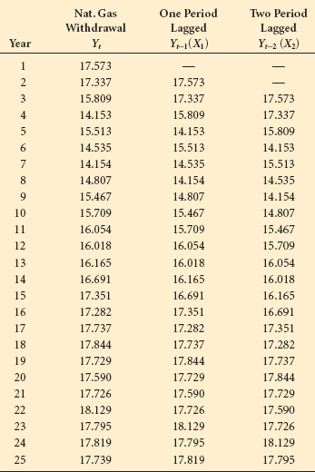

**FIGURE 15.12** Excel Autoregression Results for Natural Gas Withdrawal Data

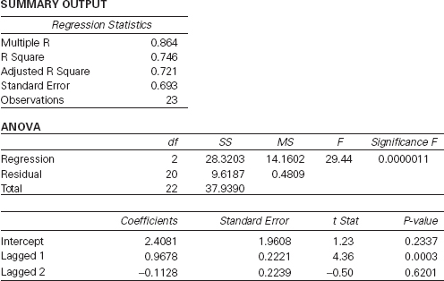

**15.5 PROBLEMS**

* **15.15** The U.S. Department of Labor publishes consumer price indexes (CPIs) on many commodities. Following are the percentage changes in the CPIs for food and for shelter for the years 1992 through 2009. Use these data to develop a linear regression model to forecast the percentage change in food CPIs by the percentage change in shelter CPIs. Compute a Durbin-Watson statistic to determine whether significant autocorrelation is present in the model. Let α = .05.

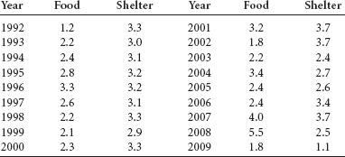

* **15.16** Use the data from Problem 15.15 to create a regression forecasting model using the first-differences data transformation. How do the results from this model differ from those obtained in Problem 15.15?
* **15.17** The Federal Deposit Insurance Corporation (FDIC) releases data on bank failures. Following are data on the number of U.S. bank failures in a given year and the total amount of bank deposits (in $ millions) involved in such failures for a given year. Use these data to develop a simple regression forecasting model that attempts to predict the failed bank assets involved in bank closings by the number of bank failures. Compute a Durbin-Watson statistic for this regression model and determine whether significant autocorrelation is present. Let α = .05.

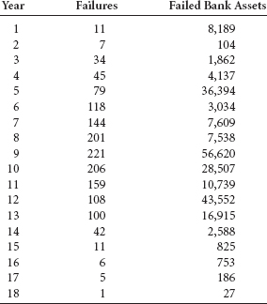

* **15.18** Use the data in Problem 15.17 to compute a regression model after recoding the data by the first-differences approach. Compute a Durbin-Watson statistic to determine whether significant autocorrelation is present in this first-differences model. Compare this model with the model determined in Problem 15.17, and compare the significance of the Durbin-Watson statistics for the two problems. Let α = .05.
* **15.19** *Current Construction Reports* from the U.S. Census Bureau contain data on new privately owned housing units. Data on new privately owned housing units (1000s) built in the West between 1980 and 2010 follow. Use these time-series data to develop an autoregression model with a one-period lag. Now try an autoregression model with a two-period lag. Discuss the results and compare the two models.

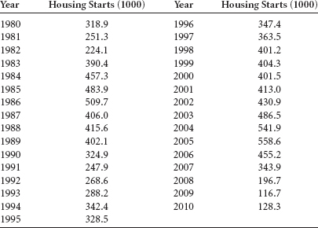

* **15.20** The U.S. Department of Agriculture publishes data on the production, utilization, and value of fruits in the United States. Shown here are the amounts of noncitrus fruit processed into juice (in kilotons) for a 25-year period. Use these data to develop an autoregression forecasting model with a two-period lag. Discuss the results of this analysis.

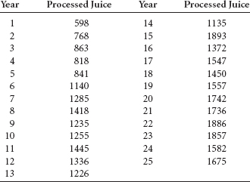

**15.6 INDEX NUMBERS**

One particular type of descriptive measure that is useful in allowing comparisons of data over time is the index number. An index number is, in part, a ratio of a measure taken during one time frame to that same measure taken during another time frame, usually denoted as the base period. Often the ratio is multiplied by 100 and is expressed as a percentage. When expressed as a percentage, index numbers serve as an alternative to comparing raw numbers. Index number users become accustomed to interpreting measures for a given time period in light of a base period on a scale in which the base period has an index of 100(%). Index numbers are used to compare phenomena from one time period to another and are especially helpful in highlighting interperiod differences.

Index numbers are widely used around the world to relate information about stock markets, inflation, sales, exports and imports, agriculture, and many other things. Some examples of specific indexes are the employment cost index, price index for construction, index of manufacturing capacity, producer price index, consumer price index, Dow Jones industrial average, index of output, and Nikkei 225 average. This section, although recognizing the importance of stock indexes and others, will focus on price indexes.

The motivation for using an index number is to reduce data to an easier-to-use, more convenient form. As an example, examine the raw data on number of business bankruptcies in the United States from 1990 through 2010 shown in [**Table 15.15**](https://learning.oreilly.com/library/view/business-statistics-for/9781118213957/26_chapter15.html#tab15.15). An analyst can describe these data by observing that, in general, the number of business bankruptcies has been decreasing since 1990. How do the number of business bankruptcies in 2000 compare to 1990? How do the number of business bankruptcies in 2003 compare to 1993 or 1995? To answer these questions without index numbers, a business researcher would probably resort to subtracting the number of business bankruptcies for the years of interest and comparing the corresponding increases or decreases. This process can be tedious and frustrating for decision makers who must maximize their effort in minimal time. Using simple index numbers, the business researcher can transform these data into values that are more usable and make it easier to compare other years to one particular key year.

**Simple Index Numbers**

How are index numbers computed? The equation for computing a **simple index number** follows.



**TABLE 15.15** Business Bankruptcy Filings in the United States

| Year | Business Bankruptcy Filings |
| --- | --- |
| 1990 | 64,853 |
| 1991 | 71,549 |
| 1992 | 70,643 |
| 1993 | 62,304 |
| 1994 | 52,374 |
| 1995 | 51,959 |
| 1996 | 53,549 |
| 1997 | 54,027 |
| 1998 | 44,367 |
| 1999 | 37,884 |
| 2000 | 35,472 |
| 2001 | 40,099 |
| 2002 | 38,540 |
| 2003 | 35,037 |
| 2004 | 34,317 |
| 2005 | 39,201 |
| 2006 | 19,695 |
| 2007 | 28,322 |
| 2008 | 43,546 |
| 2009 | 60,837 |
| 2010 | 56,282 |

Suppose bankruptcy researchers examining the data from [**Table 15.15**](https://learning.oreilly.com/library/view/business-statistics-for/9781118213957/26_chapter15.html#tab15.15) decide to compute index numbers using 1990 as the base year. The index number for the year 2000 is

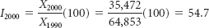

[**Table 15.16**](https://learning.oreilly.com/library/view/business-statistics-for/9781118213957/26_chapter15.html#tab15.16) displays all the index numbers for the data in [**Table 15.15**](https://learning.oreilly.com/library/view/business-statistics-for/9781118213957/26_chapter15.html#tab15.15), with 1990 as the base year, along with the raw data. A cursory glance at these index numbers reveals a decrease in the number of bankruptcies for most of the years since 1990 (because the index has been going down). In particular, the greatest drop in number seems to have occurred between 2005 and 2006—a drop of 30 in the index. Because most people are easily able to understand the concept of 100%, it is likely that decision makers can make quick judgments on the number of business bankruptcies in the United states from one year relative to another by examining the index numbers over this period.

**Unweighted Aggregate Price Index Numbers**

The use of simple index numbers makes possible the conversion of prices, costs, quantities, and so on for different time periods into a number scale with the base year equaling 100%. One of the drawbacks of simple index numbers, however, is that each time period is represented by only one item or commodity. When multiple items are involved, multiple sets of index numbers are possible. Suppose a decision maker is interested in combining or pooling the prices of several items, creating a “market basket” in order to compare the prices for several years. Fortunately, a technique does exist for combining several items and determining index numbers for the total (aggregate). Because this technique is used mostly in determining price indexes, the focus in this section is on developing aggregate price indexes. The formula for constructing the **unweighted aggregate price index number** follows.



Suppose a state's department of labor wants to compare the cost of family food buying over the years. Department officials decide that instead of using a single food item to do this comparison, they will use a food basket that consists of five items: eggs, milk, bananas, potatoes, and sugar. They gathered price information on these five items for the years 1995, 2005, and 2011. The items and the prices are listed in [**Table 15.17**](https://learning.oreilly.com/library/view/business-statistics-for/9781118213957/26_chapter15.html#tab15.17).

**TABLE 15.16** Index Numbers for Business Bankruptcy Filings in the United States

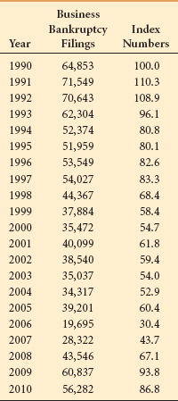

From the data in [**Table 15.17**](https://learning.oreilly.com/library/view/business-statistics-for/9781118213957/26_chapter15.html#tab15.17) and the formula, the unweighted aggregate price indexes for the years 1995, 2005, and 2011 can be computed by using 1995 as the base year. The first step is to add together, or aggregate, the prices for all the food basket items in a given year. These totals are shown in the last row of [**Table 15.17**](https://learning.oreilly.com/library/view/business-statistics-for/9781118213957/26_chapter15.html#tab15.17). The index numbers are constructed by using these totals (not individual item prices): Σ*P***1995** = 2.91, Σ*P***2005** = 3.44, and Σ*P***2011** = 5.08. From these figures, the unweighted aggregate price index for 2005 is computed as follows.

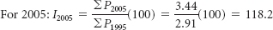

**Weighted Aggregate Price Index Numbers**

A major drawback to unweighted aggregate price indexes is that they are *unweighted*—that is, equal weight is put on each item by assuming the market basket contains only one of each item. This assumption may or may not be true. For example, a household may consume 5 pounds of bananas per year but drink 50 gallons of milk. In addition, unweighted aggregate index numbers are dependent on the units selected for various items. For example, if milk is measured in quarts instead of gallons, the price of milk used in determining the index numbers is considerably lower. A class of index numbers that can be used to avoid these problems is weighted aggregate price index numbers.

**Weighted aggregate price index numbers** are *computed by multiplying quantity weights and item prices in determining the market basket worth for a given year.* Sometimes when price and quantity are multiplied to construct index numbers, the index numbers are referred to as *value indexes.* Thus, weighted aggregate price index numbers are also value indexes.

Including quantities eliminates the problems caused by how many of each item are consumed per time period and the units of items. If 50 gallons of milk but only 5 pounds of bananas are consumed, weighted aggregate price index numbers will reflect those weights. If the business researcher switches from gallons of milk to quarts, the prices will change downward but the quantity will increase fourfold (4 quarts in a gallon).

In general, weighted aggregate price indexes are constructed by multiplying the price of each item by its quantity and then summing these products for the market basket over a given time period (often a year). The ratio of this sum for one time period of interest (year) to a base time period of interest (base year) is multiplied by 100. The following formula reflects a weighted aggregate price index computed by using quantity weights from each time period (year).

**TABLE 15.17** Prices for a Basket of Food Items

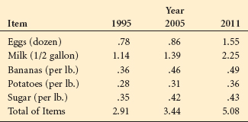

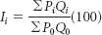

One of the problems with this formula is the implication that new and possibly different quantities apply for each time period. However, business researchers expend much time and money ascertaining the quantities used in a market basket. Redetermining quantity weights for each year is therefore often prohibitive for most organizations (even the government). Two particular types of weighted aggregate price indexes offer a solution to the problem of which quantity weights to use. The first and most widely used is the Laspeyres price index. The second and less widely used is the Paasche price index.

**Laspeyres Price Index**

The **Laspeyres price index** is *a weighted aggregate price index computed by using the quantities of the base period (year) for all other years.* The advantages of this technique are that the price indexes for all years can be compared, and new quantities do not have to be determined for each year. The formula for constructing the Laspeyres price index follows.



Notice that the formula requires the base period quantities (*Q***0**) in both the numerator and the denominator.

In [**Table 15.17**](https://learning.oreilly.com/library/view/business-statistics-for/9781118213957/26_chapter15.html#tab15.17), a food basket is presented in which aggregate price indexes are computed. This food basket consisted of eggs, milk, bananas, potatoes, and sugar. The prices of these items were combined (aggregated) for a given year and the price indexes were computed from these aggregate figures. The unweighted aggregate price indexes computed on these data gave all items equal importance. Suppose that the business researchers realize that applying equal weight to these five items is probably not a representative way to construct this food basket and consequently ascertain quantity weights on each food item for one year's consumption. [**Table 15.18**](https://learning.oreilly.com/library/view/business-statistics-for/9781118213957/26_chapter15.html#tab15.18) lists these five items, their prices, and their quantity usage weights for the base year (1995). From these data, the business researchers can compute Laspeyres price indexes.

The Laspeyres price index for 2011 with 1995 as the base year is:

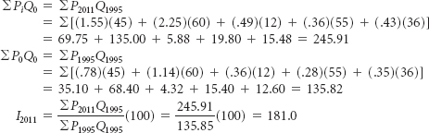

**TABLE 15.18** Food Basket Items with Quantity Weights

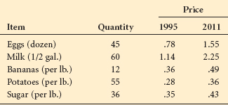

**TABLE 15.19** Food Basket Items with Yearly Quantity Weights for 1995 and 2011

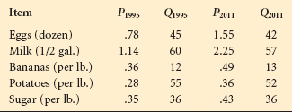

**Paasche Price Index**

The **Paasche price index** is *a weighted aggregate price index computed by using the quantities for the year of interest in computations for a given year.* The advantage of this technique is that it incorporates current quantity figures in the calculations. One disadvantage is that ascertaining quantity figures for each time period is expensive. The formula for computing Paasche price indexes follows.



Suppose the yearly quantities for the basket of food items listed in [**Table 15.18**](https://learning.oreilly.com/library/view/business-statistics-for/9781118213957/26_chapter15.html#tab15.18) are determined. The result is the quantities and prices shown in Table [**Table 15.19**](https://learning.oreilly.com/library/view/business-statistics-for/9781118213957/26_chapter15.html#tab15.19) for the years 1995 and 2011 that can be used to compute Paasche price index numbers.

The Paasche price index numbers can be determined for 2011 by using a base year of 1995 as follows.

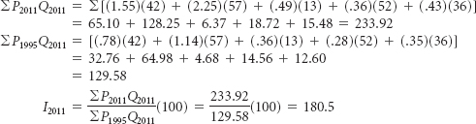

**DEMONSTRATION PROBLEM 15.5**

The Arapaho Valley Pediatrics Clinic has been in business for 18 years. The office manager noticed that prices of clinic materials and office supplies fluctuate over time. To get a handle on the price trends for running the clinic, the office manager examined prices of six items the clinic uses as part of its operation. Shown here are the items, their prices, and the quantities for the years 2010 and 2011. Use these data to develop unweighted aggregate price indexes for 2011 with a base year of 2010. Compute the Laspeyres price index for the year 2011 using 2010 as the base year. Compute the Paasche index number for 2011 using 2010 as the base year.

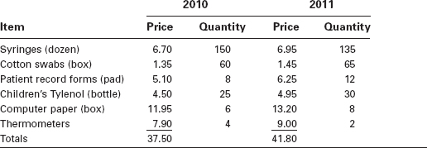

**Solution**

Unweighted Aggregate Index for 2011:

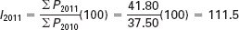

Laspeyres Index for 2011:

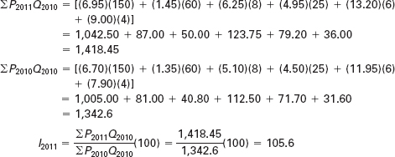

Passache Index for 2011:

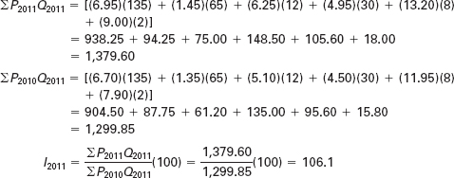

**15.6 PROBLEMS**

* **15.21** Suppose the following data represent the price of 20 reams of office paper over a 60-year time frame. Find the simple index numbers for the data.
  1. Let 1950 be the base year.
  2. Let 1980 be the base year.

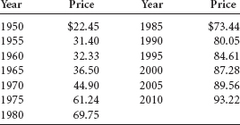

* **15.22** The U.S. Patent and Trademark Office reports fiscal year figures for patents issued in the United States. Following are the numbers of patents issued for the years 1980 through 2010. Using these data and a base year of 1990, determine the simple index numbers for each year.

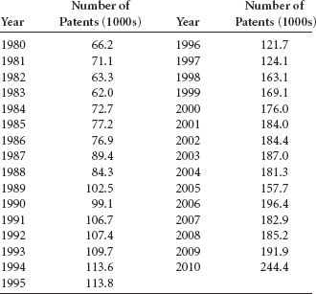

* **15.23** Using the data that follow, compute the aggregate index numbers for the four types of meat. Let 1995 be the base year for this market basket of goods.

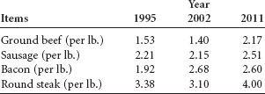

* **15.24** Suppose the following data are prices of market goods involved in household transportation for the years 2004 through 2011. Using 2006 as a base year, compute aggregate transportation price indexes for this data.

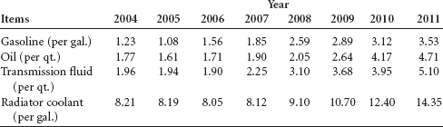

* **15.25** Calculate Laspeyres price indexes for 2009–2011 from the following data. Use 2005 as the base year.

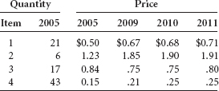

* **15.26** Calculate Paasche price indexes for 2010 and 2011 using the following data and 2005 as the base year.

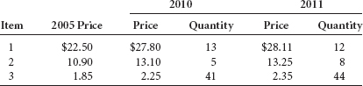

** Forecasting Air Pollution**

 In searching for the most effective forecasting technique to use to forecast either the carbon monoxide emission or the nitrogen oxide, it is useful to determine whether a trend is evident in either set of time-series data. Minitab's trend analysis output is presented here for nitrogen oxides.

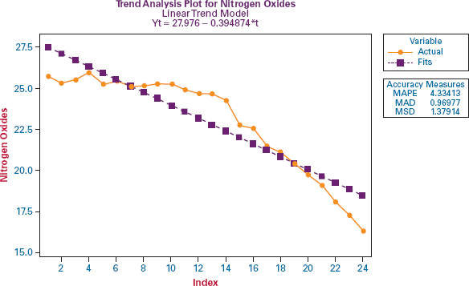

In observing the fit of this trend line and the time-series plot, it is evident that there appears to be more of a quadratic trend than a linear trend. Therefore, a Minitab-produced quadratic trend model was run and the results are presented below. Note that the error measures are all smaller for the quadratic model and that the curve fits the data much better than does the linear model.

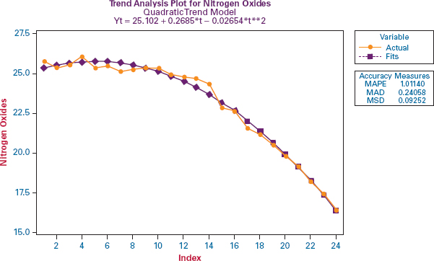

Various smoothing techniques can be used to forecast time-series data. After exploring several moving average models to predict carbon monoxide emissions, it was determined that a 3-year moving average fits the data relatively well. The results of a Minitab moving average graphical analysis of carbon monoxide using a 3-year moving average is shown below. Note that the forecasts shadow the actual values quite well and actually intersect them in two locations.

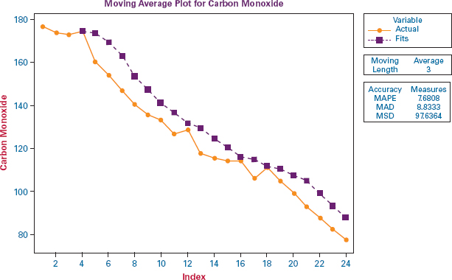

The effectiveness of exponential smoothing as a forecasting tool for nitrogen oxide emissions was tested using Minitab for several values of a. Through this analysis, it was determined that the best forecasts were obtained for values ofanear 1, indicating that the actual value for the previous time period was a much stronger contributor to the forecast than the previous time period's forecast. Shown below is a Minitab-produced graphical analysis of an exponential smoothing forecast of the nitrogen oxide data using an alpha of.95. You are encouraged to explore other methods for forecasting nitrogen oxide and carbon monoxide emissions.

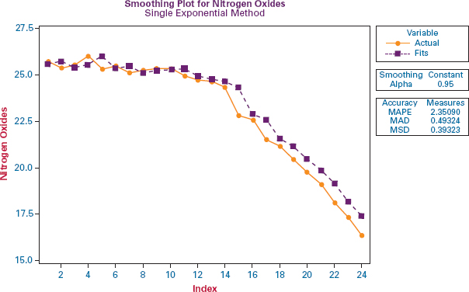

**ETHICAL CONSIDERATIONS**

**The true test of a forecast is the accuracy of the** prediction. Until the actual value is obtained for a given time period, the accuracy of the forecast is unknown. Many forecasters make predictions in society, including card readers, religious leaders, and self-proclaimed prophets. The proof of the forecast is in the outcome. The same holds true in the business world. Forecasts are made about everything from market share to interest rates to number of international air travelers. Some businesses fail because of faulty forecasts.

Forecasting is perhaps as much an art as a science. To keep forecasting ethical, the consumer of the forecast should be given the caveats and limitations of the forecast. The forecaster should be honestly cautious in selling the predictions to a client. In addition, the forecaster should be constantly on the lookout for changes in the business setting being modeled and quickly translate and incorporate those changes into the forecasting model.

Unethical behavior can occur in forecasting when particular data are selected to develop a model that has been predetermined to produce certain results. As mentioned previously, statistics can be used to “prove” almost anything. The ethical forecaster lets the data drive the model and is constantly seeking honest input from new variables to revise the forecast. He or she strives to communicate the limitations of both the forecasts and the models to clients.

**SUMMARY**

Time-series data are data that have been gathered at regular intervals over a period of time. It is generally believed that time-series data are composed of four elements—trend, cyclical effects, seasonality, and irregularity. Trend is the long-term general direction of the time-series data. Cyclical effects are the business and economic cycles that occur over periods of more than 1 year. Seasonal effects are patterns or cycles of data behavior that occur over time periods of less than 1 year. Irregular fluctuations are unaccounted-for “blips” or variations that occur over short periods of time.

One way to establish the validity of a forecast is to examine the forecasting error. The error of a forecast is the difference between the actual value and the forecast value. Computing a value to measure forecasting error can be done in several different ways. This chapter presents mean absolute deviation and mean square error for this task.

Regression analysis with either linear or quadratic models can be used to explore trend. Regression trend analysis is a special case of regression analysis in which the dependent variable is the data to be forecast and the independent variable is the time periods numbered consecutively from 1 to *k*, where *k* is the number of time periods. For the quadratic model, a second independent variable is constructed by squaring the values in the first independent variable, and both independent variables are included in the analysis.

One group of time-series forecasting methods contains smoothing techniques. Among these techniques are naïve models, averaging techniques, and simple exponential smoothing. These techniques do much better if the time series data are stationary or show no significant trend or seasonal effects. Naïve forecasting models are models in which it is assumed that the more recent time periods of data represent the best predictions or forecasts for future outcomes.

Simple averages use the average value for some given length of previous time periods to forecast the value for the next period. Moving averages are time period averages that are revised for each time period by including the most recent value(s) in the computation of the average and deleting the value or values that are farthest away from the present time period. A special case of the moving average is the weighted moving average, in which different weights are placed on the values from different time periods.

Simple (single) exponential smoothing is a technique in which data from previous time periods are weighted exponentially to forecast the value for the present time period. The forecaster has the option of selecting how much to weight more recent values versus those of previous time periods.

Decomposition is a method for isolating the four possible effects in time-series data, trend, cyclical effects, seasonality, and irregular fluctuations.

Autocorrelation or serial correlation occurs when the error terms from forecasts are correlated over time. In regression analysis, this effect is particularly disturbing because one of the assumptions is that the error terms are independent. One way to test for autocorrelation is to use the Durbin-Watson test. There are a number of methods that attempt to overcome the effects of autocorrelation on the data.

Autoregression is a forecasting technique in which timeseries data are predicted by independent variables that are lagged versions of the original dependent variable data. A variable that is lagged one period is derived from values of the previous time period. Other variables can be lagged two or more periods.

Index numbers can be used to translate raw data into numbers that are more readily comparable. Simple index numbers are constructed by creating the ratio of the raw data value for a given time period to the raw data value for the base period and multiplying the ratio by 100. The index number for the base time period is designated to be 100.

Unweighted aggregate price index numbers are constructed by summing the prices of several items for a time period and comparing that sum to the sum of the prices of the same items during a base time period and multiplying the ratio by 100. Weighted aggregate price indexes are index numbers utilizing the prices of several items, and the items are weighted by their quantity usage.

The Laspeyres price index uses the quantity weights from the base year in all calculations. The Paasche price index uses the quantity weights for the current time period for both the current time period and the base time period in calculations.

**KEY TERMS**



autocorrelation

autoregression

averaging models

cycles

cyclical effects

decomposition

deseasonalized data

Durbin-Watson test

error of an individual

forecast

exponential smoothing

first-differences approach

forecasting

forecasting error

index number

irregular fluctuations

Laspeyres price index

mean absolute deviation

(MAD)

mean square error (MSE)

moving average

naïve forecasting models

Paasche price index

seasonal effects

serial correlation

simple average

simple average model

simple index number

smoothing techniques

stationary

time-series data

trend

unweighted aggregate price

index number

weighted aggregate price

index numbers

weighted moving average

**FORMULAS**

Individual forecast error



Mean absolute deviation

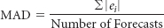

Mean square error

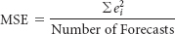

Exponential smoothing



Durbin-Watson test

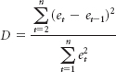

**SUPPLEMENTARY PROBLEMS**

**CALCULATING THE STATISTICS**

* **15.27** Following are the average yields of long-term new corporate bonds over a several-month period published by the Office of Market Finance of the U.S. Department of the Treasury.

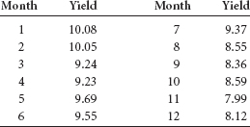

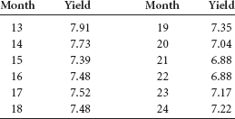

* 1. Explore trends in these data by using regression trend analysis. How strong are the models? Is the quadratic model significantly stronger than the linear trend model?
  2. Use a 4-month moving average to forecast values for each of the ensuing months.
  3. Use simple exponential smoothing to forecast values for each of the ensuing months. Let α = .3 and then let α = .7. Which weight produces better forecasts?
  4. Compute MAD for the forecasts obtained in parts (b) and (c) and compare the results.
  5. Determine seasonal effects using decomposition on these data. Let the seasonal effects have four periods. After determining the seasonal indexes, deseasonalize the data.
* **15.28** Compute index numbers for the following data using 1995 as the base year.

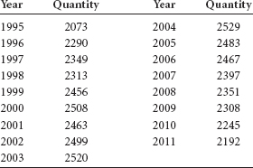

* **15.29** Compute unweighted aggregate price index numbers for each of the given years using 2007 as the base year.

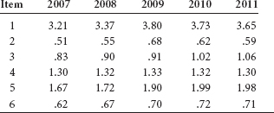

* **15.30** Using the following data and 2008 as the base year, compute the Laspeyres price index for 2011 and the Paasche price index for 2010.

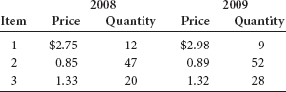

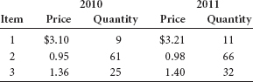

**TESTING YOUR UNDERSTANDING**

* **15.31** The following data contain the quantity (million pounds) of U.S. domestic fish caught annually over a 25-year period as published by the National Oceanic and Atmospheric Administration.
  1. Use a 3-year moving average to forecast the quantity of fish for the years 1983 through 2006 for these data. Compute the error of each forecast and then determine the mean absolute deviation of error for the forecast.
  2. Use exponential smoothing and α = .2 to forecast the data from 1983 through 2006. Let the forecast for 1981 equal the actual value for 1980. Compute the error of each forecast and then determine the mean absolute deviation of error for the forecast.
  3. Compare the results obtained in parts (a) and (b) using MAD. Which technique seems to perform better? Why?

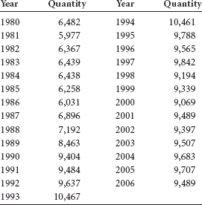

* **15.32** The U.S. Department of Commerce publishes a series of census documents referred to as *Current Industrial Reports.* Included in these documents are the manufacturers' shipments, inventories, and orders over a 5-year period. Displayed here is a portion of these data representing the shipments of chemicals and allied products from January of year 1 through December of year 5. Use time-series decomposition methods to develop the seasonal indexes for these data.

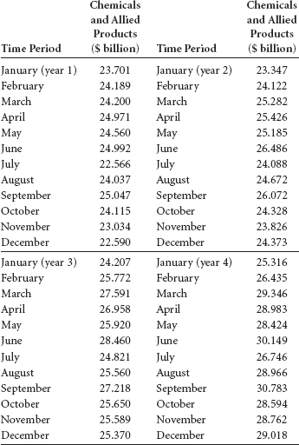

| Time Period | Chemicals and Allied Products ($ billion) |
| --- | --- |
| January (year 5) | 28.931 |
| February | 30.456 |
| March | 32.372 |
| April | 30.905 |
| May | 30.743 |
| June | 32.794 |
| July | 29.342 |
| August | 30.765 |
| September | 31.637 |
| October | 30.206 |
| November | 30.842 |
| December | 31.090 |

* **15.33** Use the seasonal indexes computed to deseasonalize the data in Problem 15.32.
* **15.34** Determine the trend for the data in Problem 15.32 using the deseasonalized data from Problem 15.33. Explore both a linear and a quadratic model in an attempt to develop the better trend model.
* **15.35** Shown here are retail price figures and quantity estimates for five different food commodities over 3 years. Use these data and a base year of 2009 to compute unweighted aggregate price indexes for this market basket of food. Using a base year of 2009, calculate Laspeyres price indexes and Paasche price indexes for 2010 and 2011.

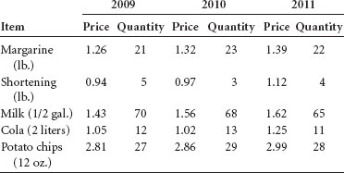

* **15.36** Given below are data on the number of business establishments (millions) and the self-employment rate (%) released by the Small Business Administration, Office of Advocacy, for a 21-year period of U.S. business activity. Develop a regression model to predict the selfemployment rate by the number of business establishments. Use this model to predict the self-employment rate for a year in which there are 7.0 (million) business establishments. Discuss the strength of the regression model. Use these data and the regression model to compute a Durbin-Watson test to determine whether significant autocorrelation is present. Let alpha be .05.

| Number of Establishments (millions) | Self-Employment Rate (%) |
| --- | --- |
| 4.54317 | 8.1 |
| 4.58651 | 8.0 |
| 4.63396 | 8.1 |
| 5.30679 | 8.2 |
| 5.51772 | 8.2 |
| 5.70149 | 8.0 |
| 5.80697 | 7.9 |
| 5.93706 | 8.0 |
| 6.01637 | 8.2 |
| 6.10692 | 8.1 |
| 6.17556 | 8.0 |
| 6.20086 | 8.1 |
| 6.31930 | 7.8 |
| 6.40123 | 8.0 |
| 6.50907 | 8.1 |
| 6.61272 | 7.9 |
| 6.73848 | 7.8 |
| 6.89487 | 7.7 |
| 6.94182 | 7.5 |
| 7.00844 | 7.2 |
| 7.07005 | 6.9 |

* **15.37** Shown here are the consumer price indexes (CPIs) for housing for the years 1990 through 2010 from the Bureau of Labor Statistics Data Web site. Use the data to answer the following questions.
  1. Compute the 4-year moving average to forecast the CPIs from 1994 through 2010.
  2. Compute the 4-year weighted moving average to fore cast the CPIs from 1994 through 2010. Weight the most recent year by 4, the next most recent year by 3, the next year by 2, and the last year of the four by 1.
  3. Determine the errors for parts (a) and (b). Compute MSE for parts (a) and (b). Compare the MSE values and comment on the effectiveness of the moving average versus the weighted moving average for these data.

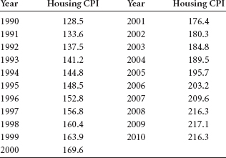

* 1. **15.38** In the *Survey of Current Business*, the U.S. Department of Commerce publishes data on farm commodity prices. Given are the cotton prices from November of year 1 through February of year 4. The prices are indexes with a base of 100 from the period of 1910 through 1914. Use a base of 100 from the period of 1910 through 1914. Use month lag and a 4-month lag. Compare the results of these two models. Which model seems to yield better predictions? Why?

| Time Period | Cotton Prices |
| --- | --- |
| November (year 1) | 552 |
| December | 519 |
| January (year 2) | 505 |
| February | 512 |
| March | 541 |
| April | 549 |
| May | 552 |
| June | 526 |
| July | 531 |
| August | 545 |
| September | 549 |
| October | 570 |
| November | 576 |
| December | 568 |
| aJnuary (year 3) | 571 |
| February | 573 |
| March | 582 |
| April | 587 |
| May | 592 |
| June | 570 |
| July | 560 |
| August | 565 |
| September | 547 |
| October | 529 |
| November | 514 |
| December | 469 |
| January (year 4) | 436 |
| February | 419 |

* **15.39** The U.S. Department of Commerce publishes data on industrial machinery and equipment. Shown here are the shipments (in $ billions) of industrial machinery and equipment from the first quarter of year 1 through the fourth quarter of year 6. Use these data to determine the seasonal indexes for the data through timeseries decomposition methods. Use the four-quarter centered moving average in the computations.

| Time Period | Industrial Machinery and Equipment Shipments |
| --- | --- |
| 1st quarter (year 1) | 54.019 |
| 2nd quarter | 56.495 |
| 3rd quarter | 50.169 |
| 4th quarter | 52.891 |
| 1st quarter (year 2) | 51.915 |
| 2nd quarter | 55.101 |
| 3rd quarter | 53.419 |
| 4th quarter | 57.236 |
| 1st quarter (year 3) | 57.063 |
| 2nd quarter | 62.488 |
| 3rd quarter | 60.373 |
| 4th quarter | 63.334 |
| 1st quarter (year 4) | 62.723 |
| 2nd quarter | 68.380 |
| 3rd quarter | 63.256 |
| 4th quarter | 66.446 |
| 1st quarter (year 5) | 65.445 |
| 2nd quarter | 68.011 |
| 3rd quarter | 63.245 |
| 4th quarter | 66.872 |
| 1st quarter (year 6) | 59.714 |
| 2nd quarter | 63.590 |
| 3rd quarter | 58.088 |
| 4th quarter | 61.443 |

* **15.40** Use the seasonal indexes computed to deseasonalize the data in Problem 15.39.
* **15.41** Use both a linear and quadratic model to explore trends in the deseasonalized data from Problem 15.40. Which model seems to produce a better fit of the data?
* **15.42** The Board of Governors of the Federal Reserve System publishes data on mortgage debt outstanding by type of property and holder. The following data give the amounts of residential nonfarm debt (in $ billions) held by savings institutions in the United States over a 10-year period. Use these data to develop an autoregression model with a one-period lag. Discuss the strength of the model.

| Year | Debt |
| --- | --- |
| 1 | 529 |
| 2 | 554 |
| 3 | 559 |
| 4 | 602 |
| 5 | 672 |
| 6 | 669 |
| 7 | 600 |
| 8 | 538 |
| 9 | 490 |
| 10 | 470 |

* **15.43** The data shown here, from the Investment Company Institute, show that the equity fund assets of mutual funds have been growing since 1981. At the same time, money market funds have been increasing since 1980. Use these data to develop a regression model to forecast the equity fund assets by money market funds. All figures are given in billion-dollar units. Conduct a Durbin-Watson test on the data and the regression model to determine whether significant autocorrelation is present. Let α = .01.

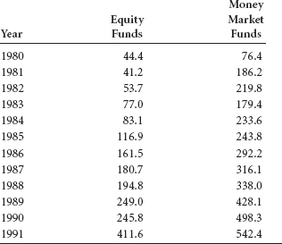

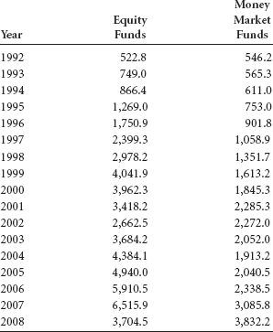

* **15.44** The purchasing-power value figures for the minimum wage in dollars for the years 1 through 18 are shown here. Use these data and exponential smoothing to develop forecasts for the years 2 through 18. Try α = .1, .5, and .8, and compare the results using MAD. Discuss your findings. Select the value of alpha that worked best and use your exponential smoothing results to predict purchasing power for year 19.

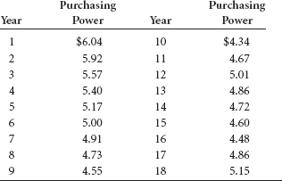

**INTERPRETING THE OUTPUT**

* **15.45** Shown on the following page is the Excel output for a regression analysis to predict the number of business bankruptcy filings over a 16-year period by the number of consumer bankruptcy filings. How strong is the model? Note the residuals. Compute a Durbin-Watson statistic from the data and discuss the presence of autocorrelation in this model.

**SUMMARY OUTPUT**

| *Regression Statistics* | |
| --- | --- |
| Multiple R | 0.529 |
| R Square | 0.280 |
| Adjusted R Square | 0.228 |
| Standard Error | 8179.84 |
| Observations | 16 |

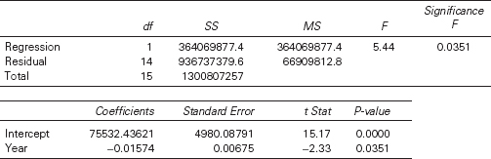

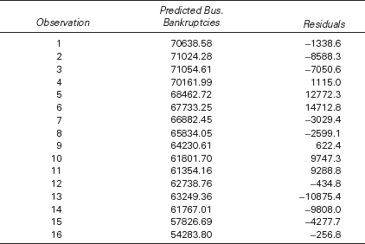

*see* [**www.wiley.com/college/black**](http://www.wiley.com/college/black) and WileyPLUS

**ANALYZING THE DATABASES**

1.  Use the Agricultural timeseries database and the variable Green Beans to forecast the number of green beans for period 169 by using following techniques.
   1. Five-period moving average
   2. Simple exponential smoothing with α = .6
   3. Time-series linear trend model
   4. Decomposition
2. Use decomposition on Carrots in the Agricultural database to determine the seasonal indexes. These data actually represent 14 years of 12-month data. Do the seasonal indexes indicate the presence of some seasonal effects? Run an autoregression model to predict Carrots by a 1-month lag and another by a 12-month lag. Compare the two models. Because vegetables are somewhat seasonal, is the 12-month lag model significant?
3. Use the Energy database to forecast year 27 U.S. coal production by using simple exponential smoothing of previous U.S. coal production data. Let α = .2 and α = .8. Compare the forecast with the actual figure. Which of the two models produces the forecast with the least error?
4. Use the International Labor database to develop a regression model to predict the unemployment rate for Germany by the unemployment rate of Italy. Test for autocorrelation and discuss its presence or absence in this regression analysis.

**CASE: DEBOURGH MANUFACTURING COMPANY**

The DeBourgh Manufacturing Company was founded in 1909 as a metal-fabricating company in Minnesota by the four Berg brothers. In the 1980s, the company ran into hard times, as did the rest of the metal-fabricating industry. Among the problems that DeBourgh faced were declining sales, deteriorating labor relations, and increasing costs. Labor unions had resisted cost-cutting measures. Losses were piling up in the heavy job-shop fabrication division, which was the largest of the company's three divisions. A division that made pedestrian steel bridges closed in 1990. The remaining company division, producer of All-American lockers, had to move to a lower-cost environment.

In 1990, with the company's survival at stake, the firm made a risky decision and moved everything from its highcost location in Minnesota to a lower-cost area in La Junta, Colorado. Eighty semitrailer trucks were used to move equipment and inventory 1000 miles at a cost of $1.2 million. The company was relocated to a building in La Junta that had stood vacant for 3 years. Only 10 of the Minnesota workers transferred with the company, which quickly hired and trained 80 more workers in La Junta. By moving to La Junta, the company was able to go nonunion.

DeBourgh also faced a financial crisis. A bank that had been loaning the company money for 35 years would no longer do so. In addition, a costly severance package was worked out with Minnesota workers to keep production going during the move. An internal stock-purchase “earnout” was arranged between company president Steven C. Berg and his three aunts, who were the other principal owners.

The roof of the building that was to be the new home of DeBourgh Manufacturing in La Junta was badly in need of repair. During the first few weeks of production, heavy rains fell on the area and production was all but halted. However, DeBourgh was able to overcome these obstacles. One year later, locker sales achieved record-high sales levels each month. The company is now more profitable than ever with sales topping $6 million. Much credit has been given to the positive spirit of teamwork fostered among its approximately 80 employees. Emphasis shifted to employee involvement in decision making, quality, teamwork, employee participation in compensation action, and shared profits. In addition, DeBourgh became a more socially responsible company by doing more for the town in which it is located and by using paints that are more environmentally friendly.

**Discussion**

1. After its move in 1990 to La Junta, Colorado, and its new initiatives, the DeBourgh Manufacturing Company began an upward climb of record sales. Suppose the figures shown here are the DeBourgh monthly sales figures from January 2003 through December 2011 (in $1,000s). Are any trends evident in the data? Does DeBourgh have a seasonal component to its sales? Shown after the sales figures is Minitab output from a decomposition analysis of the sales figures using 12-month seasonality. Next an Excel graph displays the data with a trend line. Examine the data, the output, and any additional analysis you feel is helpful, and write a short report on DeBourgh sales. Include a discussion of the general direction of sales and any seasonal tendencies that might be occurring.

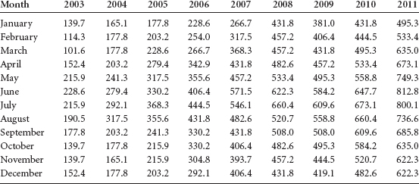

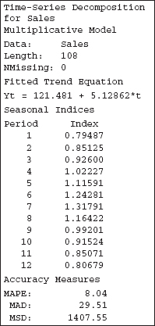

1. Suppose DeBourgh accountants computed a per-unit cost of lockers for each year since 1998, as reported here. Use techniques in this chapter to analyze the data. Forecast the per-unit labor costs through the year 2011. Use smoothing techniques, moving averages, trend analysis, and any others that seem appropriate. Calculate the error of the forecasts and determine which forecasting method seems to do the best job of minimizing error. Study the data and explain the behavior of the per-unit labor cost since 1998. Think about the company history and objectives since 1998.

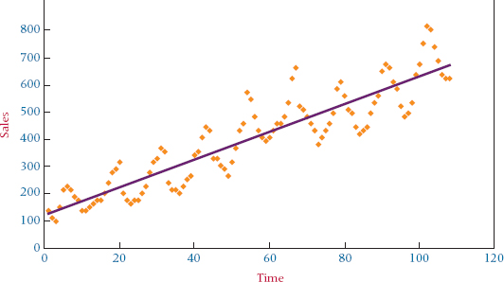

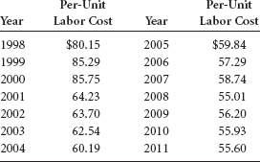

*Source:* Adapted from “DeBourgh Manufacturing Company: A Move That Saved a Company,” Real-World Lessons for America's Small Businesses: Insights from the Blue Chip Enterprise Initiative. Published by *Nation's Business* magazine on behalf of Connecticut Mutual Life Insurance Company and the U.S. Chamber of Commerce in association with the Blue Chip Enterprise Initiative, 1992, the Web site containing Colorado Springs top business stories, available at [**http://www.csbj.com/1998/981113/top_stor.htm**](http://www.csbj.com/1998/981113/top_stor.htm), and DeBourgh, available at [**http://www.debourgh.com**](http://www.debourgh.com/), 2011.

**USING THE COMPUTER**

**EXCEL**

* Excel has the capability of forecasting using several of the techniques presented in this chapter. Two of the forecasting techniques are accessed using the **Data Analysis** tool, and two other forecasting techniques are accessed using the **Insert Function**.
* To use the **Data Analysis** tool, begin by selecting the **Data** tab on the Excel worksheet. From the **Analysis** panel at the right top of the **Data** tab worksheet, click on **Data Analysis**. If your Excel worksheet does not show the **Data Analysis** option, then you can load it as an add-in following directions given in [**Chapter 2**](https://learning.oreilly.com/library/view/business-statistics-for/9781118213957/10_chapter02.html#ch2).
* To do exponential smoothing, select **Exponential Smoothing** from the **Data Analysis** pulldown menu. In the dialog box, input the location of the data to be smoothed in **Input Range**. Input the value of the dampening factor in **Damping factor**. Excel will default to .3. Input the location of the upper left cell of the output table in the **Output Range** space. The output consists of forecast values of the data. If you check **Standard Errors**, a second column of output will be given of standard errors.
* To compute moving averages, select **Moving Average** from the **Data Analysis** pulldown menu. In the dialog box, input the location of the data for which the moving averages are to be computed in **Input Range**. Record how many values you want to include in computing the moving average in **Interval**. The default number is three values. Input the location of the upper left cell of the output table in **Output Range**. The output consists of the moving averages. If you check **Standard Errors**, a second column of output will be given of standard errors.
* To use the **Insert Function** (***fx***) to compute forecasts and/or to fit a trend line, go to the **Formulas** tab on an Excel worksheet (top center tab). The **Insert Function** is on the far left of the menu bar. In the **Insert Function** dialog box at the top, there is a pulldown menu where it says **Or select a category**. From the pulldown menu associated with this command, select **Statistical**.
* To compute forecasts using linear regression, select **FORECAST** from the **Insert Function**'s **Statistical** menu. In the first line of the **FORECAST** dialog box, place the value of *x* for which you want a predicted value in **X**. An entry here is required. On the second line, place the location of the *y* values to be used in the development of the regression model in **Known_y's**. On the third line, place the location of the *x* values to be used in the development of the regression model in **Known_x's**. The output consists of the predicted value.
* To fit a trend line to data, select **TREND** from the **Insert Function**'s **Statistical** menu. On the first line of the **TREND** dialog box, place the location of the *y* values to be used in the development of the regression model in **Known_y's**. On the second line, place the location of the *x* values to be used in the development of the regression model in **Known_x's**. Note that the *x* values can consist of more than one column if you want to fit a polynomial curve. To accomplish this, place squared values of *x*, cubed values of *x*, and so on as desired in other columns, and include those columns in **Known_x**. On the third line, place the values for which you want to return corresponding *y* values in **New_x's**. In the fourth line, place **TRUE** in **Const** if you want to get a value for the constant as usual (default option). Place **FALSE** if you want to set b**0** to zero.

**MINITAB**

* There are several forecasting techniques available through Minitab. These techniques are accessed in the following way: select **Stat** from the menu bar, and from the ensuing pulldown menu, select **Time Series**. From this pulldown menu select one of several forecasting techniques as detailed below.
* To begin a **Time Series Plot**, select which of the four types of plots you want from **Simple**, **Multiple**, **With Groups**, **or Multiple with Groups**. Enter the column containing the values that you want to plot in **Series**. Other options include **Time/Scale**, where you can determine what time frame you want to use along the *x*-axis; **Labels**, where you input titles and data labels; **Data View**, where you can choose how you want the graph to appear with options of symbols, connect line, or project lines; **Multiple Graphs**; and **Data Options**.
* To begin a **Trend Analysis**, place the location of the time-series data in the **Variables** slot. Under **Model** Type, select the type of model you want to create from **Linear**, **Quadratic**, **Exponential growth**, or **S-Curve**. You can generate forecasts from your model by checking **Generate forecasts** and inserting how many forecasts you want and the starting point. Other options include **Time**, where you can determine what time frame you want to use along the *x*-axis; **Options**, where you input titles and data weights; **Storage**, where you can choose to store fits and/or residuals; **Graphs**, where you can choose from several graphical display options; and **Results**, which offers you three different ways to display the results.
* To begin a **Decomposition**, place the location of the timeseries data in the **Variables** slot. Choose the **Model Type** by selecting from **Multiplicative**, **Additive**, **Trend plus seasonal**, or **Seasonal only**. You can generate forecasts from your model by checking **Generate forecasts** and inserting how many forecasts you want and the starting point. Other options include **Time**, where you can determine what time frame you want to use along the *x*-axis; **Options**, where you input the title and the seasonal location of the first observation; **Storage**, where you can choose to store trend line, detrended data, seasonals, seasonally adjusted data, fits, and residuals; **Graphs**, where you can choose from several graphical display options; and **Results**, which offers you three different ways to display the results.
* To begin a **Moving Average**, place the location of the timeseries data in the **Variables** slot. Enter a positive integer to indicate desired length for the moving average in the **MA Length** slot. Check the **Center the moving averages** box if you want to place the moving average values at the period that is in the center of the range rather than at the end of the range. You can generate forecasts from your model by checking **Generate forecasts** and inserting how many forecasts you want and the starting point. Other options include **Time**, where you can determine what time frame you want to use along the *x*-axis; **Options**, where you input the title; **Storage**, where you can choose to store moving averages, fits, and residuals; **Graphs**, where you can choose from several graphical display options; and **Results**, which offers you three different ways to display the results.
* To beg in **Single Exp Smoothing**, place the location of the time-series data in the **Variables** slot. Under **Weight to Use in Smoothing**, if you choose **Optimal ARIMA**, the forecasts will use the default weight, which Minitab computes by fitting an ARIMA (0, 1, 1) model to the data. With this option, Minitab calculates the initial smoothed value by backcasting. If you choose **Use**, you can enter a specific weight that is between 0 and 2. You can generate forecasts from your model by checking **Generate forecasts** and inserting how many forecasts you want and the starting point. Other options include **Time**, where you can determine what time frame you want to use along the *x*-axis; **Options**, where you input the title; **Storage**, where you can choose to store smoothed data, fits, and residuals; **Graphs**, where you can choose from several graphical display options; and **Results**, which offers you three different ways to display the results.
* To beg in **Differences**, enter the column containing the variable for which you want to compute differences in **Series**. Enter a storage column for the differences in the box beside **Store differences in**. In the box beside **Lag**, enter the value for the lag. The default lag value is 1.
* To beg in **Lag**, enter the column containing the variable that you want to lag in **Series**. Enter the storage column for the lags in **Store lags in**. Enter the value for the lag in **Lag**. The default lag value is 1.
* To beg in **Autocorrelation**, enter the column containing the time series in **Series**. If you want to use the default number of lags, choose **Default number of lags**. This number is *n*/4 for a series with less than or equal to 240 observations or √*n* + 45 for a series with more than 240 observations, where *n* is the number of observations in the series. By selecting **Number of lags**, you can enter the number of lags to use instead of the default. The maximum number of lags is *n* – 1. Check **Store ACF** to store the autocorrelation values in the next available column. Check **Store t Statistics** to store the *t* statistics. Check **Store Ljung-Box Q Statistics** to store the Ljung-Box Q statistics.

z